SUBMIT EVENTS
You may submit event information per the District 7910 Promotional Guidelines. If your club does not use ClubRunner, please send your event information to Immediate Past Governor/Newsletter Editor Jim Fusco, jim.fusco2@gmail.com. And, please make sure to add Jim to your club's distribution list.

DISTRICT SOCIAL MEDIA
'Like' and share us on Facebook

'Follow' us on Twitter

DISTRICT & CLUB EVENTS

upcoming DISTRICT EVENTS

FOR: FEBRUARY 7-March 7
Pre-PETS

Saturday, February 11
9:00-11:00 a.m.

Hilton Garden Inn, Waltham

RYLA Chair Training

Saturday, February 11

9:00-10:00 a.m.

Action Unlimited, Concord

Pre-PETS

Monday, February 13

6:30-8:30 p.m.

DoubleTree Hotel, Leominster

RYLA Chair Training

Monday, February 13

7:00-8:00 p.m.

DoubleTree Hotel, Leominster

Membership Committee Meeting

Wednesday, February 15

6:30-8:30 p.m.

Hilton Garden Inn, Marlborough

RYLA Group Leader Callbacks

Thursday, February 16

6:30-8:30 p.m.

DoubleTree Hotel, Leominster

District Governor-Elect Karin Gaffney's Cabinet Meeting

Thursday, February 16

6:30-8:30 p.m.

Courtyard Hotel, Littleton

Foundation Committee Meeting

Tuesday, February 27

6:30-8:30 p.m.

Hilton Garden Inn, Marlborough

Assistant Governors Meeting - Virtual

Wednesday, February 28

Time to be determined

RYLA $s and #s from Rotary clubs are due

Thursday, March 1

Rotary Means Business Networking Event

Thursday, March 1
5:30-7:30 p.m.

Radisson Hotel & Suites, Chelmsford

RYLA Committee Meeting

Tuesday, March 7
6:30-9:00 p.m.

DoubleTree Hotel, Leominster

VIEW THESE PLUS MORE UPCOMING DISTRICT EVENTS - INCLUDING ALL GOVERNOR'S VISITS

RI SPOTLIGHT

Rotary Peace Centers: 2019 Rotary Peace Fellowship applications now available

READ MORE

RI Website Has Been Updated
For a sneak peak at the new Rotary International website, click here.
Read more about the web-refresh project
Learn more about the online tools available to you and your club

Club & District Report from RI

By Katlin Bautz

READ REPORT

In the New Year: Spend Less. Give More.

To learn 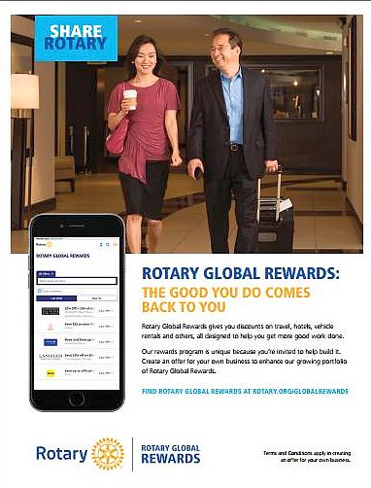more about Rotary Global Reward, click here

To download the Rotary Global Reward flyer,click here

Contact Judy Merriman, chair of the District Rotary Global Rewards Committeeat judymerriman@townisp.com.

The Rotary Foundation Named 'World’s Outstanding Foundation'

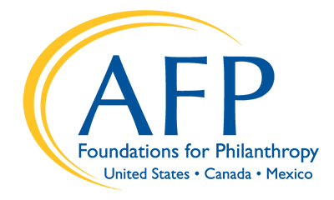
READ MORE

'Rotary Leader' Newsletter: January 2017

READ NEWSLETTER

Meet Ian Riseley: '17-'18 RI President

READ MORE
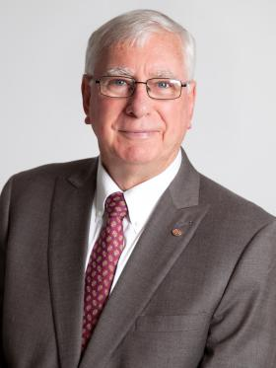

'Beyond Borders:' December 2016
By Dean Rohrs, RI Director for Zones 24 & 32
To read the December 2016 issue of Beyond Borders, click here.
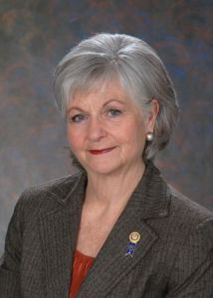

In the December issue:
- Dean describes how the age-old Christmas story and the message of Rotary offer hope for the new year.
- Director-Nominee Jeff Cadorette (see below) discusses his "journey" toward directorship - and promises to take us along with him on a great ride.
- We learn how the Toronto Sunrise club meets new immigrants in town - and supports them as they develop a brand-new club that better suits their needs.
- We follow along as Rotarians experience a National Immunization Day to Nigeria.
- We learn how millions of dollars ​ have been raised​ for The Rotary Foundation - and how we can ​ contribute.
- We hear a​n example of how "talking Rotary" turns into a service project ​all its own.​
To read Dean's highlights of the latest RI Board of Directors meeting, click here.

Meet Jeff Cadorette: Our New RI Director

READ MORE
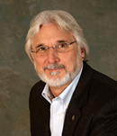

Meet Sam Owori: Our '18-'19 RI President

Sam Owon is a Ugandan businessman and a member of the Rotary Club of Kampala.

READ MORE

A Letter from '16-'17 RI President John Germ
READ MORE
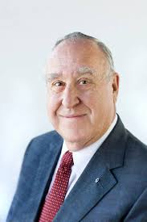

To download the World Polio Day toolkit, click here

For information on the April 2017 Rotary International Convention, click here.

To read a profile of John Germ, click here

To visit the President’s page, click here

To watch the Meet Your President video, click here

2017 Rotary Zone 24 & 32 Institute

READ MORE & REGISTER NOW

Campaign to End Polio: What you don't know

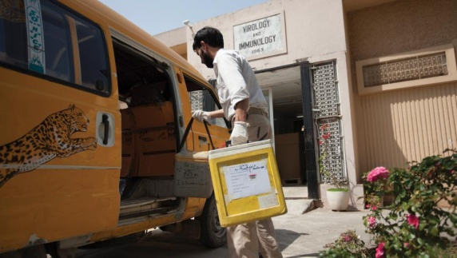
When was the last time there was polio in Europe?

READ MORE

What Millennials Love about Rotary

Millennials, an ethnically diverse, fiercely independent generation of digital natives, are doing more than just snapping selfies—they’re looking for a way to make a difference in their communities.

READ MORE

Get Ready for Your District Rotary Foundation Seminar
The Rotary Foundation is celebrating its 100th year of Doing Good in the World. Take the opportunity to strengthen your district and clubs during your district's Rotary Foundation Seminar by using resources from centennial.rotary.org.
Go to the Promotional resources tab to download the following Centennial Promotional Kit materials:
- Ideas and activities for clubs
- Doing Good in the World promotional flier
- Doing Good in the World bookmark
- Sample press release
- Centennial letterhead
- Centennial PowerPoint template
- History of the Rotary Foundation PowerPoint
- Centennial postcard
Let others know about these materials they can use to promote the Foundation in their clubs and communities.

Membership Minute: Impact Begins with You

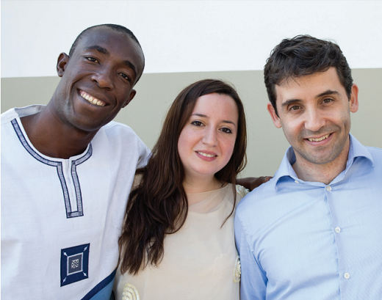
A positive member experience begins long before someone joins a Rotary club. Start by introducing prospective members to Rotary with the Impact Begins With You brochure.

READ MORE

New Tools for Membership Tool Belt

Looking to enhance your club-membership experience?

READ MORE

A How-To Membership-Leads Video

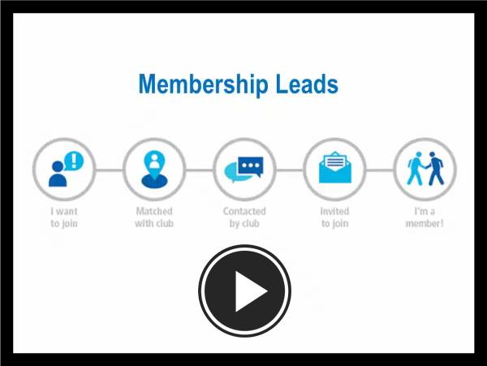
WATCH VIDEO

RI Membership Resource Guide
To download the Guide in PDF format, click here
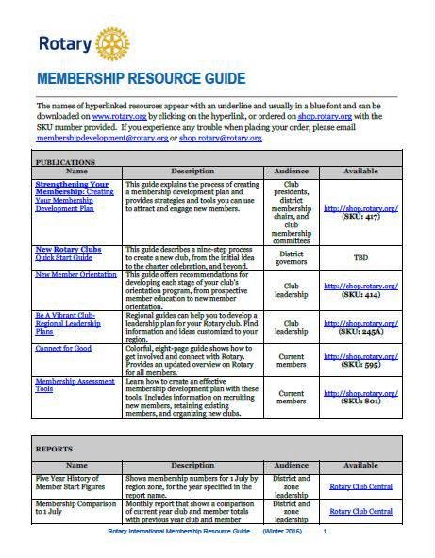

RI Makes Changes in 'Brand Center' Online Tool

We hope that you've found Rotary International’s Brand Center a useful tool to create customized logos and brochures - and to tell Rotary's story in a consistent and engaging way. To gain access, you will need to login with your Rotary Membership ID.

'16-'17 Rotary Theme: 'Rotary Serving Humanity'
To download the image in JPEG format, click here.

Check Out 'Rotary Voices' Blog

Check out Rotary Voices, the official blog of Rotary International. This blog features stories by and about Rotary members, Rotary program alumni, and the people we partner and work with.

