GOVERNOR'S MESSAGE
Multi-District Conference: All prices go up April 1 - so register now
By Pat and Skip Doyle
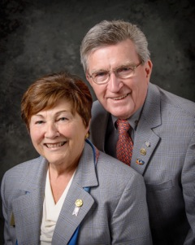
We want to make sure as many members as possible read all about our Multi-District Conference on April 28 through 30 in Providence, and so we are changing last week's "Governor's Message" only a little. If you have not as yet put this date on your calendar, please do it now so you will not forget. All prices will go up on April 1 - so don't wait to register. To register now, click here.

One thing we want to call your attention to is our Youth Program planned for Saturday and Sunday, April 29 and 30. at the District Conference. Saturday's program is an all-day conference within a conference for our Interactors and Rotaractors. There are interesting speakers, panel discussions and interactive sessions planned all day for our youth. We will include a complete schedule next week. The registration fee for our Interactors is $25, which includes lunch. Pricing for Rotaractors will be available next week - and will include an overnight stay. We hope that Rotary clubs sponsoring Interact clubs may want to defray the costs for the Interactors who participate.

On the subject of costs, if District 7910 were to plan an event such as the Multi-District Conference on its own, given the current prices for venues, it would be prohibitively expensive. We are able to provide this priceless experience at this low cost because three other districts - 7890, 7950 and 7980 - are holding this conference with ours. The venue is being paid through the collective buying power of all Rotarians from all four districts who will be attending this conference. Since we are already holding sessions in the Providence Convention Center and there are spaces available for our young people as well, you might consider your attendance at the full conference as a way to help our Interactors.

More information about schedules and pricing will be available next week.

Seeking three trustees

We are now seeking two Rotarians to become trustees of the District Board of Trustees plus one Rotarian to become a trustee of the District Special Fund Board. The need for two trustees for the Board of Trustees is due to an unforeseen circumstance.

Those who applied before are eligible to apply again. For more information, contact us at pwdoyle2@verizon.net and skipdoyle2@verizon.net.

Six important things to know:

1. The weekly submission deadline for the Newsletter will remain the same: Friday. As usual, text content must be submitted in Word format, and image content, in either JPEG or PDF format. Continue to submit your content to Immediate Past District Governor/Newsletter Editor Jim Fusco at jim.fusco2@gmail.com.

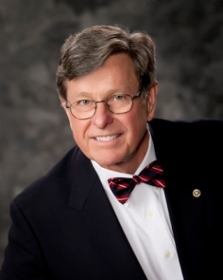
2. Resolutions: The District Resolutions Committee met on January 10 and addressed three changes to the DistrictResolution that will be proposed and voted on at the annual District Business Meeting, to be held during the Multi-District Conference in Providence, on Saturday morning, April 29. For more information on the District Resolutions, contact Resolutions Chair Doug Detweiller (shown, right) at rotary@detweiler.org.

3. District Nominations: The District Nominating Committee is seeking qualified applicants to serve as DistrictTrustee for 2017 to 2019 and District Charitable Fund Trustee for 2017 to 2020. Clubs and club leadership are asked and encouraged to actively recruit and promote service in Rotary through their member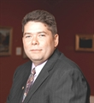s' service as district leaders. The deadline for submitting applications is this February 18. All completed applications should be either e-mailed to Nominating Committee Chair Michael Ellis (shown,right) at mellis0144@comcast.net, or mailed to him at: Michael Ellis, District 7910 Nominating Committee, 88 Coburn Ave., Gardner, MA 01440. Postmarked mail after February 18 will not be accepted. To download the Trustee Nomination Form, click here. To download the Nomination Form Supplement, click here.
4. Rotary Youth Leadership Awards: The RYLA Club Pack has been updated and posted on RYLA7910.org. When you download it, you will notice changes from last year. Please read the material carefully and direct your questions to Christine Pinney, chair of the RYLA Committee,who may be reached at christine@christinepinney.com. The RYLA season has begun and the RYLA Committee is working to make RYLA 2017 the "best RYLA ever." (See RTLA article in right hand column)

5. Club Planning Worksheet: To download the Club Planning Worksheet, click here.This worksheet is made available to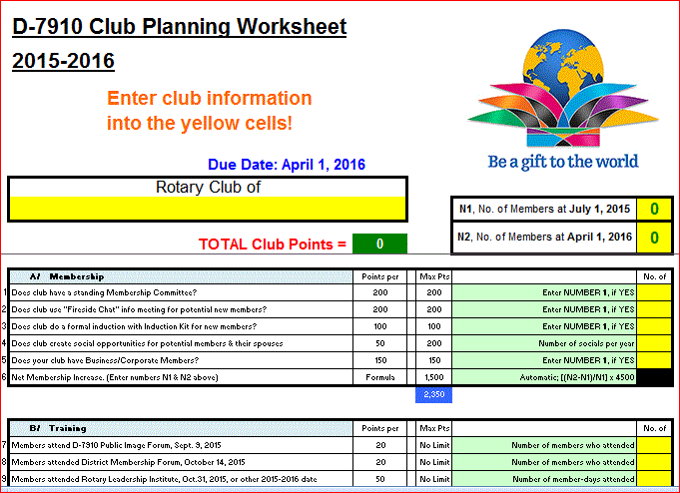 clubs so they can gauge their progress in achieving the goals they set last July. This month is a good time to review the worksheet and see how far you have come and how much farther you need to go as a club. You may surprise yourselves and realize that you are well on the way to earning district recognition. We recommend the club president appoint the president-elect to be the "champion" of the Worksheet, and to use it as a guide for the club, and to report monthly to the club's membership and board on the club's progress.

6. As your district governors, we have resolved to: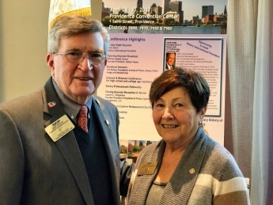
- Revisit as many clubs as possible in the next few months.
- Help our clubs achieve the goals they set in July
- Do all we can to build membership in the district
- Plan a grand event to celebrate our Million Dollar Foundation Journey
- "Move the ball forward," in harmony, with District Governor-ElectKarin Gaffney, District Governor-Nominee Steve Sager and District Governor-Nominee-Designate Pamela Anastasi
- Celebrate all of this at our Multi-District Conference this April in in Providence
'GOVERNOR'S MESSAGE' PAGE (in case you want to share a link to this article)

District Governors Pat and Skip Doyle (shown, right) may be reached
at pwdoyle2@verizon.net and skipdoyle2@verizon.net, respectively.

Click here to submit content for the Tuesday, February 14 issue.
The submission deadline for this issue is Friday, February 10.

Click here for past issues.

WELCOME, NEW ROTARIANS
Alphabetical order, by last name

- Aaron Gilbert, Brookline
- Lawrence Palmacci, Brookline
Remember to ask ... ask ... ask!

DISTRICT SCHOLARSHIP DEADLINE, MARCH 15
Applications Sought for David and Eleanor Morley Endowed Global Grant Scholarship
To learn more about the Morley Scholarship, click here.
To download the Morley Scholarship flyer in PDF format, click here.

CLUB MEMBERSHIP GROWTH, ’16-‘17
We share with you the results of club-membership growth in our district during Rotary year 2016-2017, which began July 1.

This is a unique opportunity for Rotarians and friends to discuss partnering on humanitarian projects affecting our local communities.

READ MORE

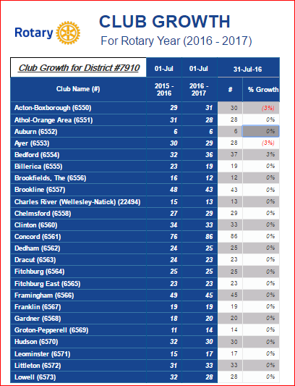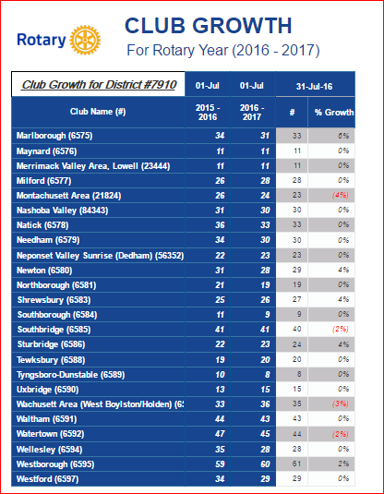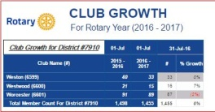

DISTRICT & CLUB ROUNDS
Needham, National Honor Society Join Forces for Food Packaging

The Rotary Club of Needham recently joined forces with 80 students from Needham High School's National Honor Society. They teamed up with Stop Hunger Now.

READ MORE

Awesome Time At January's Rotary Means Business

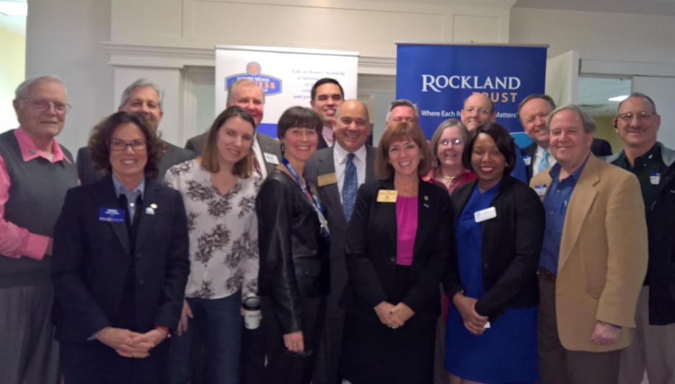
Rotarians and friends had an awesome time at District 7910's Rotary Means Business networking event on January 25 in Waltham. The event was attended by 52 Rotarians and guests from more than 25 clubs, who learned a little about each other's business.

Attendees included District Governor-Elect Karin Gaffney (second from left), Rotary Means Business Chair Ron Bott (third from left), District Governor-Nominee Steve Sager (eighth from left), and District Governor- Nominee-Designate Pam Anastasi (ninth from left), and Past District Governor Carol Toomey (10th from left) A big thank -yougoes out to Rockland Trust for sponsoring this event.

Save Wednesday, March 1 for the next Rotary Means Business networking event, at the Radisson Hotel and Suites in Chelmsford. To learn more about Rotary Means Business, click here.

Franklin Presents Rotaract Charter Certificate, RYLA grant

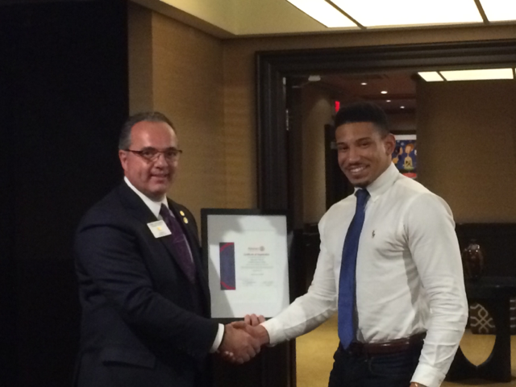

Terry Katsaros (left), president of the Rotary Club of Franklin, recently presented Robert (Nua) Toy-Giles (right), president of theRotaract Club of Franklin at Dean College,with that Rotaract club'scharter certificate.

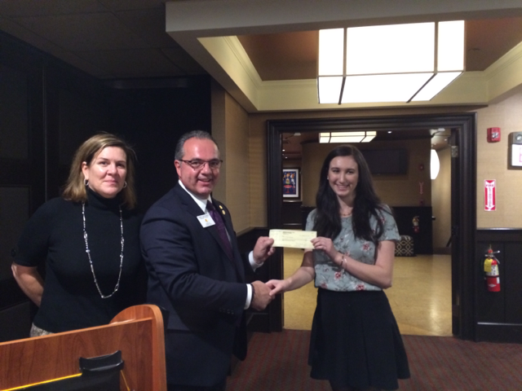

Also recently, Julie Rougeau (left), Franklin Rotary's Vocational/RYLA chair, and Terry Katsaros (middle), presented a $1,000 scholarship grant to UMass student Nicole Rabovsky (right), a 2016 graduate of Franklin High School.

To learn more about Franklin Rotary, click here.

Nashoba Valley Celebrates Power of Change
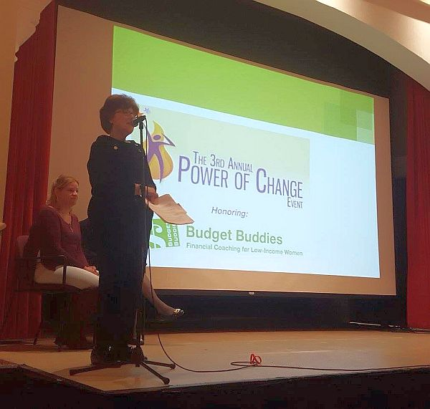

On January 23, the Rotary Club of Nashoba Valley recognized Budget Buddies as the recipient of the club's third Power of Change Award for the work the organization has done to better the lives of women.

Shown, standing, is Nashoba Valley President-Elect Mary Denio Garcia as she kicked off the Power of Change event.

To learn more about Nashoba Valley Rotary, click here.

Southborough Expands Scholarship Program

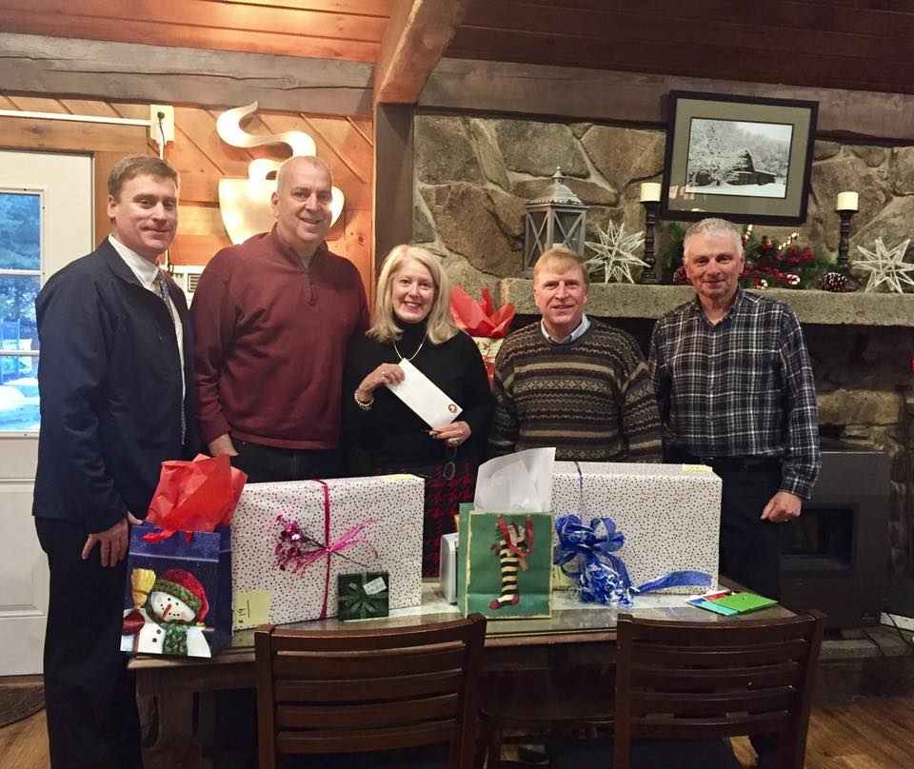

The Rotary Club of Southborough has announced a second scholarship for high school students from Southborough. The winning student will receive $1,000 per year to help attend a four-year Massachusetts state college or university. Applicants will be judged on academic achievements and public service. Prior to this, Southborough Rotary was only able to help one student for four years. Thanks to stepped-up fundraising efforts and generous donations, the club is now able to expand its program. The new scholarship means the club doesn't have to wait for its current recipient to graduate in 2020, to award another scholarship.
Applications are due by April 10. The application forms areavailable at the Algonquin Regional High School’s Guidance Office, and by contacting Southborough Treasurer Carl Guyer atcarl.guyer@gmail.com.
Shown, are several members of Southborough Rotary.
To learn more about Southborough Rotary, click here.

Our DGE Meets Rotary's PE at RI Assembly in San Diego

Note: RI PE Ian Riseley to keynote speaker at '17 NEPETS

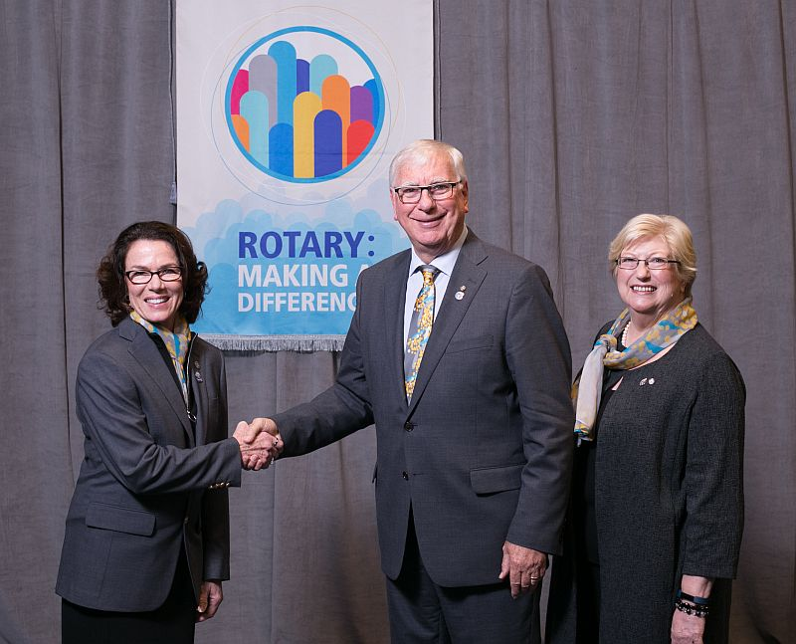

District Governor-Elect Karin Gaffney (shown, right) got to meet and pose with Ian Riseley (shown, middle), president-elect of Rotary International, and his wife, Juliet Riseley (shown, left) during the 2017 RI Assembly, held from January 15 to 21 in San Diego. The Riseleys hail from Australia, where they are members of the Rotary Club of Sandringham.

Rotary's annual training meeting gives district governor-elects the chance to share ideas for strengthening clubs and improving communities with Rotary leaders from around the world. Keynote speakers and informative presentations inspire and prepare the district governors-elect for the 2017-2018 Rotary year, which begins July 1, to lead their districts successfully. Idea exchanges, roundtable discussions, and workshops introduce them to new ways of creating positive change.

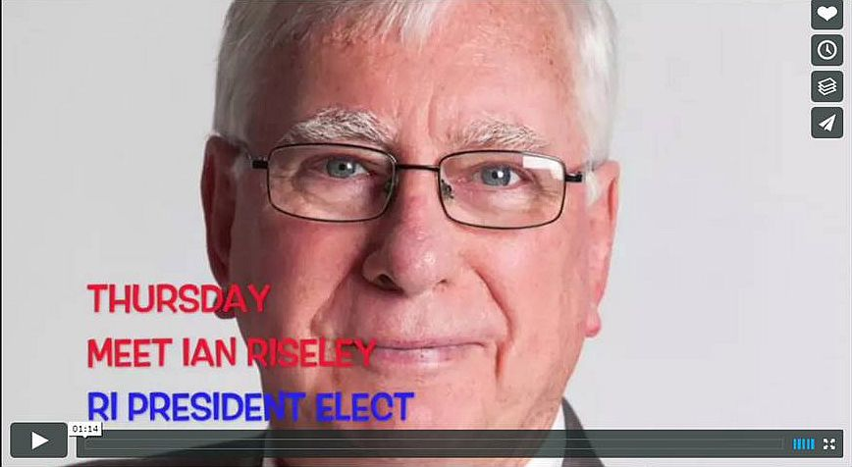Get a chance to meet Ian and Juliet Riseley when they attend the 2017 Northeast Presidents-Elect Training Seminar, where Ian will be the keynote speaker on the evening of Thursday, March 9.

To watch the promotional video for Ian Riseley's talk, click here.

To learn more about Ian Riseley, click here.

Our Interact Chair in Present in India

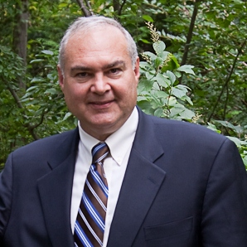Bob Anthony (shown,left), chair of the District Interact Committee, is visiting new Rotary friends from January 24 through February 10 in Goa, India. He has been invited to briefly present at the Rotary District 3170 conference there. One of that district's clubs, Hubli East, partnered with the Rotary Club of Wellesley, of which Bob is a member, through a Global Grant to implement the Peer Leadership and Depression Prevention project. To watch a two-minute video on the project, click here. Basically, the project delivers train-the-trainer on a Boston Children's Hospital curriculum to educators and, eventually, to Interact peer leaders. To learn more,click here.

To learn more about Interact, click here.

Multi-Club Power Play

Needham Teams Up with Framingham, Newton, Waltham and Watertown on India Solar-Power Project

The Rotary Clubs of Needham, Framingham, Newton, Waltham and Watertown have partnered to fund a $6,000 solar-power project (shown, left) for Film Nagar High School in Hyerabad, India. The host club there is the Rotary Club of Jubilee Hills, in District 3150.

Needham paid $3,000 of the $6,000 - $1,500 of which should come back as District Grant match. Watertown, Waltham, Newton and Framingham paid $500 each.

READ MORE

To learn more about:
- Framingham Rotary, click here
- Jubilee Hills Rotary, click here
- Needham Rotary, click here
- Newton Rotary, click here
- Waltham Rotary, click here
- Watertown Rotary, click here

Acton-Boxborough Sponsors Six High School Students for RYLA

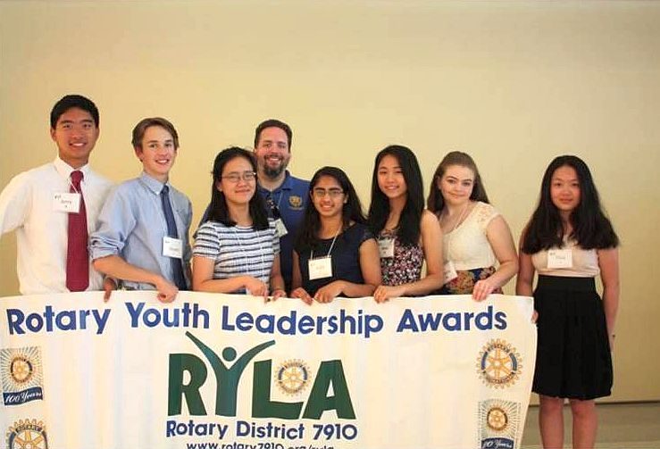

The Rotary Club of Acton-Boxborough has sponsored six sophomores Acton-Boxborough Regional High School, to attend the Rotary Youth Leadership Awards Conference to be held June 24 to 26 at Fitchburg State University.

Left to right: Anthea Bell, of Boxborough; and Lindsey Huang, Aditi Sirsikar, Juliana Walsh, Anna Wu and Jerry Wu, of Acton.

To learn more about Acton-Boxborough Rotary, click here.

Auburn Teams Up with FAME for Music & Wine Event to Benefit Education on March 17

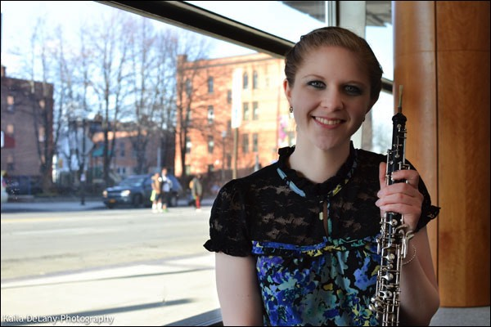

Join the Rotary Club of Auburn and Friends of Auburn Music Education for their 2017 St. Patrick’s Day Music & Wine Event. This festive celebration will take place on Friday, March 17 from 5:00 to 9:00 p.m. in the Great Hall of Pakachoag Church, located at 203 Pakachoag St. in Auburn. This community fundraiser will benefit Auburn Rotary's education scholarships and other charitable endeavors, plus FAME. This festive celebration will feature a performance by Professional Oboist Lydia Consilvio (shown, above) of Auburn, and a faculty recital by the Auburn Public Schools' Fine Arts Department.

PURCHASE TICKETS & MORE INFORMATION

To learn more about Auburn Rotary, click here.

Bedford Gears Up for April Meal-Packing Event

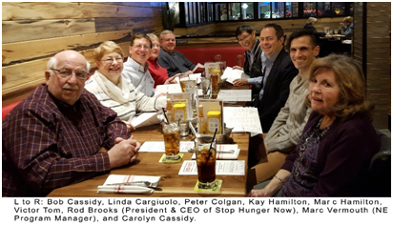

Members of the Rotary Club of Bedford were recently invited to speak with Rod Brooks, president and CEO, and the Marc Vermouth, New England program manager of Stop Hunger Now. Held at the Red Heat Tavern in Bedford, the meeting was in recognition of Bedford Rotary’s enduring (annually since 2013) and successful meal-packing programs (more than one-quarter-million total meals packaged to date) in the Bedford area assisted by other Rotary clubs and industry partners. Rod Brooks congratulated and thanked Bedford Rotarians for their efforts, and revealed expanded directions for Stop Hunger Now, including water, agriculture and educational programs to combat worldwide hunger. In the next few weeks, Stop Hunger Now will announce a new global branding and logo to reflect this focus.

For 2017, Bedford Rotary has secured the morning of Saturday, April 8 at Middlesex Community College (Bedford 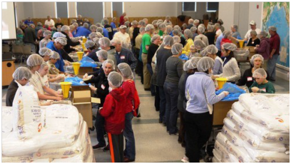Campus) for this year’s exciting meal-packing event. The club plans to have again multiple Rotary club and industry partners, including BAE Systems as the major corporate sponsor. If you are interested in joining this year’s event, please contact this year’s chair, Past District Governor Bob Cassidy, at rac011846@comcast.net.

Shown right: During Bedford Rotary's 2016 meal-packing event, volunteers from Rotary, industry and nearby communities had fun fighting world hunger, with assembly lines running from raw rice, in the foreground, to packaged boxes, in the background.

To learn more about Bedford Rotary, click here.

Hudson, Nashoba Valley Brewfest Showcased in Rotarian Magazine

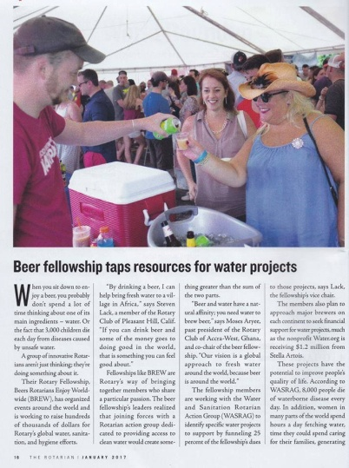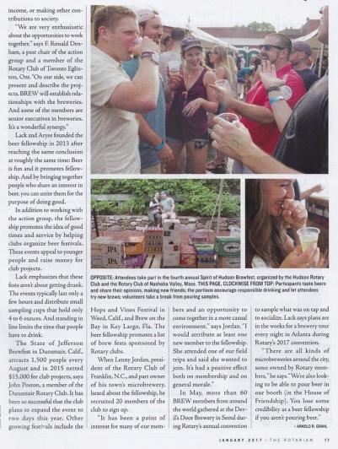

The Rotary clubs of Hudson and Nashoba Valley were showcased in the "Brewfest" section of the January issue of the Rotarian Magazine.

To read the first page of the article (shown, left), in PDF format, click here.

To read the second page of the article (shown, right), in PDF format, click here.

To learn more about Hudson Rotary, click here.

To learn more about Nashoba Valley Rotary, click here.

Dedham Publishes Cookbook: Get your copy now

Hot off the press is the first Rotary Club of Dedham Cookbook! It features 420 recipes from Rotarians and their families across the U.S. and some from far away as Russia. Special dishes featured come from the kitchens of all Americans - great ethnic foods, desserts and beverages.
The Cookbook cover features a full-page color photo of the MIT Endicott House in Dedham, where the club meets on Thursdays. This fundraising Cookbook is available for $25, plus shipping. You may purchase it at DedhamRotary.org, or by contacting Past President Sandra Nelson at skintelligence1@gmail.com. Happy New Year - and bon appetit!
To learn more about Dedham Rotary, click here

A Great Fundraising Tool for All Clubs

Westborough Uses PayPal to Raise Nearly $2,000 for Polio Plus

READ MORE

To research charities that have a registered 501(c)3 account with PayPal, click here.

To learn more about Westborough Rotary, click here.

District Highlights Fundraising Goals in Video

We are all well aware that The Rotary Foundationis celebrating its 100th anniversary in 2017.Steve Kirk, president of the Rotary Club of Concord, has produced a five-minute video that outlines our own district’s fundraising goals for the current Rotary year, which ends next June 30.

WATCH VIDEO

To learn more about The Rotary Foundation, click here.

Now Available: Video of Governor Baker's District Rotarian address

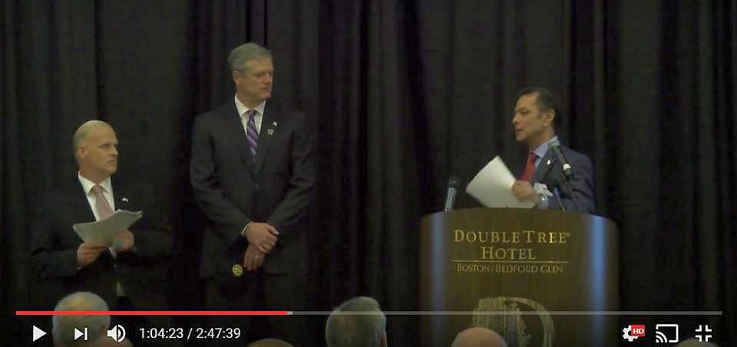

The Rotary Club of Billerica has provided a video of Governor Charlie Baker's address to District 7910 Rotarians on September 27 at the DoubleTree Hotel in Bedford. To watch the two-hour-47-minute video, click here.

The Rotary Clubs of Bedford, Billerica, Lowell, Newton and Shrewsbury sponsored the event, which was a unique opportunity for Rotarians and friends to discuss partnering on humanitarian projects affecting our local communities. To view event photos, click here.

A Great Fundraising Idea for All Clubs

Milford Distributes '16 Tab to 13,000 Homes - Record sales, 94 photos, 334 smiling faces

To read the Milford RotaryTab, click here.

To learn more about Milford Rotary, click here.

On to Atlanta in 2017: Register now!

Planning to attend? Contact District Chair Steve Glines.

To learn more, click here.

To register for the 2017 RI Convention in Atlanta, click here.

Pat and Skip Doyle Installed as '16-'17 DGs

To watch a video of the installation, click here.

District Banners Available

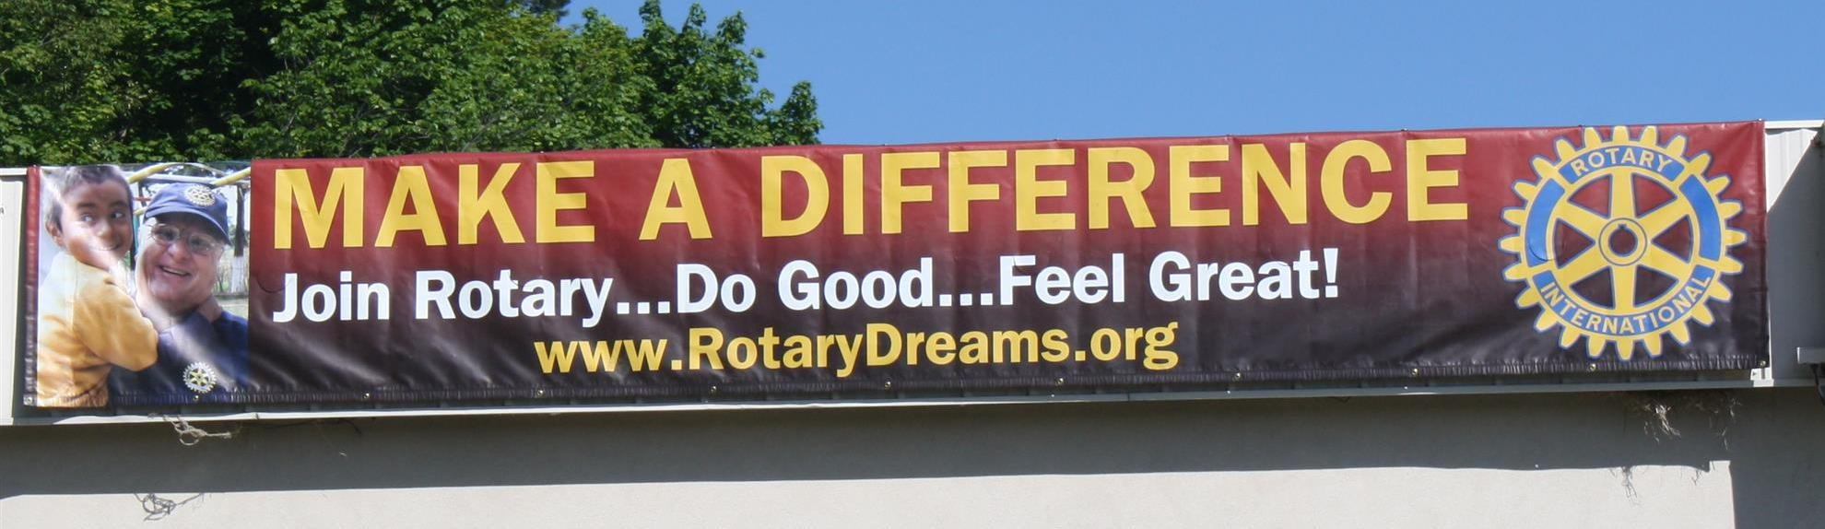

Our district banners are available for your use when you have an upcoming event or fundraiser.

If you want to reserve one of the banners, please contact PR Chair Laura Spear at laura@spear.net.

MAJOR DISTRICT & CLUB HAPPENINGS: WINTER & SPRING 2017

Friday & Saturday, March 3 & 4: Gardner - "Annual TV Auction"

To download event flyer, click here

Saturday, March 11: Uxbridge - 'Wine and Chocolate Tasting'

To visit and "like" our Facebook page, click here

To download event flyer, click here

Wednesday, March 15: District 7910 - 'Deadline for Morley Scholarship Applications'

To learn more, click here

To download flyer in PDF format, click here

Friday, March 17: Auburn - 'St. Patrick's Day Music & Wine Fundraiser'

To learn more, and to purchase tickets, click here

To download event flyer in PDF format, click here

Friday, March 17: Billerica - 'Finnegan's Wake Hilarious'

To download flyer in PDF format, click here

Tuesday, March 21; Thursday, March 23; Tuesday, March 28; or Thursday, Match 30: - District 7910 - 'Membership Workshops'

To download flyer in PDF format, click here
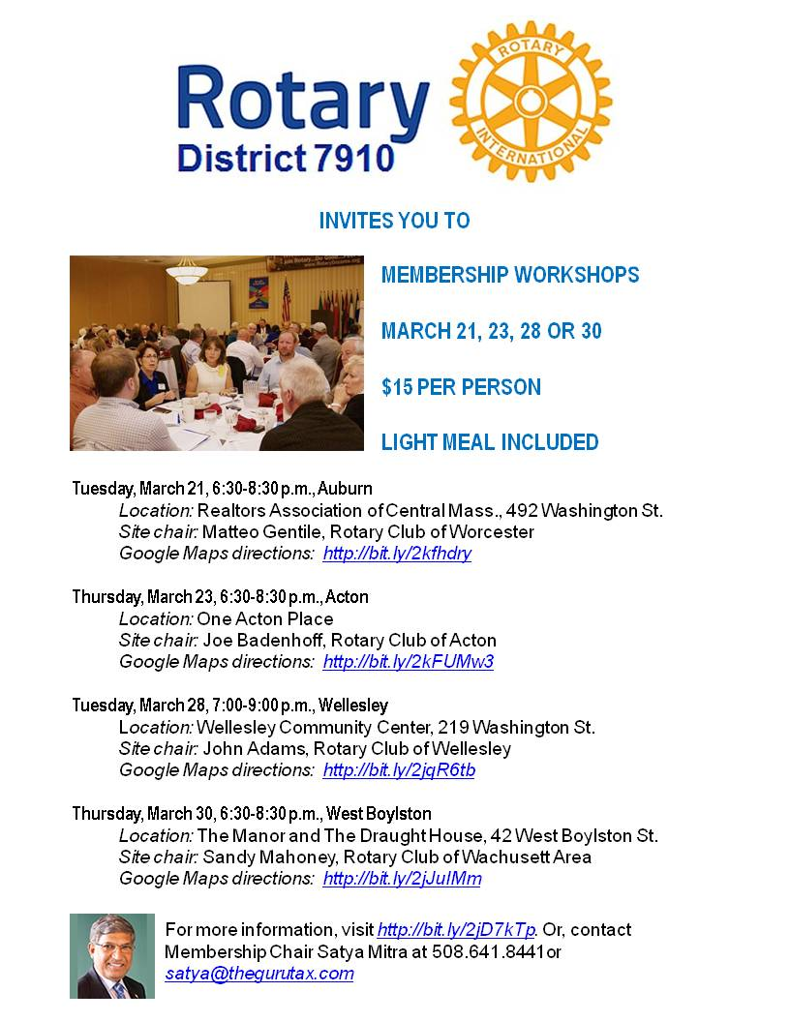

Friday, April 7: Concord - 'Pops for a Playground'

SUBMIT MAJOR CLUB HAPPENINGS

Send flyers of your club's major events and activities, in either JPEG or PDF format, to Immediate Past District
Governor/Newsletter Editor Jim Fusco at jim.fusco2@gmail.com.

GOVERNOR'S MESSAGE
Multi-District Conference: All prices go up April 1 - so register now
By Pat and Skip Doyle
We want to make sure as many members as possible read all about our Multi-District Conference on April 28 through 30 in Providence, and so we are changing last week's "Governor's Message" only a little. If you have not as yet put this date on your calendar, please do it now so you will not forget. All prices will go up on April 1 - so don't wait to register. To register now, click here.

One thing we want to call your attention to is our Youth Program planned for Saturday and Sunday, April 29 and 30. at the District Conference. Saturday's program is an all-day conference within a conference for our Interactors and Rotaractors. There are interesting speakers, panel discussions and interactive sessions planned all day for our youth. We will include a complete schedule next week. The registration fee for our Interactors is $25, which includes lunch. Pricing for Rotaractors will be available next week - and will include an overnight stay. We hope that Rotary clubs sponsoring Interact clubs may want to defray the costs for the Interactors who participate.

On the subject of costs, if District 7910 were to plan an event such as the Multi-District Conference on its own, given the current prices for venues, it would be prohibitively expensive. We are able to provide this priceless experience at this low cost because three other districts - 7890, 7950 and 7980 - are holding this conference with ours. The venue is being paid through the collective buying power of all Rotarians from all four districts who will be attending this conference. Since we are already holding sessions in the Providence Convention Center and there are spaces available for our young people as well, you might consider your attendance at the full conference as a way to help our Interactors.

More information about schedules and pricing will be available next week.

Seeking three trustees

We are now seeking two Rotarians to become trustees of the District Board of Trustees plus one Rotarian to become a trustee of the District Special Fund Board. The need for two trustees for the Board of Trustees is due to an unforeseen circumstance.

Those who applied before are eligible to apply again. For more information, contact us at pwdoyle2@verizon.net and skipdoyle2@verizon.net.

Six important things to know:

1. The weekly submission deadline for the Newsletter will remain the same: Friday. As usual, text content must be submitted in Word format, and image content, in either JPEG or PDF format. Continue to submit your content to Immediate Past District Governor/Newsletter Editor Jim Fusco at jim.fusco2@gmail.com.

2. Resolutions: The District Resolutions Committee met on January 10 and addressed three changes to the DistrictResolution that will be proposed and voted on at the annual District Business Meeting, to be held during the Multi-District Conference in Providence, on Saturday morning, April 29. For more information on the District Resolutions, contact Resolutions Chair Doug Detweiller (shown, right) at rotary@detweiler.org.

3. District Nominations: The District Nominating Committee is seeking qualified applicants to serve as DistrictTrustee for 2017 to 2019 and District Charitable Fund Trustee for 2017 to 2020. Clubs and club leadership are asked and encouraged to actively recruit and promote service in Rotary through their members' service as district leaders. The deadline for submitting applications is this February 18. All completed applications should be either e-mailed to Nominating Committee Chair Michael Ellis (shown,right) at mellis0144@comcast.net, or mailed to him at: Michael Ellis, District 7910 Nominating Committee, 88 Coburn Ave., Gardner, MA 01440. Postmarked mail after February 18 will not be accepted. To download the Trustee Nomination Form, click here. To download the Nomination Form Supplement, click here.
4. Rotary Youth Leadership Awards: The RYLA Club Pack has been updated and posted on RYLA7910.org. When you download it, you will notice changes from last year. Please read the material carefully and direct your questions to Christine Pinney, chair of the RYLA Committee,who may be reached at christine@christinepinney.com. The RYLA season has begun and the RYLA Committee is working to make RYLA 2017 the "best RYLA ever." (See RTLA article in right hand column)

5. Club Planning Worksheet: To download the Club Planning Worksheet, click here.This worksheet is made available to clubs so they can gauge their progress in achieving the goals they set last July. This month is a good time to review the worksheet and see how far you have come and how much farther you need to go as a club. You may surprise yourselves and realize that you are well on the way to earning district recognition. We recommend the club president appoint the president-elect to be the "champion" of the Worksheet, and to use it as a guide for the club, and to report monthly to the club's membership and board on the club's progress.

6. As your district governors, we have resolved to:
- Revisit as many clubs as possible in the next few months.
- Help our clubs achieve the goals they set in July
- Do all we can to build membership in the district
- Plan a grand event to celebrate our Million Dollar Foundation Journey
- "Move the ball forward," in harmony, with District Governor-ElectKarin Gaffney, District Governor-Nominee Steve Sager and District Governor-Nominee-Designate Pamela Anastasi
- Celebrate all of this at our Multi-District Conference this April in in Providence
'GOVERNOR'S MESSAGE' PAGE (in case you want to share a link to this article)

District Governors Pat and Skip Doyle (shown, right) may be reached
at pwdoyle2@verizon.net and skipdoyle2@verizon.net, respectively.

Click here to submit content for the Tuesday, February 14 issue.
The submission deadline for this issue is Friday, February 10.

Click here for past issues.

WELCOME, NEW ROTARIANS
Alphabetical order, by last name

- Aaron Gilbert, Brookline
- Lawrence Palmacci, Brookline
Remember to ask ... ask ... ask!

DISTRICT SCHOLARSHIP DEADLINE, MARCH 15
Applications Sought for David and Eleanor Morley Endowed Global Grant Scholarship
To learn more about the Morley Scholarship, click here.
To download the Morley Scholarship flyer in PDF format, click here.

CLUB MEMBERSHIP GROWTH, ’16-‘17
We share with you the results of club-membership growth in our district during Rotary year 2016-2017, which began July 1.

This is a unique opportunity for Rotarians and friends to discuss partnering on humanitarian projects affecting our local communities.

READ MORE

DISTRICT & CLUB ROUNDS
Needham, National Honor Society Join Forces for Food Packaging

The Rotary Club of Needham recently joined forces with 80 students from Needham High School's National Honor Society. They teamed up with Stop Hunger Now.

READ MORE

Awesome Time At January's Rotary Means Business

Rotarians and friends had an awesome time at District 7910's Rotary Means Business networking event on January 25 in Waltham. The event was attended by 52 Rotarians and guests from more than 25 clubs, who learned a little about each other's business.

Attendees included District Governor-Elect Karin Gaffney (second from left), Rotary Means Business Chair Ron Bott (third from left), District Governor-Nominee Steve Sager (eighth from left), and District Governor- Nominee-Designate Pam Anastasi (ninth from left), and Past District Governor Carol Toomey (10th from left) A big thank -yougoes out to Rockland Trust for sponsoring this event.

Save Wednesday, March 1 for the next Rotary Means Business networking event, at the Radisson Hotel and Suites in Chelmsford. To learn more about Rotary Means Business, click here.

Franklin Presents Rotaract Charter Certificate, RYLA grant

Terry Katsaros (left), president of the Rotary Club of Franklin, recently presented Robert (Nua) Toy-Giles (right), president of theRotaract Club of Franklin at Dean College,with that Rotaract club'scharter certificate.

Also recently, Julie Rougeau (left), Franklin Rotary's Vocational/RYLA chair, and Terry Katsaros (middle), presented a $1,000 scholarship grant to UMass student Nicole Rabovsky (right), a 2016 graduate of Franklin High School.

To learn more about Franklin Rotary, click here.

Nashoba Valley Celebrates Power of Change

On January 23, the Rotary Club of Nashoba Valley recognized Budget Buddies as the recipient of the club's third Power of Change Award for the work the organization has done to better the lives of women.

Shown, standing, is Nashoba Valley President-Elect Mary Denio Garcia as she kicked off the Power of Change event.

To learn more about Nashoba Valley Rotary, click here.

Southborough Expands Scholarship Program

The Rotary Club of Southborough has announced a second scholarship for high school students from Southborough. The winning student will receive $1,000 per year to help attend a four-year Massachusetts state college or university. Applicants will be judged on academic achievements and public service. Prior to this, Southborough Rotary was only able to help one student for four years. Thanks to stepped-up fundraising efforts and generous donations, the club is now able to expand its program. The new scholarship means the club doesn't have to wait for its current recipient to graduate in 2020, to award another scholarship.
Applications are due by April 10. The application forms areavailable at the Algonquin Regional High School’s Guidance Office, and by contacting Southborough Treasurer Carl Guyer atcarl.guyer@gmail.com.
Shown, are several members of Southborough Rotary.
To learn more about Southborough Rotary, click here.

Our DGE Meets Rotary's PE at RI Assembly in San Diego

Note: RI PE Ian Riseley to keynote speaker at '17 NEPETS

District Governor-Elect Karin Gaffney (shown, right) got to meet and pose with Ian Riseley (shown, middle), president-elect of Rotary International, and his wife, Juliet Riseley (shown, left) during the 2017 RI Assembly, held from January 15 to 21 in San Diego. The Riseleys hail from Australia, where they are members of the Rotary Club of Sandringham.

Rotary's annual training meeting gives district governor-elects the chance to share ideas for strengthening clubs and improving communities with Rotary leaders from around the world. Keynote speakers and informative presentations inspire and prepare the district governors-elect for the 2017-2018 Rotary year, which begins July 1, to lead their districts successfully. Idea exchanges, roundtable discussions, and workshops introduce them to new ways of creating positive change.

Get a chance to meet Ian and Juliet Riseley when they attend the 2017 Northeast Presidents-Elect Training Seminar, where Ian will be the keynote speaker on the evening of Thursday, March 9.

To watch the promotional video for Ian Riseley's talk, click here.

To learn more about Ian Riseley, click here.

Our Interact Chair in Present in India

Bob Anthony (shown,left), chair of the District Interact Committee, is visiting new Rotary friends from January 24 through February 10 in Goa, India. He has been invited to briefly present at the Rotary District 3170 conference there. One of that district's clubs, Hubli East, partnered with the Rotary Club of Wellesley, of which Bob is a member, through a Global Grant to implement the Peer Leadership and Depression Prevention project. To watch a two-minute video on the project, click here. Basically, the project delivers train-the-trainer on a Boston Children's Hospital curriculum to educators and, eventually, to Interact peer leaders. To learn more,click here.

To learn more about Interact, click here.

Multi-Club Power Play

Needham Teams Up with Framingham, Newton, Waltham and Watertown on India Solar-Power Project

The Rotary Clubs of Needham, Framingham, Newton, Waltham and Watertown have partnered to fund a $6,000 solar-power project (shown, left) for Film Nagar High School in Hyerabad, India. The host club there is the Rotary Club of Jubilee Hills, in District 3150.

Needham paid $3,000 of the $6,000 - $1,500 of which should come back as District Grant match. Watertown, Waltham, Newton and Framingham paid $500 each.

READ MORE

To learn more about:
- Framingham Rotary, click here
- Jubilee Hills Rotary, click here
- Needham Rotary, click here
- Newton Rotary, click here
- Waltham Rotary, click here
- Watertown Rotary, click here

Acton-Boxborough Sponsors Six High School Students for RYLA

The Rotary Club of Acton-Boxborough has sponsored six sophomores Acton-Boxborough Regional High School, to attend the Rotary Youth Leadership Awards Conference to be held June 24 to 26 at Fitchburg State University.

Left to right: Anthea Bell, of Boxborough; and Lindsey Huang, Aditi Sirsikar, Juliana Walsh, Anna Wu and Jerry Wu, of Acton.

To learn more about Acton-Boxborough Rotary, click here.

Auburn Teams Up with FAME for Music & Wine Event to Benefit Education on March 17

Join the Rotary Club of Auburn and Friends of Auburn Music Education for their 2017 St. Patrick’s Day Music & Wine Event. This festive celebration will take place on Friday, March 17 from 5:00 to 9:00 p.m. in the Great Hall of Pakachoag Church, located at 203 Pakachoag St. in Auburn. This community fundraiser will benefit Auburn Rotary's education scholarships and other charitable endeavors, plus FAME. This festive celebration will feature a performance by Professional Oboist Lydia Consilvio (shown, above) of Auburn, and a faculty recital by the Auburn Public Schools' Fine Arts Department.

PURCHASE TICKETS & MORE INFORMATION

To learn more about Auburn Rotary, click here.

Bedford Gears Up for April Meal-Packing Event

Members of the Rotary Club of Bedford were recently invited to speak with Rod Brooks, president and CEO, and the Marc Vermouth, New England program manager of Stop Hunger Now. Held at the Red Heat Tavern in Bedford, the meeting was in recognition of Bedford Rotary’s enduring (annually since 2013) and successful meal-packing programs (more than one-quarter-million total meals packaged to date) in the Bedford area assisted by other Rotary clubs and industry partners. Rod Brooks congratulated and thanked Bedford Rotarians for their efforts, and revealed expanded directions for Stop Hunger Now, including water, agriculture and educational programs to combat worldwide hunger. In the next few weeks, Stop Hunger Now will announce a new global branding and logo to reflect this focus.

For 2017, Bedford Rotary has secured the morning of Saturday, April 8 at Middlesex Community College (Bedford Campus) for this year’s exciting meal-packing event. The club plans to have again multiple Rotary club and industry partners, including BAE Systems as the major corporate sponsor. If you are interested in joining this year’s event, please contact this year’s chair, Past District Governor Bob Cassidy, at rac011846@comcast.net.

Shown right: During Bedford Rotary's 2016 meal-packing event, volunteers from Rotary, industry and nearby communities had fun fighting world hunger, with assembly lines running from raw rice, in the foreground, to packaged boxes, in the background.

To learn more about Bedford Rotary, click here.

Hudson, Nashoba Valley Brewfest Showcased in Rotarian Magazine

The Rotary clubs of Hudson and Nashoba Valley were showcased in the "Brewfest" section of the January issue of the Rotarian Magazine.

To read the first page of the article (shown, left), in PDF format, click here.

To read the second page of the article (shown, right), in PDF format, click here.

To learn more about Hudson Rotary, click here.

To learn more about Nashoba Valley Rotary, click here.

Dedham Publishes Cookbook: Get your copy now

Hot off the press is the first Rotary Club of Dedham Cookbook! It features 420 recipes from Rotarians and their families across the U.S. and some from far away as Russia. Special dishes featured come from the kitchens of all Americans - great ethnic foods, desserts and beverages.
The Cookbook cover features a full-page color photo of the MIT Endicott House in Dedham, where the club meets on Thursdays. This fundraising Cookbook is available for $25, plus shipping. You may purchase it at DedhamRotary.org, or by contacting Past President Sandra Nelson at skintelligence1@gmail.com. Happy New Year - and bon appetit!
To learn more about Dedham Rotary, click here

A Great Fundraising Tool for All Clubs

Westborough Uses PayPal to Raise Nearly $2,000 for Polio Plus

READ MORE

To research charities that have a registered 501(c)3 account with PayPal, click here.

To learn more about Westborough Rotary, click here.

District Highlights Fundraising Goals in Video

We are all well aware that The Rotary Foundationis celebrating its 100th anniversary in 2017.Steve Kirk, president of the Rotary Club of Concord, has produced a five-minute video that outlines our own district’s fundraising goals for the current Rotary year, which ends next June 30.

WATCH VIDEO

To learn more about The Rotary Foundation, click here.

Now Available: Video of Governor Baker's District Rotarian address

The Rotary Club of Billerica has provided a video of Governor Charlie Baker's address to District 7910 Rotarians on September 27 at the DoubleTree Hotel in Bedford. To watch the two-hour-47-minute video, click here.

The Rotary Clubs of Bedford, Billerica, Lowell, Newton and Shrewsbury sponsored the event, which was a unique opportunity for Rotarians and friends to discuss partnering on humanitarian projects affecting our local communities. To view event photos, click here.

A Great Fundraising Idea for All Clubs

Milford Distributes '16 Tab to 13,000 Homes - Record sales, 94 photos, 334 smiling faces

To read the Milford RotaryTab, click here.

To learn more about Milford Rotary, click here.

On to Atlanta in 2017: Register now!

Planning to attend? Contact District Chair Steve Glines.

To learn more, click here.

To register for the 2017 RI Convention in Atlanta, click here.

Pat and Skip Doyle Installed as '16-'17 DGs

To watch a video of the installation, click here.

District Banners Available

Our district banners are available for your use when you have an upcoming event or fundraiser.

If you want to reserve one of the banners, please contact PR Chair Laura Spear at laura@spear.net.

MAJOR DISTRICT & CLUB HAPPENINGS: WINTER & SPRING 2017

Friday & Saturday, March 3 & 4: Gardner - "Annual TV Auction"

To download event flyer, click here

Saturday, March 11: Uxbridge - 'Wine and Chocolate Tasting'

To visit and "like" our Facebook page, click here

To download event flyer, click here

Wednesday, March 15: District 7910 - 'Deadline for Morley Scholarship Applications'

To learn more, click here

To download flyer in PDF format, click here

Friday, March 17: Auburn - 'St. Patrick's Day Music & Wine Fundraiser'

To learn more, and to purchase tickets, click here

To download event flyer in PDF format, click here

Friday, March 17: Billerica - 'Finnegan's Wake Hilarious'

To download flyer in PDF format, click here

Tuesday, March 21; Thursday, March 23; Tuesday, March 28; or Thursday, Match 30: - District 7910 - 'Membership Workshops'

To download flyer in PDF format, click here

Friday, April 7: Concord - 'Pops for a Playground'

SUBMIT MAJOR CLUB HAPPENINGS

Send flyers of your club's major events and activities, in either JPEG or PDF format, to Immediate Past District
Governor/Newsletter Editor Jim Fusco at jim.fusco2@gmail.com.

