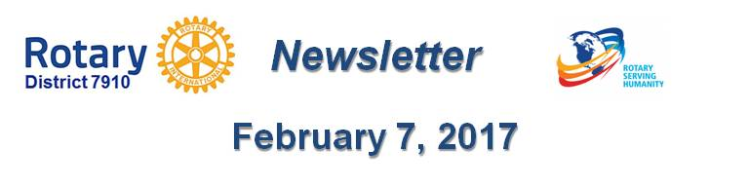

Articulate your message
By Laura Spear

See whether you can articulate your club’s event, service project, fundraiser, or announcement in words a regular reader will care about. In other words, be sure what you’re doing is newsworthy.

Simply sending out a press release is no guarantee that it will get printed or read.

To learn more in Rotary Voice and Visual Identity Guidelines, click here.

To learn more about PR for your club, click on the Public Relations section of the navigation bar of the District 7910 website.

Laura Spear, chair of District 7910's Public Relations Committee, may be reached at laura@spear.net.

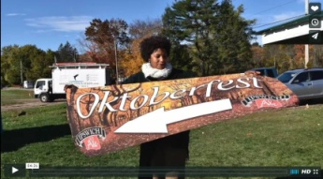Click here for an excellent example of a club-event promotional video by Concord President Steve Kirk.

Return to February 7 Newsletter

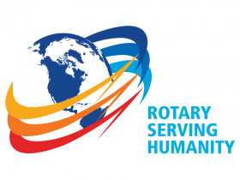Visit our website
'Like' our Facebook page
'Follow' us on Twitter
Watch our videos
View our photo albums

