COMMITTEE REPORTS
RI President Ian Riseley Announces '17-'18 Rotary Theme ...
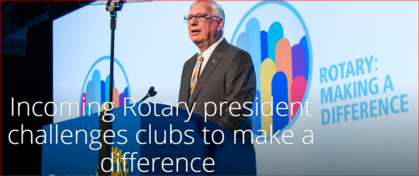
... And Here It Is
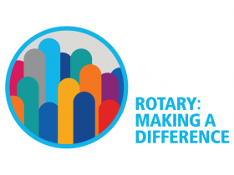

Governor-Elect Report: Register now for NEPETS, March 9-11, Framingham

RI President-Elect Ian Riseley to be Keynote Speaker

By Karin Gaffney

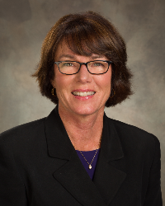

READ MORE

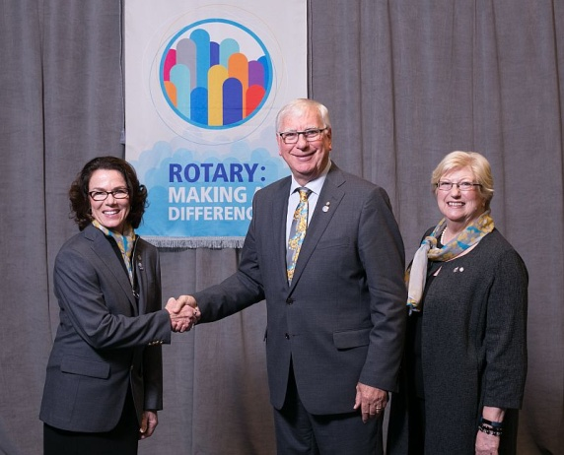

RI President Elect Ian Riseley and his wife, Juliette Riseley - shown (middle and right) recently posing at the International Assembly in San Diego with District Governor-Elect Karin Gaffney (left).

Million Dollar Dinner: $850,000 raised so far

By Satya Mitra

READ MORE

Membership Corner: Mark your calendar for March Membership Workshops

By Tom Sturiale
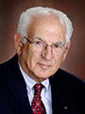

READ MORE

To learn how the Rotary Club of Melbourne in Victoria, Australia does corporate membership, click here

To learn about District 7910 Membership Workshops in October, click here.

Membership Materials On Sale: Order now!
To order, click here

RYLA Update: Training, Registration and Deadlines for Rotary Youth Leadership Awards

By Christine Pinney

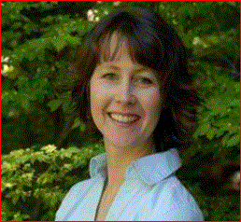

READ MORE

Foundation Note: Foundation-giving scorecard in '16-'17

By Sanjay Deshpande

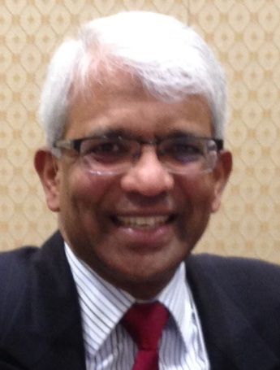

READ MORE

Polio Plus Update: Donation to Polio Plus would be great birthday present to Rotary

By Carl Good III

READ MORE

Nominations Call: Seeking qualified applicants

By Mike Ellis

READ MORE

ESSEX Examples: Who's behind making us best

READ MORE

PR Tips: ???

By Laura Spear
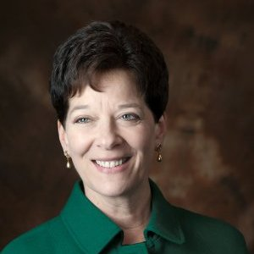

READ MORE

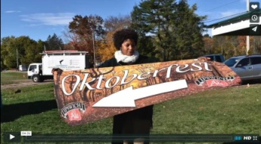

Click here for an excellent example of a club-event promotional video by Concord President Steve Kirk.

What Is The Mission of Rotary Leadership Institute?

By Doug Detweiler

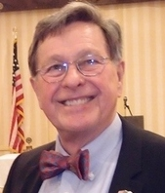

READ MORE

FAQs about RLI: Click here

What are the courses? Click here
To download the brochure with all of the RLI Northeast America classes for 2016-2017, click here.

For the complete RLI Northeast America schedule, click here.

'17 RI Convention in Atlanta: Register now!

Beyond Borders Dinner on June 11: To register now, click here.

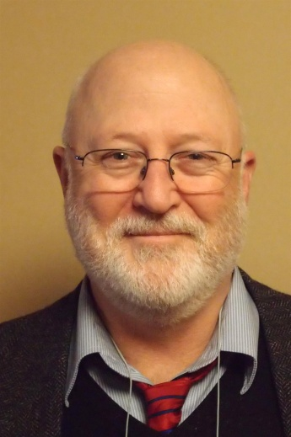

More Than 100 Breakout Sessions

There will be more than 100 breakout sessions at the RI Convention in Atlanta. Help us plan the sessions by taking a survey: TAKE SURVEY
Here's a letter from Steve Glines (shown, above), chair of the District International Convention Promotion Committee: READ LETTER

To register and find hotel options, click here.

For more information on the 2017 RI Convention in Atlanta, click here

Interact Actions: Interact teens invited to help in Providence and Atlanta

By Bob Anthony
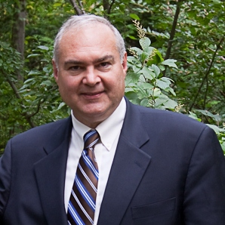

READ MORE

How to launch an Interact club

WATCH VIDEO

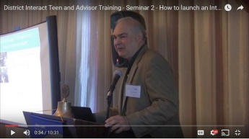

A Healthy Rotarian Is A More Effective Rotarian - Make a great New Year's resolution

By Ron Goodenow

READMORE

Club Central: Short video on how to post your club goals

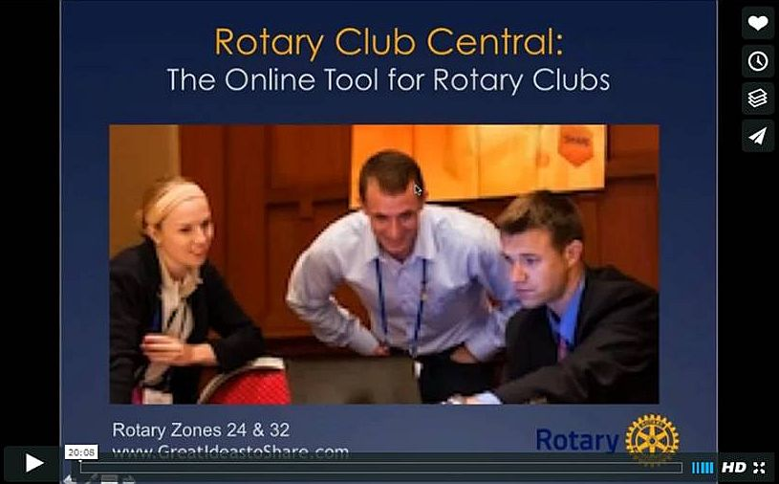
This 20-minute webinar recording is designed for club leaders to assist in posting goals on Rotary Club Central. Bob Wallace andIan Lancaster, facilitators from Rotary Zone 24 East, provide practical start-up information.

CLICK HERE

Did You Know?: District 7640 has more Interactors than Rotarians

READ MORE

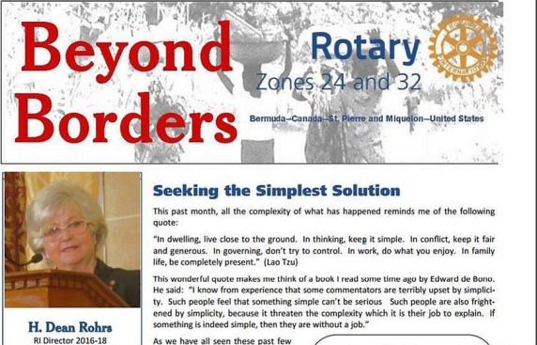

RAAGNE Newsletter: Update on visioning process

By Klaus Hachfeld

READ MORE

Treasurer's Report: All Clubs have been sent their District and RI invoices

By Jack Hoell

If it has not been received, contact Jack Hoell ASAP!

District and RI dues are billed in July and in January

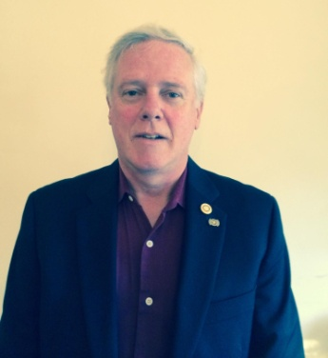

READ MORE

Speaker's Bureau: Looking for good speaker for your club?

By Steve Levitsky

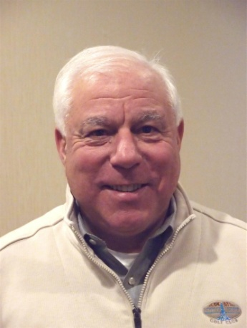

It's not always easy to come up with ideas week after week. We have many suggestions for you. Here are just a few:

- Power of the mind: Bob Martel - Newest topic addition to our list
- Rwandan genocide: Carine Boggis
- Elevator-pitch tips: Andy Winig
- Differentiation and game-changing simplicity: Stephen Melanson
VIEW MORE

District Charity Fund: How does DCF operate?

By Karin Gaffney

READ MORE

Communications Link: Seeking club photo, video albums
By Steve Jones-D'Agostino
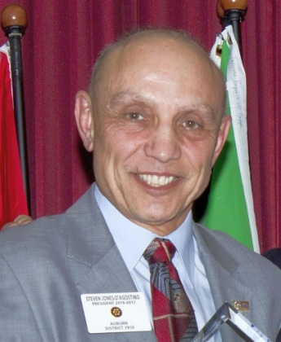

READ MORE

SUBMIT CONTENT
To submit content for consideration for the Tuesday, February 14 issue of Rotary District 7910 Newsletter, please e-mail it to Immediate Past District Governor and Newsletter Editor Jim Fusco at jim.fusco2@gmail.com.

The submission deadline for that issue is Friday, February 10. All text must be in Word format. All images must be in either JPEG or PDF format.
Please, please please ... identify the people, left to right, who are shown in your photos, including their first and last name as well as their club or other title.

PAST ISSUES
To view past issues of the weekly Rotary District 7910 Newsletter, click here

D7910 ONLINE
Visit Our Website

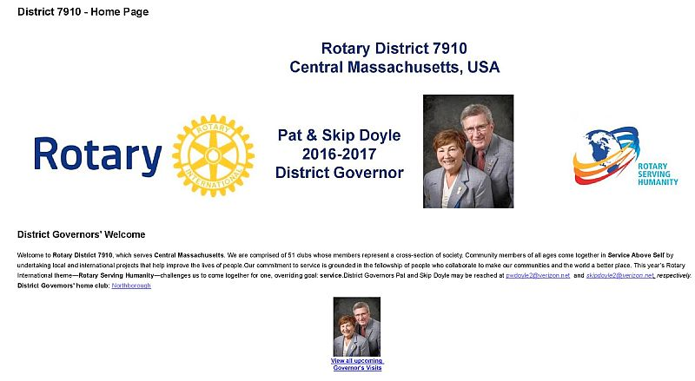
Click on each one

'Like' And Share Us On Facebook

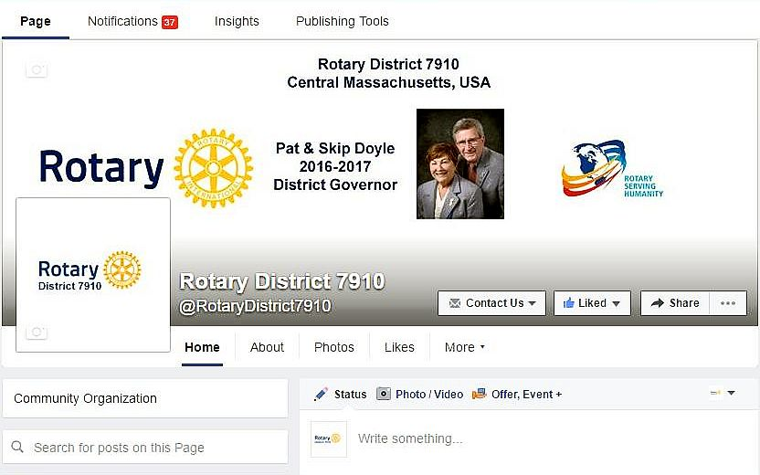

'Follow' Us On Twitter

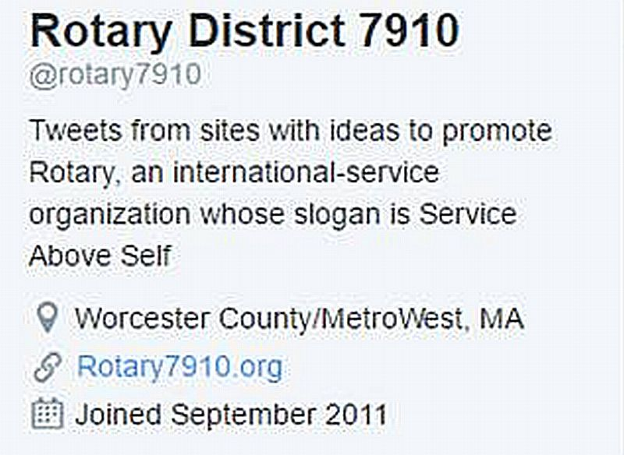

Watch Our Videos
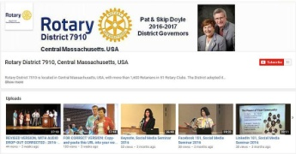

View Our Photos
Archived on Google Photos, since May 2015; and on ClubRunner, before May 2015
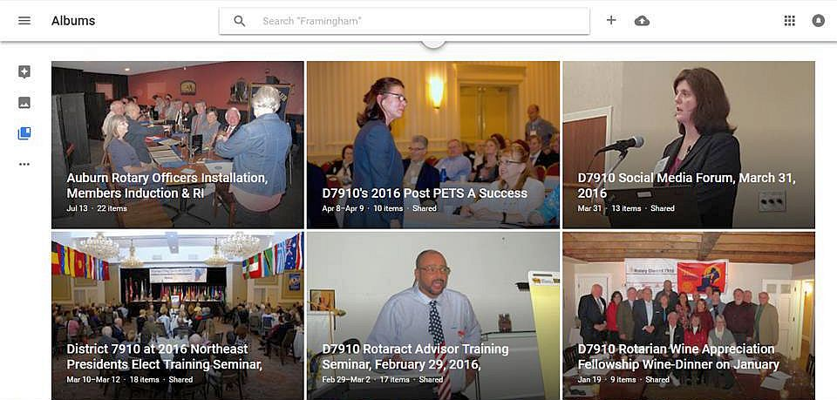

CONTACT US

Jim Fusco, Immediate Past District Governor and Newsletter Editor
​jim.fusco2@gmail.com
Steve Jones-D'Agostino, District Webmaster and Newsletter Copyeditor
​srdagostino@icloud.com
© Copyright 2017-2018 - Rotary District 7910, Central Massachusetts, USA

