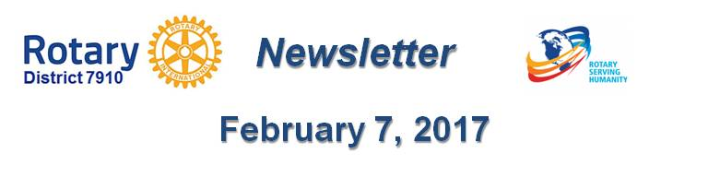

it's Time to Treasure Rotary - and For Rotary to Give Loud Voice to Its Values
By Ron Goodenow
Okay, it's time to be honest. How many times in the past few days have you been proud and relieved to be a Rotarian? Proud, because of our values, international-exchange programs, reputation, and fearless service across borders and barriers to all in need, regardless of religion, ethnicity or national origin. And yes, proud of our refugee programs.
Just Google around or spend some time on the Rotary International site and you will find an enormous number of programs, including those providing shelter boxes, honoring exchange scholars who are pitching in, helping refugees settle into European and North American communities with active Rotary clubs, and much more. Many brilliant ideas to emulate.
Rotary has been actively providing shelter boxes in Syria, where "the plight of Syria’s refugees is a litmus test for the world's compassion,” states RI General Secretary John Hewko. “Rotary members worldwide are profoundly disheartened by the refugee crisis now unfolding in Syria and other parts of the world,” which the United Nations has described as the worst in decades.
I think often of Malala Yousafzai, whose Rotarian values have led her to speak out - even as I write - on our country’s new refugee and immigration policies. “Just think of the children,” she said last week. Will her home country, Pakistan, soon be added to our travel-ban list? Will it take her two years to get a U.S. visa?
We recently had a high-ranking military officer and Rotarian from Pakistan with us, and I remember vividly his descriptions of how, in the midst of murder threats and disinformation, Rotarians went out and led the polio fight. Proudly and fearlessly. And, yes, many of us are relieved there is a place where we can repeat the Rotary Four-Way Test, and look for ways to give it life, even in the face of hostile governments, including perhaps our own.
Many of us have very personal reasons to worry, and want to take action. As in my case, a member of the family has a green card from a country singled out for hostility. I have been reminded that, while doing several weeks of research at a Vietnamese refugee camp after the fall of Saigon in 1975, wonderful Marines did all they could to protect and help translators, educators and many others who assisted in the war effort. That was unlike what we are now doing to those very same people who helped in Iraq - and who are now subject to murder and massacre, after years of promises they could come to America. This isn’t "American" and it isn’t "Rotarian."
So what do we do? Do we understand whether there are refugees in legal or other need in our communities? Do they have family members promised entry who may never get here due to new restrictions on green cards, visas, etc. Do we have "dreamers" living in terror (and in the shadows) who may need help as policies become more restrictive?
One can think of many ways to work with other Rotary clubs, community organizations and religious groups. It’s our patriotic obligation to at the very least understand facts on the ground - and perhaps learn of people who would make great Rotarians. To tell our stories.
Finally, there is RI itself. We have a huge international convention planned for this June in Atlanta. Should new restrictions go into place, is Rotary prepared to not roll over but instead to help its members, Rotary Peace Fellows, Rotaract members, exchange scholars and others who are Muslim or live in a "dangerous" part of the world get safely here and home again?
There is a big, new Rotary club in Baghdad. Can its members travel freely to be with us? Can Guled Ibrahim of Somalia, who was recently selected as a recipient of the prestigious Rotary Peace Fellowship, get here? Can Syrian refugees become as successful as Vietnamese ones? Will Rotarians from Muslim countries want to come here? A large, global academic conference scheduled in Atlanta in the next few weeks is falling apart. Do we want that?
Bottom line: Should we in good conscience go ahead with an international conference if our members and honored guests cannot attend - in a worst-case scenario? What pressures can Rotary apply to avoid what would surely be a crisis - and live up to our reputation? Serious questions for a dangerous time.
If we can cure polio, we can take big steps to help realize Rotary goals of peace and justice internationally. Let us expect RI to keep us, and potential attendees, informed.
Ideas? Examples? Feedback? Drop a note to me at ron.goodenow@gmail.com. And please note: These views are strictly personal.
Ron Goodenow is a member of the Rotary Club of Westborough.
Return to February 7 Newsletter

Visit o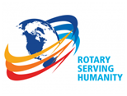ur website
'Like' our Facebook page
'Follow' us on Twitter
Watch our videos
View our photo albums

