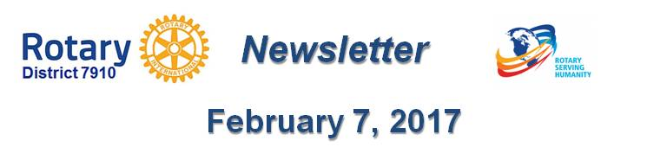

NEXT NETWORKING MEETING ON March 1 IN chelmsford
By Ron Bott

The next Rotary Means Business event in District 7910 will be held on Wednesday, March 1 from 5:30 to 7:30 p.m. at the Radisson Hotel & Suites in Chelmsford. The cost for Rotarians is $15 through February 10 - $20, after then. The cost for non-Rotarians is $20. Light appetizers will be served and a cash bar will be available.

To register and pay as a Rotarian, click here.

To register and pay as a non-Rotarian, click here.

Founded in 2013 as an official Rotary International Fellowship, Rotary Means Business provides Rotarians with business-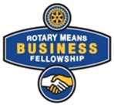networking events to meet and socialize with other Rotarians in business. RMB encourages Rotarians to support the success of their fellow Rotarians by doing business with them, and by referring others to them.

Rotary was originally established in 1905 as a business-networking organization and evolved into the international service organization that we know today. With Rotary Means Business, Rotarians are embracing the original foundations on which the Rotary was based. An active RMB chapter serves as another value-added benefit to Rotary membership.

For more information, contact Ron Bott, chair of the District 7910 Rotary Means Business Committee, at 978-423-0564 orron@bottgroup.com.

Return to February 7 Newsletter

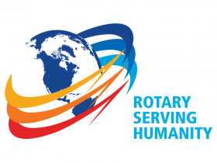Visit our website
'Like' our Facebook page
'Follow' us on Twitter
Watch our videos
View our photo albums

