2018 Rotary Peace fellowship application now available
Dear Rotarian,
The 2018 Rotary Peace Fellowship application is now available! Our new online application will streamline the submission and review process and help districts manage the increasing number of Rotary Peace Fellowship applications.
Users of the new application can expect:
- Better functionality and design
- A district dashboard for reviewing and endorsing applications and communicating with applicants
- Automated email communications from the platform
- Technical support and training from our platform provider, Embark
- A sign-in process that is separate from My Rotary and other Rotary databases and applications
Please note that the application is in English, only, and we will no longer be able to accept applications in PDF format.

As a Rotary leader, you play a key role in communicating information about the peace centers program to club and district leaders, who help identify and nominate candidates for the fellowships. We encourage you to use and share these resources:
- Rotary Peace Centers Program Guide: Information on eligibility requirements and finding qualified candidates
- Application video: Explains the steps to completing the application
- Webinars for applicants (see below)
Here are the remaining webinars for Rotarians:
- Rotary Peace Centers: The important role of Rotarians (French) - Thursday, February 9, 10:00 to 10:45 a.m.
- Rotary Peace Centers: The important role of Rotarians (Spanish) - Thursday, February 9, 11:30 a.m. to 12:15 p.m.
Check out the Rotary Peace Centers Facebook page. Follow us and spread the news about our
program.
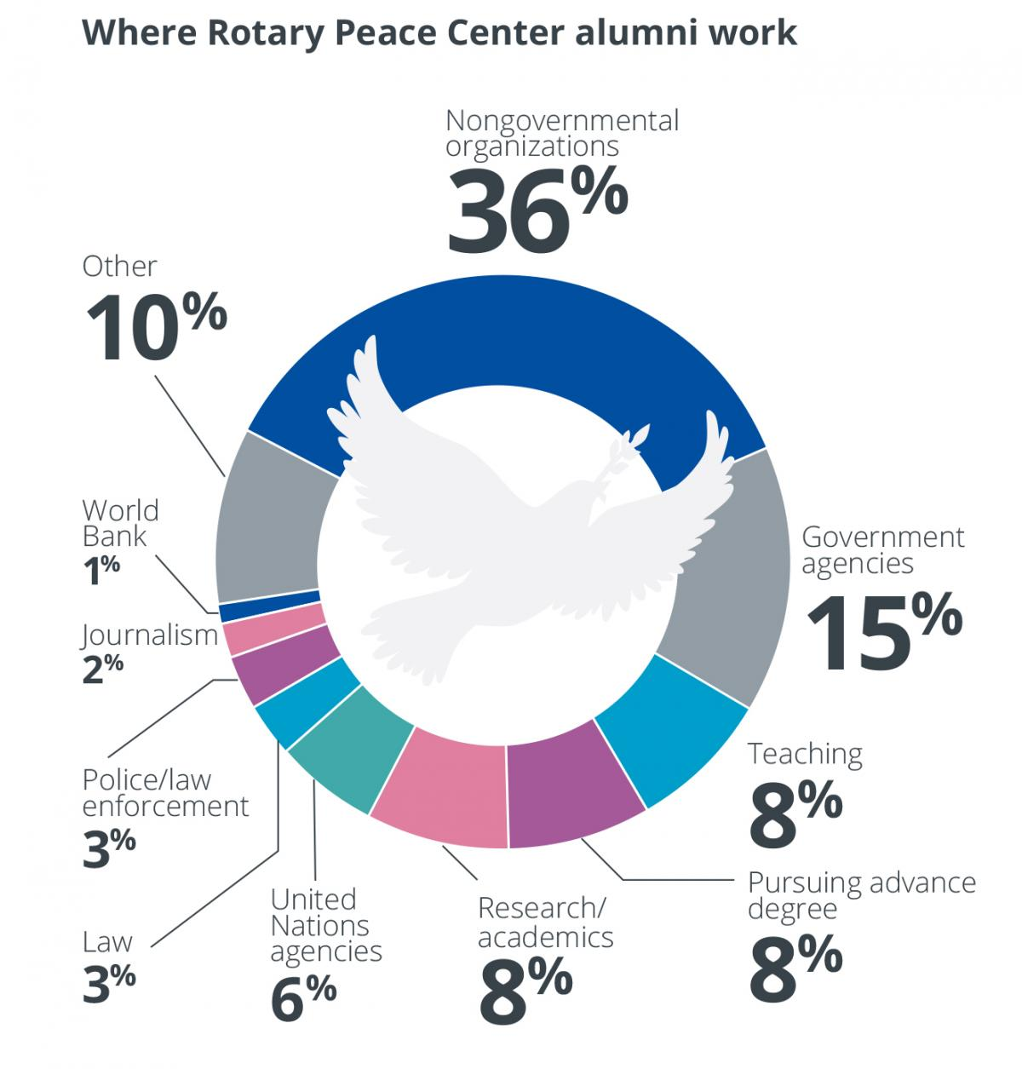

Candidates have until May 31 to submit applications to their district.

Districts must submit endorsed applications to The Rotary Foundation by July 1.

Should you need technical support in this transition, please contact Embark at support@embark.com.

General inquiries regarding the fellowship program may be sent to rotarypeacecenters@rotary.org.

We thank you for your dedication to the Rotary Peace Centers and your continuous support in educating the Rotary network about the fellowships!
Sincerely,
Rotary Peace Centers

Return to February 7 Newsletter

Visit our website
'Like' our Facebook page
'Follow' us on Twitter
Watch our videos
View our photo albums

