DISTRICT INTERACT TEEN AND ADVISOR TRAINING SEMINAR A HUGE SUCCESS

By Bob Anthony
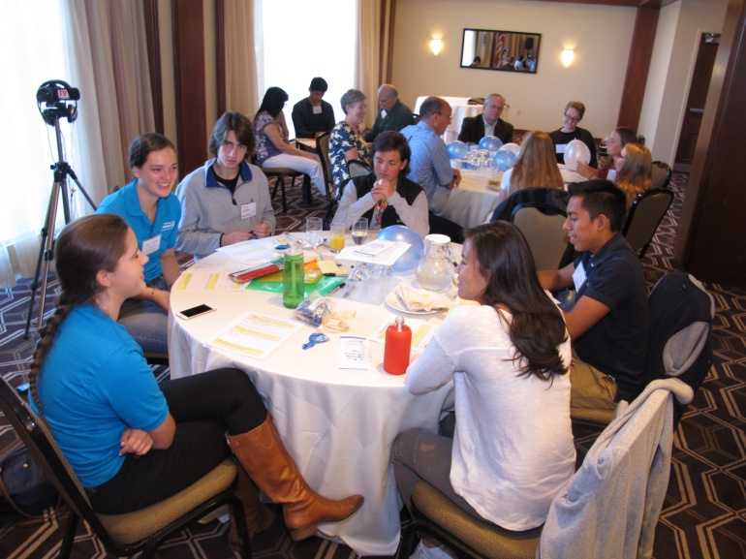
Nearly 50 participants from 14 Rotary communities took part in a District Interact Teen and Advisor Training Seminar, which was held on Saturday, September 17 at the Sheraton Hotel in Needham.
Two types of content were presented: Seminars 1 through 4 discussed how to either launch a new Interact club or enhance an existing club, including a District 7910 monthly video clip competition about projects underway by each club; and Seminar 5 was a train- the- trainer workshop for launching the Interact peer-leadership and depression-prevention project in a local community.

Here is a listing of the presenters and their topics, including links to video of the Seminar presentations, which were recorded and produced by Steve Jones-D'Agostino of Auburn Rotary:

Seminar 1: Wellesley Interactors Hannah Lee and Lindsay Canaday:
(To watch 7-minute video, click here)
- Why I am in Interact
- The Wellness Project experience and outcomes
- What I expect and need from the Rotary and faculty advisors
Seminar 2: District Interact Committee Chair Bob Anthony:
(To watch 10-minute video, click here)
- How to launch an Interact club
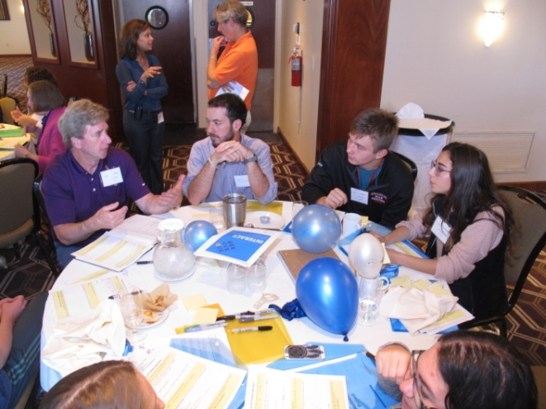
- Certification letter, roles and responsibilities of the president, the Rotary advisor and, in the case of school-based clubs, the faculty advisor
Seminar 3: Wellesley Interactors Hannah Lee and Lindsay Canaday:
(To watch 27-minute video, click here)
- Review the Presidential Citation; invite monthly video-clip competition
- Membership, succession, financial viability and sustainability
- Motivational life coach
Seminar 4 Part 1: Motivational life coach Jeff Levin:
(To watch 16-minute video, click here)

- Brainstorming with PIP (Problems, Ideas, Plans)
- One idea for each Interact club's goal for the year
- One idea adopted by all district Interact clubs to implement
- Action plan, including routine communication among district Interact members

Seminar 4 Part 2: Psychologist Nadja Reilly of Family and Educational Wellness Center - with motivational life coach Jeff Levin, at the end, getting the audience involved in a sing-along
(To watch 114- minute video, click here)
- Brainstorming with PIP (Problems, Ideas, Plans)
- One idea for each Interact club's goal for the year
- One idea adopted by all district Interact clubs to implement
- Action plan, including routine communication among district Interact members
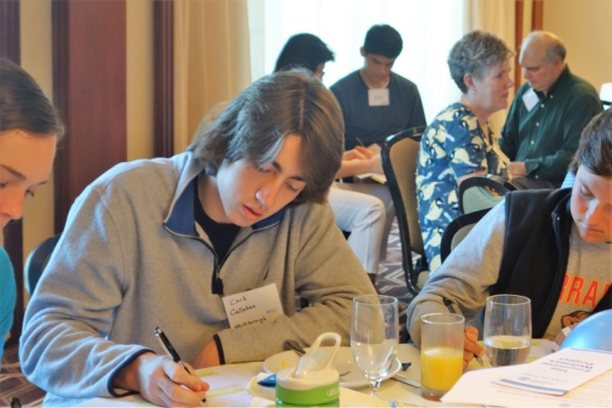
Seminar 5: Psychologist Nadja Reilly of Family and Educational Wellness Center
(To watch 86-minute video, click here)
- How to co-facilitate the Wellness Project in your community
- Train-the-Trainer workshop using the Break Free From Depression curriculum opportunities to teleconference with Interact peer leaders in other schools locally and internationally sharing ideas and experiences around the Wellness Project
- Motivational life coach Jeff Levin gets the audience involved in a sing-along

Photos: Steve Jones-D'Agostino, Auburn Rotary; and Cynthia Sibold, Wellesley Rotary

To view and download these and additional Seminar photos, click here.

To learn more about Interact, click here.

For more information, contact Bob Anthony, chair of the District 7910 Interact Committee, at bobanthony@adolescentwellness.org. ​​​​​​

Return to September 26 Newsletter

View past issues
Visit our website
'Like' our Facebook page
'Follow' our Twitter page

