AVAILABLE DISTRICT DESIGNATED FUNDS FOR GLOBAL GRANTS
By Sanjay Deshpande
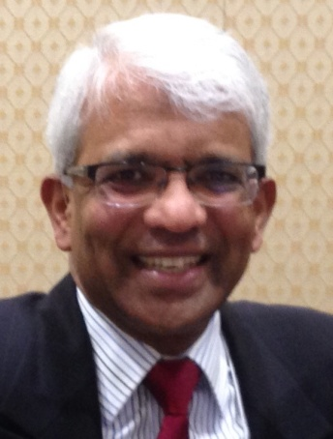
The District 7910 Foundation Advisory Board of the District Foundation Committee requires that there should be full transparency in the administration of foundation grants, which include District and Global Grants. Accordingly, this quarterly report of available District Designated Funds (DDF) for Global Grants is being published.

Global Grant projects, which have a minimum total budget of $35,000, are large international humanitarian projects with measurable outcomes in one or more of Rotary’s six Areas of Focus and must require a minimum grant of $15,000 from The Rotary Foundation (TRF).

Available DDF for Global Grants in ‘16-17

One element of funding for Global Grants is DDF. Our district started the 2016-2017 Rotary year last July 1 with a carryover balance of $35,008 from the prior year (see Table I, Section I). Contributions to TRF’s Annual Fund-SHARE in ‘13-‘14 (Past District Governor Doug Detweiler’s year) resulted in $89,044 of incoming DDF in ‘16-‘17 and available District Endowment Fund shared earnings added $1,857more to DDF for a July 1, 2016 balance of $125,909. To this, $900 in unused DDF from the ‘15-‘16 District Grant Program were added and $46,436 for the ‘16-‘17 District Grant Program were deducted (see Table I, Section II) leaving $80,373 for open and incoming Global Grant applications during ‘16-‘17.

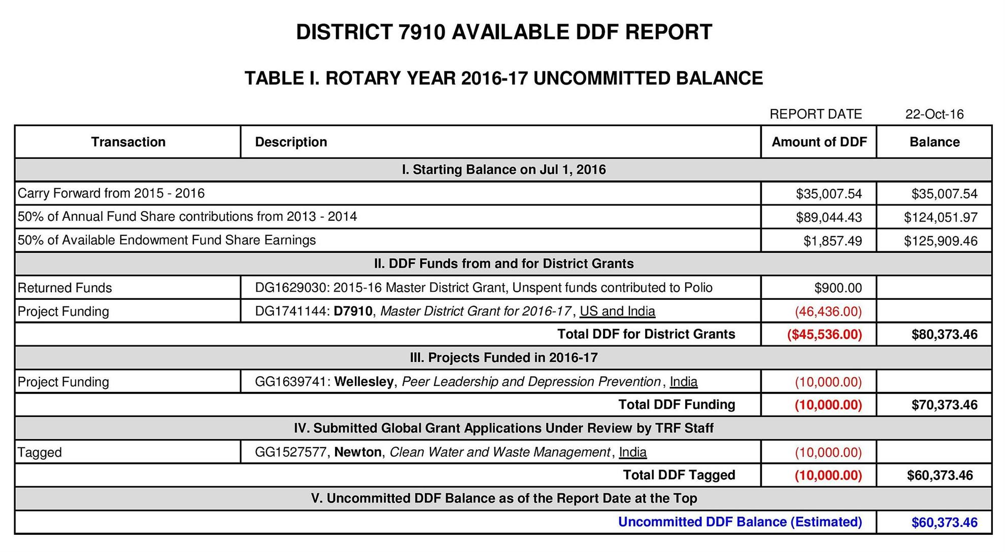

Prior-Year Submitted Global Grant Applications

In the first quarter of this Rotary year, the Newton and Wellesley clubs submitted Global Grant applications that were cleared by D7910 in prior years for review by TRF staff.

The Wellesley Global Grant project, GG1639741, titled Peer Leadership and Depression Prevention in India and with a total budget of $35,000, was approved by TRF staff and received D7910 DDF of $10,000 (see Table I, Section III) and a TRF grant of $15,000.

The Newtown Global Grant project, GG1527577, titled Clean Water and Waste Management in India, is under review by TRF staff and TRF has tagged $10,000 of available D7910 DDF (see Table I, Section IV) for the project. The TRF grant for this project will be $23,867 when the project is approved by TRF staff.

As a result, D7910 now has $60,373 in uncommitted DDF (see Table I, Section V) for the Global Grants to be processed in ‘16-‘17. The projections for these uncommitted funds are shown in Table II, below.

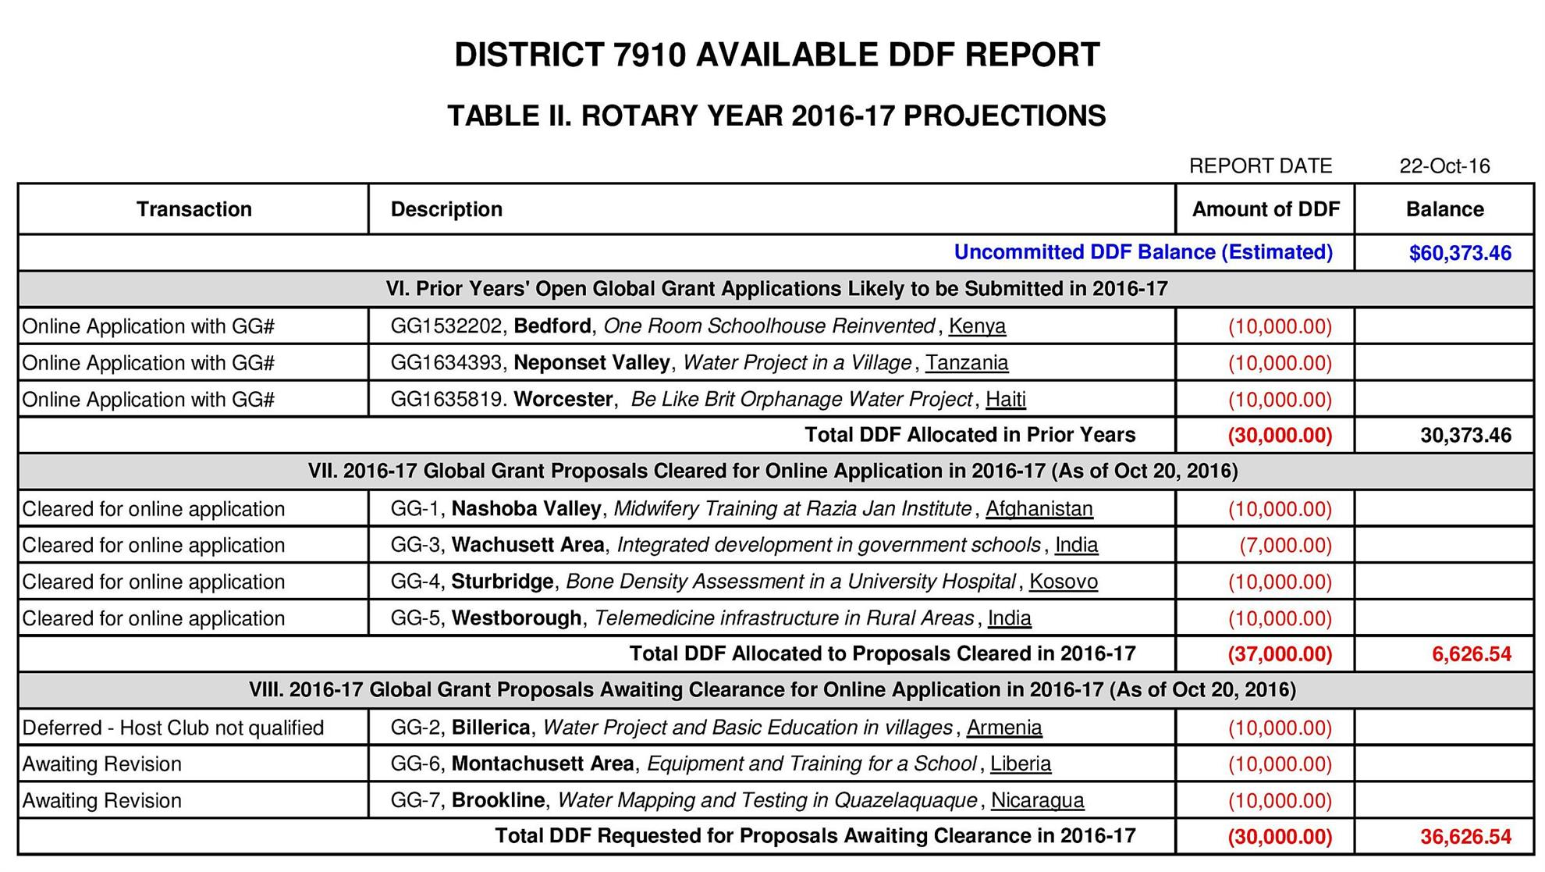

Prior-Year Open Global Grant Applications

There are three open Global Grant applications on projects approved in prior years. These applications were started in the year they were approved, but also need to be completed before they can be authorized by the district governor and the district Foundation Committee chair of the respective host district as well as by the DG and Foundation chair of D7910. If these applications are authorized prior to next June 30, D7910 would be obligated to give DDF to these projects. After the district officers authorize it, the two primary contacts – one from the host club and one from the D7910 club – must authorize the application to submit it for TRF staff review. The DDF committed by D7910 for these projects will be either tagged or deducted when they are approved by TRF staff.

The three open projects, detailed below in chronological order, have $30,000 commitment in D7910 DDF, leaving $30,373 (see Table II, Section VI) for the Global Grant projects that will follow.

The Bedford Global Grant project, GG1532202, One Room Schoolhouse Reinvented, Kenya, has a completed application and it is likely that this will be submitted in ‘16-‘17 after the six required authorizations. The project budget is $42,500 and $10,000 DDF is requested from D7910. The project will have cash contributions from clubs in Beverly Hills, California and Shanghai, China. The TRF grant for this project will be $17,500 when approved by TRF staff.

The Neponset Valley Global Grant project, GG1634393, Water Project in a Village, Tanzania, has a completed application seeking to establish a bore well and water-collection and -distribution system in Mkutani village in Tanzania for a total project cost of $38,420 for which $10,000 DDF is requested from D7910. Engineers Without Borders is a partner in this project. The application has been authorized by D7910 but not also by D9211 officers because the host club – Mwalimu Nyerere Dodoma – is not qualified per D9211 rules. This application will not be submitted for TRF staff review until authorization is complete. The TRF grant requested for this project is $16,140.

The Worcester Global Grant project, GG1635819, Water Project at Be Like Brit Orphanage, Haiti, will soon have the application completed. The project budget is $35,000 and the DDF requested from D7910 is $10,000. The TRF grant for this project will be $15,000 when approved by TRF staff.

If these three open applications are not authorized before next June 30, the D7910 DDF commitment would lapse and the projects would have to be resubmitted as proposal in future years.

‘16-‘17 Global Grant Proposals Cleared for Online Applications

The District Grants Subcommittee last week cleared four Global Grant proposals for online applications on the Grant Application Tool. These four projects will require commitment of $37,000 in DDF against $30,373 available, which implies a DDF deficit of $6,627 (see Table II, Section VII) should the applications for these four projects and the open applications for the three prior-year projects all be tagged, if not approved, by TRF staff.

The four proposals approved for online applications are listed in Table 2 and details were provided in the September 12 and 19 issues of this newsletter, which you can access in the Foundation Note Archive.

‘16-‘17 Proposals Awaiting Clearance for Online Application

The Grants Subcommittee has received three other proposals (see Table II), which await clearance for online application. Each of those proposals requests $10,000 in DDF, which would raise the DDF deficit to $36,627 (Table II, Section VIII) if all approved by TRF prior to next June 30.

It should be noted that the Billerica Global Grant proposal’s clearance for online application is being deferred until the host club, Yerevan International, is confirmed to be qualified by the host district, D2452 per their rules. This action will avoid the online Global Grant being stalled at the authorization stage, such the Neponset Valley application described above.

How Would D7910 Manage a DDF Deficit for Global Grants in ‘16-‘17?

DDF for Global Grants will be used up as and when the applications are tagged by TRF staff. Once applications are initiated online, District Foundation funding will depend on availability of DDF when an application is either tagged or approved. It is possible that one of the ‘16-‘17 Global Grant applications will get tagged before one or more of the prior-year applications. Thus, it is hard to predict when the DDF deficit will arise and which of the applications will be either tagged or approved.

All the clubs that have open online applications are therefore advised to get the applications completed, authorized and submitted for TRF staff review as fast as they can so that the applications are either approved or have DDF tagged for them before a DDF deficit arises.

If a DDF deficit does arise, our Grants Subcommittee could recommend to the Foundation Advisory Board that some of the DDF reserved for the District Grant Program (DG1741144) be returned for erasing the DDF deficit for Global Grants, provided the Grants Subcommittee determines that all of the $46,436 reserved for the District Grant program is not likely to be utilized prior to next June 30.

In the event that sufficient DDF from the District Grant program is not available for Global Grants, authorization of all open Global Grant applications by District Governor Patand Skip Doyle and our Foundation Committee would be deferred until the ‘17-‘18 DDF becomes available next July 1.

Stay tuned for the next quarterly report of available DDFs for Global Grants.

If you have any questions about the District Foundation Committee, contact either District Grants Subcommittee Chair Jorge Yarzebski at yj.rotary@gmail.com or me, District Foundation Committee Chair Sanjay Deshpande, sanjdesh51@aol.com.

For the Foundation Notes archive, click here

Learn more about District 7910 Foundation Grants:
- Rotary Areas of Focus Policy Statements (PDF Format)
- District 7910 Eligible and Ineligible Activities in a District Grant (Word Format)
- Timeline for District 7910 Foundation Grants (Web Page)
- District 7910 Grant Qualification Table (Excel Format)
- District 7910 Grant Proposals and Qualifications Status (Web Page)
- District 7910 2015-2016 Foundation Contributions Report - (Excel Format)
- Foundation Grants in 2016-'17 and Beyond (PDF Format)
- District 7910 2016-2017 District Grant Proposal Template (PDF Format)
- District Grant Proposal Form (Word Format)
- Global Grant Proposal Form (Word Format)
- District 7910 District Grants Scoring Rubric (PDF format)
- District 7910 Club Memorandum of Understanding (PDF Format)
Return to October 24 Newsletter

View pa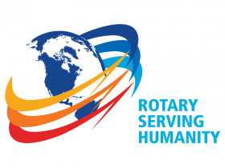st issues
Visit our website
'Like' our Facebook page
'Follow' our Twitter page

