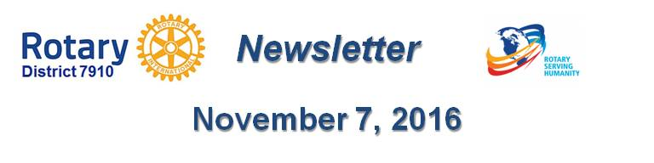

District Drive to Add $1 Million to TRF Endowment Fund in ‘16-‘17
By Sanjay Deshpande

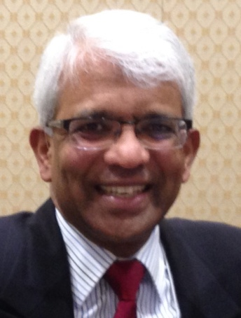Assistant Governor Satya Mitra, chair of the District Endowments and Major Gifts Subcommittee, with the encouragement of District Governors Pat and Skip Doyle and the full support of the District Foundation Committee, has launched the drive to add $1 million to The Rotary Foundation Endowment Fund in this Rotary year, which ends next June 30. With the launch of this drive, Satya has been appointed the chair of the District Million Dollar Journey and Celebration, and is pleased to share his first monthly report on this historic and ambitious campaign.

So, What Is the Million Dollar Dinner Journey?

By Satya Mitra

This Rotary 2016-2017 year marks the centennial of The Rotary Foundation. In 1917, then Rotary International President Arch C. Klumph 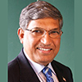shared his vision of The Rotary Foundation in which funds raised through annul giving, major gifts, endowments and bequests could be used to do good in the world. That vision, which started TRF with an initial donation of only $26.50 (in 1917 dollars), has grown in 100 years to billions of dollars today!

A “foundation” is comprised of funds given for the permanent support of an organization. The Rotary Foundation, a public charitable entity that has garnered the highest rating among its peers, transforms the donations it receives into projects that change lives both close to home and around the world by tapping into a global network of Rotarians who invest their time, money, and expertise into priorities embodied in Rotary’s six areas of focus. The support that TRF has provided throughout the last century has made a significant and profound difference in the entire world, with the near-eradication of polio as the crowning achievement.

Hence, this year, TRF Centennial Celebrations are being planned worldwide. In our district, Governors Pat and Skip Doyle have decided to commemorate the TRF Centennial by launching a drive to add $1 million to the TRF Endowment Fund and celebrate that achievement with a Dinner Event. I deem my appointment as chair of this drive a special honor and am absolutely thrilled and excited to see that we accomplish this goal together in our district and have the celebration event.

This drive has been launched to create an opportunity for our members and friends to give a cumulative total of $1 million to the Endowment Fund in the form of:
- An outright contribution - Major Gift - of at least $10,000 in cash or appreciated stock, or
- A bequest of at least $10,000 established through one’s will, or
- The designation of TRF as a beneficiary for at least $10,000 in either a life-insurance policy or a retirement account.
The district’s goal is to accumulate contributions to the Endowment Fund from these three forms of giving totaling $1 million between last July 1 and next April 30, so that the gala celebratory dinner can be held next May. Million Dollar Dinner events are generally attended by one or more Rotary dignitaries such as the RI president, an RI director or a TRF Trustee. The district’s gala dinner event is tentatively planned sometime in May, depending on the availability of an appropriate Rotary dignitary. All members and friends who either become a contributor to the Endowment Fund, achieve Major Donor status or become a Bequest Society member will participate in the Foundation Centennial and Million Dollar Goal Achievement Dinner event.

We are guided in our drive by the experience of other districts in the U.S. that have successfully completed the Million Dollar Journey. This drive will be led by 10 Table Captains, each of whom is already a Major Donor or a Bequest Society Member and will be trained to approach and convince other Rotarians and their friends and convince them to make a qualifying contribution in one of the three ways described above. I am thankful to following members who have agreed to be Table Captains for this exciting event (alphabetically, by last name):
- Victor Bhakta, Leominster
- Val Callahan, Worcester
- Robert Guernsey, Tyngsborough-Dunstable
- Steve Levitsky, Concord
- Arnie Miller, Brookline
- Tom Polito, Neponset Valley
- John Sbrogna, Montachusett Area
I am looking for three more members to serve as Table Captains. If anyone is interested in joining, please contact me immediately. In addition, Past District Governor Carol Toomey has agreed to provide her support and advice for the event. Sanjay Deshpande, chair of the District Foundation Committee, District Governors Pat and Skip Doyle, District Governor-Elect Karin Gaffney, District Governor-Nominee Steve Sager and Immediate Past District Governor Jim Fusco will offer their full support in their respective leadership roles.

The key is for all members in the district to make a contribution to the Endowment Fund in one of the three ways listed above so that the district can accumulate a total sum of at least $1 million by next April 30. Please note that this is our district’s effort and we all have to do our best to make it happen. This is a TRF Centennial Celebration, so we should all be as generous as we can so that our contribution and generosity stand as a representation of hope for many who find life is hopeless for them.

I am determined to achieve this goal by talking about it with my fellow Rotarians and non-Rotarian friends and I urge all of you to talk about this special event and promote the program. If any club wants me to make a presentation about this program, I would be happy to come and talk.
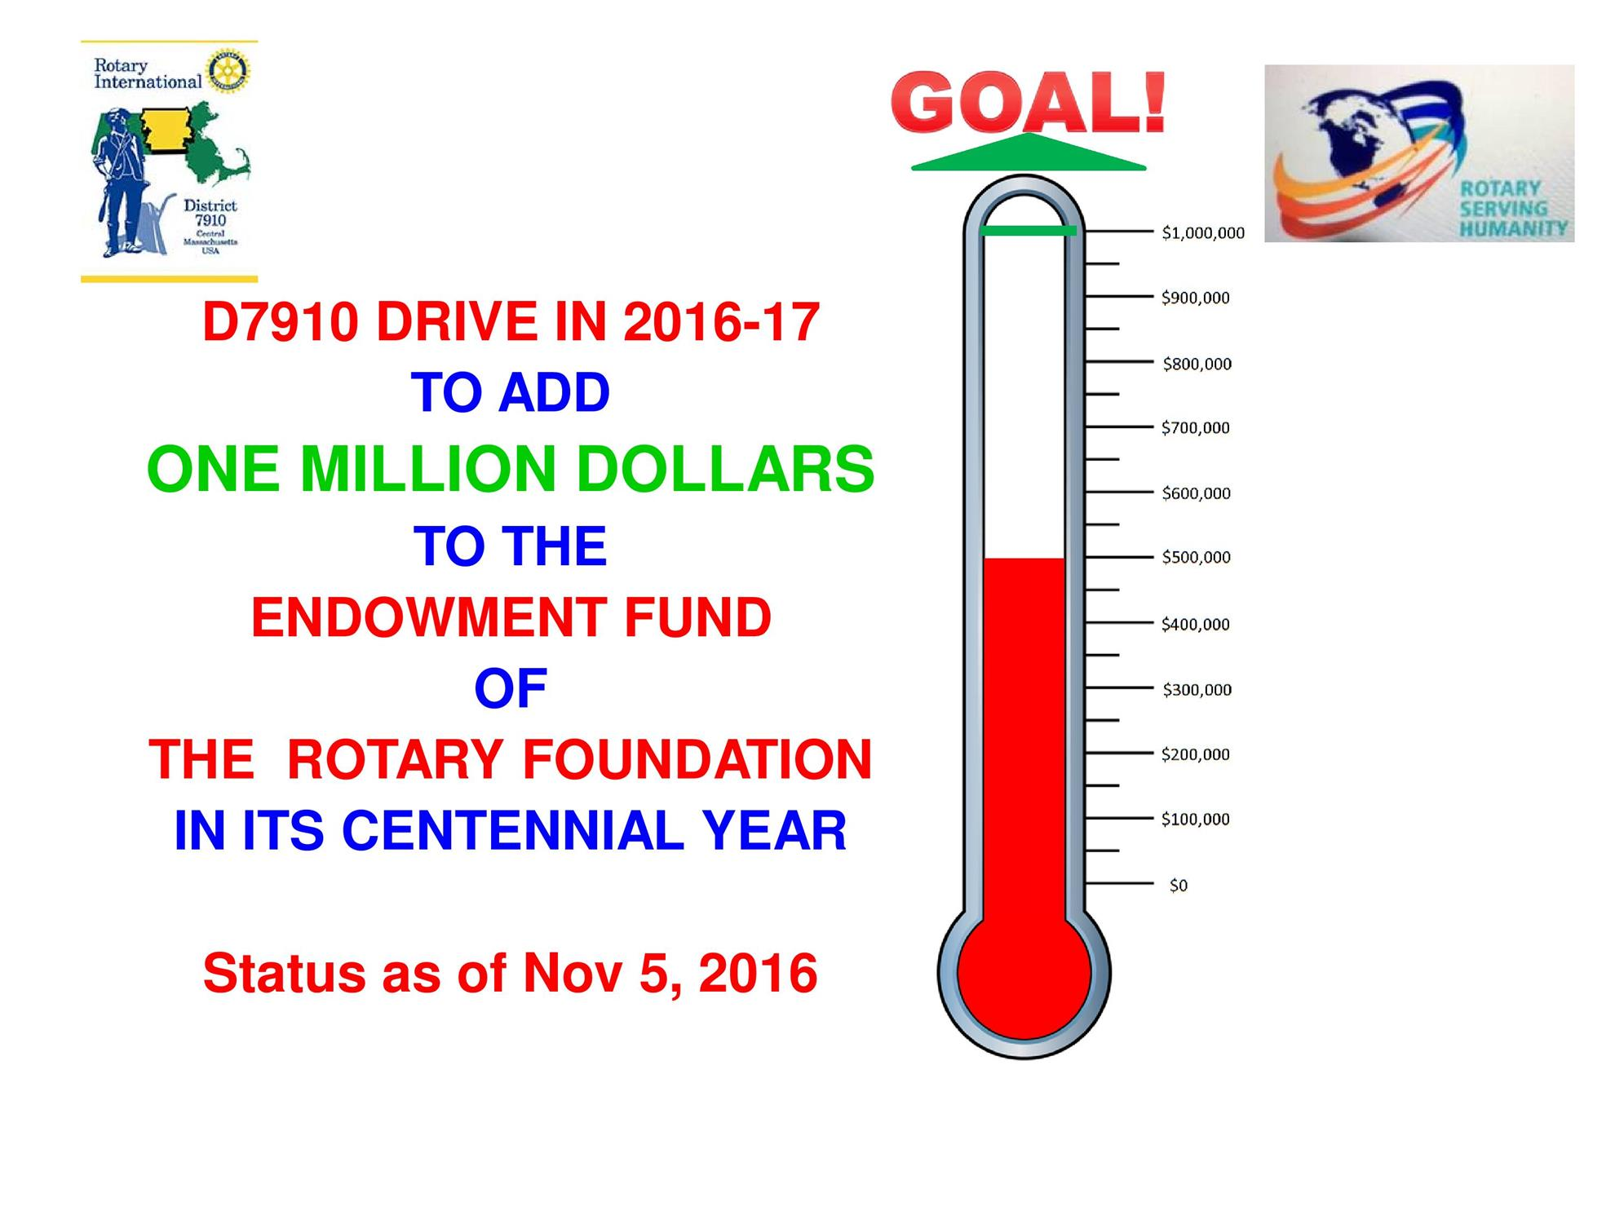
I am very happy to announce that I have been working hard and approaching my friends and fellow Rotarians for their generous commitment or contribution for this cause, and I have already raised $500,000 – half-a-million dollars – by combining outright gifts and Bequest Society commitments. The thermometer (shown, right) tracks our progress toward the goal.

I have no doubt that our district will raise much more than $1 million this year. We will set an example and establish a historic record for District 7910.

Let’s do it altogether. Let’s have super fun and let’s celebrate the TRF Centennial with joy and pride and do more good in the world.

Satya Mitra may be reached at satya@thegurutax.com.

From Sanjay Deshpande: As chair of the District Foundation Committee, I wholeheartedly commend Satya Mitra on his untiring and exemplary effort in generating pledges for half-a-million dollars already. I, too, am confident that we will exceed the $1-million goal by next April 30.

I would also like to add that this drive will continue beyond the celebratory dinner into future years because these contributions are “legacy giving.” Legacy giving ensures that the good we do in the world will live on. If you want to do good in this world after you leave it, please bequest a part of your estate to The Rotary Foundation. Remember, gifts to the Endowment Fund are never spent. Only a portion of the earnings are spent each year on Rotary’s programs, which creates a legacy of support that lasts for generations.

If you have any questions about the District Foundation Committee, contact either District Grants Subcommittee Chair Jorge Yarzebski at yj.rotary@gmail.com or me, District Foundation Committee Chair Sanjay Deshpande, sanjdesh51@aol.com.

For the Foundation Notes archive, click here

Learn more about District 7910 Foundation Grants:
- Rotary Areas of Focus Policy Statements (PDF Format)
- District 7910 Eligible and Ineligible Activities in a District Grant (Word Format)
- Timeline for District 7910 Foundation Grants (Web Page)
- District 7910 Grant Qualification Table (Excel Format)
- District 7910 Grant Proposals and Qualifications Status (Web Page)
- District 7910 2015-2016 Foundation Contributions Report - (Excel Format)
- Foundation Grants in 2016-'17 and Beyond (PDF Format)
- District 7910 2016-2017 District Grant Proposal Template (PDF Format)
- District Grant Proposal Form (Word Format)
- Global Grant Proposal Form (Word Format)
- District 7910 District Grants Scoring Rubric (PDF format)
- District 7910 Club Memorandum of Understanding (PDF Format)
Return to November 7 Newsletter

View pa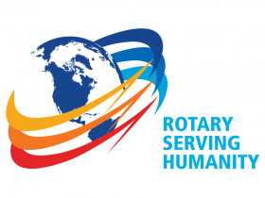st issues
Visit our website
'Like' our Facebook page
'Follow' our Twitter page

