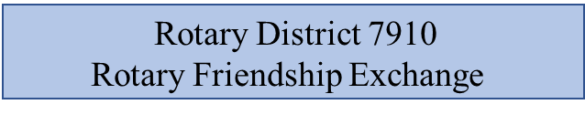
Add link boxes:
Interested in hosting
Interested in traveling

(Link “Interested in traveling” to Suggestion/Request for a Rotary Friendship Exchange listed below)
(Link “Interested in traveling” to PJ Avella’s email address; Subject line: “Interested in Rotary Friendship Exchange Hosting”)
(Will add 7-10 open source pictures on a rotary banner)
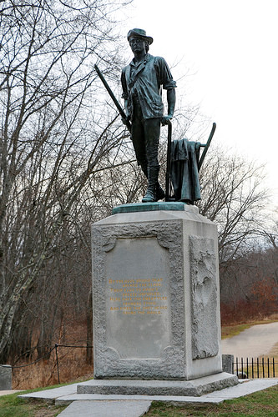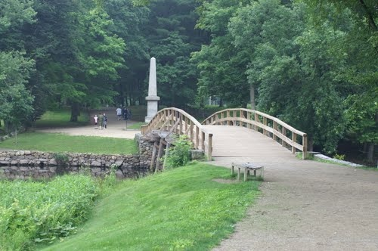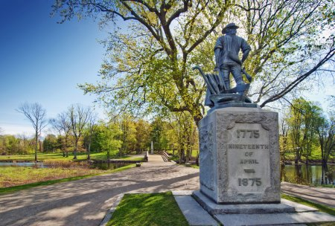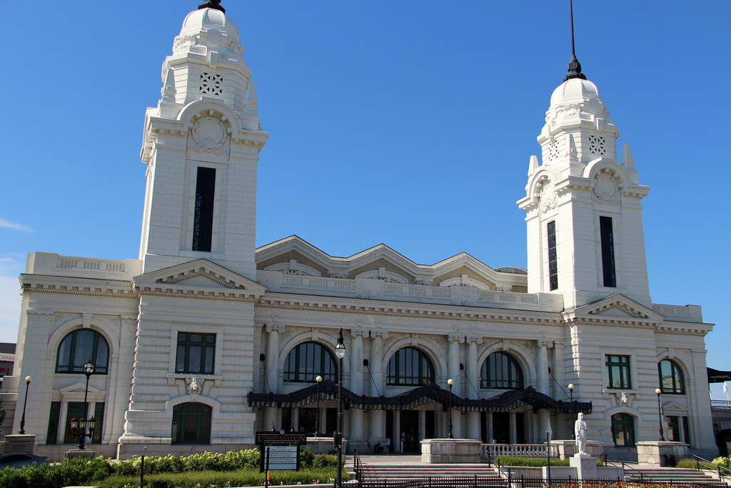
Rotary District 7910 Rotary Friendship Exchange program: The Rotary Friendship Exchange program gives Rotarians and their families the opportunity to experience other cultures firsthand, by participating in reciprocal visits with Rotarians from other countries and their families. Introduced in 1984, this program aims to advance international understanding among Rotarians. It provides Rotarians with the opportunity to form personal contacts and make long-lasting friendships while exploring different areas of the world. Go here to download the Rotary Friendship Exchange Manual.

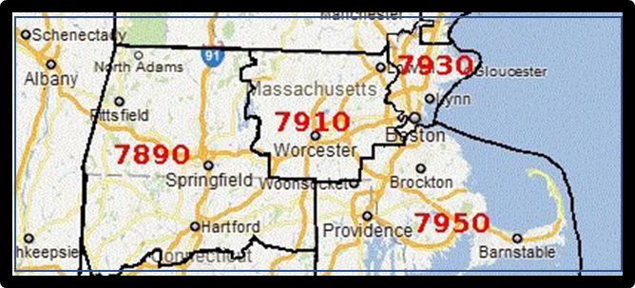
District 7910
Make the page two (2) columns???? Everything in the box below go in the left column???

District 7910 point of contact:
Paul Avella
Rotary Club of Littleton, MA #6572
avellap@comcast.net
+1 781 354 7235

Rotary Club of Littleton
Attn: Paul Avella
Post Office Box 315
Littleton, MA 01460

Link to District 7910’s club directory and contacts https://rotary7910.org/clubdirectory
(Make “District 7910’s club directory and contacts” the hyperlink to the URL)

(Items 1-5 below, make each its own hyperlink)
- Major Universities and Colleges in the Great Boston, MA area https://en.wikipedia.org/wiki/List_of_colleges_and_universities_in_metropolitan_Boston

- List of professional and collegiate sports teams in the Greater Boston area http://www.masportsoffice.com/teams/

- 90 great things to do in Massachusetts https://www.visit-massachusetts.com/state/90-great-things-to-do-in-massachusetts/

- 70 great things to do in New Hampshire https://www.visit-newhampshire.com/state/70-great-things-to-do-in-new-hampshire/

- 58 great things to do in Rhode Island https://www.vacationsmadeeasy.com/TheBLT/RhodeIslandBucketList749.html

Proposed Rotary Friendship Exchanges (Make this a hyper link to “Locations”)
Locations
Stockholm, Sweden, District 2360 (make “District 2360” a hyperlink to https://www.rotary.se/2360/home/ )
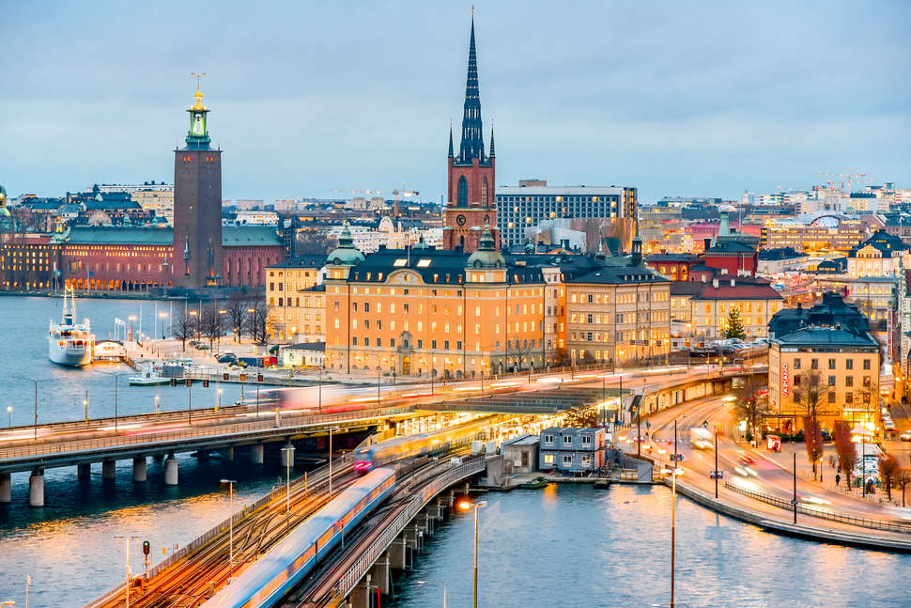 (place photo to right of (Stockholm, Sweden, District 2360)
Dates: Spring 2020 – District 7910 to District 2360
Fall 2020 – District 2360 to District 7910
Number of couples/people: TBD/TBD
(STOCKHOLM, SWEDEN IS AN ACTUAL PROPOSAL)

Paris, France, District 905 (Make District 905 a hyperlink to http://www.rotaryparis.org/
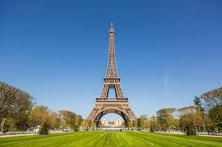
(PARIS, FRANCE IS AN EXAMPLE. IT IS NOT A CURRENT PROPOSAL)
Suggestion/Request for a Rotary Friendship Exchange (Create a form with info request below. When submitted, the form info goes to PJ Avella’ email.)
Name
Email
Telephone
Location suggestion/request
Additional information

Planned Rotary Friendship Exchanges (Make this a hyper link to “Locations”)
Locations
Stockholm, Sweden, District 2360 (make “District 2360” a hyper link to https://www.rotary.se/2360/home/ )
(place photo to right of (Stockholm, Sweden, District 2360)
Dates: Spring 2020 – District 7910 to District 2360
Fall 2020 – District 2360 to District 7910
Number of couples/people: TBD/TBD
Dates: Spring 2020 – District 7910 to District 2360
Fall 2020 – District 2360 to District 7910
Number of couples/people: 5/10
Interested in participating in a Rotary Friendship Exchange (Create a form with info request below. When submitted, the form info goes to PJ Avella’ email.)
Name
Email
Telephone
Location
Additional information

Previous Rotary Friendship Exchanges (Make this a link to “Location”)
Locations
Stockholm, Sweden, District 2360 (make “District 2360” a hyper link to https://www.rotary.se/2360/home/ )
(place photo to right of (Stockholm, Sweden, District 2360)
Example
Dates: 12 May 2020 – 20 May 2020, District 7910 to District 2360
Number of couples/people: 4/8
Clubs represented:
Littleton #6572 (1/2)
Fitchburg #6564 (3/6)
Satisfaction

