Governor Baker 'Meet AND Greet' on September 27 in Bedford
By Heidi Heilman, Weston & Wayland Rotary

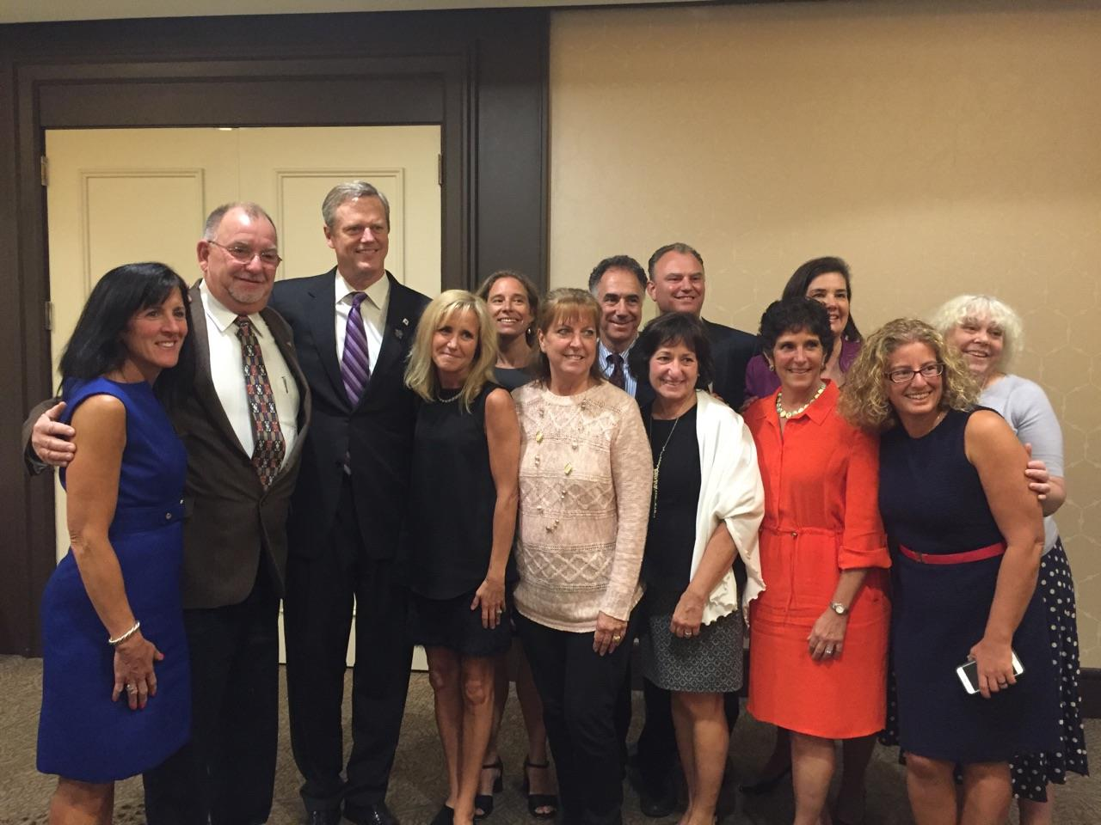
Shown, left to right: Carol Read, Needham Public Health Department; Peter Juaire, Marlborough City Council; Charlie Baker; Heidi Heilman, Massachusetts Prevention Alliance; Amy Turncliff, A Decision at Every Turn, in Ashland; Cheryl Juaire, Magnolia New Beginnings;John Scheft, Law Enforcement Dimensions; Lynn Frano, Organizing Against Substance Abuse, in Stoughton; Lester Hensley, Westborough Planning Board; Beverly Madden, Substance Prevention & Awareness Network, in Dover-Sherborn; Jody Hensley, Westborough School Committee; Stephanie Patten, Organizing Against Substance Abuse Stoughton; and Karen Walsh, South Hadley Drug & Alcohol Prevention Coalition.

The Rotary Clubs of Bedford, Billerica, Lowell, Newton and Shrewsbury sponsored "Meet and Greet" with Governor Charlie Baker on September 27 at the DoubleTree Bedford Glen Hotel in Bedford. The purpose of the event was to foster collaboration with our governor and legislators that will improve our communities and the lives of people in the Commonwealth. This unique networking opportunity offered District 7910 Rotarians an occasion to learn about some of the humanitarian work being done in Massachusetts and to get involved in projects that align with the interests and goals of our Massachusetts government.

Governor Baker spent an hour with the group discussing important initiatives that will build a stronger, better Massachusetts. He stated in order to be a great state, every single community in the Commonwealth must be healthy and thriving. He highlighted some of the details of education, transportation and health-care projects. He cited data and urged the group to support the expansion of charter schools in Massachusetts. He also urged all Rotarians in the District to vote "no" on Ballot Question 4, indicating that it is directly counter-productive to the work being done to build healthy, thriving Massachusetts communities. He spoke of legislation that is working to address the opiate epidemic and said there is much more to do in preventing and reducing addiction. When asked to identify an accomplishment he is most proud of since taking office, he answered that an organization is only as strong as the leadership team, and that he is very proud of his administration and how they work together to get things done.

There were four other featured speakers on the agenda. Bedford Rotarian Bob Cassidy spoke about the work he championed to bring the Gift of Life Program to New England. With the establishment of this program, needy children from around the world are receiving treatment for their heart disease at participating hospitals in New England. To date, almost 100 children have been treated and given the gift of an extended, full life. Bob Cassidy reminded the group that Rotarians make powerful impact by championing great ideas.

State Senator Jason Lewis followed with details of Ballot Question 4, explaining why 130 Massachusetts legislators, Governor Baker, Lt. Governor Karen Polito, Boston Mayor Marty Walsh and many health, business, education and medical organizations are strongly opposed to it, including the Massachusetts Hospital Association, the Massachusetts Medical Society, Massachusetts Municipal Association and Associated Industries of Massachusetts. Senator Lewis stated Ballot Question 4 was written by representatives of the marijuana business wanting to industrialize a billion-dollar, commercial-marijuana enterprise and aggressively market and sell high potency THC products in every community. He said this would adversely affect Massachusetts’ communities, families and children and be counter-productive to all the work the state is doing to address the current opiate and addiction epidemic.

Senator Lewis described how Ballot Question 4 goes way beyond Colorado’s law by:
- Allowing people to grow up to 12 plants in their home (Colorado’s law allows only six plants per household)
- Authorizing the sale of high potency THC concentrates and edibles where THC is extracted from the marijuana plant and infused into candies, cookies, ice creams, fruit drinks and other products that appeal to children
- Stripping away local controls to regulate the industry at the municipal level where Boards of Selectmen and City Councils in Massachusetts will not be able to ban retails stores or marijuana bars, as they can (and the majority have done) in Colorado.
Senator Lewis also said Ballot Question 4 would ultimately cost taxpayers because the referendum sets a Massachusetts marijuana tax at 12 percent, a rate too low to cover the cost of adequate regulatory and enforcement measures needed to implement the law. The senator explained Washington state’s marijuana tax is set at 30 percent and Colorado's marijuana tax is at 25 percent, adding that those two states, having legalized marijuana, continue to have challenges with the costs associated with regulating the industry and enforcing the law, despite the tax revenue being collected.

Senator Lewis discussed safety and enforcement problems that would worsen if Ballot Question 4 passes, including increased drugged driving, increased black-market sales, and increased youth drug use and addiction – all outcomes that Colorado has experienced since it legalized marijuana in 2014. He said that no matter what people think about legalizing marijuana as a philosophical idea, Ballot Question 4 would be a very bad law for Massachusetts. He encouraged those in the room to vote "no" on Ballot Question 4 and let others know to vote "no" as well.

Richard DeVito, a member of Weston-Wayland Rotary followed Senator Lewis with a presentation about his work on pain management and opioid addiction. Mr. DeVito was a founder of the International Conference on Opioids and his company publishes the Journal of Opioid Management. He showcased the Rotarian Opiate Safety Card Project he is leading, and provided details on how clubs can help get this addiction-prevention resource into every household in the Commonwealth and beyond. He spoke about balancing patients’ needs while reducing risk, abuse and death due to addiction.

Heidi Heilman, the final speaker of the evening and also a member of Weston-Wayland Rotary, spoke about the International Rotarian Action Group for Addiction Prevention (RAG AP), her work at the United Nation's Global Assembly Special Session on Drug Policy and the statewide network of the Massachusetts Prevention Alliance, an organization made up of leading stakeholders in almost every community in the Commonwealth working to address local youth risk, drug use and addiction. Ms. Heilman emphasized that businesspeople in the private sector who rely on a drug-free workforce and thriving, healthy communities must begin to engage collaboratively in addressing drug use and addiction with upstream prevention measures. She stated there is no money in not selling drugs and way too much profit to be made in their aggressive marketing and sales. She explained that many of the experts – researchers, public-health officials and drug-prevention experts – are tied to public-funding streams that restrict lobbying. She said this poses a challenge when addiction prevention becomes politicized through drug-industry initiatives pushing for policies and law that protect their profit-driven interests. For this reason, she said, government and health officials need full support from the private sector to address the current drug-use and -addiction epidemic that continues to grow. She noted that Rotary is strongly positioned to service this role purposefully and effectively.

Ms. Heilman explained how Rotary clubs in our district may collaborate with their local representatives of the Massachusetts Prevention Alliance to prevent youth drug use and addiction in their communities. She had three asks of the group:
- Help get information out to communities about the flaws of Ballot Question 4, help raise capital for the opposition campaign that Senator Lewis spoke about, and work with with local representatives of the Massachusetts Prevention Alliance to disseminate educational information on the ballot question throughout their community.
- Sign up for IRAGAP and, after the November 8 general election, work with the Massachusetts Prevention Alliance to get the Opiate Safety Card into every household in the Commonwealth
- If anything resonated with what either Senator Lewis, Governor Baker, Richard Devito or she spoke about, get involved and help build and grow the Massachusetts Prevention Alliance (a statewide 501(c)3 non-profit organization) and its mission to reduce drug use and addiction at the local level.
To view these and other photos of this event, taken by Frank Sibley of Acton-Boxborough Rotary and Rich Prager of Worcester Rotary, click here.
To watch a video by Concord Rotarian Steve Kirk, which was played during this event, click here.

For either questions or more information on the "Meet and Greet" with Governor Charlie Baker, contact event organizer Billerica Rotarian John Peterson at johnpetersonrealestate@gmail.com or 781-820-3858.

Return to October 24 Newsletter
Return to October 17 Newsletter

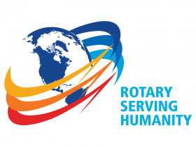
View past issues
Visit our website
'Like' our Facebook page
'Follow' our Twitter page

