Why Should I Go to The Rotary International Convention?
By Karin Gaffney
I a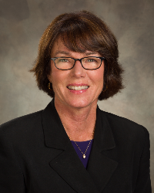m providing testimonials from our Rotarians who have attended a Rotary International Convention. Here's a testimonial from Past District Governor Carol Toomey of Nashoba Valley Rotary:

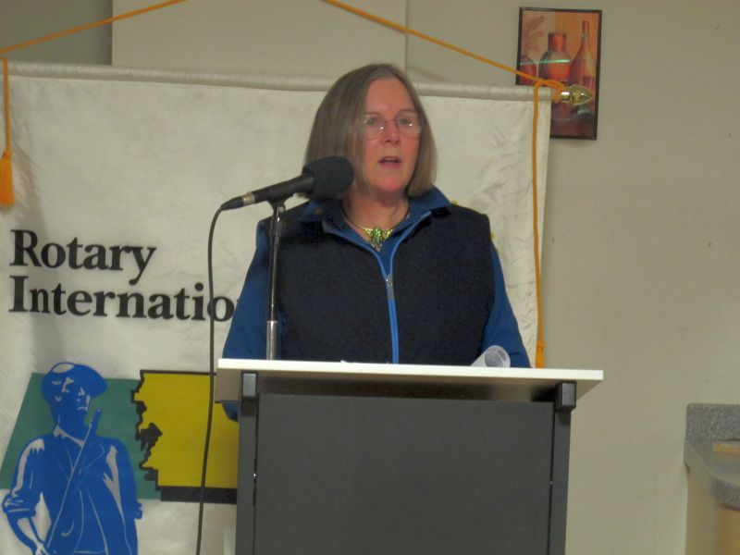

For more information on the 2017 RI Convention in Atlanta, click here.

Past District Governor Carol Toomey may be reached at carolrotary@gmail.com.

Next week, I'll have a testimonial from ??? of ??? Rotary.

District Governor-Elect Karin Gaffney may be reached at karin.gaffney@rocklandtrust.com.

Return to October 24 Newsletter

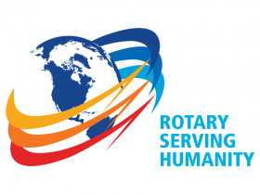
View past issues
Visit our website
'Like' our Facebook page
'Follow' our Twitter page

