COUNTDOWN TO OUR DISTRICT-WIDE FOOD PACKagING EVENT: 5 Days Left
By Pat and Skip Doyle
What is our goal for the next 5 days? To raise as much money as possible to support our District Stop Hunger Now Food Packaging Event next Saturday, November 12 from 12:00 noon to 3:00 p.m. at the Solomon Pond Mall in Marlborough.

We are thankful for the many members, young and old, as well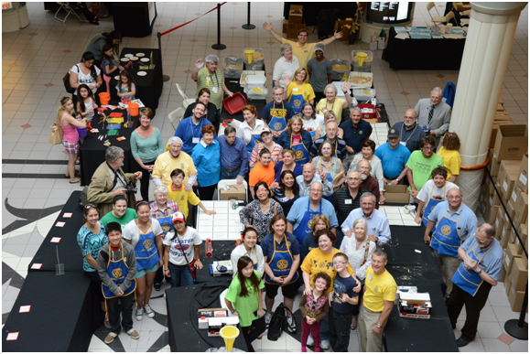 as their families and friends who are volunteering to help us package the meals. But more help also means we need more food to package. And that means we need more monetary donations to provide the raw materials. Please visit our Stop Hunger Now website and make a donation. To both donate and volunteer,
click here.

We had fun last year! Join the fun this year!

Always remember, you can call us with questions at 508-393-9031.

District Governors Pat and Skip Doyle may be reached at pwdoyle2@verizon.net and skipdoyle2@verizon.net,
respectively.

Click here to submit content for the November 14 issue. The submission deadline for this issue is November 11.

Click here for past issues.

Return to November 7 Newsletter

Visit our website
'Like' our Facebook page
'Follow us on

