Dear $NICK_NAME$,

It is our pleasure to share with you the January 17 issue of Rotary District 7910 Newsletter, which will now come out on Tuesday at 10:00 a.m. The weekly submission deadline remains the same: Friday.

For the complete issue, click here.

To explore past issues, click here.

Highlights of the January 17 issue:
- Governor’s Message: When change is good, not so good, and productive – By Pat and Skip Doyle
- Membership Corner: Another set of Membership Workshops in March – By Tom Sturiale
- Foundation Note: Foundation-giving scorecard in '16-'17 – By Sanjay Deshpande
- Polio Plus Update: You can donate to polio eradication as an individual Rotarian – By Carl Good III
- ESSEX Examples: Discover a great youth program
- Nominations Call: Seeking qualified applicants for District Trustee and District Charitable Fund Trustee – By Mike Ellis
- District Scholarship Deadline: March 15 is application deadline for David and Eleanor Morley Endowed Global Grant Scholarship
- Nashoba Valley Tools Up: Bolton Repair Cafe set for January 21
- Wellesley Video: Promoting peer leadership and depression prevention
- District interact Video Contest: Entry deadline is January 31
Our next newsletter will come out on Tuesday, January 24. The submission deadline is Friday, January 20. Text content must be submitted in Word format. Image content must be submitted in either JPEG or PDF format. Send your content submissions to Immediate Past District Governor/Newsletter Editor Jim Fusco at jim.fusco2@gmail.com.

Governors Pat & Skip

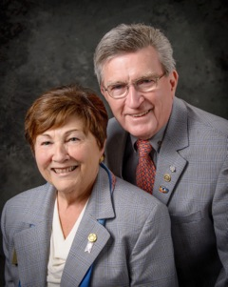Pat and Skip Doyle
2016-2017 Governors
Rotary District 7910
pwdoyle2@verizon.net
skipdoyle2@verizon.net

