Foundation-Giving Scorecard in '16-'17
By Sanjay Deshpande

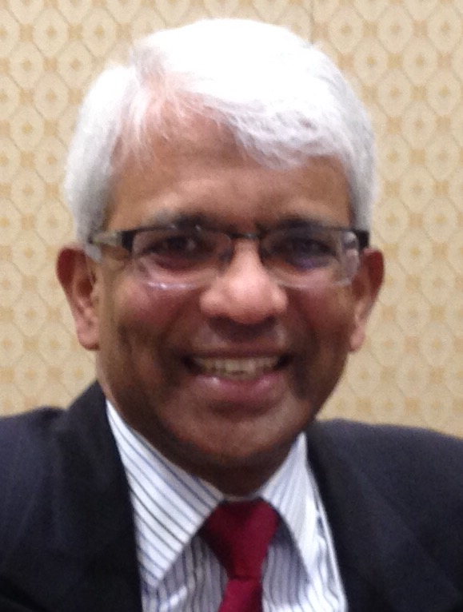
The Rotary Foundation is supported by contributions from Rotarians all around the world. Our district has set a goal of $325,000 in total Foundation giving in 2016-2017, - about 10 percent above the $293,705 contributed in '15-16. The per-capita average goal for '16-17 is about $225.

As of December 30, District 7910’s total giving stood at $103,949 - or 32 percent of the annual goal. Historically, both December and the April-June quarter are the highest contribution periods. Due to the efforts of District Governor-Nominee Designate Pam Anastasi leading the district-wide charge towards the goal with the help of Steve Levitsky, chair of the Fundraising Subcommittee, and Satya Mitra, chair of the Endowments and Major Gifts Subcommittee, contributions in December reached an all-time high of $68,312.

The leaders of the Foundation-giving effort so far are shown in the Table 1, ranked by per-capita contribution through December 30.

The Top 10 leaders in Foundation-giving, through December 30, ranked by per-capita contribution:

Rank | Club | Members, July 1, 2016 | Per-capita amount
1 | Lowell | 28 | $328
2 | Wachusett Area | 36 | $257
3 | Bedford | 36 | $231
4 | Fitchburg East | 23 | $217
5 | Needham | 30 | $178
6 | Nashoba Valley | 30 | $176
7 | Milford | 28 | $165
8 | Worcester | 89 | $157
9 | Brookline | 43 | $152
10 | Auburn | 6 | $144

Two other clubs, Athol-Orange and Billerica have exceeded the $100 per-capita mark and Fitchburg is at $98 per capita.

For the complete list, in PDF format, of District 7910 club contributions, in alphabetical order, click here.

For the complete list, in PDF format, of District 7910 club contributions, in order of total per-capita giving, click here

Congratulations to Pam Anastasi, Steve Levitsky and Satya Mitra for successfully approaching all Rotarians and appealing for their generous contributions to The Rotary Foundation. Reaching $100,000 in total contributions by mid-year is a fantastic achievement.

Pam, Steve and Satya have been approaching all Rotarians through your clubs to appeal for your generous contributions to The Rotary Foundation. Pam may be reached at pamela.anastasi@ebtc.com, Steve, at stevey50@aol.com, and Satya, at satya@thegurutax.com.

If you have any questions about the District Foundation Committee, contact either District Grants Subcommittee Chair Jorge Yarzebski at yj.rotary@gmail.com or me, District Foundation Committee Chair Sanjay Deshpande, sanjdesh51@aol.com.

For the Foundation Notes archive, click here

Learn more about District 7910 Foundation Grants:
- Timeline for District 7910 Foundation Grants (Web Page)
- District 7910 Monthly Club Contribution Report - Total Per Capita (PDF Format)
- District 7910 Monthly Club Contribution Report - Alphabetical (PDF Format)
- Rotary Areas of Focus Policy Statements (PDF Format)
- District 7910 Eligible and Ineligible Activities in a District Grant (Word Format)
- District 7910 Grant Qualification Table (PDF Format)
- District 7910 Grant Proposals and Qualifications Status (Web Page)
- District 7910 2015-2016 Foundation Contributions Report - (Excel Format)
- Foundation Grants in 2016-'17 and Beyond (PDF Format)
- District 7910 2016-2017 District Grant Proposal Template (PDF Format)
- District Grant Proposal Form (Word Format)
- Global Grant Proposal Form (Word Format)
- District 7910 District Grants Scoring Rubric (PDF format)
- District 7910 Club Memorandum of Understanding (PDF Format)

Return to January 17 Newsletter

Visit our website
'Like' our Facebook page
'Follow' us on Twitter
Watch our videos
View our photo albums

