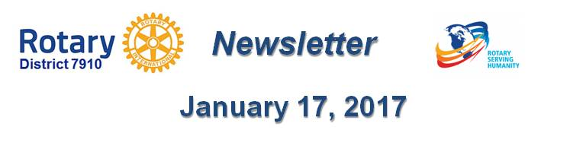

A Letter from the RI President
By John Germ
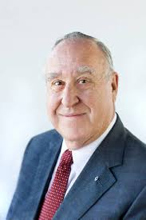For many, Rotary.org is an introduction to the great work that you and your fellow club members do to improve lives around the world. It’s meant to create an emotional connection that inspires potential members, donors, and partners to get involved. The latest changes to the public pages of the website (which are the pages accessed prior to signing in to My Rotary) do that and more. Visit Rotary.org to see all the improvements. The next phase of this project begins soon, which is when we will begin working on updating My Rotary. Work has already begun on Rotary Club Central. Next Rotary year, we will begin working on the club and district administration pages.
How are initiatives and projects like this possible? One way we will continue to provide you with the tools and resources you need to tell Rotary’s story is through the upcoming dues increase. The 2016 Council on Legislation voted to increase per capita dues by $4 per year beginning in July 2017. More information is available here.
One resource I hope you have been putting to good use is our membership-leads program. This project directs prospective members to you to help grow your clubs. Since 2015, the membership leads program has grown by 400 percent. Each week, Rotary hears from 800 to 1,000 people from all over the world who have expressed an interest in joining.
But in the last six months, only 34% of the membership leads were followed up on by districts and only 20 percent of those leads were assigned to clubs. In addition to a lost opportunity for qualified new members in Rotary clubs, leaving these inquiries unanswered could result in a negative public image for our organization. I encourage you all to check to see if your district has any outstanding leads. If you do, I urge you to follow up on them promptly.
As we enter 2017, my goal for all of you is that you look back on this Rotary year and have the satisfaction of knowing that there are people in the world whose lives have been made better because of work you were a part of. Thank you for all that you do—and continue to do—to help all of Rotary achieve that goal: Doing Good in the World, through Rotary Serving Humanity.
John Germ is the 2016-2017 president of Rotary International.
Return to January 17 Newsletter

Visit our website
'Like' our Facebook page
'Follow' us on Twitter
Watch our videos
View our photo albums

