
Articles posted during Rotary 2016-2017

January 2017:

January 17: Another series of Membership Workshops in March

January 9: The Rotary mid-year check

December 2016:

December 19 & 26: Improving effective membership efforts

December 5: Does your club’s strategy have an impact on membership?

November 2016:

November 28: How to improve membership in Rotary

November 21: RYLA is a great membership opportunity

November 14: Rotary clubs honor veterans

November 7: The Rotary 'why' factor

October 2016:

October 31: Membership Workshops Recap

October 17: Membership Workshops start on October 24

September 2016:

September 5: Corporate memberships in Rotary

September 19: What are our Rotary objectives? Membership! Membership! Membership!

September 26: Rotary club objectives

August 2016:

August 1: What would Paul Harris do?

August 8: Where will we find new members?

August 15: How do we approach prospective members?

August 22: Visioning

August 29: Unique approach to publicize Rotary by Northborough

July 2016:

July 4: RYLA is a great membership opportunity

July 11: Rotary - It's a New Year

July 25: Are we volunteers – or are we Rotarians? What’s the difference?

Please let Tom know any ideas, comments and/or stories for "Membership Corner" that you would like to share. E-mail Tom at tsturiale36@gmail.com.

Documents for October 2016 Membership Workshops, in PDF format:
- Participant Comments
- Introductory Notes for Moderators
- Sessions Discussion Points
- Rotary Membership-Development Ideas Sites
To learn about the October 2016 Membership Workshops, click here.

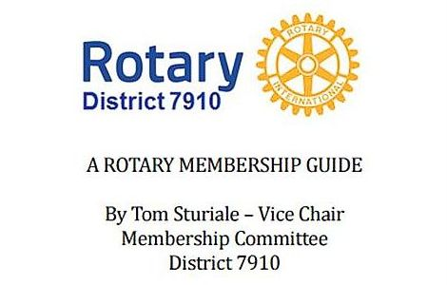"A Rotary Membership Guide" is a collection of "Membership Corner" articles written for this weekly newsletter during the 2015-2016 Rotary year, which began July 1, 2015. Each article is intended to offer an idea or thought aimed at stimulating discussions, questions and actions, to effectively increase membership at all our clubs.

Click here, to read and download this 52-page "Guide," in PDF format.

