GOVERNOR'S MESSAGE

When Change Is Good, Not So Good, and Productive
By Pat and Skip Doyle
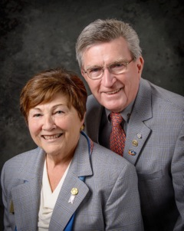
Words for the week: change is good(sometimes). Boy, that is sometimes a phrase difficult to swallow.

Why do we mention it in this week's newsletter? Because, as you may have noticed, this week's newsletter arrived Tuesday at mid-morning rather than Monday at daybreak. We are hoping that this slight change will up our readership, exposing more of our members to the important information that our newsletter team puts together each week.

Another change that is not so good is the one in ownership of theHoliday Inn in Boxborough. As you can see from the notice in red at the top of both this newsletter and the district website, ownership haschanged and District 7910 Rotary events will no longer be held at that location. We guess you could say we have all been spoiled for many years by the wonderful relationship we had with the management of that venerable location. In the time we have been Rotarians, we have attended at least seven District Conferences and two ESSEX conferences there. Our RYLA program was enhanced because we had a central location at no charge for all of our RYLA-facilitator training sessions. The hotel's decision to not honor existing contracts has adversely affected our district and we are very upset with this development. Please be diligent about checking meeting locations - we do not want people going miles out of their way.

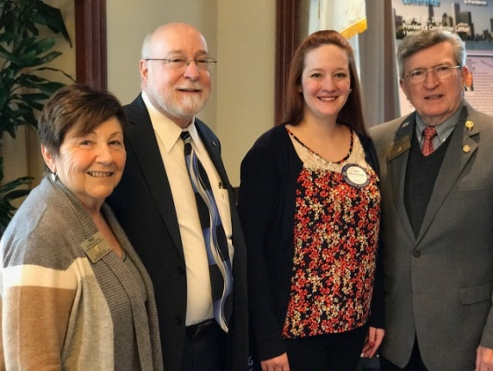
On January 10, we witnessed a change that was very productive. Because theRotary Club of Watertown's meeting location closes for January, they were forced to changelocations. They joined the Rotary Club of Needham for a joint meeting on January 10 at 12 noon, and we were able to present both clubs an overview of the 2017 Multi-District Conference - a.k.a. Quadcon. Joint meetings such as this are a great idea. Why not try one for a change?

Left to right: District Governor Pat Doyle, Needham President Ted Shaughnessy, Watertown President Lilia Weisfeldt, and District Skip Doyle

Six important things to know:

1. The weekly submission deadline for the Newsletter will remain the same: Friday. As usual, text content must be submitted in Word format, and image content, in either JPEG or PDF format. Continue to submit your content to Immediate Past District Governor/Newsletter Editor Jim Fusco at jim.fusco2@gmail.com.

2. Resolutions: The District Resolutions Committee met on January 10 and addressed three changes to the District 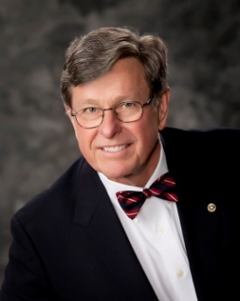Resolution that will be proposed and voted on at the annual District Business Meeting, to be held during the Multi-District Conference in Providence, on Saturday morning, April 29. Formore information on the District Resolutions, contact Resolutions Chair Doug Detweiller (shown, right) at rotary@detweiler.org.

3. District Nominations: The District Nominating Committee is seeking qualified applicants to serve as District 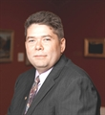Trustee for 2017 to 2019 and District Charitable Fund Trustee for 2017 to 2020. Clubs and club leadership are asked and encouraged to actively recruit and promote service in Rotary through their members' service as district leaders. The deadline for submitting applications is this February 18. All completed applications should be either e-mailed to Nominating Committee Chair Michael Ellis (shown, right) at mellis0144@comcast.net, or mailed to him at: Michael Ellis, District 7910 Nominating Committee, 88 Coburn Ave., Gardner, MA 01440. Postmarked mail after February 18 will not be accepted. To download the Trustee Nomination Form, click here. To download the Nomination Form Supplement, click here.
4. Rotary Youth Leadership Awards: The RYLA Club Pack has been updated and posted on RYLA7910.org. When you download it, you will notice changes from last year. Please read the material carefully and direct your questions to Christine Pinney, chair of the RYLA Committee,who may be reached at christine@christinepinney.com. The RYLA season has begun and the RYLA Committee is working to make RYLA 2017 the "best RYLA ever." (See RTLA article in right hand column)

5. Club Planning Worksheet: To download the Club Planning Worksheet, click here.This worksheet is made available to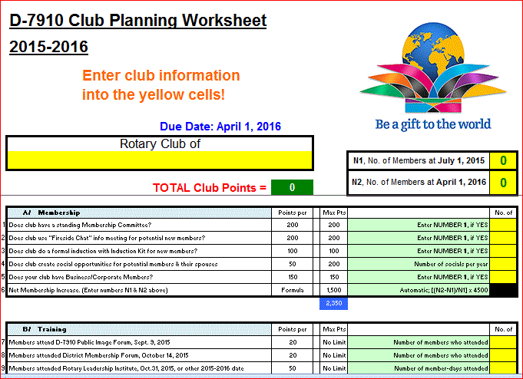 clubs so they can gauge their progress in achieving the goals they set last July. This month is a good time to review the worksheet and see how far you have come and how much farther you need to go as a club. You may surprise yourselves and realize that you are well on the way to earning district recognition. We recommend the club president appoint the president-elect to be the "champion" of the Worksheet, and to use it as a guide for the club, and to report monthly to the club's membership and board on the club's progress.

6. As your district governors, we have resolved to:
- Revisit as many clubs as possible in the next few months.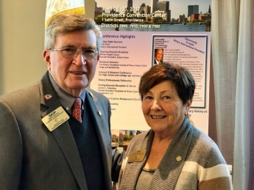
- Help our clubs achieve the goals they set in July
- Do all we can to build membership in the district
- Plan a grand event to celebrate our Million Dollar Foundation Journey
- "Move the ball forward," in harmony, with District Governor-ElectKarin Gaffney, District Governor-Nominee Steve Sager and District Governor-Nominee-Designate Pamela Anastasi
- Celebrate all of this at our Multi-District Conference this April in in Providence
If you want to share a link to the Governor's Message, click here.

District Governors Pat and Skip Doyle (shown, right) may be reached at pwdoyle2@verizon.net and skipdoyle2@verizon.net, respectively.

Click here to submit content for the Tuesday, January 24 issue. The submission deadline for this issue is Friday, January 20.

Click here for past issues.

WELCOME, NEW ROTARIANS
Alphabetical order, by last name

- Jay Antonetti, Groton Pepperell
- Kathi Crowley, Groton Pepperell
- Oceana Montalvo, Milford
Remember to ask ... ask ... ask!

REMEMBERING OUR ROTARIANS
Alphabetical order, by last name

Walter Bayliss and Dr. George Gianis, Lowell

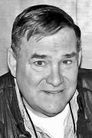
Walter "Wally" Bayliss (shown, left) passed away on November and George “Doc” Gianis (shown, below) passed away on December 23. Wally was a Rotarian for more than 40 years and Doc was a member for 56 years. Both men have left quite a legacy of “service above self” - and they will be missed dearly!

The members or the Rotary Club of Lowell stood honor guard at both funerals and proudly represented Rotary.

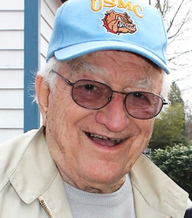

Raymond Reynolds, Wellesley

As the Rotary Club of Wellesley notes in its weekly newsletter, Raymond "Ray" Reynolds" (shown, left) was a loyal Rotarian for 50 years giving of himself at every turn to a Rotary cause. Rotary was always uppermost in his mind and he looked after it like it was part of his family. And it was! ... He was truly 'service above self'."

READ MORE

DISTRICT SCHOLARSHIP DEADLINE, MARCH 15
Applications Sought for David and Eleanor Morley Endowed Global Grant Scholarship
To learn more about the Morley Scholarship, click here.
To download the Morley Scholarship flyer in PDF format, click here.

CLUB MEMBERSHIP GROWTH, ’16-‘17
We share with you the results of club-membership growth in our district during Rotary year 2016-2017, which began July 1.

This is a unique opportunity for Rotarians and friends to discuss partnering on humanitarian projects affecting our local communities.

READ MORE

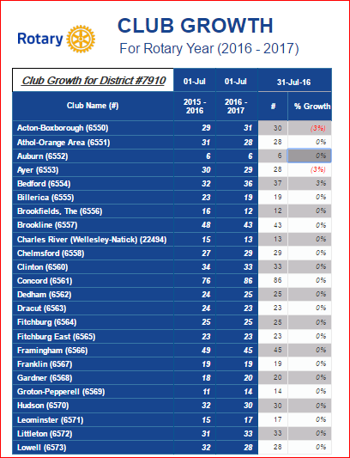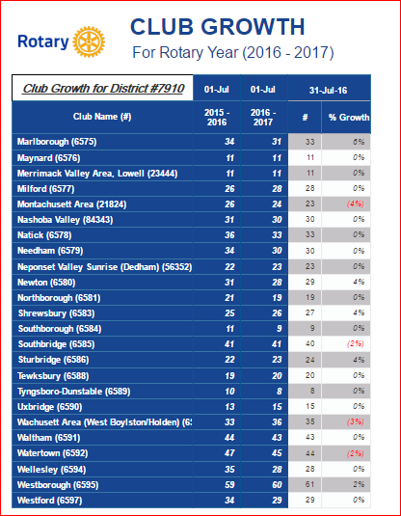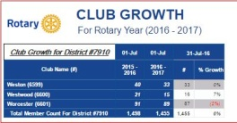

DISTRICT & CLUB ROUNDS

Joint Club Meetings: DGs Pat and Skip Doyle Revisit Needham and Watertown

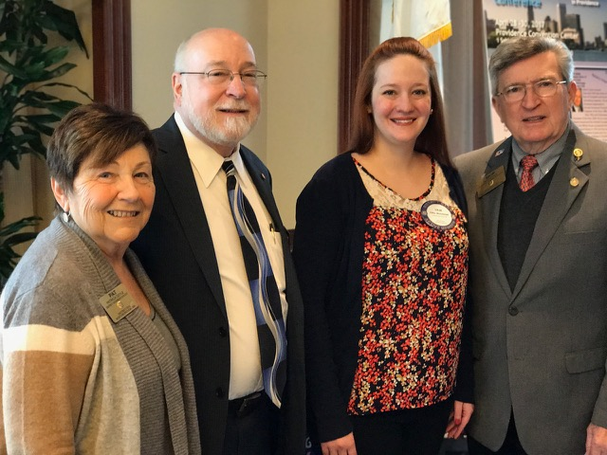
Because theRotary Club of Watertown's meeting location closes for January, they were forced to changelocations. They joined the Rotary Club of Needham for a joint meeting on January 10 and 12 noon, and we were able to present both clubs an overview of the 2017 Multi-District Conference - a.k.a. Quadcon. Joint meetings such as this are a great idea. Why not try one for a change?

Left to right: District Governor Pat Doyle, Needham President Ted Shaughnessy, Watertown President Lilia Weisfeldt, and District Skip Doyle

Auburn Teams Up with FAME for Music & Wine Event to Benefit Education on March 17

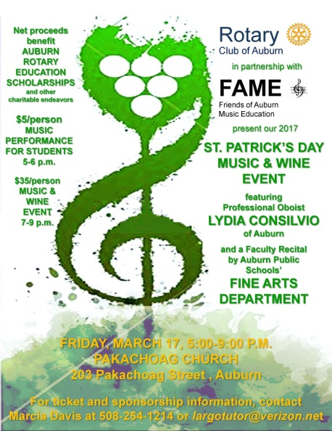Join the Rotary Club of Auburnand Friends of Auburn Music Education for their 2017 St. Patrick’s Day Music & Wine Event on Friday, March 17 from5:00 to 9:00 p.m. at Pakachoag Church, 203 Pakachoag St. The event will feature professional oboist Lydia Consilvio of Auburn, and a faculty recital by the Auburn Public Schools' Fine Arts Department. Tickets are $5 per person for the Music Performance for Students, to be held from 5 to 6 p.m, and $35 per person for the Music & Wine Event to follow, from 7 to 9 p.m. Net proceeds will benefit Auburn Rotary's education scholarships - and other charitable endeavors. To register, click here. For ticket and sponsorship information, contact Auburn Immediate Past PresidentMarcia Davis at 508-254-1214 or largotutor@verizon.net.

DOWNLOAD EVENT FLYER

To learn more about Auburn Rotary, click here.

To learn more about FAME, click here.

Chelmsford Honors Six High School Students of Month

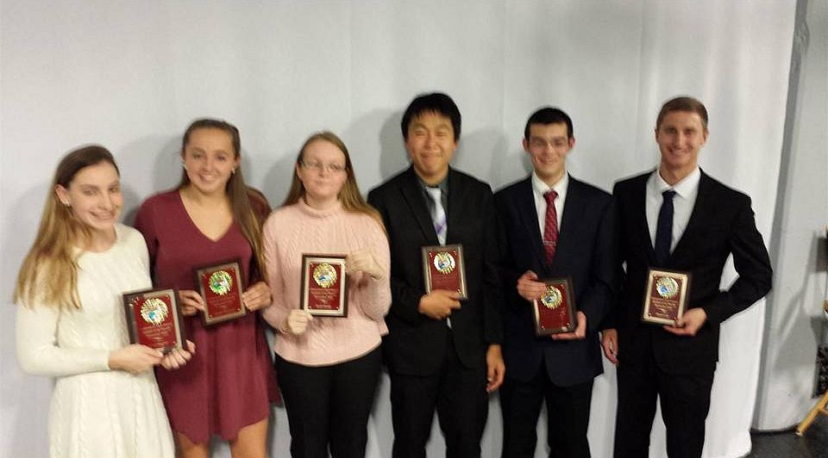Chelmsford High School has selected six HouseStudents of the Monthfor December. All Students of the Month are honored at a luncheon by the Rotary Club of Chelmsford recognized at Activities Night.

Left to right: Riley Higgins, of Emerson House; Sophia Haywood, of Hawthorne House; Sarah Benda and Jason Shin, of Whittier House;Eric Miu, of Emerson House; and David Cote, of Hawthorne House
READ MORE
To learn more about Chelmsford Rotary, click here.

Dedham Publishes Cookbook: Get your copy now

Hot off the press is the firstRotary Club of Dedham Cookbook! It features 420 recipes from Rotarians and their families across the U.S. and some from far away as Russia. Special dishes featured come from the kitchens of all Americans - great ethnic foods, desserts and beverages.
The Cookbook cover features a full-page color photo of the MIT Endicott House in Dedham, where the club meets on Thursdays. This fundraising Cookbook is available for $25, plus shipping. You may purchase it at DedhamRotary.org, or by contacting Past President Sandra Nelson at skintelligence1@gmail.com. Happy New Year - and bon appetit!

Maynard Presented RI Membership Retention Award

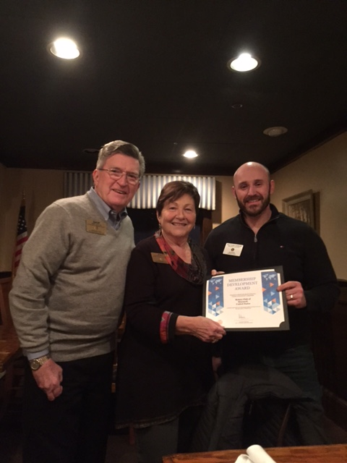
Left to right: District Governors Pat and Skip Doyle, posing with President Matt Farrow

Southborough Looks for Talent

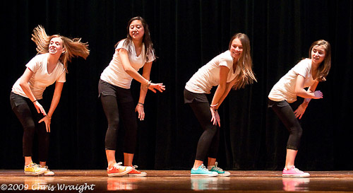
The Rotary Club of Southborough is looking for talented performers from fifth grade to adults to participate in the 17th Annual Talent Show, to be held Friday, March 10. Auditions will take place Monday,January 23 starting at 6:30 p.m. in the auditorium of the Trottier Middle School, located 49 Parkerville Rd. in Southborugh.

For more information or to schedule an audition, contact eitherRachel Bartolomei at rbartolomei@nsboro.k12.ma.us or Jessica Dimitrov jdimitrov@nsboro.k12.ma.us.

To learn more about Southborough Rotary, click here.

Uxbridge Present Student Scholarships

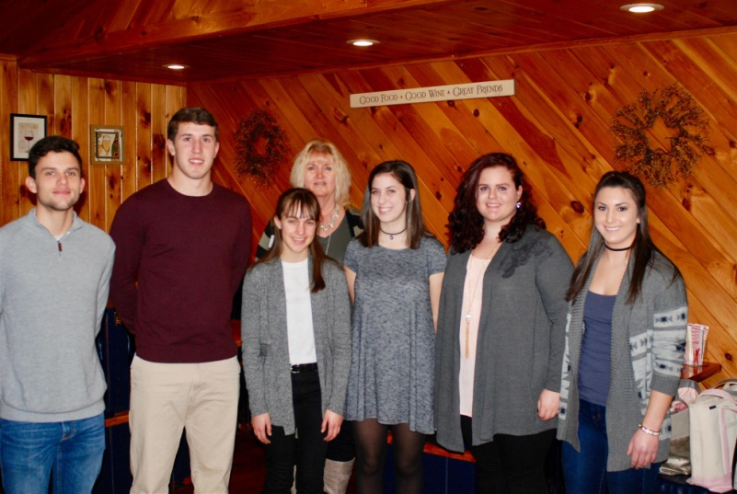

At the weekly meeting of the Rotary Club of Uxbridge on January 3, members, parents and students gathered as scholarships were presented to seven high school students.

Left to right: Zachary Ells and Michael Tourony, of Douglas High School; Angela Eppelet, of Whitinsville Christian School; Uxbridge Rotary President Linn Doll Butler; Keryn Moriarty, of Uxbridge High School; and Samantha Tackett-Marvill and Jillian Shenian, of Northbridge High School. Not shown: Taylor Walsh, of Blackstone Valley Regional Vocational Technical School.

To learn more about Uxbridge Rotary, click here.

Westborough Inducts Neil Bock as Newest Member

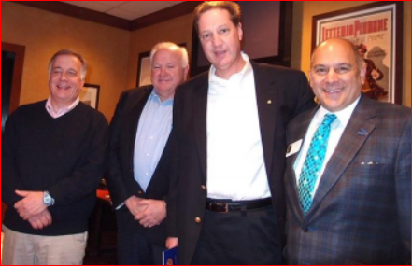

Left to right: President Gerry Gross, Member Peter Gardner, Neil Bock, and District Governor-Nominee Steve Sager

To learn more about Westborough Rotary, click here.

Wellesley Video Promotes Peer Leadership and Depression Prevention

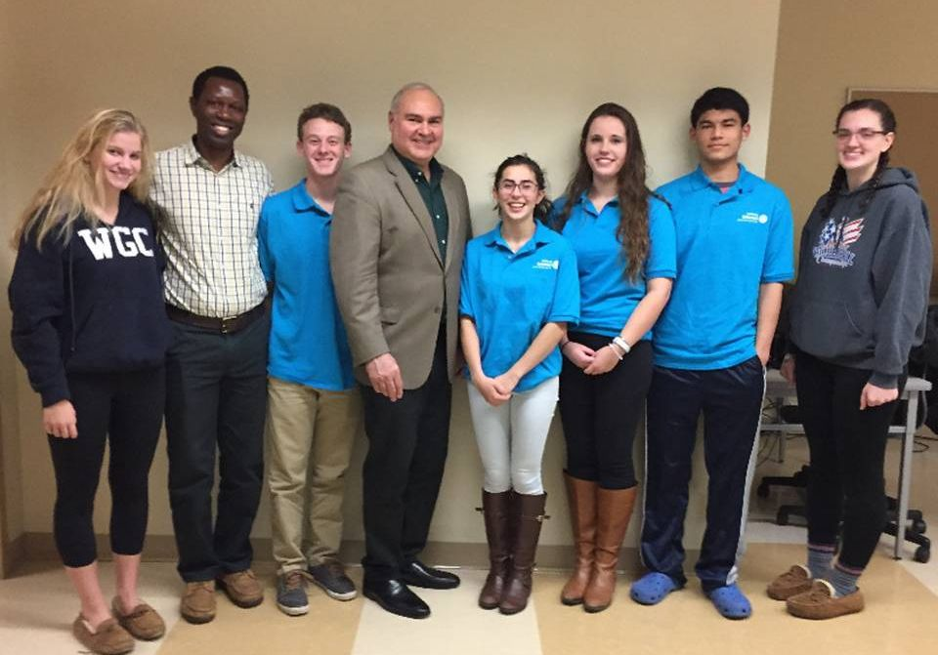

Six members of the Interact Club of Wellesley are shown posing recently with Ramnath Subba Siddi (second from left) and Wellesley Rotarian Bob Anthony (fourth from left), chair of the District Interact Committee. Ramnath, from Yellapur, India, was visiting the U.S. Bob founded a non-profit called Adolescent Wellness Inc. that helped with some related projects for Ramnath.

READ MORE

To learn more about Wellesley Rotary, click here.

To learn more about Interact, click here.

Westborough Thanked By Big Brothers Big Sisters

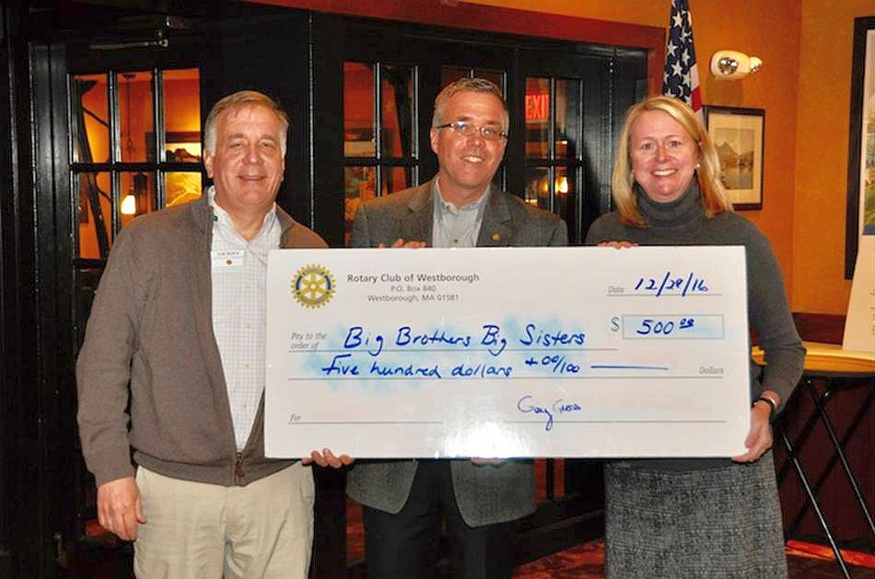

Harold Pinkham (shown, middle), a member of the Rotary Club of Westborough who works at Big Brothers Big Sisters of Central Mass./Metrowest, recently thanked the club for its support of the BBBS’ Winter Celebration event, which took place in December at Westborough High School. The club gave $500 to BBBS in support of this longstanding event that brings “Bigs” and “Littles” together for a day of fun, learning, gifting and celebration. Westborough RotariansDave Kaiser and Steve Sager, who is also district governor-elect, were acknowledged for their participation in the event.

Left to right: Westborough President Jerry Gross and Giving ChairBetsy Moquin present Harold Pinkham with the club’s donation.

To learn more about Westborough Rotary, click here.

District Interact Committee Seeks Entries for January Interact Video Contest

Deadline is January 31

RULES FOR DISTRICT INTERACT VIDEO CONTEST: JANUARY 2017
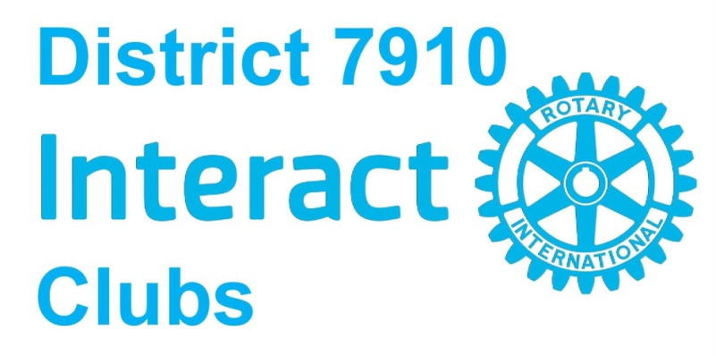

WATCH NORTHBOROUGH-SOUTHBOROUGH'S AWARD-WINNING VIDEO FOR DECEMBER

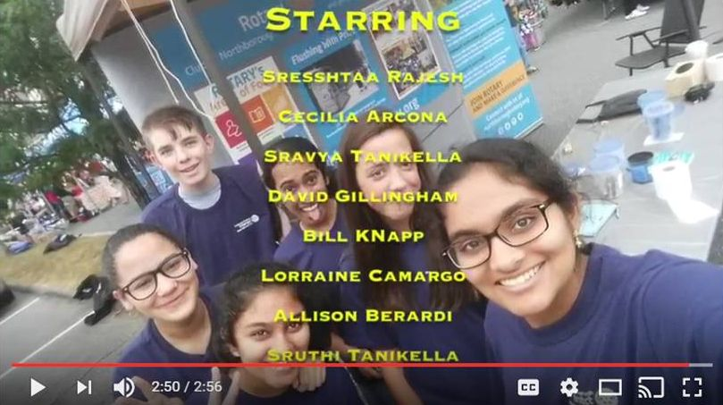

Northborough-Southborough Interact is sponsored by the Rotary Club of Northborough. To learn more about Northborough Rotary, click here. To learn more about Interact, click here.

WATCH BAY PATH HIGH'S AWARD-WINNING VIDEO FOR NOVEMBER

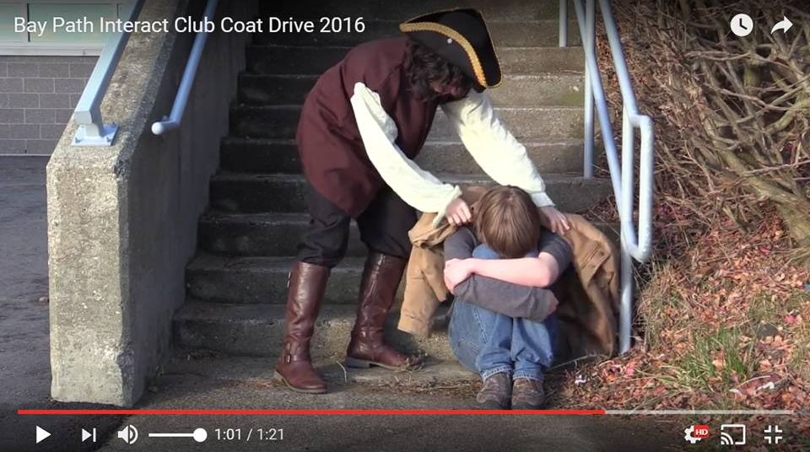

Bay Path Interact is sponsored by the Rotary Clubs of Auburn and Southbridge. To learn more about Auburn Rotary, click here. To learn more about Southbridge Rotary, click here. To learn more about Interact, click here.

Westborough Uses PayPal to Raise Nearly $2,000 for Polio Plus

READ MORE

To research charities that have a registered 501(c)3 account with PayPal, click here.

To learn more about Westborough Rotary, click here.

Nashoba Valley To Host Third Annual 'Power of Change' Event on January 23
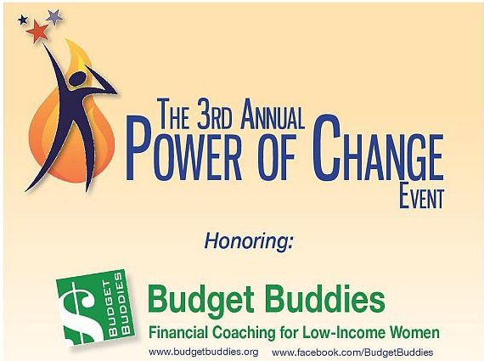

READ MORE, AND REGISTER NOW

To learn more about Nashoba Valley Rotary, click here.

Nashoba Valley Tools Up for Bolton Repair Cafe on January 21

READ MORE

To learn more about Nashoba Valley Rotary, click here.

Tewksbury Rotary, Lions Teaming Up for Sock Hop on January 20

READ MORE

To learn more about Tewksbury Rotary, click here.

District Highlights Fundraising Goals in Video

We are all well aware that The Rotary Foundationis celebrating its 100th anniversary in 2017.Steve Kirk, president of the Rotary Club of Concord, has produced a five-minute video that outlines our own district’s fundraising goals for the current Rotary year, which ends next June 30.

WATCH VIDEO

To learn more about The Rotary Foundation, click here.

Video of Governor Baker's Address to District Rotarians Now Available

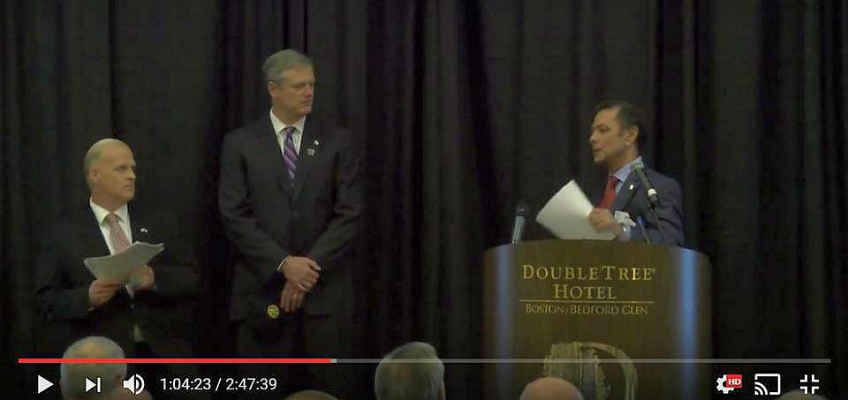

The Rotary Club of Billerica has provided a video of Governor Charlie Baker's address to District 7910 Rotarians on September 27 at the DoubleTree Hotel in Bedford. To watch the two-hour-47-minute video, click here.

The Rotary Clubs of Bedford, Billerica, Lowell, Newton and Shrewsbury sponsored the event, which was a unique opportunity for Rotarians and friends to discuss partnering on humanitarian projects affecting our local communities. To view event photos, click here.

Meet Tatsuya Hayase, Our Rotary Scholar

To Have Tatsuya Speak to Your Club, Contact Indira Desai

READ MORE

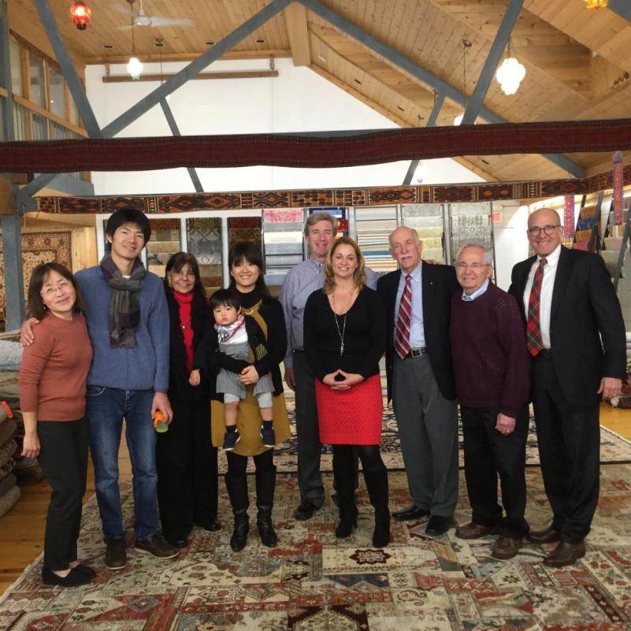

Left to right: Newton Rotarian Chris Chu; Rotary Scholar Tatsuya Hayase, his wife, Marie Hayase, and their son, Yuto Hayase; Host Counselor Indira Desai, immediate past president of Newton Rotary; Newton Rotary President Paul Sullivan and his wife, Monica Sullivan; District Scholarship Chair Tory DeFazio, a Wellesley Rotarian; and Newton Rotarians Tony Bibbo and Tom Keery.

A Great Fundraising Idea for All Clubs

Milford Distributes '16 Tab to 13,000 Homes - Record sales, 94 photos, 334 smiling faces

To read the Milford RotaryTab, click here.

To learn more about Milford Rotary, click here.

On to Atlanta in 2017: Register now!

Planning to attend? Contact District Chair Steve Glines.

To learn more, click here.

To register for the 2017 RI Convention in Atlanta, click here.

Pat and Skip Doyle Installed as '16-'17 DGs

To watch a video of the installation, click here.

District Banners Available

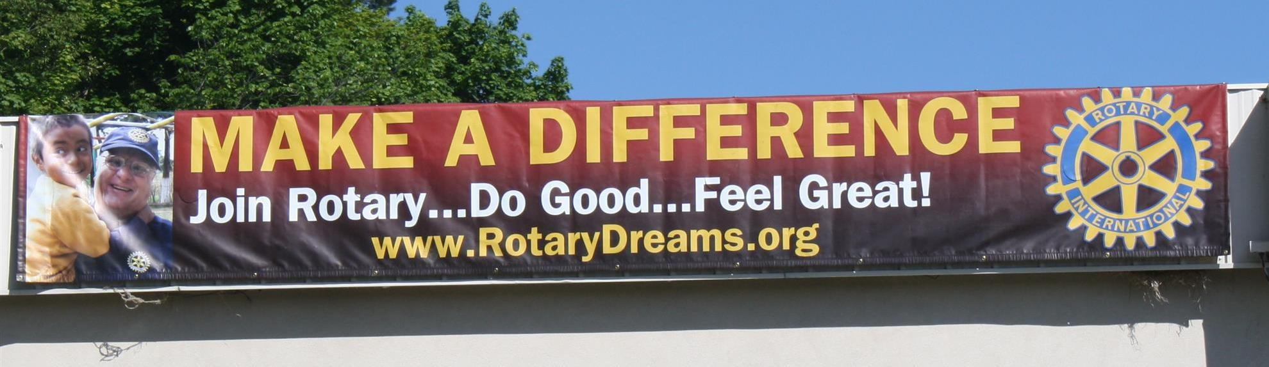

Our district banners are available for your use when you have an upcoming event or fundraiser.

If you want to reserve one of the banners, please contact PR Chair Laura Spear at laura@spear.net.

MAJOR DISTRICT & CLUB HAPPENINGS: WINTER 2017

Friday, January 20: - Tewksbury - 'Sock Hop'

To learn more, click here

Monday, January 23: Nashoba Valley - 'Third Annual Power of Change Event'

To learn more, and to register for this free event, click here

To download flyer in PDF format, click here
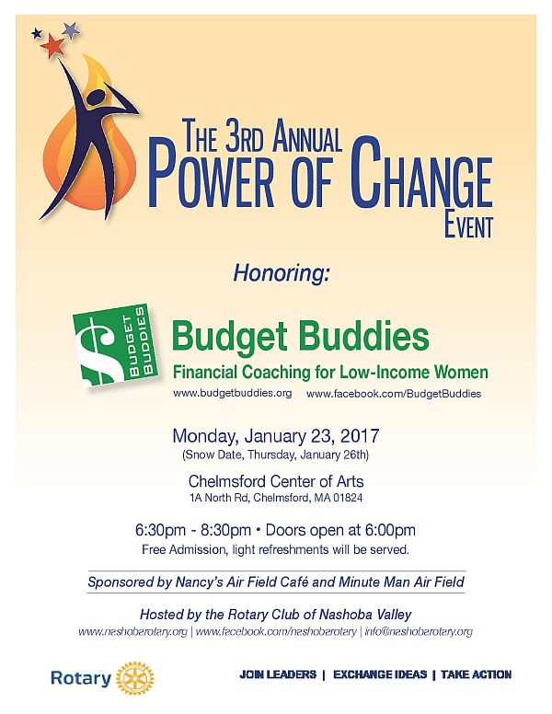

Saturday, January 28: Brookfields - 'Murder Mystery Dinner'

For more information, contact Lynn Duffey-O'Shea at 413-262-8783 or President Chet Lubelczyk at 508-867-3203.

Click here to download event flyer

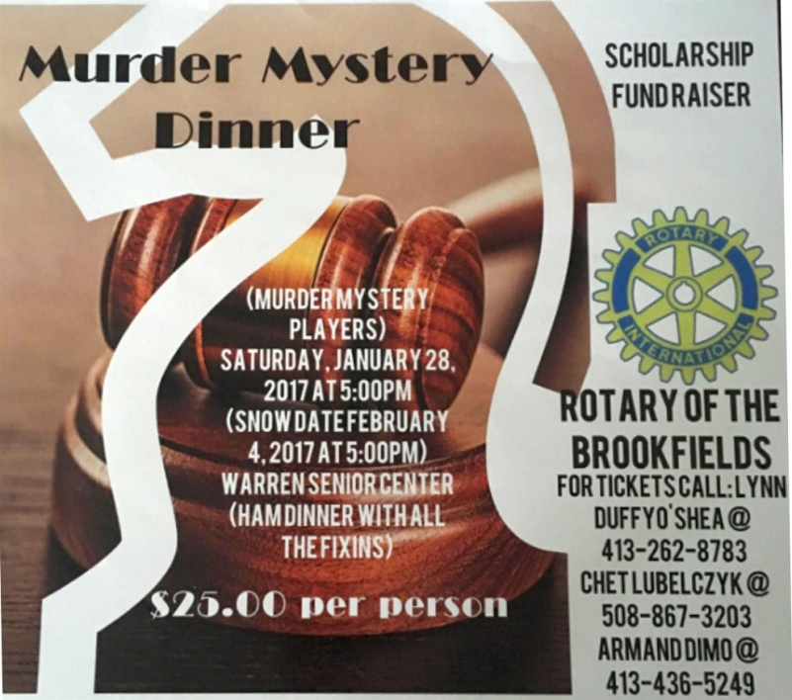

Saturday, March 11: Uxbridge - 'Wine and Chocolate Tasting'

See our Facebook Page <click here>

Click here to download event flyer

Wednesday, March 15: District 7910 - 'Deadline for Morley Scholarship Applications'

To learn more, click here

To download flyer in PDF format, click here

Friday, March 17: Auburn - '2017 St. Patrick's Day Music & Wine Event to Benefit Education'

To download event flyer in PDF format, click here
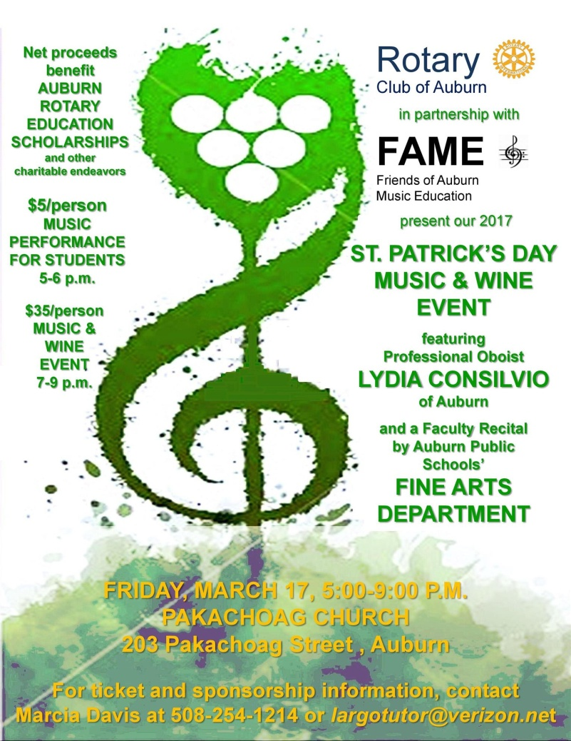

SUBMIT MAJOR CLUB HAPPENINGS

Send flyers of your club's major events and activities, in eitherJPEG or PDF format, to Immediate Past District
Governor/Newsletter Editor Jim Fusco at jim.fusco2@gmail.com.

