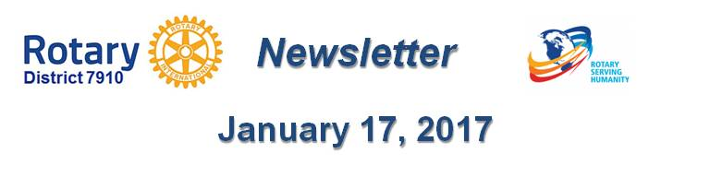

Pictures: Show something awesome!
By Laura Spear

Don’t use a cookie-cutter picture of people shaking hands, standing in a row, or presenting a large check. That is so old-school. If you want to attract the attention of sponsors, donors, attendees, and potential younger members, show your club in action.

Per Rotary International, “Whenever possible, try to use shots depicting multiple Rotarians of
diverse ethnicities and age ranges. Refrain from focusing on an individual, unless he or she is profiled or featured in a story. ... When beneficiaries are depicted, they should appear actively engaged with Rotarians … .”

To learn more in Rotary Voice and Visual Identity Guidelines, click here.

To learn more about PR for your club, click on the Public Relations section of the navigation bar of the District 7910 website.

Laura Spear, chair of District 7910's Public Relations Committee, may be reached at laura@spear.net.

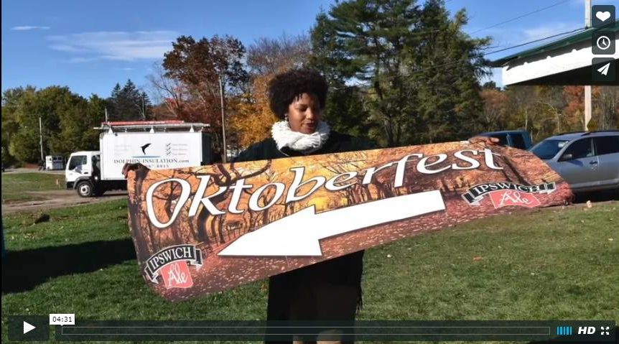Click here for an excellent example of a club-event promotional video by Concord President Steve Kirk.

Return to January 17 Newsletter

Visit our website
'Like' our Facebook page
'Follow' us on Twitter
Watch our videos
View our photo albums

