

Wellesley Video Promotes Peer Leadership and Depression Prevention

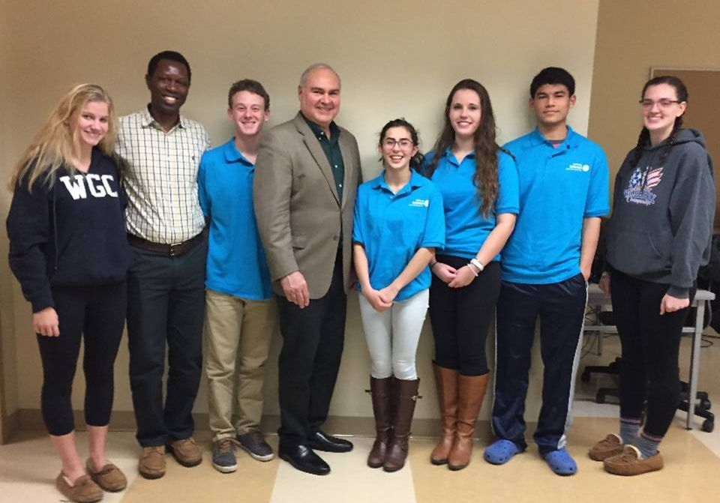Six members of the Interact Club of Wellesley are shown posing recently with Ramnath Subba Siddi (second from left, and in video screenshot) and Wellesley Rotarian Bob Anthony (fourth from left), chair of the District Interact Committee. Ramnath, from Yellapur, India, was visiting the U.S. Bob founded a non-profit called Adolescent Wellness Inc. that helped with some related projects for Ramnath.

Ramnath, who has since returned to Yellapur, is a social worker 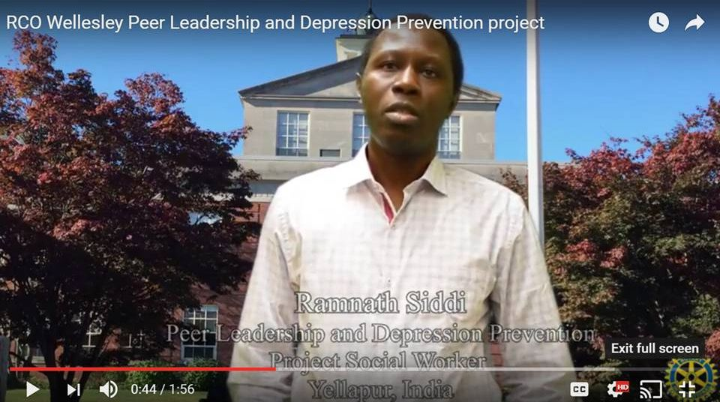for the PLDP Project operating there. While he is not a Rotarian, Bob is encouraging him to find a local club in Karnataka state and join it.

Bob is traveling to Goa, India from January 24 through February 10 and have been invited to briefly present at the Rotary District 3170 conference there. One of that district's clubs, Hubli East, partnered with the Rotary Club of Wellesley through a Global Grant to implement the Peer Leadership and Depression Prevention project there. To watch a two-minute video about the project, click here.

To learn more about Wellesley Rotary, click here.

To learn more about Interact, click here.

Bob Anthony, chair of the District Interact Committee, may be reached at bobanthony@adolescentwellness.org.

Return to January 17 Newsletter

Visit our website
'Like' our Facebook page
'Follow' us on Twitter
Watch our videos
View our photo albums

Wellesley Video Promotes Peer Leadership and Depression Prevention

Six members of the Interact Club of Wellesley are shown posing recently with Ramnath Subba Siddi (second from left, and in video screenshot) and Wellesley Rotarian Bob Anthony (fourth from left), chair of the District Interact Committee. Ramnath, from Yellapur, India, was visiting the U.S. Bob founded a non-profit called Adolescent Wellness, Inc. that helped with some related projects for Ramnath.

The Rotary Club of Wellesley has produced a two-minute video on Wellesley Interact’s Peer Leadership and Depression Prevention project. Ramnath, who has since returned to Yellapur, is a social worker for the PLDP Project operating there. While he is not a Rotarian, Bob is encouraging him to find a local club in Karnataka state and join it.
Bob is traveling to Goa, India from January 24 through February 10 and have been invited to briefly present at the Rotary District 3170 conference there. One of that district's clubs, Hubli East, partnered with Wellesley Rotary through a Global Grant to implement the Peer Leadership and Depression Prevention project there. To watch a two-minute video about the project, click here
[[https://youtu.be/pnecz-2wbdg]]

To learn more about Wellesley Rotary, click here. [[http://www.wellesleyrotary.org/]]

