HOT OFF THE PRESS! 2016-2017 ROTARY DISTRICT 7910 DIRECTORY
Our information-packed, 332-page Directory for this Rotary year is now availa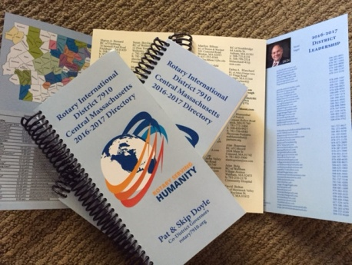ble for automatic download, in PDF format.

The Directory includes: District 7910 and Rotary International general information; a complete District 7910 clubs listing; a complete District 7910 membership listing; District 7910 Resolutions; and Yellow Pages of Rotarian-run businesses;.

Please note: Member login is required.

Click here, to download

