Happy New Year to All!
By Pat and Skip Doyle

It does not seem possible that our year as District Governors is half over. During the past six months, we visited all 51 clubs at least once - and many clubs, more than once. In the next six months, we hope to continue our Rotary Year journey by coming back to see you all again.
If you have a special event planned that you would like us to attend, please let us know as soon as possible so we can put the date on our calendar. We would hate to miss the fun. Moreover, we really want to come to your clubs - not as just as special guests, but also as friends who can sit with you, listen to your concerns and offer the district's help in any possible way.

Don't be strangers. We want to hear from you about what is going on in your clubs.
Here are a couple of important notes:

- Rotary Youth Leadership Awards: The RYLA Club Pack has been updated and posted on RYLA7910.org. When you download it, you will notice changes from last year. Please read the material carefully and direct your questions to Christine Pinney, chair of the RYLA Committee, who may be reached at christine@christinepinney.com. The RYLA season has begun and the RYLA Committee is working to make RYLA 2017 the "best RYLA ever."

- Club Planning Works: To download the Club Planning Worksheet, click here.This worksheet is made available to clubs so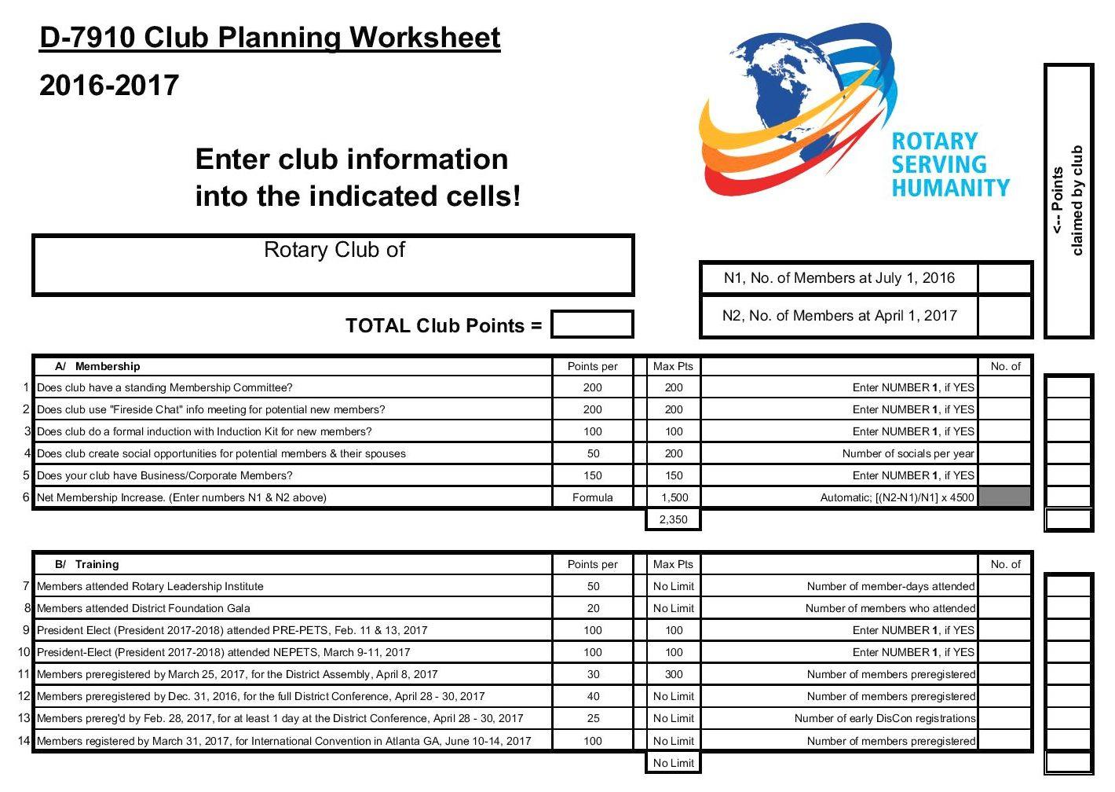 they can gauge their progress in achieving the goals they set last July. This month is a good time to review the worksheet and see how far you have come and how much farther you need to go as a club. You may surprise yourselves and realize that you are well on the way to earning district recognition. We recommend the club president appoint the president-elect to be the "champion" of the Worksheet, and to use it as a guide for the club, and to report monthly to the club's membership and board on the club's progress.
It is a wonderful time to look forward to the excitement, promise and adventures that lie ahead in the year to come. Your district governors wish you all the best in 2017!

Always remember, you can call us with questions at 508-393-9031.

District Governors Pat and Skip Doyle may be reached at pwdoyle2@verizon.net and skipdoyle2@verizon.net,
respectively.

Click here to submit content for the January 9 issue. The submission deadline for this issue is Friday, January 6.

Click here for past issues.

Return to January 2 Newsletter

Visit our website
'Like' our Facebook page
'Follow' us on

