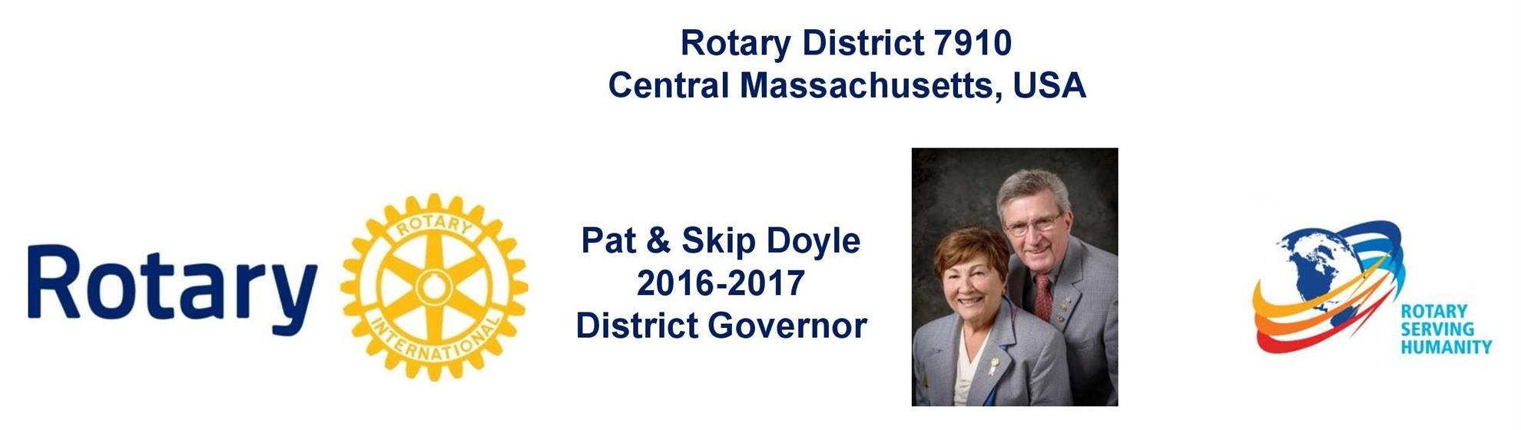

Governors' Welcome
Welcome to Rotary District 7910, which serves Central Massachusetts. We are comprised of 51 clubs whose members represent a cross-section of society. Community members of all ages come together in Service Above Self by undertaking local and international projects that help improve the lives of people.

Our commitment to service is grounded in the fellowship of people who collaborate to make our communities and the world a better place. This year’s Rotary International theme—Rotary Serving Humanity—challenges us to come together for one, overriding goal: service.

District Governors Pat and Skip Doyle may be reached at pwdoyle2@verizon.net and
skipdoyle2@verizon.net, respectively.

District Governors' home club: Northborough

register now: 2017 Multi-District Conference, April 28-30, Providence. To Register, click here.
To download the Conference Highlights flyer (shown, below) in:
- PDF format, click here
- JPEG format, click here
To download the Conference Sponsorship Donation form in PDF format, click here

To download the Rotary Waterfire Fundraiser brochure in PDF format, click here

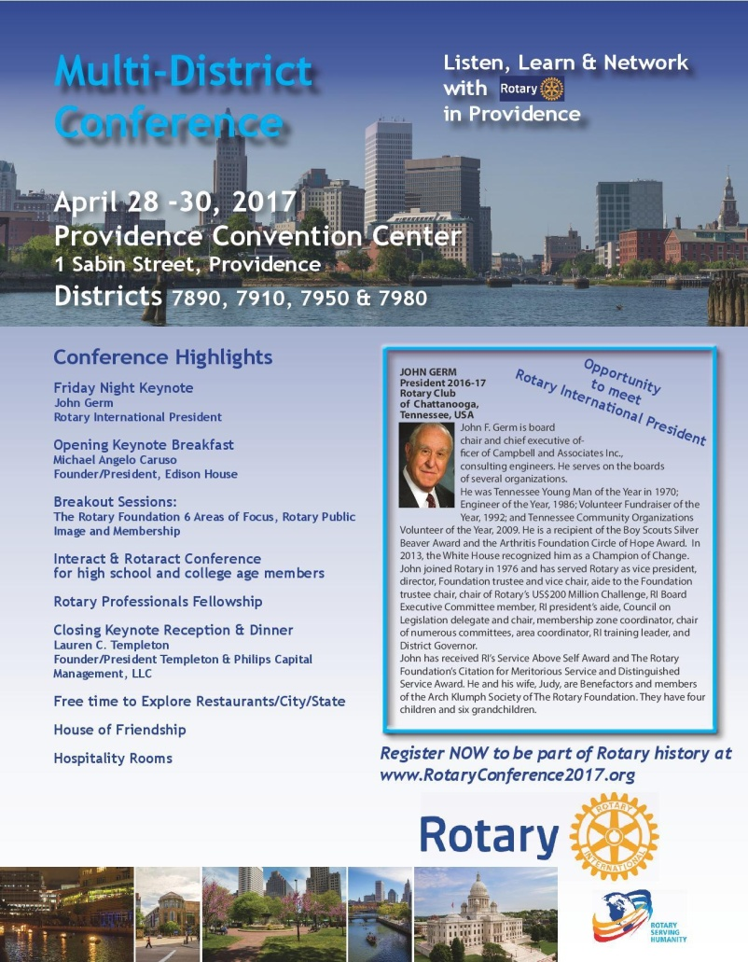

Hot Off the Press!
2016-2017 Rotary District 7910 Directory
Print copies of our 332-page, information-packed 2016-2017 Rotary District 7910 Directory will soon be delivered to your club.

The Directory includes:
- District 7910 and Rotary International general information
- District club information
- Yellow Pages of Rotarian-run businesses
- District Resolutions
- Complete membership directory

A digital version of the Directory is now available for automatic download, in PDF format. Please note: Member login is required.

Click here, to download

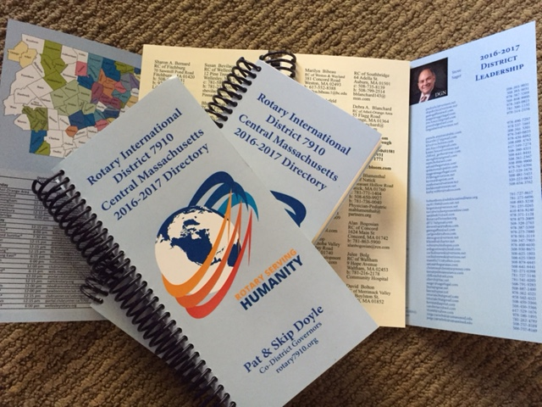

District at a glance

Click on each one

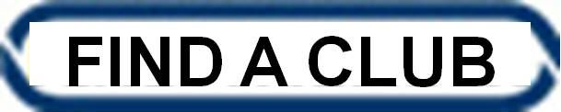

District SOCIAL MEDIA

Click on each one

View Live: Our Facebook Page!
Rotary District 7910

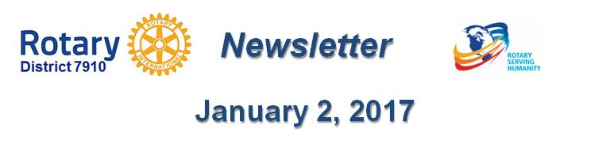

Click here for the complete issue

Or, click on each of these issue highlights:

Governor’s Message: Happy New Year To All! - By Pat and Skip Doyle

2017 Multi-District Conference: April 28-30 in Providence – Register Now!

District Scholarship Deadline, March 15: Applications Sought for David and Eleanor Morley Endowed Global Grant Scholarship

Northborough-Southborough Interact Wins District Video Contest for December: Focuses on the history behind the club''s formation

Rules for January’s District Interact Video Contest: Submission deadline is January 31

A Healthy Rotarian Is A More Effective Rotarian: Make a great New Year's resolution – By Ron Goodenow

What Is The Mission of Rotary Leader Institute? - By Doug Detweiler

Membership Corner: The Rotary 'why' factor - By Tom Sturiale

PR Tips: Rotary Blue is not just any blue - By Laura Spear

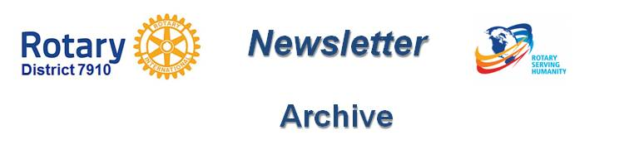

Click here for our archive of past issues

