DISTRICT INTERACT VIDEO CONTEST RULES: JANUARY 2017
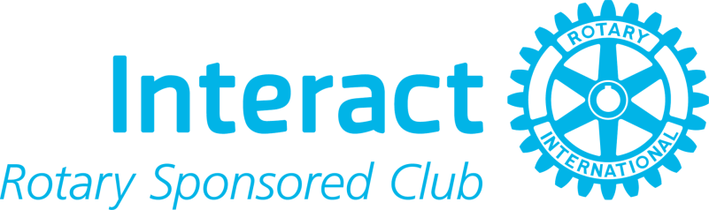The District Interact Committee is pleased to announce that all Interact clubs are again invited to submit a video for a January competition:

Deliverable: Create a short (about two minutes) video on one of the following topics:
- What has the local Rotary club accomplished in your community?
- What has your local Interact club accomplished within your community?
Goal: Create awareness about the local Rotary and Interact clubs.

Audience: Fell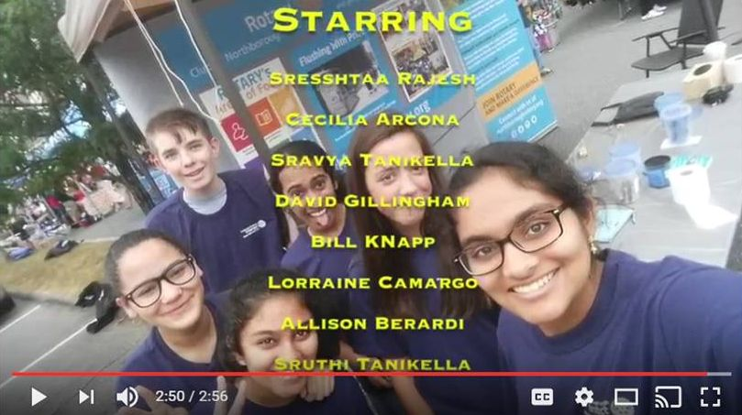ow members of your community
Award: $250 contribution to your Interact club and an invitation to show your video at the multi-district conference next April in Providence

Due Date: January 31, 2016

Award Date: February 2017

How to Submit: Publish your video on YouTube and e-mail the link to Interact Committee Member Bill Westerman at 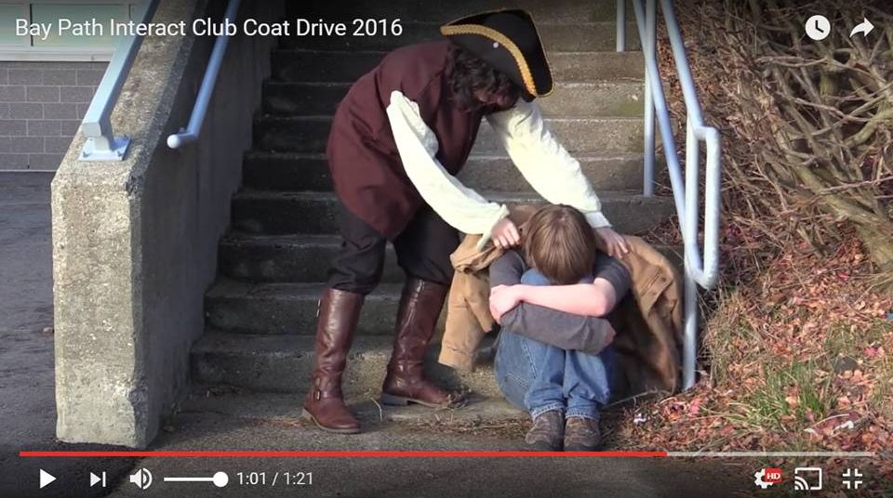whwesterman@yahoo.com and Chair Bob Anthony at rwa1645@gmail.com, along with suggestions and questions.

Video Tips and Tricks:
- Interview Rotary and Interact club members
- Interview people in the community
- Create a script that tells a story
  - Set the stage with a theme
  - Provide details that support the theme
  - Recap the key points of the theme at the end
Past Winners:
- Northborough-Southborugh Interact, December 2016
- Bay Path High Interact, November 2016
To learn more about Interact, click here

Return to January 2 Newsletter

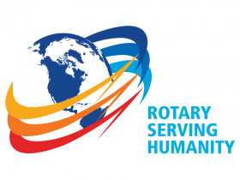Visit our website
'Like' our Facebook page
'Follow us on Twitter

