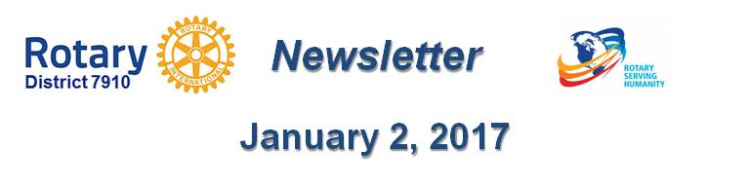

The rotary 'why' factor

By Tom Sturiale

(This article ran originally in the November 7, 2016 issue)

During the four District Membership Workshops in October, it seemed clear that the question most folks struggle with is, “Why do people want to join Rotary?” Isn’t this the heart of the matter? If we cannot answer this question clearly, succinctly and quickly, we would have a major problem.

Most Rotarians understand the need to add members in order to assure continued success and sustainability, to bring in younger members, to share the load, to do good in the world, to raise more funds and to bring in new ideas and technology. Sure, we can address the mechanics of the process, whom to talk to and what to say, despite the difficulties associated with those steps. But the Why Factor remains the big nut to crack. How can we address this issue?

Is this related to WIIFM – what’s in it for me? Maybe. It seems the more self-centered new generations are very interested in that. If so, we would need to answer the question for prospective members. It may be more important to answer the question for our current members. Why are we Rotarians? If we can clearly articulate what it means to us, it would be easier and more meaningful to a prospective member. It might be a useful exercise for every club president to ask each member to write an answer to the question.

I was attracted to Rotary because of an experience in high school when several of us were invited to a Rotary meeting. We were introduced to all the movers and shakers in the town and were duly impressed. Decades later in my early days of retirement, I wanted to be a part of something important, to do meaningful things for the community, to meet some folks outside of my former business world, to get involved and, yes, to give back.

The early memories of the Rotary event caused me to approach the local club. I really knew nothing about what Rotary did locally or internationally. I was fortunate in that someone got me engaged quickly, which piqued my interest and continued involvement, leading to committees, chairs, board participation and president.

I’ve learned much more about Rotary during the past several years, become further involved at the district level and even attended a Rotary International Convention in Montreal, which was a fantastic experience. I enjoy the company and friendship of our club members and many throughout the district, I enjoy creating new opportunities for our club and I enjoy the real sense of purpose in my retirement years. I could add several other enjoyment factors, but you get the point. What do you enjoy and why? Can you show that enthusiasm to a prospective member? If not, don’t approach them – get someone else to do it.

Another approach is to examine the goals and objectives of your club. What is your vision? What is your club’s story? Why are you in existence? What are you trying to achieve? You need to align your objectives to the interests of your current members and use those objectives to attract others interested in similar objectives.

We might consider running our clubs similar to businesses. We have to figure out what it is we are trying to sell, how to package it, how to brand it and how to market it. We cannot continue to simply wave the Rotary flag, believe our own press releases and expect folks to march along with us. The new generations are more demanding.

Let’s get creative and work hard at the club level to clearly articulate what the objectives and visions are. Then, we can take that message out to the public and attract more like-minded folks to help us grow our clubs and Rotary. This is not easy work. Commit - and get busy.

Tom Sturiale, chair of District 7910's Visioning Committee and vice chair of its Membership Committee, may be reached at tsturiale36@gmail.com.

December 2016 'Membership Corner' articles:
- December 5: Does your club’s strategy have an impact on membership?
- December 19 & 26: Improving effective membership efforts
- To read previous articles for Rotary 2016-2017, click here
Documents for October 2016 Membership Workshops, in PDF format:
- Participant Comments
- Introductory Notes for Moderators
- Sessions Discussion Points
- Rotary Membership-Development Ideas Sites
To learn about the October 2016 Membership Workshops, click here.

For more information on Rotary memberships:
- Rotary Individual Membership Application - Word Format
- Rotary Corporate Membership Application - Word Format
- Rotary Corporate Membership Opportunity - Word Format
- Rotary Corporate Membership Information - Word Format

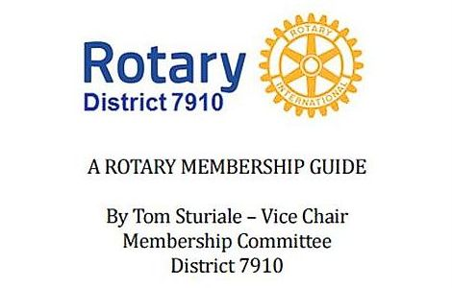"A Rotary Membership Guide" is a collection of "Membership Corner" articles written for this weekly newsletter during the 2015-2016 Rotary year, which began last July 1. It is intended to offer an idea or thought each week aimed at stimulating discussions, questions and actions to effectively increase membership at all our clubs. Click here, to download this 52-page "Guide," in Word format.

Return to January 2 Newsletter

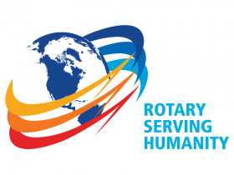Visit our website
'Like' our Facebook page
'Follow' us on Twitter

