GOVERNOR'S MESSAGE
Happy New Year To All!
By Pat and Skip Doyle
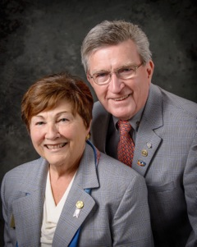It does not seem possible that our year as District Governors is half over. During the past six months, we visited all 51 clubs at least once - and many clubs, more than once. In the next six months, we hope to continue our Rotary Year journey by coming back to see you all again.
If you have a special event planned that you would like us to attend, please let us know as soon as possible so we can put the date on our calendar. We would hate to miss the fun. Moreover, we really want to come to your clubs - not as just as special guests, but also as friends who can sit with you, listen to your concerns and offer the district's help in any possible way.
Don't be strangers. We want to hear from you about what is going on in your clubs.
Here are a couple of important notes:
- Rotary Youth Leadership Awards: The RYLA Club Pack has been updated and posted on RYLA7910.org. When you download it, you will notice changes from last year. Please read the material carefully and direct your questions to Christine Pinney, chair of the RYLA Committee, who may be reached at christine@christinepinney.com. The RYLA season has begun and the RYLA Committee is working to make RYLA 2017 the "best RYLA ever."

- Club Planning Works: To download the Club Planning Worksheet, click here.This worksheet is made available to clubs so 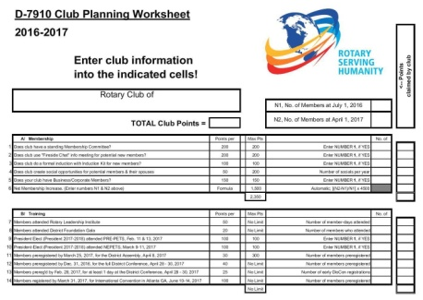they can gauge their progress in achieving the goals they set last July. This month is a good time to review the worksheet and see how far you have come and how much farther you need to go as a club. You may surprise yourselves and realize that you are well on the way to earning district recognition. We recommend the club president appoint the president-elect to be the "champion" of the Worksheet, and to use it as a guide for the club, and to report monthly to the club's membership and board on the club's progress.
It is a wonderful time to look forward to the excitement, promise and adventures that lie ahead in the year to come. Your district governors wish you all the best in 2017!

District Governors Pat and Skip Doyle may be reached at pwdoyle2@verizon.net and skipdoyle2@verizon.net, respectively.

Click here to submit content for the January 9 issue. The submission deadline for this issue is Friday, January 6.

Click here for past issues.

WELCOME, NEW ROTARIANS

Alphabetical order, by last name
- Judith Alfred, Franklin
- Laura Allen, Brookline
- Jacyln Biancuzzo, Westwood
- Neil Bock, Westborough
- Jason Burack, Westborough
- Jon Davis, Franklin
- Kevin Goffe, Franklin
- Gary Gregory, Westborough
- Hillary Kohler, Westwood
- Cindy Kozil, Franklin
- Kattie Lawson, Westborough
- Paula Rooney, Franklin
- Andrew Rubenstein, Franklin
Remember to ask ... ask ... ask!

REMEMBERING OUR ROTARIANS
Alphabetical order, by last name

Dr. George Gianis, Lowell

READ MORE

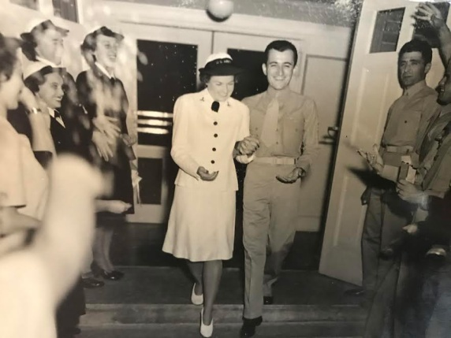

Mike Trotto, Shrewsbury

READ MORE

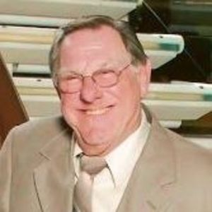

DISTRICT SCHOLARSHIP DEADLINE, MARCH 15
Applications Sought for David and Eleanor Morley Endowed Global Grant Scholarship
District 7910 is offering a special scholarship for graduate study and research abroad. It is the David and Eleanor Morley Endowed Global Grant Scholarship.
One-year funding of up to $35,000 is available through the Morley Scholarship for graduate study and/or graduate research internationally. Additional scholarship funding is not anticipated the following year. Areas of study identified by Rotary International are:
- Peace and conflict resolution
- Disease prevention and treatment
- Economic and community development
- Maternal and child health
- Water and sanitation
- Basic education and literacy
This is a great opportunity for the right person.
Study must begin in the Fall of 2017, and applications must be received by this March 15. There is a series of steps that must be taken before the scholarship is granted.
To learn more about the Morley Scholarship, click here.

To download the Morley Scholarship flyer in PDF format, click here.

2017 MULTI-DISTRICT CONFERENCE, APRIL 28-30, PROVIDENCE

TO REGISTER, CLICK HERE
To download the Conference Highlights flyer (shown, below) in:
- PDF format, click here
- JPEG Format, click here
To download the Conference Sponsorship Donation form in PDF format, click here
To download the Rotary Waterfire Fundraiser brochure in PDF format, click here
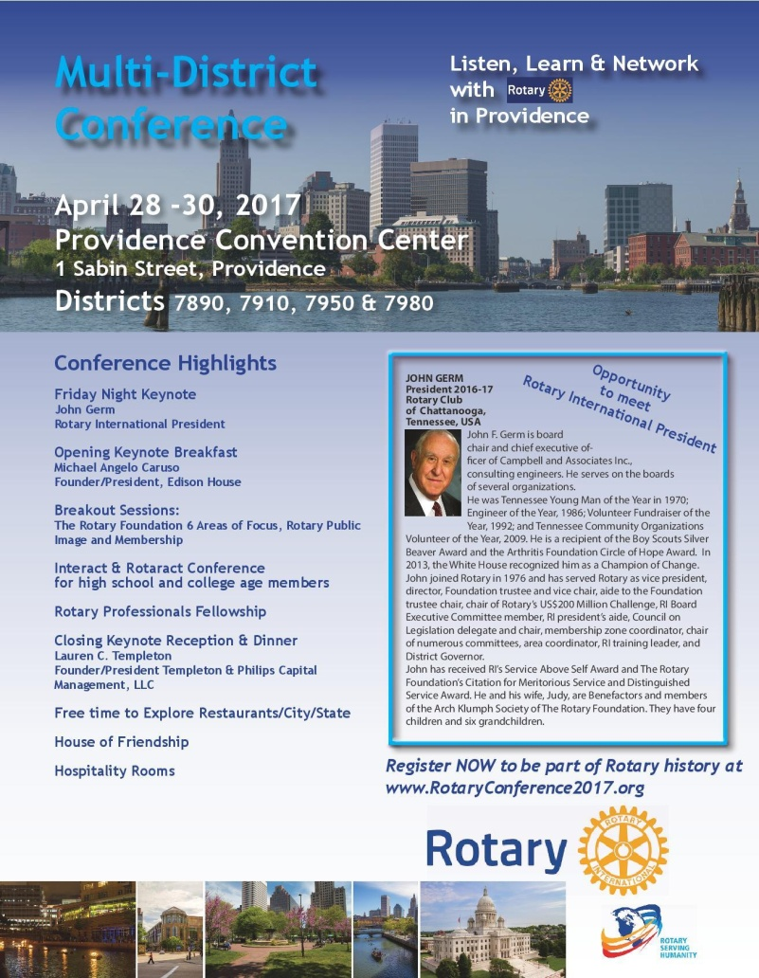

CLUB MEMBERSHIP GROWTH, ’16-‘17
We share with you the results of club-membership growth in our district during Rotary year 2016-2017, which began July 1.

This is a unique opportunity for Rotarians and friends to discuss partnering on humanitarian projects affecting our local communities.

READ MORE

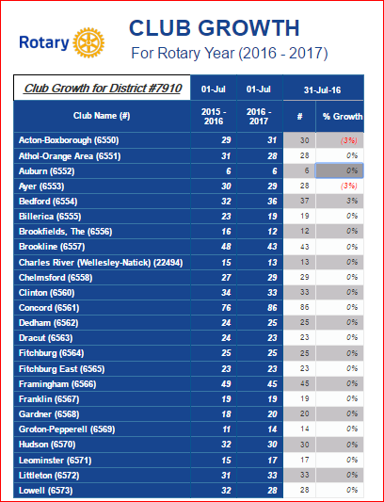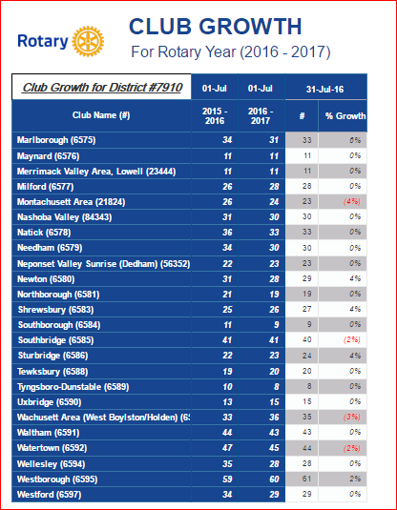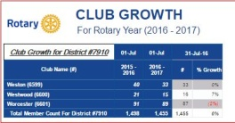

CLUB PLANNING WORKSHEET '16-'17
In both Excel and PDF formats, we share with you the Club Planning Worksheet for Rotary year 2016-2017, which began on July 1.
Please enter your club information in the indicated cells.

Excel Format

PDF Format

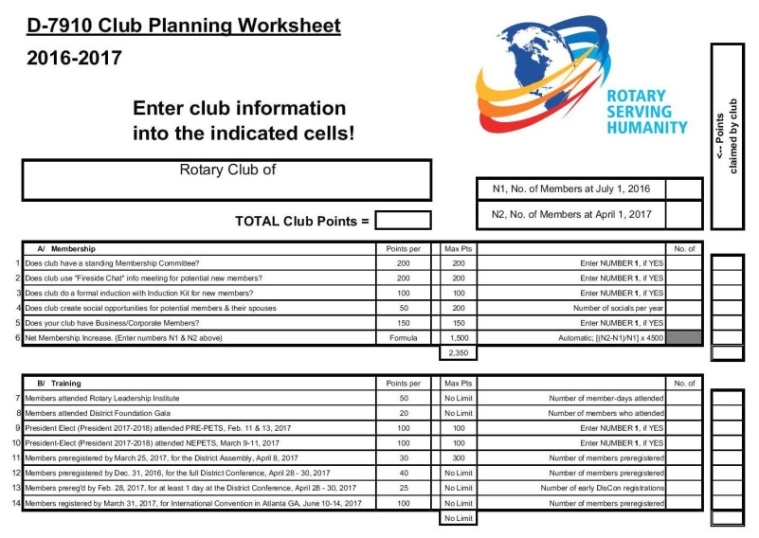

DISTRICT & CLUB ROUNDS
Rotary Rings the Bell For Salvation Army

Each holiday season, most of our district's Rotary clubs volunteer to Ring the Bell for the Salvation Army. The 2016 season was no different as Rotarians and friends braved the cold and snow to Ring the Bell - although some clubs got to ring in the warmth of indoor malls. Many clubs also have Rotarians who are also members of the Salvation Army. Here are two photos we want to share with you. If your club Rang the Bell, please send your photos to Newsletter Editor Jim Fusco at jim.fusco2@gmail.com, and we will include them in future issues. Thank you for your efforts!

Rotary Club of Fitchburg

Left to right: Fitchburg State Representative Stephan Hay and Fitchburg Rotarian Karen Fusco

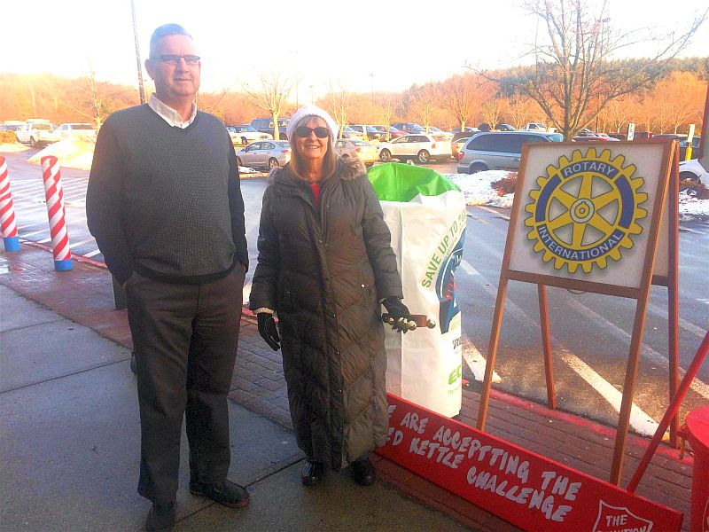

Rotary Club of Montachusett Area

Left to right: Past President Leslie Storrs, Members Lynn Saaro and Jeanie Storrs, and Rotary friend Keith LaFerriere

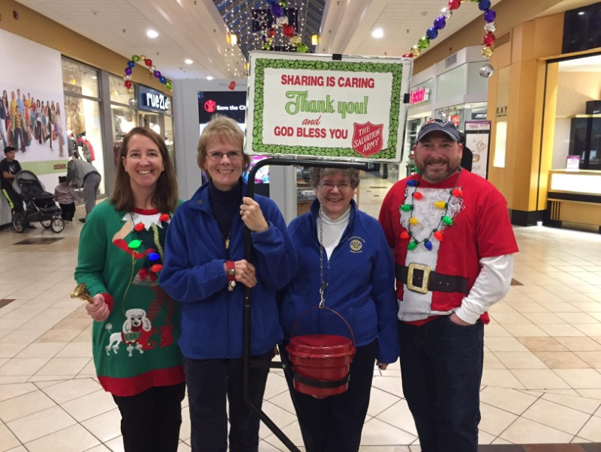

District Interact Committee Picks December Video Contest Winner, Presents Check to November Winner

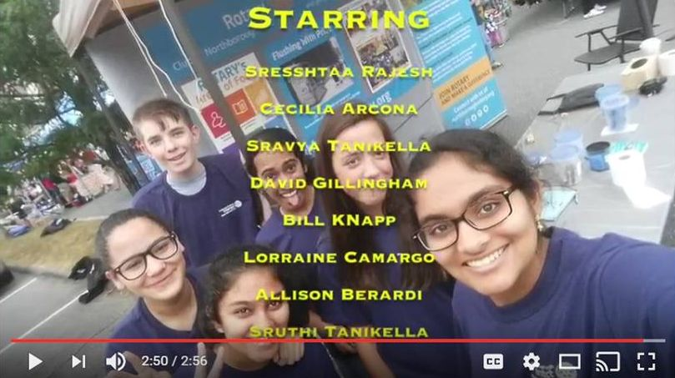

The newly formed Interact Club of Northborough-Southborough has won the District Interact Video Contest for December. The three-minute video focuses on the history behind the formation of the club. The selection, which includes a $250 prize, was made by the District Interact Committee.

WATCH NORTHBOROUGH-SOUTHBOROUGH'S AWARD-WINNING VIDEO FOR DECEMBER

Northborough-Southborough Interact is sponsored by the Rotary Club of Northborough. To learn more about Northborough Rotary, click here. To learn more about Interact, click here.

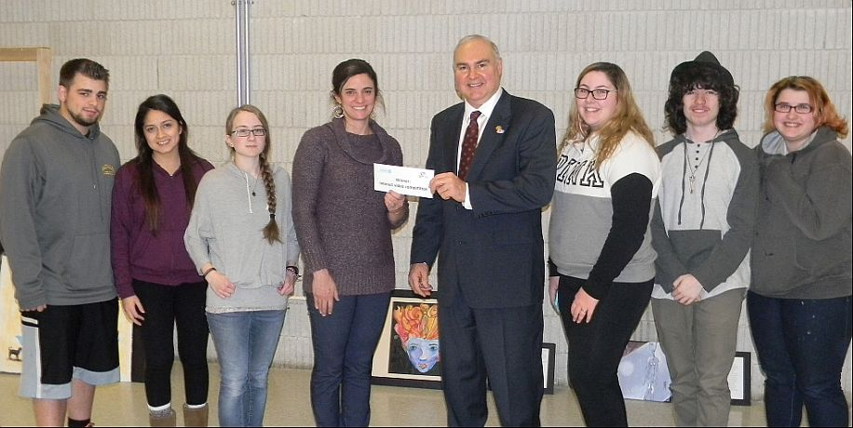

Bob Anthony (fourth from right), chair of the District Interact Committee, has presented a $250 check to the Interact Club of Bay Path Regional Vocational Technical High School, which won the district’s first Interact Video Contest, for November. The award ceremony took place on December 19 at Bay Path in Charlton. The winning video was inspired by Bay Path High’s participation in the sixth annual Worcester County Coat Drive, conducted by the Worcester County Sheriff's Office. Bay Path Interact is splitting the $250 award, 50-50, with the school’s Video Club, which shot and edited the winning entry.

Left to right: Interactor Matt Pecore; Interact President Veronica Martinez; Interactor Kayleigh Blanchard; Bay Path Teacher Jennifer Reil, Auburn Rotary’s advisor to the Interact Club; Bob Anthony; Interactor Taryn Stevens; Interactor Jamie Butkiewicz, who stars in the video; and Interactor Maura Griffis.

WATCH BAY PATH HIGH'S AWARD-WINNING VIDEO FOR NOVEMBER

Bay Path Interact is sponsored by the Rotary Clubs of Auburn and Southbridge. To learn more about Auburn Rotary, click here. To learn more about Southbridge Rotary, click here. To learn more about Interact, click here.

RULES FOR DISTRICT INTERACT VIDEO CONTEST; JANUARY 2017

Acton-Boxborough Brings Holiday Spirit to Acton Life Care Center

VIEW MORE PHOTOS

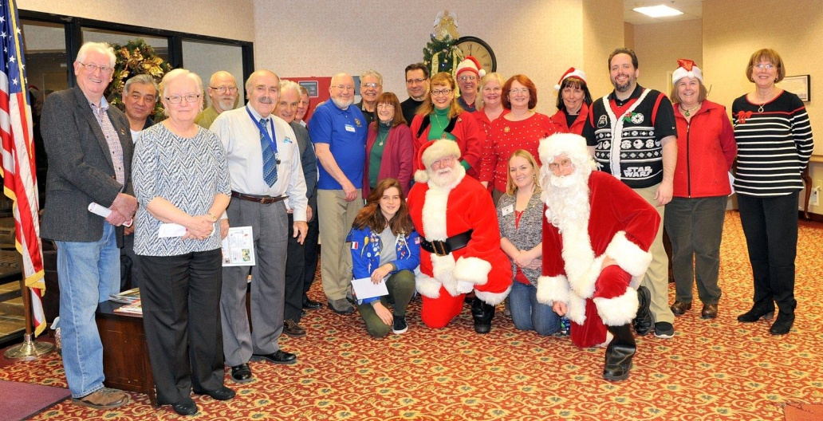

Auburn Presents Scholarship To Bay Path High Graduate

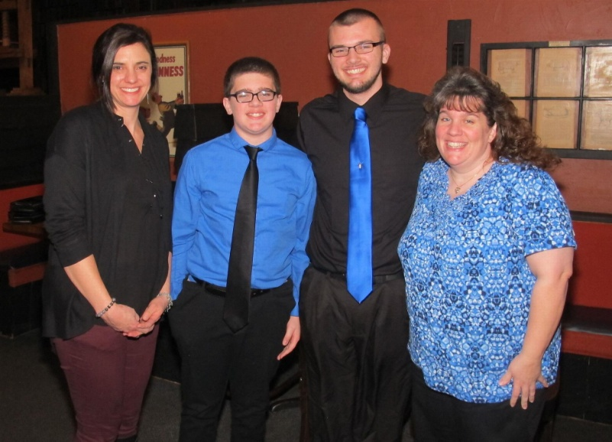

The Rotary Club of Auburn has presented a $500 scholarship to Zachary Martins, a graduate of Bay Path Regional Vocational Technical High School High in Charlton who attends the University of Northwestern Ohio. The presentation took place during a Scholarship Dinner on December 28 at Chuck's Steak House in Auburn.

Left to right: Auburn Rotarian Jennifer Reil, a Bay Path High teacher, poses with Anthony and Zachary Martins and their mother, Jennifer Martins.

To learn more about Auburn Rotary, click here.

Nashoba Valley To Host Third Annual 'Power of Change' Event
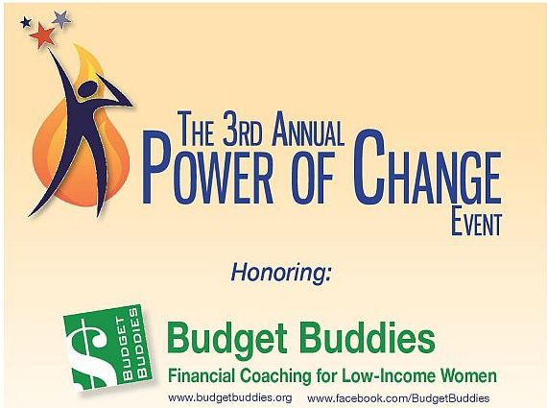

Join the Rotary Club of Nashoba Valley as it hosts its third annual Power of Change event and honors Budget Buddies. The event is sponsored by Nancy's Airfield Cafe and Minute Man Air Field.
Doors open at 6:00 p.m. This event is free and open to the public, although contributions to Budget Buddies will be welcomed. The snow date is January 26.
READ MORE, AND REGISTER NOW

To learn more about Nashoba Valley Rotary, click here.

Nashoba Valley Tools Up for Bolton Repair Cafe on January 21

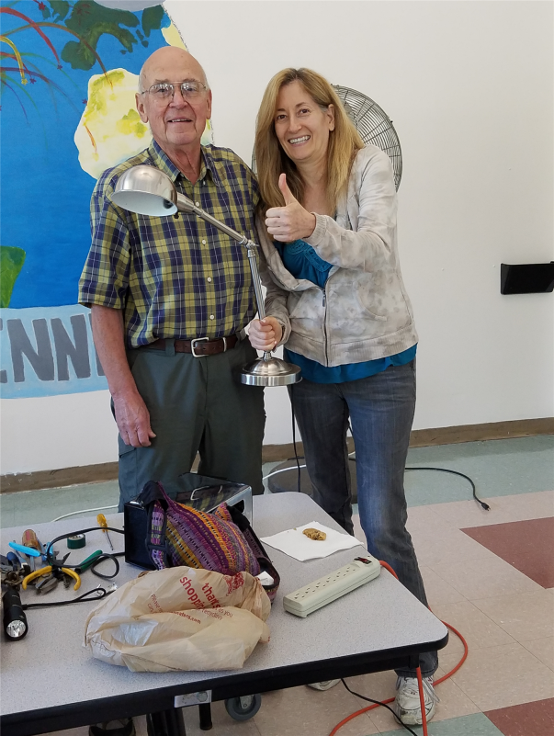The Rotary Club of Nashoba Valley, with help from Bolton Local, will hold the next Bolton Repair Café on Saturday, January 21, from 9:00 a.m. to 1:00 p.m. The snow date is January 28. The event will be held in the cafeteria of the Florence Sawyer School, at 100 Mechanic St. in Bolton. The school is located behind the Emerson School, which is on the same driveway/street. Residents of Bolton and surrounding towns are invited to come and find out what a Repair Café is all about.

Left to right: Volunteer Rene Goutte of the Bolton Lions Club and guest Sue Brent.

READ MORE

To learn more about Nashoba Valley Rotary, click here.

Westborough Uses PayPal to Raise Nearly $2,000 for Polio Plus

The Rotary Club of Westborough has used PayPal to great effect in raising almost $2,000 for Polio Plus. Any of our clubs can use this very effective technique. Westborough Rotary set up a PayPal account and asked their friends and contacts to use it to donate $10 each. It was very effective at reaching other Rotarians as well as non-Rotarian friends and colleagues. To find out whether your club's charity is a registered 501(c)3 account with PayPal, click here.

The Westborough club told the following Rotary and Polio Plus story through e-mails to promote their request for donations via PayPal, which your club is welcomed to use:

READ MORE

To research charities that have a registered 501(c)3 account with PayPal, click here.

To learn more about Westborough Rotary, click here.

Sturbridge Visited by District Governor-Nominee, Incoming District Membership Chair

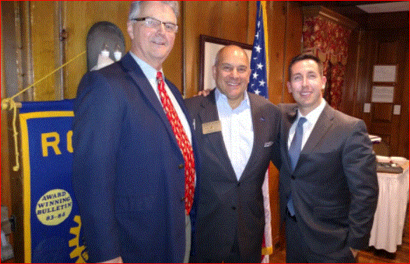

At the December 19 meeting of the Rotary Club of Sturbridge, District Governor-Nominee Steve Sager and Jason Camuti, incoming chair of the District Membership Committee, spoke about new membership initiatives in our district to attract and maintain membership.

Left-right: Sturbridge President Otto Prohaska, Steve Sager and Jason Camuti.

READ MORE

Westborough Inducts Gary Gregory As Newest Member

Left to right: District Governor-Nominee Steve Sager; newly inducted Member Gary Gregory, Immediate Past President Jim O'Connor, President Gerry Gross, and Membership Chair Sue Abladian.

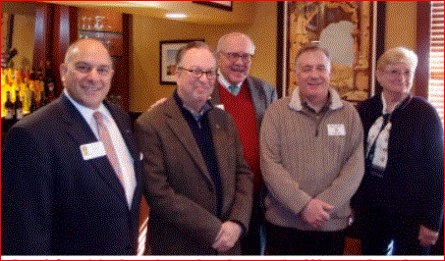

Westborough Showcases Holiday Party

Thanks to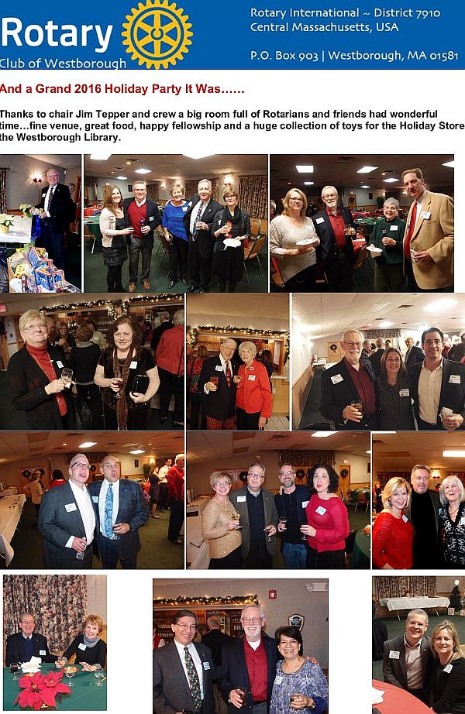 Jim Tepper, chair of the Holiday Party Committee for the Rotary Club of Westborough, and his crew, a big room full of Rotarians and friends had a wonderful time. They enjoyed a fine venue, great food, happy fellowship and a huge collection of toys for the Holiday Store at the Westborough Public Library.

READ HOLIDAY PARTY SUPPLEMENT

To learn more about Westborough Rotary, click here.

District Highlights Fundraising Goals in Video

We are all well aware that The Rotary Foundationis celebrating its 100th anniversary in 2017.Steve Kirk, president of the Rotary Club of Concord, has produced a five-minute video that outlines our own district’s fundraising goals for the current Rotary year, which ends next June 30.

WATCH VIDEO

To learn more about The Rotary Foundation, click here.

Auburn Picks Heather Chivallatti as President-Elect, Installs Rick Stock as Member

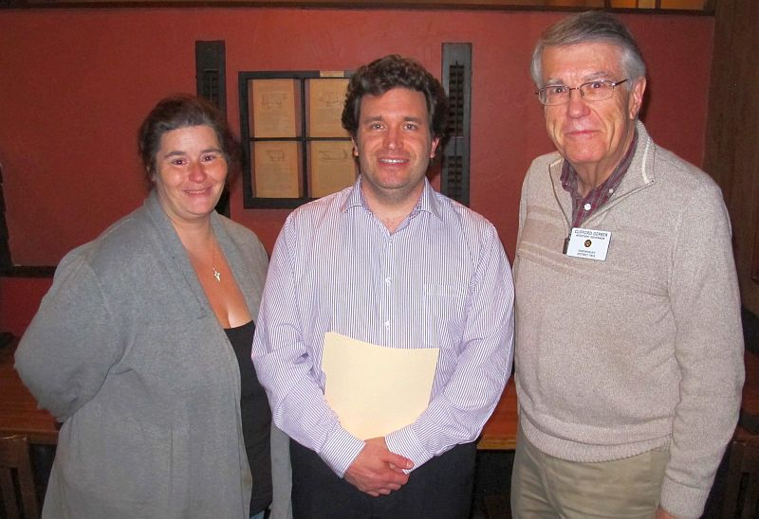

Heather Chivallatti (left), president-elect and secretary of the Rotary Club of Auburn, and newly installed Auburn Rotarian Rick Stock (middle) pose with Assistant Governor Cliff Gerber (right) on December 7 at Chuck's Steak House in Auburn. The club voted unanimously to choose Heather as president-elect for the Rotary year that begins next July 1. Cliff installed Rick, who was sponsored by Heather.

To learn more about Auburn Rotary, click here.

Auburn Helps Auburn Middle School, Bay Path High Raise $632 in Purple Pinkie Campaign

The Rotary Club of Auburn has helped students at Auburn Middle School and Bay Path Regional Vocational Technical High School to raise $632 for the 2016 Purple Pinkie campaign, promoted by Rotary International’s global drive to End Polio Now. Because the Bill & Melinda Gates Foundation matches 2-to-1 every dollar raised to eradicate polio, $1,896 will directly go to the worldwide vaccination effort. The two schools held their fundraisers on October 24, World Polio Day, with club President-Elect and Secretary Heather Chivallatti coordinating the Auburn Middle School push and club Interact Chair Jennifer Reil, a Bay Path teacher, and Rick Carrero, also a Bay Path teacher, overseeing that school’s effort. “Auburn Rotary is proud to have played a small but important part in the global movement to wipe out polio,” states club President Steve Jones-D’Agostino, “We are grateful to Auburn Middle and Bay Pay High for their generous support of this noble cause.”

READ MORE

To learn more about the Rotary Club of Auburn, click here.

Fitchburg Holds Breakfast With Santa

The Rotary Club of Fitchburgparticipated recently inBreakfast with Santa at Hollis Farm in Fitchburg. This was third straight year that Fitchburg has sponsored Santa Claus and provided photo services.

Left to right: Fitchburg Members Paul Gauvin andKaren Fusco, Fitchburg Immediate Past President Wayne Carney, andSanta Claus. Can you guess who is playing Santa?

Tewksbury Rotary, Lions Teaming Up for Sock Hop

The Rotary Club of Tewksbury and the Tewksbury Lions Club are teaming up for an all-new event, complete with live entertainment, dancing and raffle prizes. The event, called Sock Hop, will be held on Friday, January 20 at 7:00 p.m. at Tewksbury Country Club.Reminisce, a New England-based vocal group will perform songs of the 1950s and '60s.
READ MORE

To learn more about Tewksbury Rotary, click here.

Worcester Awards $10,000 To Be Like Brit Foundation

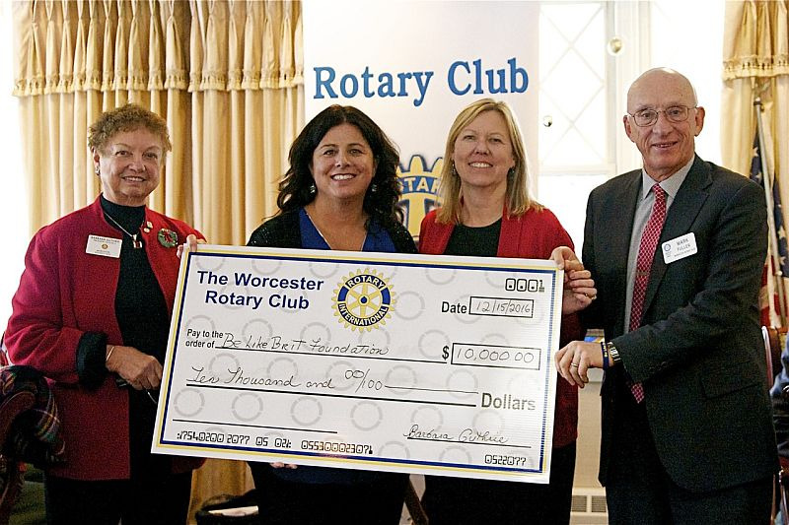

On December 15, theRotary Club of Worcestercelebrated its annualHoliday Glogg Party.During the event the club presented a check for $10,000 to Cherylann Gengeland the Be Like Brit Foundation to be used to provide water to an orphanage the Gengels built in Haiti. Left to right: Worcester PresidentBarbara Guthrie; Cherylann Gengel of the Be Like Brit Foundation; Patty Eppinger; and Worcester Member Mark Fuller.

To learn more about Worcester Rotary, click here.

Worcester Donates $41,000 for Opioid Education, Addiction Prevention

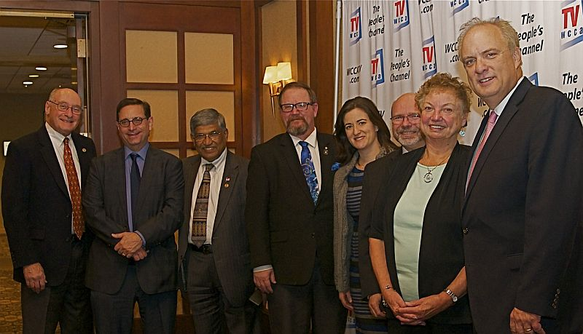

On November 29, the Rotary Club of Worcester presented a check for$41,000 to the City of Worcester. The city will use the donation for opioid education and addiction prevention. Left to right: Worcester Members Richard Prager and Mauro DePasquale; Worcester Past President Satya Mitra,;Worcester Members Chris Gates and Amy Mosher Berry; Worcester Immediate Past President Bob Mangan; Worcester President Barbara Guthrie; and Worcester Mayor Joseph Petty.

To learn more about Worcester Rotary, click here.

Worcester Receives Humanitarian Award from WCCA-TV

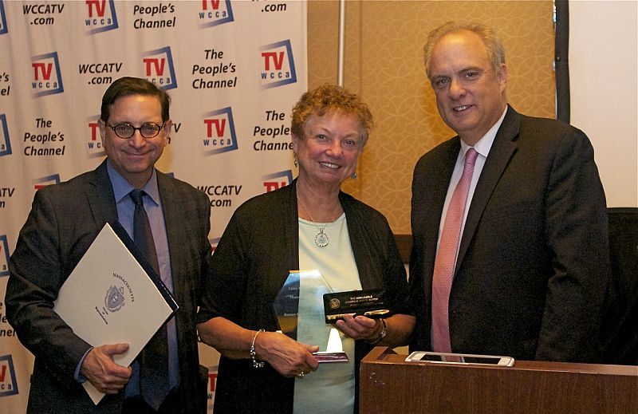

On November 17, the Rotary Club of Worcester received the Father Michael Bafaro Humanitarian Award from WCCA-TV, the cable community-access channel for Worcester. The award celebrated Worcester Rotary's humanitarian contributions to Worcester. Left to right: Worcester Member and WCCA-TV General Manager Mauro DePasquale; Worcester PresidentBarbara Guthrie; and Worcester Mayor Joseph Petty.

To learn more about Worcester Rotary, click here.

Video of Governor Baker's Address to District Rotarians Now Available

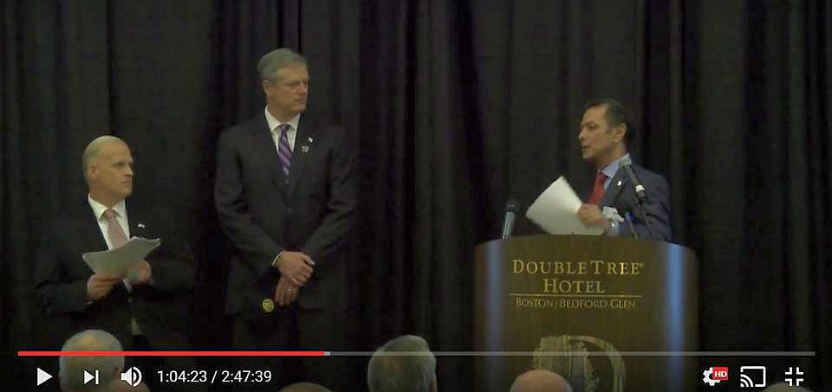

The Rotary Club of Billerica has provided a video of Governor Charlie Baker's address to District 7910 Rotarians on September 27 at the DoubleTree Hotel in Bedford. To watch the two-hour-47-minute video, click here.

The Rotary Clubs of Bedford, Billerica, Lowell, Newton and Shrewsbury sponsored the event, which was a unique opportunity for Rotarians and friends to discuss partnering on humanitarian projects affecting our local communities. To viewevent photos, click here.

Meet Tatsuya Hayase, Our Rotary Scholar

To Have Tatsuya Speak to Your Club, Contact Indira Desai

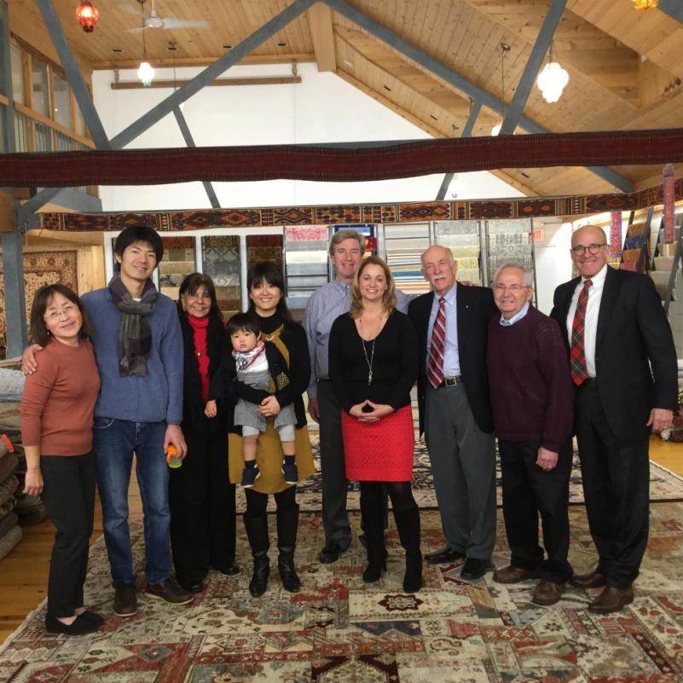

Meet Tatsuya Hayase(second from left), a Rotary Scholar from District 2760 (Aichi Prefecture in Japan) who is visiting our district. He is spending the year at the Heller School for Social Policy and Management at Brandeis University in Waltham studying Peace and Conflict Prevention and Resolution.
READ MORE
Left to right: Newton Rotarian Chris Chu; Rotary Scholar Tatsuya Hayase, his wife, Marie Hayase, and their son, Yuto Hayase; Host Counselor Indira Desai, immediate past president of Newton Rotary; Newton Rotary President Paul Sullivan and his wife, Monica Sullivan; District Scholarship Chair Tory DeFazio, a Wellesley Rotarian; and Newton Rotarians Tony Bibbo and Tom Keery.

Athol-Orange's Al Bowers Makes Foundation Presentation

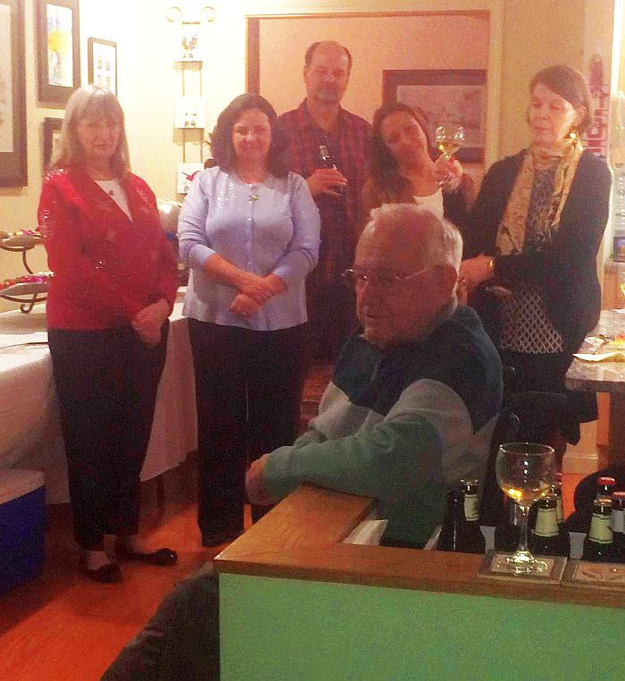

The Rotary Club of Athol-Orange held its annual Christmas Party at the home of Member Bill Howland. Club Foundatioin Chair Al Bowers, immediate past District Charitable Fund chair, attended and made a wonderful presentation on The Rotary Foundation. A surprise Paul Harris recognition was bestowed on club Secretary Carol Courville by Assistant Governor Karen Fusco.

Posing during the Athol-Orange Christmas Party with club Foundation Chair Al Bowers, seated, are, left to right, Assistant Governor Karen Fusco, club Secretary Carol Courville, club Member Ted Ledgard, club President-Elect Tanya Quinn, and club Member Barbara Robichaud.

Chelmsford Donates $1,000 to The Wish Project

The Rotary Club of Chelmsford made a $1,000 donation to The Wish Project at a recent meeting. The project's mission is to "help end homelessness by providing otherwise-expensive home and baby items for free so that families moving out of shelters succeed the first time."

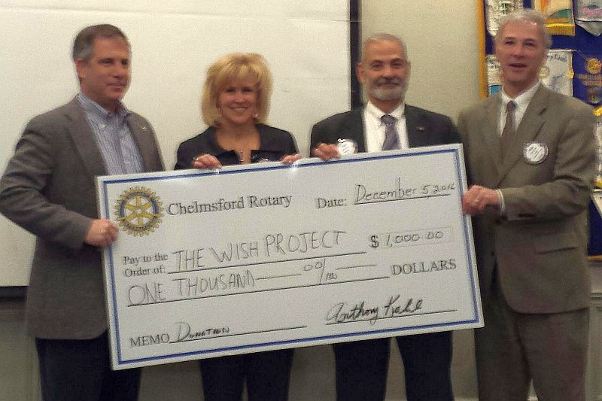

Left to right: David Fitzgerald, executive director of The Wish Project, Chelmsford Past President Dawn Ferrari; Chelmsford Treasurer Tony Kalil; and Chelmsford President Paul Cohen.

Wachusett Area Rotary, Chamber Hear State Secretary Jay Ash Offer Local Economic Outlook

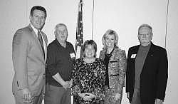

Jay Ash, secretary of the state Executive Office of Housing and Economic Development, shared his outlook on economic development in Central Massachusetts on December 2 at a breakfast co-hosted in West Boylston co-hosted by the Rotary Club of Wachusett Area and the Wachusett Area Chamber of Commerce.

Left to right: Secretary Jay Ash, Chamber President Iain McKinlay, State Senator Anne Gobi, State Representative Kim Ferguson, and Rotary President Gary Hough.

READ MORE

To learn more about Wachusett Area Rotary, click here.

District Holiday Party A Great Success

VIEW ALL PHOTOS

Past District Governor Klaus Hachfeld (right) of Sturbridge Rotary and Sergeant Kevin Williams (left) of the Brookfield State Police Barracks pose with some of the many donated Teddy bears.

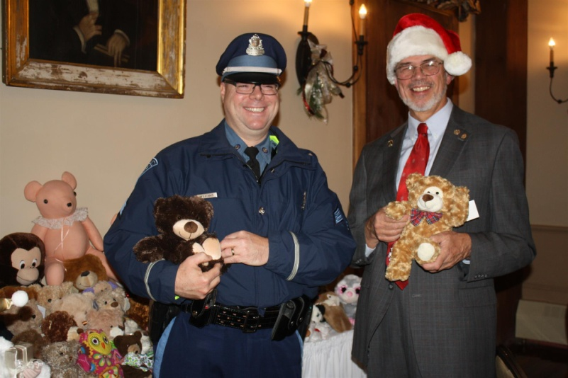

District Governors Pat and Skip Doyle hosted the annual District Holiday Party on Sunday, December 4 at the Publick House in Sturbridge. Ninety-five attendees enjoyed the festivities. with entertainment provided by the Tantasqua Regional High School" Choraleers." Attendees brought Teddy bears. which were presented to Sergeant Kevin Williams of the Brookfield State Police Barracks. The grand finale was the "coronation" of Pam Anastasi of the Rotary Club of Billerica as district governor-nominee-designate. She will serve as district governor for Rotary year 2019-2020. Thank you to Past District Governor Klaus Hachfeld and his wife, Glenys Hachfeld, both of whom are members of the Rotary Club of Sturbridge for planning this event, and to MC Steve Jones-D'Agostino of the Rotary Club of Auburn, and our ace district photographers, Immediate Past District Governor Jim Fusco of the Rotary Club of Montachusett Area and Cheryl Rosen of the Rotary Club of Hudson.

Tantasqua Regional High School "Choraleers," led by Derek Ternullo (second from left), performed several holiday-season songs in acapella style during the Holiday Party. They were introduced by Past District Governor Klaus Hachfeld (far right) of Sturbridge Rotary.

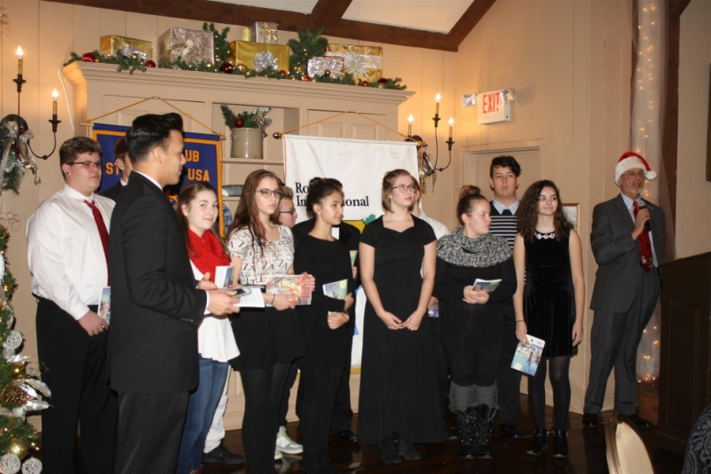

Franklin Rotaract Club Installed at Dean College

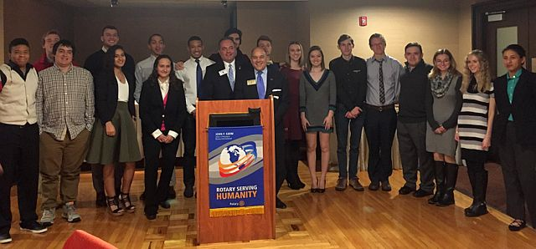
The new Rotaract Club of Dean College was installed on November 17. Shown, are the 18 of the 19 charter members of the Rotaract club posing with Rotary Club of Franklin President Terry Katsaros(left, behind podium) and District Governor-Nominee Steve Sager
(right, behind podium).

To learn more about Franklin Rotary, click here.

A Great Fundraising Idea for All Clubs

Milford Distributes '16 Tab to 13,000 Homes - Record sales, 94 photos, 334 smiling faces

To read the Milford RotaryTab, click here.

To learn more about Milford Rotary, click here.

On to Atlanta in 2017: Register now!

Planning to attend? Contact District Chair Steve Glines.

More than 43,000 attendees left the Rotary International Convention in South Korea inspired to end polio for good, to celebrate The Rotary Foundation's centennial, and to champion changes that will help Rotary appeal to a broader audience. On the last day, RI President K.R. “Ravi” Ravindran shared a personal story of his mother’s triumph over polio.

To read the story, click here.

To register for the 2017 RI Convention in Atlanta, click here.

Pat and Skip Doyle Installed as '16-'17 DGs

District 7910's 2016 Rotary Youth Leadership Awards were held on June 24 through 26 at Fitchburg State University, ending with the installation of longtime RYLA supporters Pat and Skip Doyle as District Governors for 2016-2017. The three-day RYLA event was attended by 188 sophomores. To learn more about RYLA, visit ryla7910.org.

To watch a video of the installation, click here.

District Banners Available

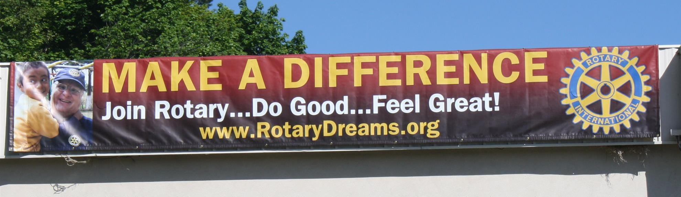

Our district banners are available for your use when you have an upcoming event or fundraiser.

If you want to reserve one of the banners, please contact PR Chair Laura Spear at laura@spear.net.

MAJOR DISTRICT & CLUB HAPPENINGS: WINTER 2017
Friday, January 20: - Tewksbury - 'Sock Hop'

To learn more, click here

Monday, January 23: Nashoba Valley - 'Third Annual Power of Change Event'

To learn more, and to register for this free event, click here

To download flyer in PDF format, click here
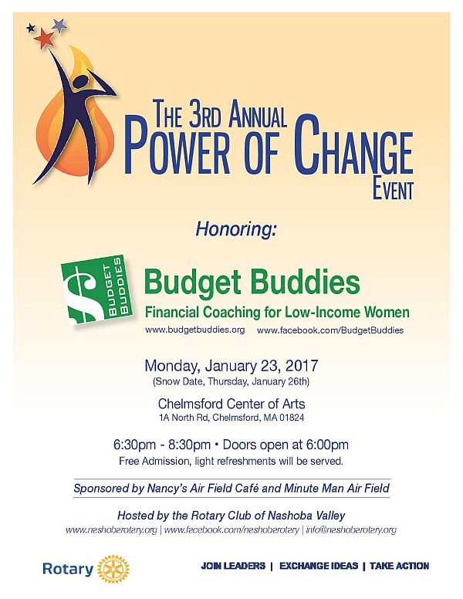

Saturday, January 28: Brookfields - 'Murder Mystery Dinner'

For more information, contact Lynn Duffey-O'Shea at 413-262-8783 or President Chet Lubelczyk at 508-867-3203.

Click here to download event flyer

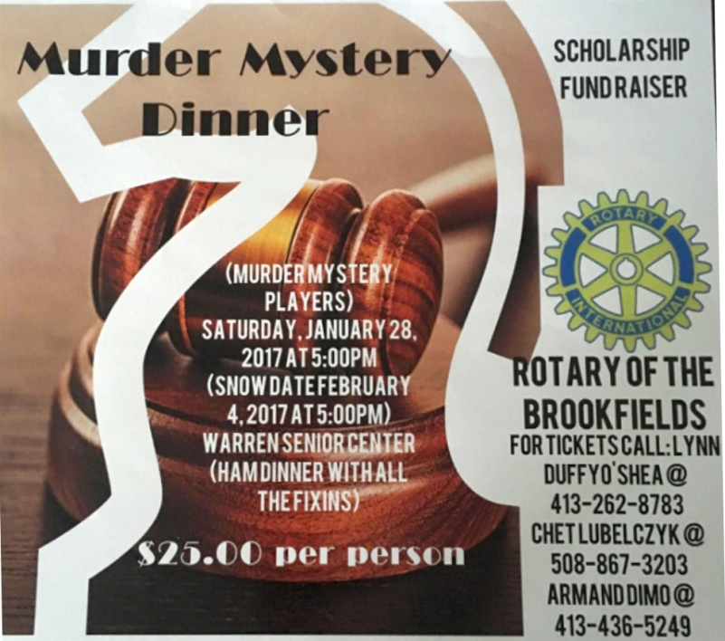

Saturday, March 11: Uxbridge - 'Wine and Chocolate Tasting'

Click here to download event flyer

Wednesday, March 15: District 7910 'Deadline for Morley Scholarship Applications'

To learn more, click here

To download flyer in PDF format, click here

SUBMIT MAJOR CLUB HAPPENINGS

Send flyers of your club's major events and activities, in eitherJPEG or PDF format, to Immediate Past District
Governor/Newsletter Editor Jim Fusco at jim.fusco2@gmail.com.

