Nashoba Valley Tools Up for Bolton Repair Cafe on January 21
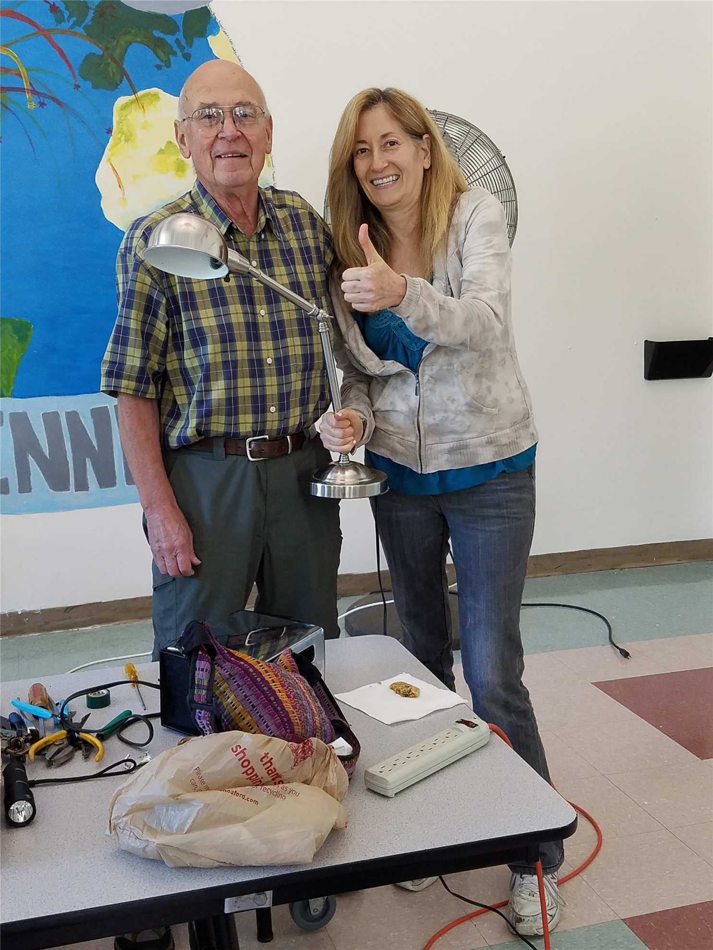The Rotary Club of Nashoba Valley, with help from Bolton Local, will hold the next Bolton Repair Café on Saturday, January 21, from 9:00 a.m. to 1:00 p.m. The snow date is January 28. The event will be held in the cafeteria of the Florence Sawyer School, at 100 Mechanic St. in Bolton. The school is located behind the Emerson School, which is on the same driveway/street. Residents of Bolton and surrounding towns are invited to come and find out what a Repair Café is all about.

At the Repair Café, everything centers on making repairs. Knowledgeable volunteers will help repair items such as clean and mendable clothing, lamps, small appliances, computers and other electronics, bikes, toys, and jewelry. They can also sharpen knives, scissors, and garden tools. You only pay for needed parts. If you know what parts are needed, please get them ahead of time and bring them to the Repair Café to save time.

Please note that the Repair Cafe cannot work on outdoor power equipment in the winter. Please bring those items to the Cafe's spring or fall event.

Volunteers at the Repair Café will look at all items brought in and try to repair them. If the volunteers cannot repair something, they would offer suggestions about where you could go for repairs.

Unlike a “fix-it” shop, where people drop off items to be repaired and continue about their day, the Repair Café is meant to get people involved with the repair process and create connections with others in the community. People bringing in items for repair are asked to stay while your items are being fixed. You can just watch, help with the repair, fix the item yourself with help from volunteers, or just have a snack and visit with neighbors.

Promoting repairs will help reduce mountains of waste. According to organizer Ray Pfau, a member of Nashoba Valley Rotary “We throw away lots of things that often have almost nothing wrong with them, things that could easily be used again after a simple repair. Unfortunately, many people have forgotten that they can fix things. Repair Café wants to change all that.”

Repair Café is also meant to put neighbors in touch with each other in a new way. Neighbors may discover that a lot of know-how and practical skills can be found close to home. “If you repair a bike, a CD player, or a pair of trousers with previously unfamiliar neighbors, you look at them in a different light the next time you see them," Pfau states. "Jointly making repairs can lead to connections in the community.” Making repairs can also save money and resources.

The Bolton Repair Café is sponsored by Nashoba Valley Rotary with support from Bolton Local and the Repair Café Foundation. The Foundation has been organizing Repair Cafés in the Netherlands since 2010 and has provided support since January 2011 to local groups in and outside the Netherlands wanting to start their own Repair Cafés. Bolton has been holding Repair Cafés since the fall of 2013.

Repair Cafés are springing up in the local area. The Rotary Club of Westborough Rotary and Westborough Public Library and will hold their next Repair Café in the spring. The Stow Council on Aging will also hold their next Repair Café in the spring.

For more information, contact Ray Pfau at 978-779-5545 or ray.pfau@alum.mit.edu, or visit www.nashobarotary.org.

Return to January 2 Newsletter
View past issues
Visit our website
'Like' our Facebook page
'Follow' our Twitter page

