COMMITTEE REPORTS

Treasurer's Report: Dues bills to be invoiced this month

By Jack Hoell
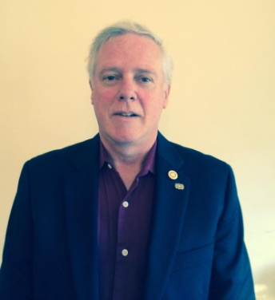

Rotary International dues bills will be invoiced this month based on membership numbers that were shown on your membership roster as of this December 31, so ensure that your membership numbers are always accurate and up-to-date. District dues will be based on the same membership numbers that are used by Rotary International The RI and District dues bills will be sent to club presidents and secretaries in mid January.
READ MORE

Rotary Means Business: Holds first event in our district - Next one on January 25
By Ron Bott

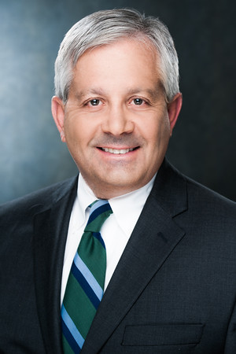

On December 7, our district’s business-networking fellowship, Rotary Means Business, was launched. More than 30 Rotarians and guests attended.

READ MORE (including event photos)

What Is The Mission of Rotary Leadership Institute?

By Doug Detweiler

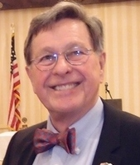

The Rotary Leadership Institute is a grassroots, multi-district leadership-development program whose mission is to strengthen Rotary clubs through quality leadership education.

READ MORE

What are the courses? Click here
To download the brochure with all of the RLI Northeast America classes for 2016-2017, click here.

For the complete RLI Northeast America schedule, click here.

A Healthy Rotarian Is A More Effective Rotarian - Make a great New Year's resolution

By Ron Goodenow

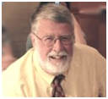

As luck would have it, I ran into a one-time Rotarian friend well into middle age while shopping the other day. After the pleasantries about the holidays, cameras, the Patriots, shopping and travel, he asked me how I was doing physically.

READ MORE

'17 RI Convention in Atlanta: Register now!

Beyond Borders Dinner on June 11: To register now, click here.

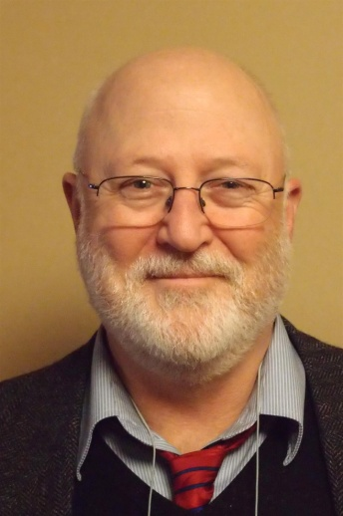

More Than 100 Breakout Sessions

There will be more than 100 breakout sessions at the RI Convention in Atlanta. Help us plan the sessions by taking a survey: TAKE SURVEY
Here's a letter from Steve Glines, chair of the District International Convention Promotion Committee: READ LETTER

To register and find hotel options, click here

For more information on the 2017 RI Convention in Atlanta, click here

Interact Actions: Interact teens invited to help in Providence and Atlanta
By Bob Anthony
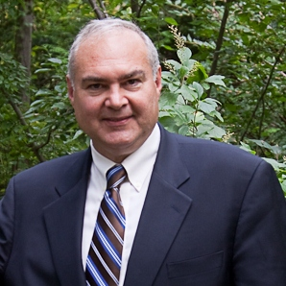

All Interact teens are invited to help staff the House of Friendship booths next April 29 during the Multi-District Conference in Providence and next June 10 through 14 at the Rotary International Conference in Atlanta.
READ MORE

How to launch an Interact club

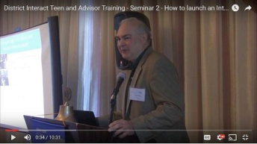

In Seminar 2 of the District Interact Teen and Advisor Training Seminar, held on September 17 in Needham, Bob Anthony, chair of the District Interact Committee, discusses “How to launch an Interact club,”including the certification letter, roles and responsibilities of the president, the Rotary advisor and, in the case of school-based clubs, the faculty advisor.

WATCH VIDEO

Foundation Note: Foundation-Giving Scorecard for ‘16-‘17
By Sanjay Deshpande

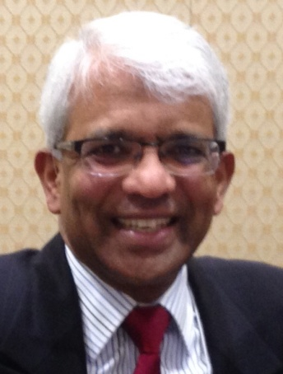

The Rotary Foundation is supported by contributions from Rotarians all around the world. Our district has set a goal of $325,000 in total Foundation giving in Rotary year 2016-2017, which ends next June 30. That’s about 10 percent above the $293,705 contributed during ’15-‘16. The ’16-’17 per-capita average goal is about $225. As of December 17, the district’s total giving stood at $41,548, or 13 percent of the annual goal.

READ MORE

Membership Corner: The Rotary 'why' factor

By Tom Sturiale
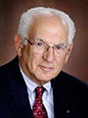

(This article ran originally in the November 7, 2016 issue)
During the four District Membership Workshops in October, it seemed clear that the question most folks struggle with is, “Why do people want to join Rotary?” Isn’t this the heart of the matter? If we cannot answer this question clearly, succinctly and quickly, we would have a major problem.

READ MORE

To learn how the Rotary Club of Melbourne in Victoria, Australia does corporate membership, click here

To learn about District 7910 Membership Workshops in October, click here.

Membership Materials On Sale: Order now!
To order, click here

PR Tips: Rotary Blue is not just any blue

By Laura Spear
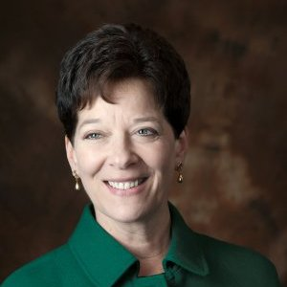

Rotarians are smart, compassionate, persevering, and inspiring. As a result, Rotary International has chosen a set of colors to express those attributes.

READ MORE

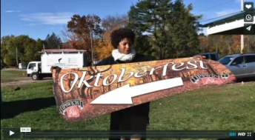

Click here for an excellent example of a club-event promotional video by Concord President Steve Kirk.

Million Dollar Dinner: RI Past President Kalyan Banerjee to be keynote speaker

By Satya Mitra

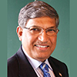

I am pleased to inform you that Kalyan Banerjee, a past Rotary International president and chair and trustee of The Rotary Foundation, has confirmed his attendance next May 25 for our district’s Million Dollar Dinner. He needs to attend another event in Zurich, Switzerland on May 27 May, so he will leave early on May 26.

The venue, Mechanics Hall in Worcester, has been reserved for this gala event. Let’s do a grand celebration of the centennial year of The Rotary Foundation.

READ MORE

Polio Plus Update: Portion of Papa’s Boots Proceeds to Benefit Polio Plus

By Carl Good III

On December 9, Amanda Graves gave a moving presentation to the Rotary Club of Wachusett Area on her children's book Papa's Boots. The short, beautifully illustrated book chronicles a grandfather explaining his childhood polio to his grandson. Amanda is an excellent speaker and provides a portion of the proceeds to Polio Plus. For more information, contact Amanda at amandacooks@hotmail.com. To buy the book at Amazon.com, click here.
READ MORE

Club Central: Short video on how to post your club goals

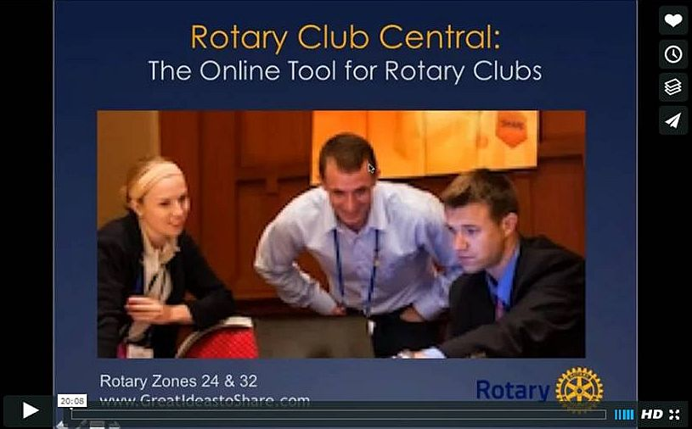

This 20-minute webinar recording is designed for club leaders to assist in posting goals on Rotary Club Central. Bob Wallace and Ian Lancaster, facilitators from Rotary Zone 24 East, provide practical start-up information.

CLICK HERE

Did You Know?: District 7640 has more Interactors than Rotarians

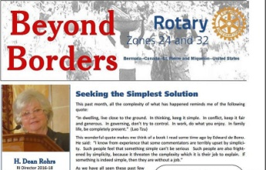

READ MORE

RAAGNE Newsletter: Update on visioning process

By Klaus Hachfeld

Hello, members and friends of the Rotary Alumni Association of Greater New England! Here is to the latest edition of the RAAGNE newsletter! Over the past year, we went through a visioning process to work out the future direction of RAAGNE.

READ MORE

Speaker's Bureau: Looking for good speaker for your club?

By Steve Levitsky

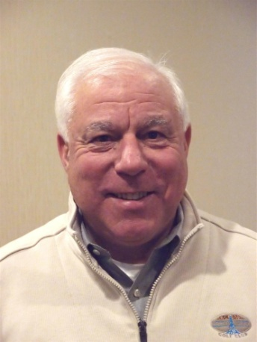

It's not always easy to come up with ideas week after week. We have many suggestions for you. Here are just a few:
- Rwandan genocide: Carine Boggis
- Elevator-pitch tips: Andy Winig
- Positive-results hypnosis: Bob Martel
- Differentiation and game-changing simplicity: Stephen Melanson
VIEW MORE

District Charity Fund: How does DCF operate?

By Karin Gaffney
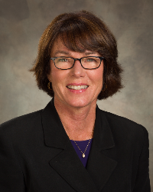

The District Charity Fund is a 501(c)3 charitable, non-profit that can be used by the Rotary clubs in District 7910.
READ MORE

Communications Link: Seeking club photo, video albums
By Steve Jones-D'Agostino
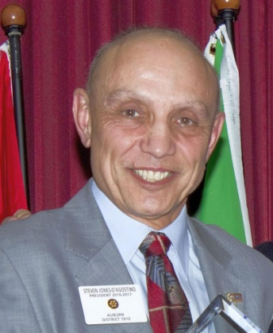

Does your District committee or Club have Rotary-related photo and/or video albums that you'd like to share with other Rotarians?
READ MORE

SUBMIT CONTENT
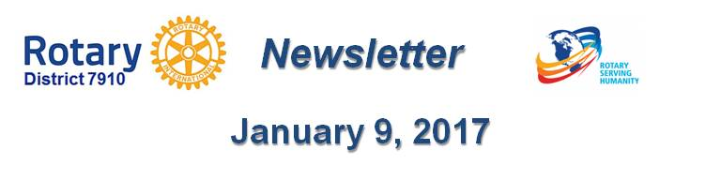
To submit content for consideration for the January 9 issue of Rotary District 7910 Newsletter, please e-mail it to Immediate Past District Governor and Newsletter Editor Jim Fusco at jim.fusco2@gmail.com.
The submission deadline for that issue is Friday, January 6. All text must be in Word format. All images must be in either JPEG or PDF format. Please identify the people, left to right, who are shown in your photos, including their first and last name as well as their club or other title.

PAST ISSUES
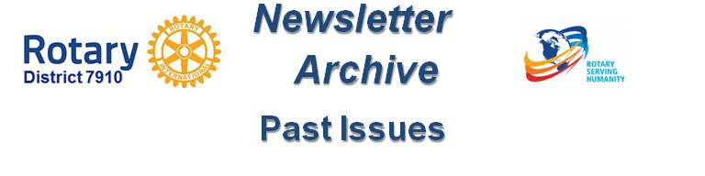To view past issues of the weekly Rotary District 7910 Newsletter, click here

D7910 ONLINE
Visit our website
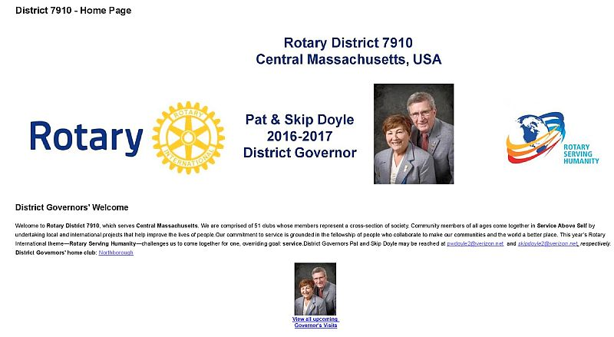
Click on each one

'Like' and share us on Facebook
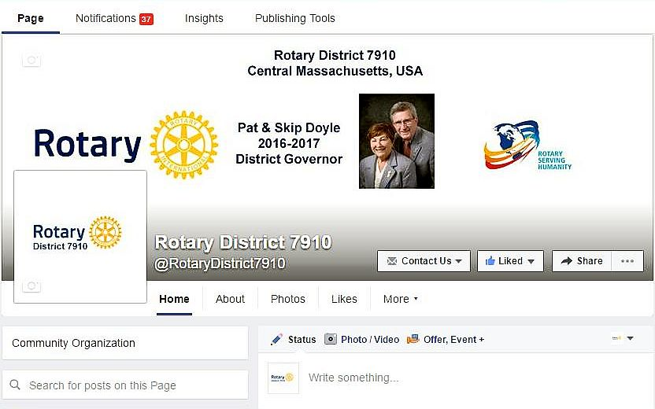

Watch Our Videos
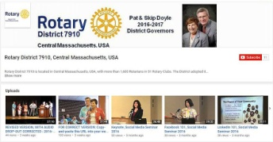

View Our Photos
Archived on Google Photos, since May 2015; and on ClubRunner, before May 2015
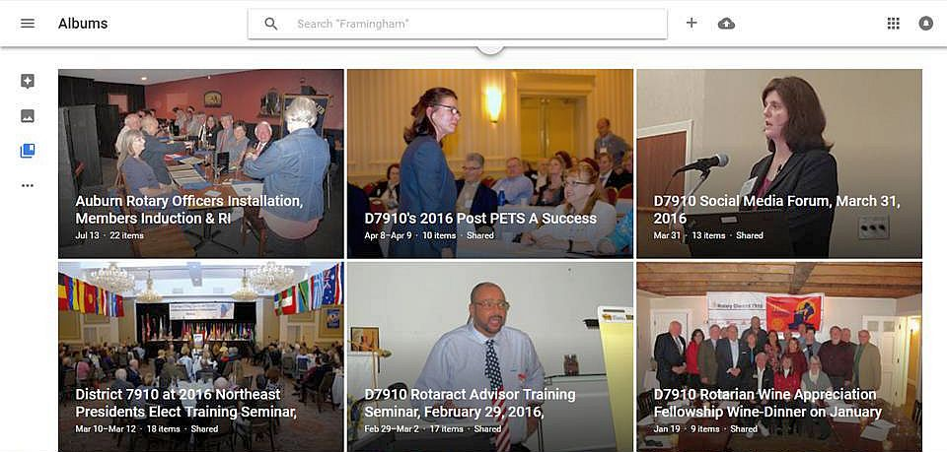

CONTACT US
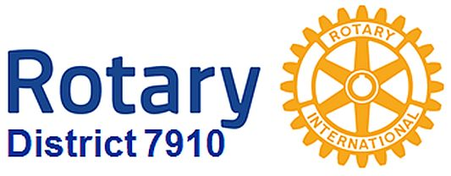

Jim Fusco, Immediate Past District Governor and Newsletter Editor
​jim.fusco2@gmail.com
Steve Jones-D'Agostino,District Webmaster and Newsletter Copyeditor
​srdagostino@icloud.com
© Copyright 2016-2017 - Rotary District 7910, Central Massachusetts, USA

