REGISTER NOW: 2017 MULTI-DISTRICT CONFERENCE, APRIL 28-30, PROVIDENCE. TO REGISTER, CLICK HERE.
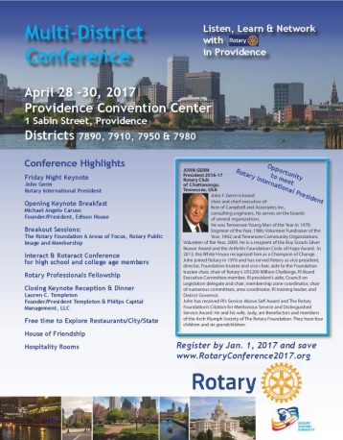To download the Conference Highlights flyer (shown, below) in PDF format, click here

To download the Conference Sponsorship Donation form in PDF format, click here

To download the Rotary

