seeking to change destructive dynamics of opioid crisis
By Pat and Skip Doyle
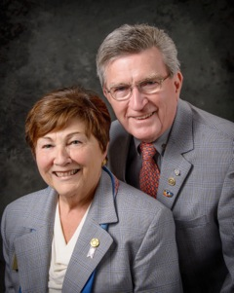
We visited a joint meeting of the Rotary clubs of Hudson and Northborough last week and were sharply reminded of the opiod crisis that is facing our state and our Rotary district. Speakers for the evening were Erin Holmes of Learn 2 Cope, and Kathy Leonard of the Marlborough Substance Use Prevention Coalition. They shared their personal experiences of losing children to opiods. Joining them were Jason Webster, principal of Quinn Middle School in Hudson, Paul Sullivan, president of the Rotary Club of Newton and therapist Jeff Levin, speaking to the problems our young people experience in school such as anxiety, depression and drug abuse.
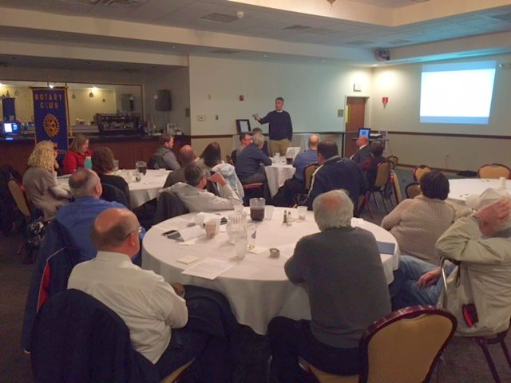
Our comments today are not about the presentations, as good as they were, as much as they are about the discussions, which began at our tables during dinner and continued throughout the evening. These discussions were very personal and got to the heart of the feelings that people have about this crisis. The question came up more than once, "Is there anything Rotary can do to help with a solution?" While we do not believe that we as individuals have an answer, we do believe that the collective resources of Rotary might be able to come up with some ideas.

Already, we have heard of individual Rotarians - to name a few, Richard DeVito, Heidi Hellman, Jon Fetherston, Roy Balfour, Christine Guthery, and Paul Sullivan - who are putting plans together to get Rotary involved.
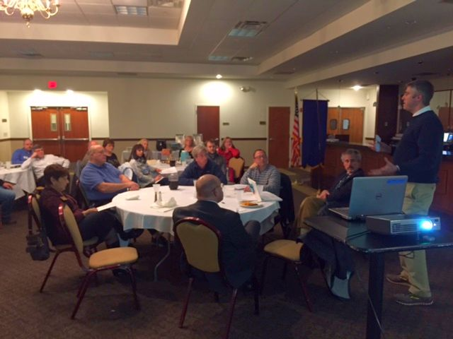
A quote from the draft of a statement from the Newton Rotary states: "However, the part of the iceberg we cannot 'see, below the waterline, consists of mounting stress, pressure, and disconnection in our kids, schools, communities, and even ourselves, which are causing the symptoms that we all see. This is what our coalition seeks to repair and thus reduce the dramatic and dangerous negative choices our kids are making.

"With Rotary leading the way through communication and fundraising, we seek to change these destructive dynamics, school by school and town by town."

If you feel inclined to join this growing movement, contact any of those members mentioned here or contact us at any time.

Six important things to know:

1. The weekly submission deadline for the Newsletter will remain the same: Friday. As usual, text content must be submitted in Word format, and image content, in either JPEG or PDF format. Continue to submit your content to Immediate Past District Governor/Newsletter Editor Jim Fusco at jim.fusco2@gmail.com.

2. Resolutions: The District Resolutions Committee met on January 10 and addressed three changes to the District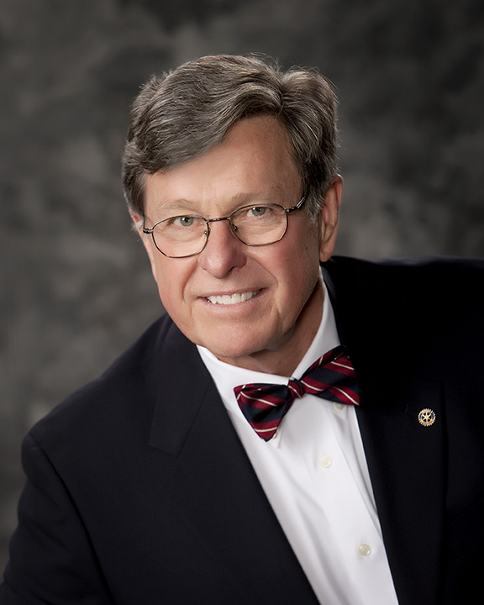Resolution that will be proposed and voted on at the annual District Business Meeting, to be held during the Multi-District Conference in Providence, on Saturday morning, April 29. For more information on the District Resolutions, contact Resolutions Chair Doug Detweiller (shown, right) at rotary@detweiler.org.

3. District Nominations: The District Nominating Committee is seeking qualified applicants to serve as DistrictTrustee for 2017 to 2019 and District Charitable Fund Trustee for 2017 to 2020. Clubs and club leadership are asked and encouraged to actively recruit and promote service in Rotary through their members' service as district leaders. The deadline for submitting applications is this February 18. All completed applications should be either e-mailed to Nominating Committee Chair Michael Ellis (shown, right) at mellis0144@comcast.net, or mailed to him at: Michael Ellis, District 7910 Nominating Committee, 88 Coburn Ave., Gardner, MA 01440. Postmarked mail after February 18 will not be accepted. To download the Trustee Nomination Form, click here. To download the Nomination Form Supplement, click here.
4. Rotary Youth Leadership Awards: The RYLA Club Pack has been updated and posted on RYLA7910.org. When you download it, you will notice changes from last year. Please read the material carefully and direct your questions to Christine Pinney, chair of the RYLA Committee,who may be reached at christine@christinepinney.com. The RYLA season has begun and the RYLA Committee is working to make RYLA 2017 the "best RYLA ever." (See RTLA article in right hand column)

5. Club Planning Worksheet: To download the Club Planning Worksheet, click here.This worksheet is made available to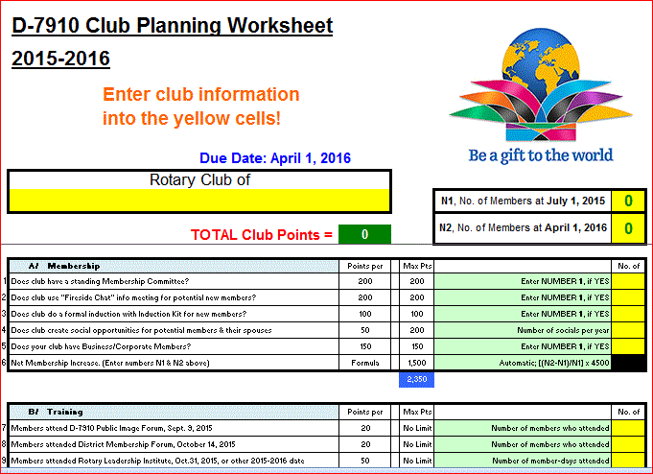 clubs so they can gauge their progress in achieving the goals they set last July. This month is a good time to review the worksheet and see how far you have come and how much farther you need to go as a club. You may surprise yourselves and realize that you are well on the way to earning district recognition. We recommend the club president appoint the president-elect to be the "champion" of the Worksheet, and to use it as a guide for the club, and to report monthly to the club's membership and board on the club's progress.

6. As your district governors, we have resolved to:
- Revisit as many clubs as possible in the next few months.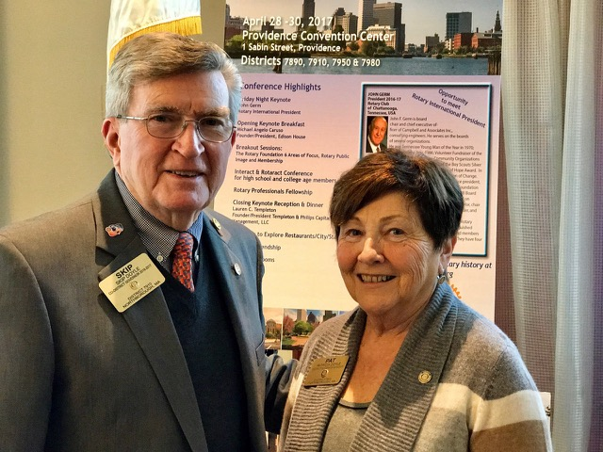
- Help our clubs achieve the goals they set in July
- Do all we can to build membership in the district
- Plan a grand event to celebrate our Million Dollar Foundation Journey
- "Move the ball forward," in harmony, with District Governor-ElectKarin Gaffney, District Governor-Nominee Steve Sager and District Governor-Nominee-Designate Pamela Anastasi
- Celebrate all of this at our Multi-District Conference this April in in Providence
District Governors Pat and Skip Doyle (shown, right) may be reached at pwdoyle2@verizon.net and skipdoyle2@verizon.net, respectively.

Click here to submit content for the Tuesday, January 31 issue. The submission deadline for this issue is Friday, January 27.

Click here for past issues.

Return to January 24 Newsletter

Visit our website
'Like' our Facebook page
'Follow' us on Twitter
Watch our videos
View our photo albums

