March Membership Workshops
By Tom Sturiale

​​​​​​​As mentioned last week, our district will conduct four regional membership workshops in March. We’re looking for members from clubs of any size who seek help and advice on attracting new members, plus members from clubs that have been very successful with member attraction and are willing to share their knowledge and experience with others. Of course, the workshops will offer the same opportunities to Rotarians seeking to explore the networking opportunities these gathering always provide.

How will the Membership Workshops be organized? First, the moderator will spend a few minutes describing the structure of the meeting and the objective of the workshop. Of course, a light meal will be provided at a moderate price ($15 each) and be available soon thereafter.

The attendees will be divided into tables of five to seven people each, with a facilitator and a note-taker. Then, we will continue with three 20-minute breakout sessions.

The participants will be presented a case study describing an imaginary Rotary club that has fallen on difficult times and needs to be rebuilt. The objective will be to develop a plan to aggressively increase the membership over a three-year period in a healthy, effective manner. Here is an opportunity for attendees to use their imagination and skills to design the Rotary club of their dreams.

The three breakout sessions are aimed at all the stages of club and member development.
- In the first session, the meeting structure, venue, fees, meals, agendas, speakers, club objectives, vision, community needs and member-satisfaction issues will be reviewed.
- The second session will be aimed at determining what types of members the club wants and/or need, all the possible sources of potential members, and how to develop a list of target members.
- During the third session, the groups will determine ways of contacting potential members as well as introducing, vetting, approving, inducting, welcoming, engaging, educating and retaining new members.
The last step in the process will be for each table to select a spokesperson to briefly review the key points of their club development plan.

All of the notes will be written and summarized for distribution to attendees. This will be a fun, educational experience. Please mark tentatively your calendars for the evenings of March 21, 23, 28 and 30 for a Membership Workshop near you. Specific locations and club assignments will soon be determined.

Tom Sturiale, chair of District 7910's Visioning Committee and vice chair of its Membership Committee, may be reached at tsturiale36@gmail.com.

December 2016 'Membership Corner' articles:
- December 5: Does your club’s strategy have an impact on membership?
- December 19 & 26: Improving effective membership efforts
- To read previous articles for Rotary 2016-2017, click here
Documents for October 2016 Membership Workshops, in PDF format:
- Participant Comments
- Introductory Notes for Moderators
- Sessions Discussion Points
- Rotary Membership-Development Ideas Sites
To learn about the October 2016 Membership Workshops, click here.

For more information on Rotary memberships:
- Rotary Individual Membership Application - Word Format
- Rotary Corporate Membership Application - Word Format
- Rotary Corporate Membership Opportunity - Word Format
- Rotary Corporate Membership Information - Word Format

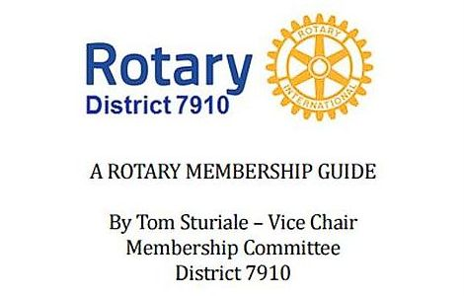"A Rotary Membership Guide" is a collection of "Membership Corner" articles written for this weekly newsletter during the 2015-2016 Rotary year, which began last July 1. It is intended to offer an idea or thought each week aimed at stimulating discussions, questions and actions to effectively increase membership at all our clubs. Click here, to download this 52-page "Guide," in Word format.

Return to January 24 Newsletter

Visit our website
'Like' our Facebook page
'Follow' us on Twitter
Watch our videos
View our photo albums

