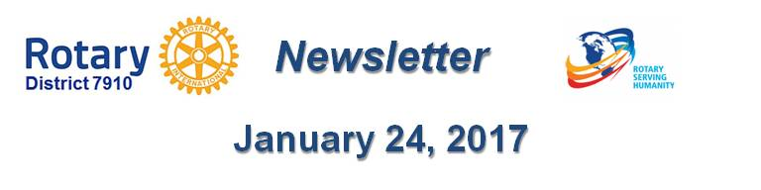

Million Dollar Dinner: $850,000 raised so far

By Satya Mitra

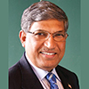With the encouragement of District Governors Pat and Skip Doyle and the full support of the District Foundation Committee, we have launched a drive to add $1 million to The Rotary Foundation Endowment Fund in this 2016-2017 Rotary year, which ends on June 30. With the launch, we plan to celebrate the Centennial Year of the Foundation by organizing a Million Dollar Dinner for the very first time in our district. I am honored to have been appointed as chair of the District Million Dollar Dinner Committee, and pleased to update you about our current status on this project on behalf of Sanjay Deshpande, chair of the District Foundation Committee.

Let me refresh you first about the Million Dollar Dinner and The Rotary Foundation, which was founded in 1917 by then-Rotary International President Arch Klumph. He shared his vision of a foundation in which funds raised through annual giving, major gifts, endowments and bequests could be used to do good in the world. That vision, which started the Rotary Foundation with an initial donation of only $26.50 – in 1917 dollars - has grown in 100 years to billions of dollars today!

A “foundation” is comprised of funds given for the permanent support of an organization. The Rotary Foundation a public charitable entity that has garnered the highest rating among its peers, transforms the donations it receives into projects that change lives both close to home and around the world. It does so by tapping into a global network of Rotarians who invest their time, money, and expertise into priorities embodied in Rotary’s six areas of focus. The support that the Foundation has provided throughout the past century has made a significant and profound difference in the entire world - with the near-eradication of polio as the crowning achievement.

Hence, this year, Foundation Centennial Celebrations are being planned worldwide. In our district, Pat and Skip Doyle have decided to commemorate the Centennial Year by launching a drive to add $1 million to the Foundation’s Endowment Fund and celebrate that achievement with a Million Dollar. I deem my appointment as chair for this drive a special honor and am absolutely thrilled and excited to see that we accomplish this goal together in our district and have the celebration event.

This drive has been launched to create an opportunity for our members and friends to give to the Endowment Fund a cumulative total of $1 million in the form of one or more of the following:
- An outright contribution - major gift - of at least $10,000 in cash or appreciated stock
- A bequest of at least $10,000 established through one’s will
- The designation of the Foundation as a beneficiary for at least $10,000 in a life-insurance policy, including a term policy or a retirement account such as a 401(k), 403(b) or IRA
- A commitment to donate only $277.77 per month for 36 months - totaling $10,000
Our district’s goal is to accumulate contributions to the Foundation’s Endowment Fund from these four forms of giving 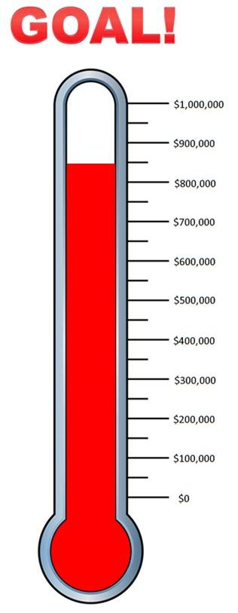totaling $1 million between last July 1 and this April 30. I am very happy to inform you that we have raised $850,000, combining outright gifts and Bequest Society commitments (see thermometer graphic, right).

I am especially happy to update that our Million Dollar Dinner is scheduled for Thursday, May 25 at Mechanics Hall in Worcester, and that Kalyan Banerjee (shown, left), past president of Rotary International and chair of The Rotary Foundation, has agreed to attend the event as our chief guest and keynote speaker. Please mark the date and plan to attend this historic celebration. Additional details will soon be provided.

We are guided in our drive by the experience and training from our Rotary Zone 32 advisor, Mac Leask, a past district governor from Connecticut. This drive will be led by 10 table captains, each of whom is already a major donor or a Bequest Society member. They will be trained to approach and convince other Rotarians and their friends and convince them to make a qualifying contribution in one of the four ways described above.

I am thankful to the following seven Rotarians who have so far agreed to be Table Captains for this exciting event (alphabetical, by last name):

- Victor Bhakta, Leominster
- Val Callahan, Worcester
- Robert Guernsey, Tyngsborough-Dunstable
- Steve Levitsky, Concord
- Arnie Miller, Brookline
- Tom Polito, Neponset Valley
- John Sbrogna, Montachusett Area
I am looking for three more members to serve as Table Captains. If anyone is interested in joining, please contact me immediately. In addition, Past District Governor Carol Toomey has agreed to provide her support and advice for the event. Pat and Skip Doyle, Sanjay Deshpande, District Governor-Elect Karin Gaffney, District Governor-Nominee Steve Sager and Immediate Past District Governor Jim Fusco have offered their full support in their leadership roles.

The key is for all members in the district to make a contribution to the Endowment Fund in one of the four ways listed above so that the district can accumulate a total sum of at least $1 million by April 30. Please note that this is our District’s effort and we all have to do our best to make it happen. This is a Foundation Centennial Celebration, so we should all be as generous as we can so that our contribution and generosity stands as a representation of hope for many people who find life is hopeless for them.

I am determined to achieve this goal by talking about it with my fellow Rotarians and non-Rotarian friends and I urge you all to talk about this special event and promote the program. If any club wants me to make a presentation about this program, I would be happy to come and talk.

I have no doubt that our district will raise much more than $1 million this Rotary year. We will set an example and establish an historic record for District 7910.

Let’s do it together. Let’s have super fun and let’s celebrate the Foundation’s Centennial Birthday with joy and pride - and do more good in the world.

I would also like to add that this drive will continue beyond the Centennial Year. I urge you to support The Rotary Foundation and create a legacy of support that lasts for generations.

Satya Mitra, chair of both the District Endowments and Major Gifts Committee and the District Million Dollar Dinner Committee, may be reached at satya@thegurutax.com.

Return to January 24 Newsletter

View pa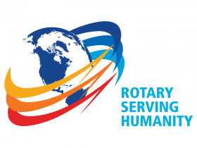st issues
Visit our website
'Like' our Facebook page
'Follow' our Twitter page

