Put yourself in a reader’s shoes
By Laura Spear

Try to think like the average newspaper reader. Search through the paper for stories, see what other non-profit organizations are promoting, and determine what editors think their readers find important.

Editors are your primary audience. That's because they’ll be deciding whether your story runs based on what they think their readers want to read.

To learn more in Rotary Voice and Visual Identity Guidelines, click here.

To learn more about PR for your club, click on the Public Relations section of the navigation bar of the District 7910 website.

Laura Spear, chair of District 7910's Public Relations Committee, may be reached at laura@spear.net.

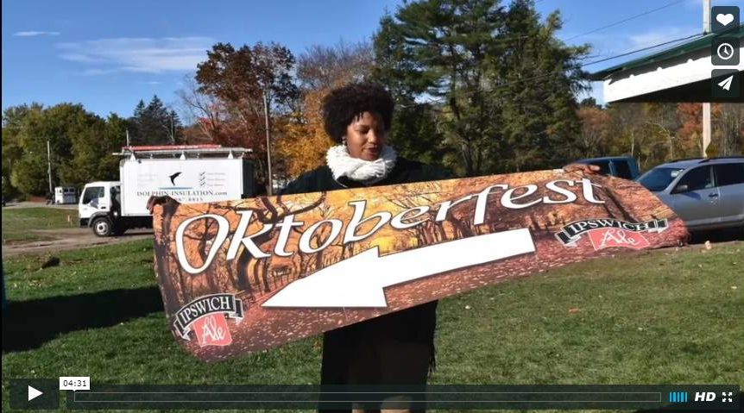Click here for an excellent example of a club-event promotional video by Concord President Steve Kirk.

Return to January 24 Newsletter

Visit our website
'Like' our Facebook page
'Follow' us on Twitter
Watch our videos
View our photo albums

