Looking Forward to Seeing You at Multi-District Conference
By Pat and Skip Doyle
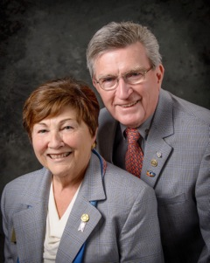
Join us this April 28 to 30 in Providence for the 2017 Multi-District Conference. As you all know, the Conference is fast-approaching. We have a great weekend planned, with fantastic world-class speakers at the event. As we have said, it is an “international” Convention that does not require either a passport or an airplane ticket.

On Friday, April 28 at 12:00 noon, we will have a Paul Harris Luncheon, followed by the Opening Ceremony with Break-out Sessions. 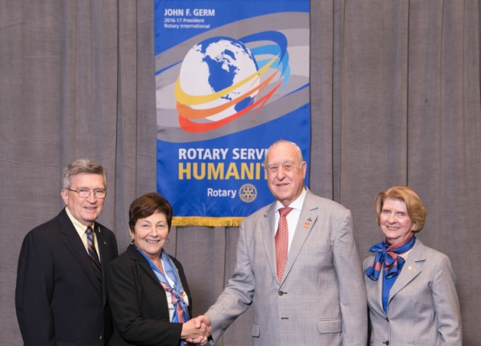 For those of you who have purchased the full weekend package, there will be a cocktail reception with Rotary International President John Germ (second from right) and his wife, Judy Germ (far right). (They are shown posing with Skip Doyle, far left, and Pat Doyle, second from left).

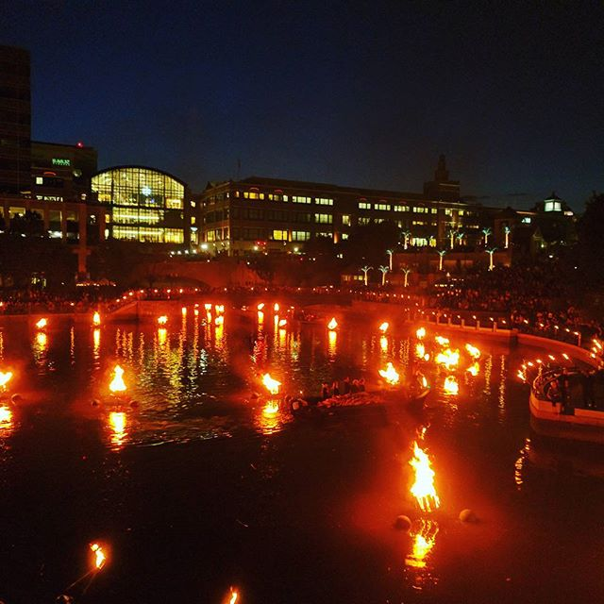John Germ will also be the keynote speaker for our Dinner on Friday. At the end of that event, we will be invited to Providence’s famed outdoor attraction, WaterFire (shown, left). To download the WaterFire fundraiser brochure in PDF format, click here.

During Breakfast on Saturday, April 29, we will have an enthusiastic motivational speaker and Rotarian, Michael Angelo Caruso (shown, right). You may want check him out on YouTube. Breakfast will be followed by 45-minute break-out sessions on many topics as well as individual district business meetings.

Saturday is also Youth Day. All Interactors, Rotoractors, ESSEX students and RYLAns are invited to attend a program put together by our young people for our young people and their advisors. Registration for this event is separate from the Conference registration. The fee for Interactors, Rotaractors and ESSEX students plus their club advisors is $25 per person, which includes lunch. The fee for Rotaractors will soon be announced.

Rotary Means Business will hold an event on Saturday afternoon. All Rotarians and their guests are invited to network and then stay for Saturday evening dinner, featuring Lauren Templeton (shown, left), president of Templeton and Phillips Capital Management, LLC, and co-author of Investing the Templeton Way and the Maximum Pessimism Report.

Sunday, April 30 will feature a time to honor deceased Rotarians. That ceremony will be followed by a brunch with an international flair, featuring Rotary Exchange Students from the four districts as well as a Group Study Exchange team from Australia. The GSE team’s focus is peace and conflict resolution.

A top-quality event such as this does not come without expenses. That is why we encourage you and your club’s Rotarians to register early. The District Conference Committee has just approved al la carte pricing for Rotarians who cannot attend for the entire event. To register for the Multi-District Conference, click here.

District 7910 Rotary clubs, businesses and Rotarians will also have the opportunity to sponsor the Multi District Conference in more than one way. First, with an ad in the magazine-style event program. These can be a small as one line with a personal note from an individual Rotarian, to different-size ads of up to full-page. To download the Program Ad Rates in PDF format, click here. (Note: The ad-rates offer is exclusively for individuals from Districts 7890, 7910, 7950, and 7980, and does not apply to either Rotary clubs or businesses. )

The Conference Committee is also looking for Gold, Platinum, and Signature sponsors for the WaterFire event. To download the Sponsorship Donations form in PDF format, click here.

Thank you very much for the moral and financial support over the past year. Rotary International, District 7910 and we are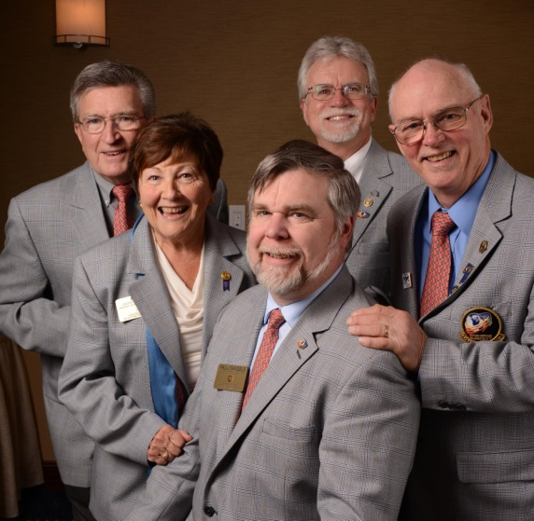 very much appreciative. No one can do alone this job of district governor. We all need each other to make this a successful Rotary year for our communities, clubs and members - as we continue to follow RI President John Germ’s theme for this Rotary year: Rotary Serving Humanity.

Thank you again, we look forward to seeing everyone at the Multi-District Conference in April in Providence.

Shown, left, are the governors of the four Rotary districts that are holding this year's Multi-District Conference: Skip and Pat Doyle (far left and second from left) of our own District 7910; Frank Mangels of District 7980; Russell Bertrand of District 7950, and Frank Wargo of District 7890.)

Six important things to know:

1. The weekly submission deadline for the Newsletter will remain the same: Friday. As usual, text content must be submitted in Word format, and image content, in either JPEG or PDF format. Continue to submit your content to Immediate Past District Governor/Newsletter Editor Jim Fusco at jim.fusco2@gmail.com.
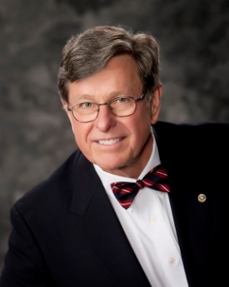
2. Resolutions: The District Resolutions Committee met on January 10 and addressed three changes to the District Resolutions that will be proposed and voted on at the annual District Business Meeting, to be held during the Multi-District Conference in Providence, on Saturday morning, April 29. For more information on the District Resolutions, contact Resolutions Chair Doug Detweiller (shown, right) at rotary@detweiler.org.

3. District Nominations: The District Nominating Committee is seeking qualified applicants to serve as District Trustee for 2017 to 2019 and District Charitable Fund Trustee for 2017 to 2020. Clubs and club leadership are asked and encouraged to actively recruit and promote service in Rotary through their members' service as district leaders. The deadline for submitting applications is this February 18. All completed applications should be either e-mailed to Nominating Committee Chair Michael Ellis (shown, right) at mellis0144@comcast.net, or mailed to him at: Michael Ellis, District 7910 Nominating Committee, 88 Coburn Ave., Gardner, MA 01440. Postmarked mail after February 18 will not be accepted. To download the Trustee Nomination Form, click here. To download the Nomination Form Supplement, click here.
4. Rotary Youth Leadership Awards: The RYLA Club Pack has been updated and posted on RYLA7910.org. When you download it, you will notice changes from last year. Please read the material carefully and direct your questions to Christine Pinney, chair of the RYLA Committee,who may be reached at christine@christinepinney.com. The RYLA season has begun and the RYLA Committee is working to make RYLA 2017 the "best RYLA ever." (See RTLA article in right hand column)

5. Club Planning Worksheet: To download the Club Planning Worksheet, click here.This worksheet is made available to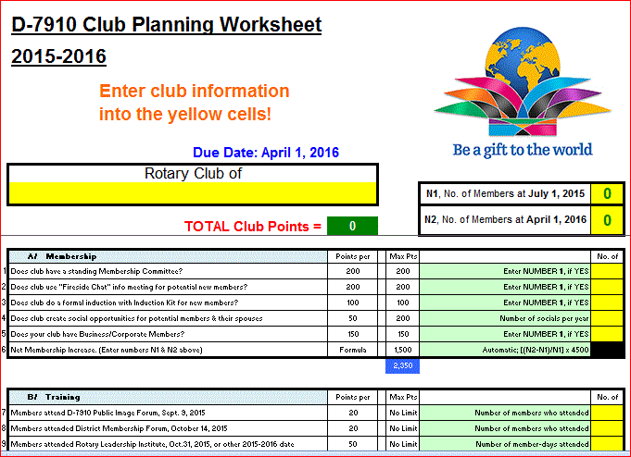 clubs so they can gauge their progress in achieving the goals they set last July. This month is a good time to review the worksheet and see how far you have come and how much farther you need to go as a club. You may surprise yourselves and realize that you are well on the way to earning district recognition. We recommend the club president appoint the president-elect to be the "champion" of the Worksheet, and to use it as a guide for the club, and to report monthly to the club's membership and board on the club's progress.

6. As your district governors, we have resolved to:
- Revisit as many clubs as possible in the next few months.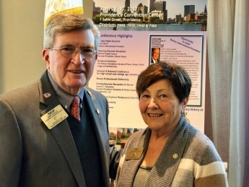
- Help our clubs achieve the goals they set in July
- Do all we can to build membership in the district
- Plan a grand event to celebrate our Million Dollar Foundation Journey
- "Move the ball forward," in harmony, with District Governor-ElectKarin Gaffney, District Governor-Nominee Steve Sager and District Governor-Nominee-Designate Pamela Anastasi
- Celebrate all of this at our Multi-District Conference this April in in Providence
District Governors Pat and Skip Doyle (shown, right) may be reached at pwdoyle2@verizon.net and skipdoyle2@verizon.net, respectively.

Click here to submit content for the Tuesday, February 7 issue. The submission deadline for this issue is Friday, February 3.

Click here for past issues.

Return to January 31 Newsletter

Visit our website
'Like' our Facebook page
'Follow' us on Twitter
Watch our videos
View our photo albums

