GOVERNORS' WELCOME
Welcome to Rotary District 7910, which serves Central Massachusetts. We are comprised of 51 clubs whose members represent a cross-section of society. Community members of all ages come together in Service Above Self by undertaking local and international projects that help improve the lives of people.

Our commitment to service is grounded in the fellowship of people who collaborate to make our communities and the world a better place. This year’s Rotary International theme—Rotary Serving Humanity—challenges us to come together for one, overriding goal: service.

District Governors Pat and Skip Doyle may be reached at pwdoyle2@verizon.net and
skipdoyle2@verizon.net, respectively.

District Governors' home club: Northborough

REGISTER NOW: 2017 MULTI-DISTRICT CONFERENCE, APRIL 28-30, PROVIDENCE.

TO REGISTER, CLICK HERE.
To download the Conference Highlights flyer (shown, below) in:
- PDF format, click here
- JPEG format, click here
To download the Conference Sponsorship Donation form in PDF format, click here

To download the Rotary Waterfire Fundraiser brochure in PDF format, click here

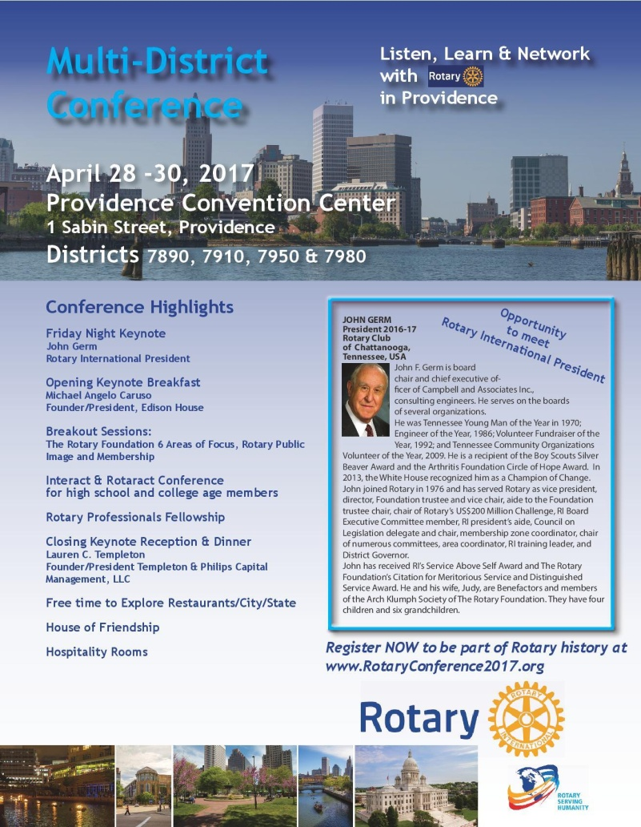

SAVE A DATE: DISTRICT MEMBERSHIP WORKSHOPS, MARCH 21, 23, 28 OR 30
To learn more on the Membership Workshops, click here

To download the Workshops flyer in PDF format, click here

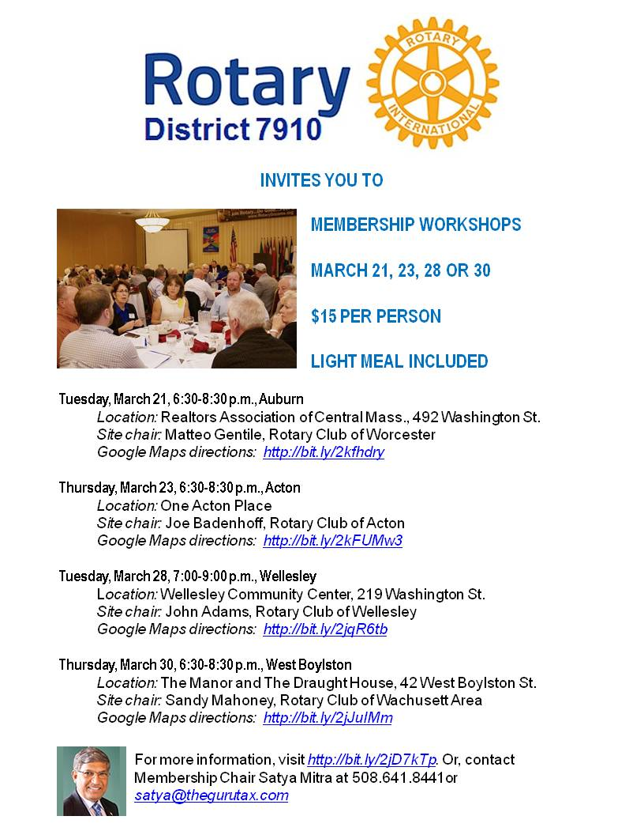

HOT OFF THE PRESS!

2016-2017 ROTARY DISTRICT 7910 DIRECTORY

Print copies of our 332-page, information-packed 2016-2017 RotaryDistrict 7910 Directory have been delivered to your club.

The Directory includes:
- District 7910 and Rotary International general information
- District club information
- Yellow Pages of Rotarian-run businesses
- District Resolutions
- Complete membership directory

A digital version of the Directory is now available for automatic download, in PDF format. Please note: Member login is required.

Click here, to download

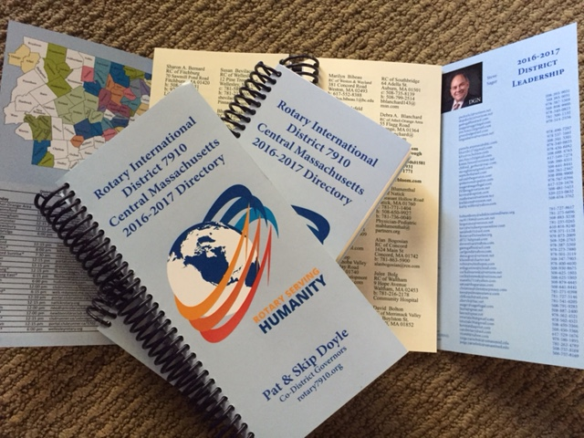

DISTRICT AT A GLANCE

Click on each one

DISTRICT SOCIAL MEDIA

Click on each one

VIEW LIVE: OUR FACEBOOK PAGE!
Rotary District 7910

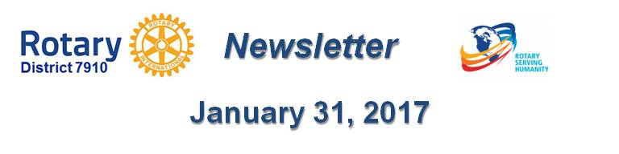

Click here for the complete issue

Or, click on each of these issue highlights:

Governor’s Message: Looking Forward to Seeing You at Multi-District Conference - By Pat and Skip Doyle

RYLA Update: Training, Registration and Deadlines for Rotary Youth Leadership Awards - By Christine Pinney

Membership Corner: Mark your calendar for March Membership Workshops - By Tom Sturiale

Morley Scholarship Deadline: Applications due by March 15

Million Dollar Dinner: $850,000 raised so far - By Satya Mitra

PR Tips: Know what role your club plays in your community - By Laura Spear
Plus: Lots more district and club news, information and events

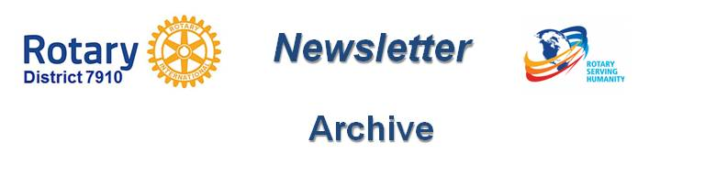

Click here for our archive of past issues

