GOVERNOR'S MESSAGE
Looking Forward to Seeing You at Multi-District Conference

By Pat and Skip Doyle
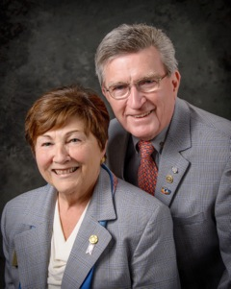Join us this April 28 to 30 in Providence for the 2017 Multi-District Conference. As you all know, the Conference is fast-approaching. We have a great weekend planned, with fantastic world-class speakers at the event. As we have said, it is an “international” Convention that does not require either a passport or an airplane ticket.

On Friday, April 28 at 12:00 noon, we will have a Paul Harris Luncheon, followed by the Opening Ceremony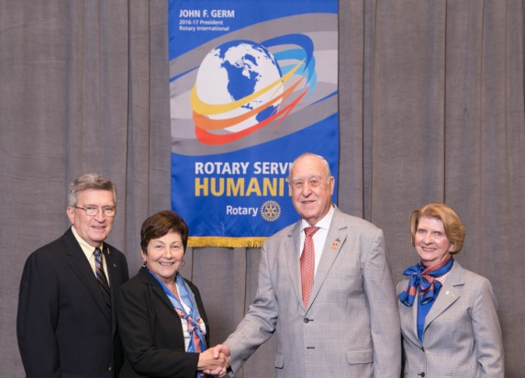 with Break-out Sessions. For those of you who have purchased the full weekend package, there will be a cocktail reception with Rotary International President John Germ (second from right) and his wife, Judy Germ (far right). (They are shown posing with Skip Doyle, far left, and Pat Doyle, second from left).

John Germ will also be the keynote speaker for our Dinner on Friday. At the end of that event, we will be invited to Providence’s famed outdoor attraction, WaterFire (shown, left). To download the WaterFire fundraiser brochure in PDF format, click here.

During Breakfast on Saturday, April 29, we will have an enthusiastic motivational 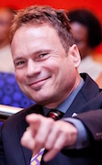speaker and Rotarian, Michael Angelo Caruso (shown, right). You may want check him out on YouTube. Breakfast will be followed by 45-minute break-out sessions on many topics as well as individual district business meetings.

Saturday is also Youth Day. All Interactors, Rotoractors and RYLAns are invited to attend a program put together by our young people for our young people and their advisors. Registration for this event is separate from the Conference registration. The fee for Interactors, Rotaractors and ESSEX students plus their club advisors is $25 per person, which includes lunch. The fee for Rotaractors will soon be announced.

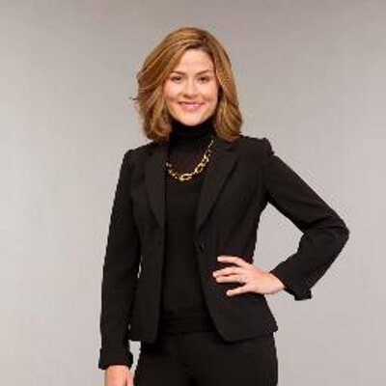Rotary Means Business will hold an event on Saturday afternoon. All Rotarians and their guests are invited to network and then stay for Saturday evening dinner, featuring Lauren Templeton (shown, left), president of Templeton and Phillips Capital Management, LLC, and co-author of Investing the Templeton Way and the Maximum Pessimism Report.

Sunday, April 30 will feature a time to honor deceased Rotarians. That ceremony will be followed by a brunch with an international flair, featuring Rotary Exchange Students from the four districts as well as a Group Study Exchange team from Australia. The GSE team’s focus is peace and conflict resolution.

A top-quality event such as this does not come without expenses. That is why we encourage you and your club’s Rotarians to register early. The District Conference Committee has just approved al la carte pricing for Rotarians who cannot attend for the entire event. To register for the Multi-District Conference, click here.

District 7910 Rotary clubs, businesses and Rotarians will also have the opportunity to sponsor the Multi District Conference in more than one way. First, with an ad in the magazine-style event program. These can be a small as one line with a personal note from an individual Rotarian, to different-size ads of up to full-page. To download the Program Ad Rates in PDF format, click here. (Note: The ad-rates offer is exclusively for individuals from Districts 7890, 7910, 7950, and 7980, and does not apply to either Rotary clubs or businesses.)

The Conference Committee is also looking for Gold, Platinum, and Signature sponsors for the WaterFire event. To download the Sponsorship Donations form in PDF format, click here.

Thank you very much for the moral and financial support over the past year. Rotary International, District 7910 and we are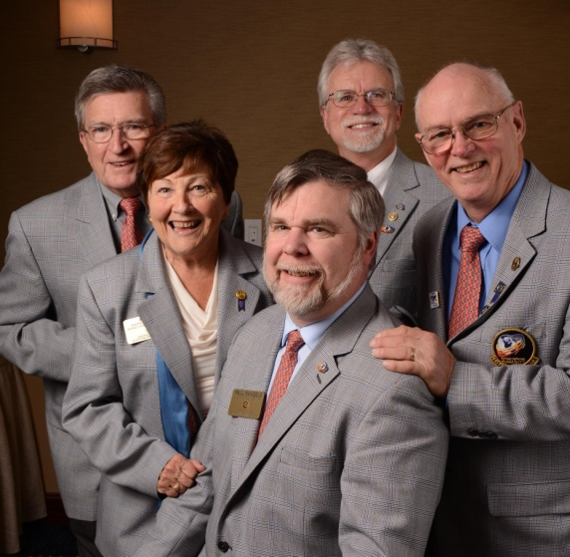 very much appreciative. No one can do alone this job of district governor. We all need each other to make this a successful Rotary year for our communities, clubs and members - as we continue to follow RI President John Germ’s theme for this Rotary year: Rotary Serving Humanity.

Thank you again, we look forward to seeing everyone at the Multi-District Conference in April in Providence.

Shown, left, are the governors of the four Rotary districts that are holding this year's Multi-District Conference: Skip and Pat Doyle (far left and second from left) of our own District 7910; Frank Mangels of District 7980; Russell Bertrand of District 7950, and Frank Wargo of District 7890.)

Six important things to know:

1. The weekly submission deadline for the Newsletter will remain the same: Friday. As usual, text content must be submitted in Word format, and image content, in either JPEG or PDF format. Continue to submit your content to Immediate Past District Governor/Newsletter Editor Jim Fusco at jim.fusco2@gmail.com.

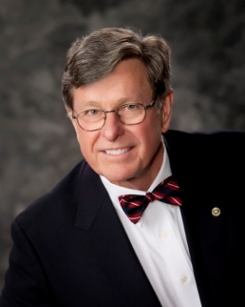
2. Resolutions: The District Resolutions Committee met on January 10 and addressed three changes to the DistrictResolution that will be proposed and voted on at the annual District Business Meeting, to be held during the Multi-District Conference in Providence, on Saturday morning, April 29. For more information on the District Resolutions, contact Resolutions Chair Doug Detweiller (shown, right) at rotary@detweiler.org.

3. District Nominations: The District Nominating Committee is seeking qualified applicants to serve as DistrictTrustee for 2017 to 2019 and District Charitable Fund Trustee for 2017 to 2020. Clubs and club leadership are asked and encouraged to actively recruit and promote service in Rotary through their member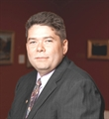s' service as district leaders. The deadline for submitting applications is this February 18. All completed applications should be either e-mailed to Nominating Committee Chair Michael Ellis (shown,right) at mellis0144@comcast.net, or mailed to him at: Michael Ellis, District 7910 Nominating Committee, 88 Coburn Ave., Gardner, MA 01440. Postmarked mail after February 18 will not be accepted. To download the Trustee Nomination Form, click here. To download the Nomination Form Supplement, click here.
4. Rotary Youth Leadership Awards: The RYLA Club Pack has been updated and posted on RYLA7910.org. When you download it, you will notice changes from last year. Please read the material carefully and direct your questions to Christine Pinney, chair of the RYLA Committee,who may be reached at christine@christinepinney.com. The RYLA season has begun and the RYLA Committee is working to make RYLA 2017 the "best RYLA ever." (See RTLA article in right hand column)

5. Club Planning Worksheet: To download the Club Planning Worksheet, click here.This worksheet is made available to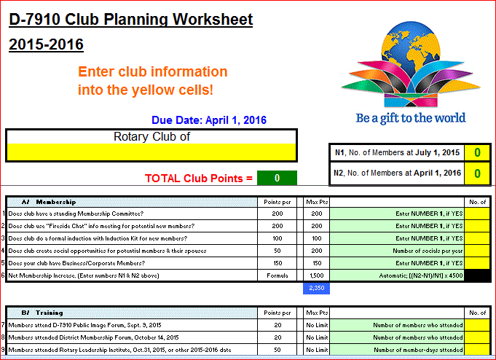 clubs so they can gauge their progress in achieving the goals they set last July. This month is a good time to review the worksheet and see how far you have come and how much farther you need to go as a club. You may surprise yourselves and realize that you are well on the way to earning district recognition. We recommend the club president appoint the president-elect to be the "champion" of the Worksheet, and to use it as a guide for the club, and to report monthly to the club's membership and board on the club's progress.

6. As your district governors, we have resolved to: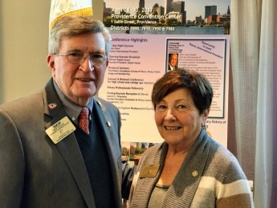
- Revisit as many clubs as possible in the next few months.
- Help our clubs achieve the goals they set in July
- Do all we can to build membership in the district
- Plan a grand event to celebrate our Million Dollar Foundation Journey
- "Move the ball forward," in harmony, with District Governor-ElectKarin Gaffney, District Governor-Nominee Steve Sager and District Governor-Nominee-Designate Pamela Anastasi
- Celebrate all of this at our Multi-District Conference this April in in Providence
GOVERNOR'S MESSAGE PAGE (in case you want to share a link to this article)

District Governors Pat and Skip Doyle (shown, right) may be reached
at pwdoyle2@verizon.net and skipdoyle2@verizon.net, respectively.

Click here to submit content for the Tuesday, February 7 issue.
The submission deadline for this issue is Friday, February 3.

Click here for past issues.

WELCOME, NEW ROTARIANS
Alphabetical order, by last name
- Yun-Ju Choi, Lowell
- Carrie Medley, Ayer
- Jesse Medley, Ayer
- Justin Mussler. Shrewsbury
- Robert Toy-Giles, Franklin
Remember to ask ... ask ... ask!

REMEMBERING OUR ROTARIANS
Alphabetical order, by last name

Morton Wolf of Milton, 1922-2017

It is with a sad heart that we inform you that our fellow Rotarian, Dr. Morton Wolf, DVM, has passed away. He died peacefully on January 28, surrounded by his family. He was a dedicated member of the Rotary Club of Milton for more than 30 years. We will greatly miss him. The funeral services and sitting shiva took place yesterday, January 30.

LEARN MORE

DISTRICT SCHOLARSHIP DEADLINE, MARCH 15
Applications Sought for David and Eleanor Morley Endowed Global Grant Scholarship
To learn more about the Morley Scholarship, click here.
To download the Morley Scholarship flyer in PDF format, click here.

CLUB MEMBERSHIP GROWTH, ’16-‘17
We share with you the results of club-membership growth in our district during Rotary year 2016-2017, which began July 1.

This is a unique opportunity for Rotarians and friends to discuss partnering on humanitarian projects affecting our local communities.

READ MORE

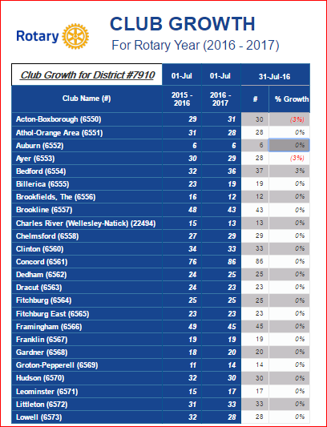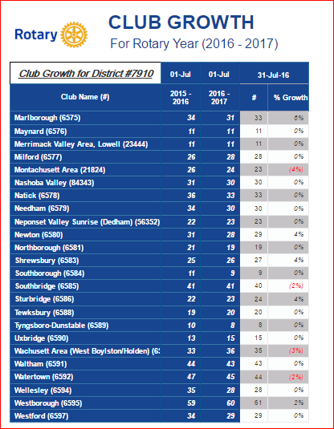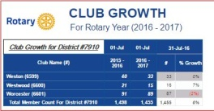

DISTRICT & CLUB ROUNDS
Awesome Time At January's Rotary Means Business

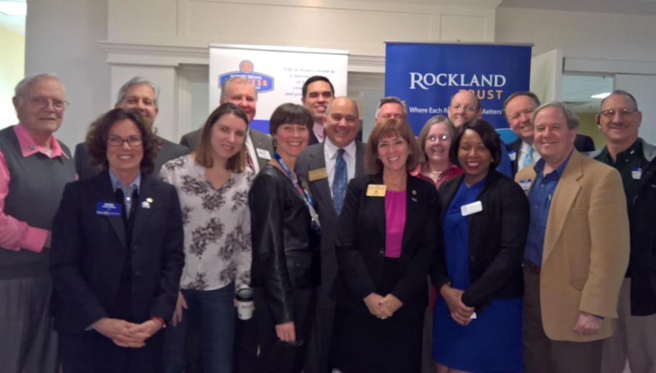

Rotarians and friends had an awesome time at District 7910's Rotary Means Business networking event on January 25 in Waltham. The event was attended by 52 Rotarians and guests from more than 25 clubs, who learned a little about each other's business.

Attendees included District Governor-Elect Karin Gaffney (second from left), Rotary Means Business Chair Ron Bott (third from left), District Governor-Nominee Steve Sager (eighth from left), and District Governor- Nominee-Designate Pam Anastasi (ninth from left), and Past District Governor Carol Toomey (10th from left) A big thank -you goes out to Rockland Trust for sponsoring this event.

Save Wednesday, March 1 for the next Rotary Means Business networking event, at the Radisson Hotel and Suites in Chelmsford. To learn more about Rotary Means Business, click here.

Franklin Presents Rotaract Charter Certificate, RYLA grant

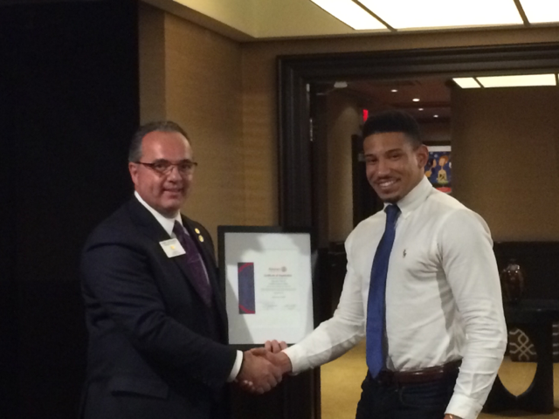

Terry Katsaros (left), president of the Rotary Club of Franklin, recently presented Robert (Nua) Toy-Giles (right), president of the Rotaract Club of Franklin at Dean College,with that Rotaract club's charter certificate.

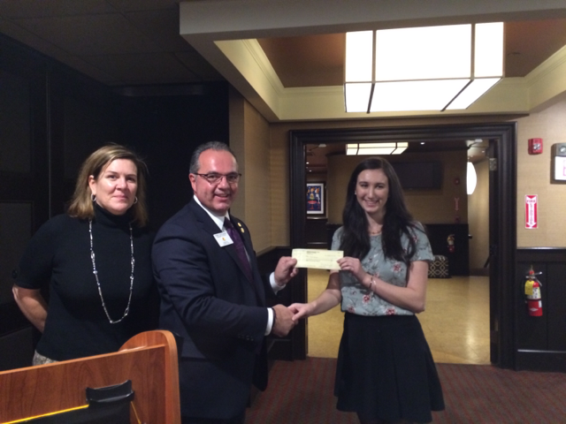

Also recently, Julie Rougeau (left), Franklin Rotary's Vocational/RYLA chair, and Terry Katsaros (middle), presented a $1,000 scholarship grant to UMass student Nicole Rabovsky (right), a 2016 graduate of Franklin High School.

To learn more about Franklin Rotary, click here.

Nashoba Valley Celebrates Power of Change
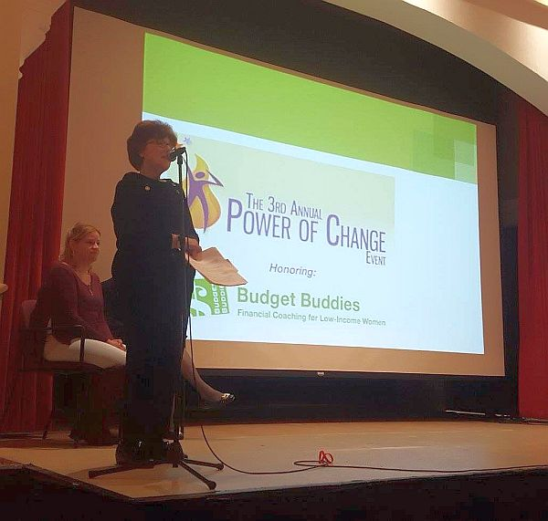

On January 23, the Rotary Club of Nashoba Valley recognized Budget Buddies as the recipient of the club's third Power of Change Award for the work the organization has done to better the lives of women.

Shown, standing, is Nashoba Valley President-Elect Mary Denio Garcia as she kicked off the Power of Change event.

To learn more about Nashoba Valley Rotary, click here.

Southborough Expands Scholarship Program

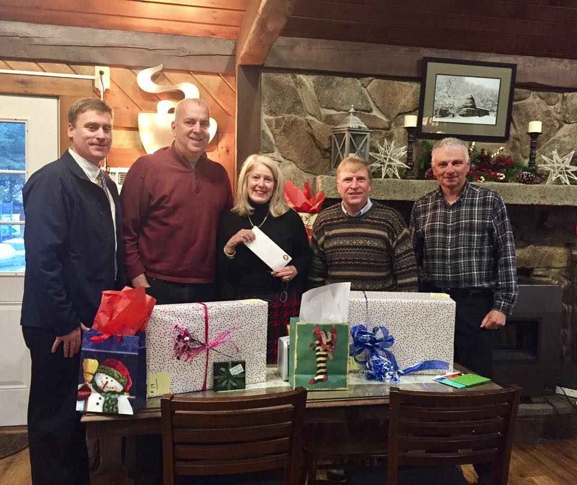

The Rotary Club of Southborough has announced a second scholarship for high school students from Southborough. The winning student will receive $1,000 per year to help attend a four-year Massachusetts state college or university. Applicants will be judged on academic achievements and public service. Prior to this, Southborough Rotary was only able to help one student for four years. Thanks to stepped-up fundraising efforts and generous donations, the club is now able to expand its program. The new scholarship means the club doesn't have to wait for its current recipient to graduate in 2020, to award another scholarship.
Applications are due by April 10. The application forms are available at the Algonquin Regional High School’s Guidance Office, and by contacting Southborough Treasurer Carl Guyer at carl.guyer@gmail.com.
Shown, are several members of Southborough Rotary.
To learn more about Southborough Rotary, click here.

Our DGE Meets Rotary's PE at RI Assembly in San Diego

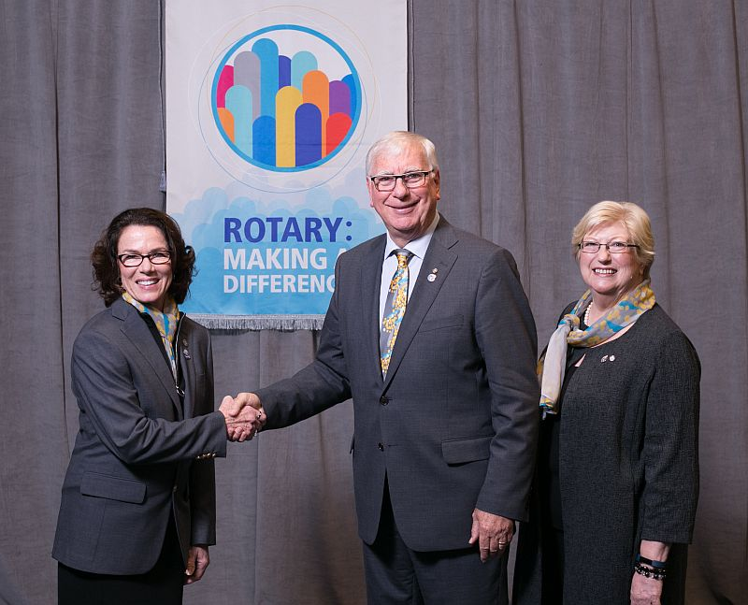

District Governor-Elect Karin Gaffney (shown, right) got to meet and pose with Ian Riseley (shown, middle), president-elect of Rotary International, and his wife, Janet Riseley (shown, left) during the 2017 RI Assembly, held from January 15 to 21 in San Diego. The Riseleys hail from Australia, where they are members of the Rotary Club of Sandringham.

Rotary's annual training meeting gives district governor-elects the chance to share ideas for strengthening clubs and improving communities with Rotary leaders from around the world. Keynote speakers and informative presentations inspire and prepare the DGEs for 2017-2018 Rotary year, which begins July 1, to lead their districts successfully. Idea exchanges, roundtable discussions, and workshops introduce them to new ways of creating positive change.

To learn more about Ian Riseley, click here.

Our Interact Chair in Present in India

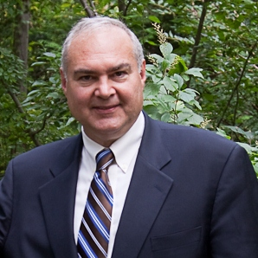Bob Anthony (shown,left), chair of theDistrict Interact Committee, is visiting new Rotary friends from January 24 through February 10 in Goa, India. He has been invited to briefly present at the Rotary District 3170 conference there. One of that district's clubs, Hubli East, partnered with the Rotary Club of Wellesley, of which Bob is a member, through a Global Grant to implement the Peer Leadership and Depression Prevention project. To watch a two-minute video on the project, click here. Basically, the project delivers train-the-trainer on a Boston Children's Hospital curriculum to educators and, eventually, to Interact peer leaders. To learn more,click here.

To learn more about Interact, click here.

Multi-Club Power Play

Needham Teams Up with Framingham, Newton, Waltham and Watertown on India Solar-Power Project

The Rotary Clubs of Needham, Framingham, Newton, Waltham and Watertown have partnered to fund a $6,000 solar-power project (shown, left) for Film Nagar High School in Hyerabad, India. The host club there is the Rotary Club of Jubilee Hills, in District 3150.

Needham paid $3,000 of the $6,000 - $1,500 of which should come back as District Grant match. Watertown, Waltham, Newton and Framingham paid $500 each.

READ MORE

To learn more about:
- Framingham Rotary, click here
- Jubilee Hills Rotary, click here
- Needham Rotary, click here
- Newton Rotary, click here
- Waltham Rotary, click here
- Watertown Rotary, click here

Acton-Boxborough Sponsors Six High School Students for RYLA

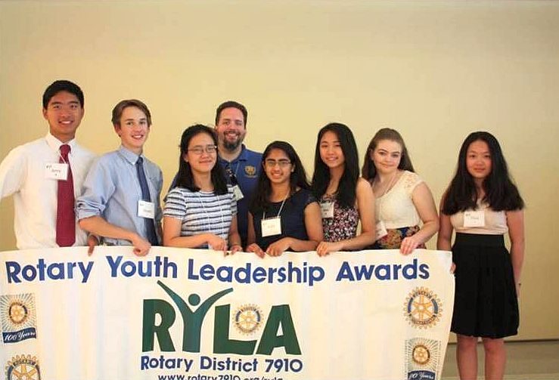

The Rotary Club of Acton-Boxborough has sponsored six sophomores Acton-Boxborough Regional High School, to attend the Rotary Youth Leadership Awards Conference to be held June 24 to 26 at Fitchburg State University.

Left to right: Anthea Bell, of Boxborough; and Lindsey Huang, Aditi Sirsikar, Juliana Walsh, Anna Wu and Jerry Wu, of Acton.

To learn more about Acton-Boxborough Rotary, click here.

Auburn Teams Up with FAME for Music & Wine Event to Benefit Education on March 17

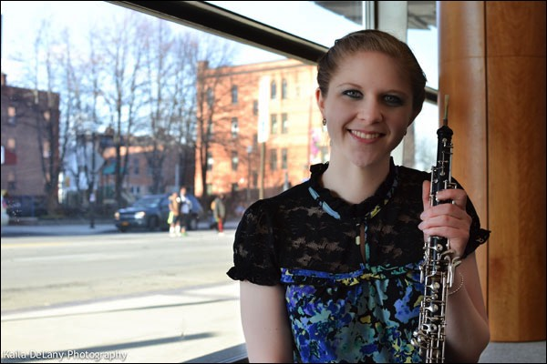

Join the Rotary Club of Auburn and Friends of Auburn Music Education for their 2017 St. Patrick’s Day Music & Wine Event. This festive celebration will take place on Friday, March 17 from 5:00 to 9:00 p.m. in the Great Hall of Pakachoag Church, located at 203 Pakachoag St. in Auburn. This community fundraiser will benefit Auburn Rotary's education scholarships and other charitable endeavors, plus FAME. This festive celebration will feature a performance by Professional Oboist Lydia Consilvio (shown, above) of Auburn, and a faculty recital by the Auburn Public Schools' Fine Arts Department.

PURCHASE TICKETS & MORE INFORMATION

To learn more about Auburn Rotary, click here.

Bedford Gears Up for April Meal-Packing Event

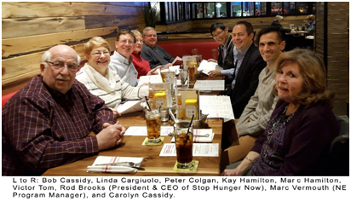

Members of the Rotary Club of Bedford were recently invited to speak with Rod Brooks, president and CEO, and the Marc Vermouth, New England program manager of Stop Hunger Now. Held at the Red Heat Tavern in Bedford, the meeting was in recognition of Bedford Rotary’s enduring (annually since 2013) and successful meal-packing programs (more than one-quarter-million total meals packaged to date) in the Bedford area assisted by other Rotary clubs and industry partners. Rod Brooks congratulated and thanked Bedford Rotarians for their efforts, and revealed expanded directions for Stop Hunger Now, including water, agriculture and educational programs to combat worldwide hunger. In the next few weeks, Stop Hunger Now will announce a new global branding and logo to reflect this focus.

For 2017, Bedford Rotary has secured the morning of Saturday, April 8 at Middlesex Community College (Bedford Campus) for this year’s exciting meal-packing event. The club plans to have again multiple Rotary club and industry partners, including BAE Systems as the major corporate sponsor. If you are interested in joining this year’s event, please contact this year’s chair, Past District Governor Bob Cassidy, at rac011846@comcast.net.

Shown right: During Bedford Rotary's 2016 meal-packing event, volunteers from Rotary, industry and nearby communities had fun fighting world hunger, with assembly lines running from raw rice, in the foreground, to packaged boxes, in the background.

To learn more about Bedford Rotary, click here.

Hudson, Nashoba Valley Brewfest Showcased in Rotary Magazine

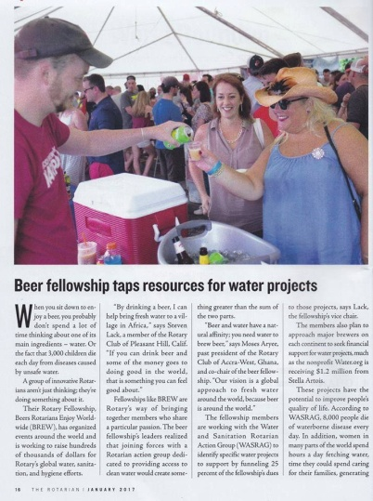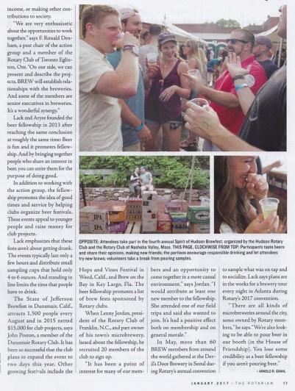

The Rotary clubs of Hudson and Nashoba Valley were showcased in the "Brewfest" section of the January issue of the Rotary Magazine.

To read the first page of the article (shown, left), in PDF format, click here.

To read the second page of the article (shown, right), in PDF format, click here.

To learn more about Hudson Rotary, click here.

To learn more about Nashoba Valley Rotary, click here.

Dedham Publishes Cookbook: Get your copy now

Hot off the press is the first Rotary Club of Dedham Cookbook! It features 420 recipes from Rotarians and their families across the U.S. and some from far away as Russia. Special dishes featured come from the kitchens of all Americans - great ethnic foods, desserts and beverages.
The Cookbook cover features a full-page color photo of the MIT Endicott House in Dedham, where the club meets on Thursdays. This fundraising Cookbook is available for $25, plus shipping. You may purchase it at DedhamRotary.org, or by contacting Past President Sandra Nelson at skintelligence1@gmail.com. Happy New Year - and bon appetit!
To learn more about Dedham Rotary, click here

Westborough Uses PayPal to Raise Nearly $2,000 for Polio Plus

READ MORE

To research charities that have a registered 501(c)3 account with PayPal, click here.

To learn more about Westborough Rotary, click here.

District Highlights Fundraising Goals in Video

We are all well aware that The Rotary Foundationis celebrating its 100th anniversary in 2017.Steve Kirk, president of the Rotary Club of Concord, has produced a five-minute video that outlines our own district’s fundraising goals for the current Rotary year, which ends next June 30.

WATCH VIDEO

To learn more about The Rotary Foundation, click here.

Now Available: Video of Governor Baker's District Rotarian address

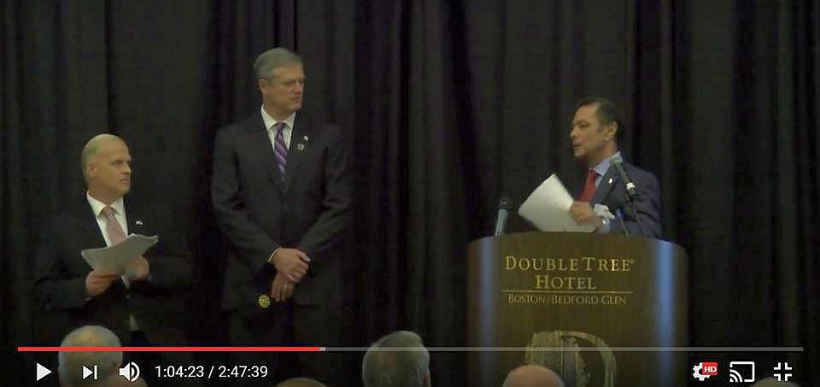

The Rotary Club of Billerica has provided a video of Governor Charlie Baker's address to District 7910 Rotarians on September 27 at the DoubleTree Hotel in Bedford. To watch the two-hour-47-minute video, click here.

The Rotary Clubs of Bedford, Billerica, Lowell, Newton and Shrewsbury sponsored the event, which was a unique opportunity for Rotarians and friends to discuss partnering on humanitarian projects affecting our local communities. To view event photos, click here.

Meet Tatsuya Hayase, Our Rotary Scholar

To Have Tatsuya Speak to Your Club, Contact Indira Desai

READ MORE

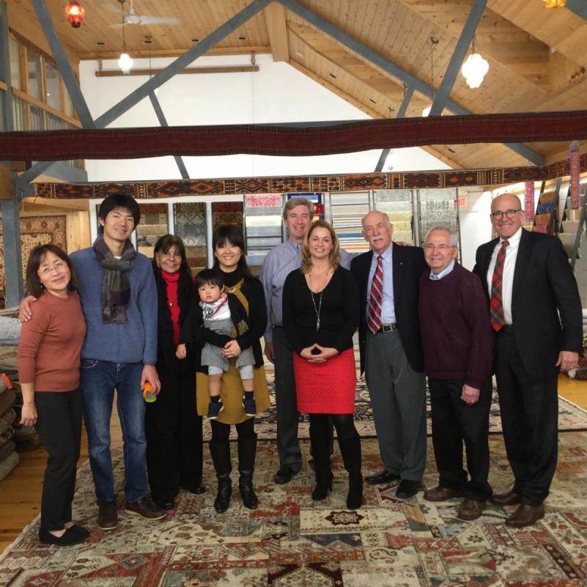

Left to right: Newton Rotarian Chris Chu; Rotary Scholar Tatsuya Hayase, his wife, Marie Hayase, and their son, Yuto Hayase; Host Counselor Indira Desai, immediate past president of Newton Rotary; Newton Rotary President Paul Sullivan and his wife, Monica Sullivan; District Scholarship Chair Tory DeFazio, a Wellesley Rotarian; and Newton Rotarians Tony Bibbo and Tom Keery.

A Great Fundraising Idea for All Clubs

Milford Distributes '16 Tab to 13,000 Homes - Record sales, 94 photos, 334 smiling faces

To read the Milford RotaryTab, click here.

To learn more about Milford Rotary, click here.

On to Atlanta in 2017: Register now!

Planning to attend? Contact District Chair Steve Glines.

To learn more, click here.

To register for the 2017 RI Convention in Atlanta, click here.

Pat and Skip Doyle Installed as '16-'17 DGs

To watch a video of the installation, click here.

District Banners Available

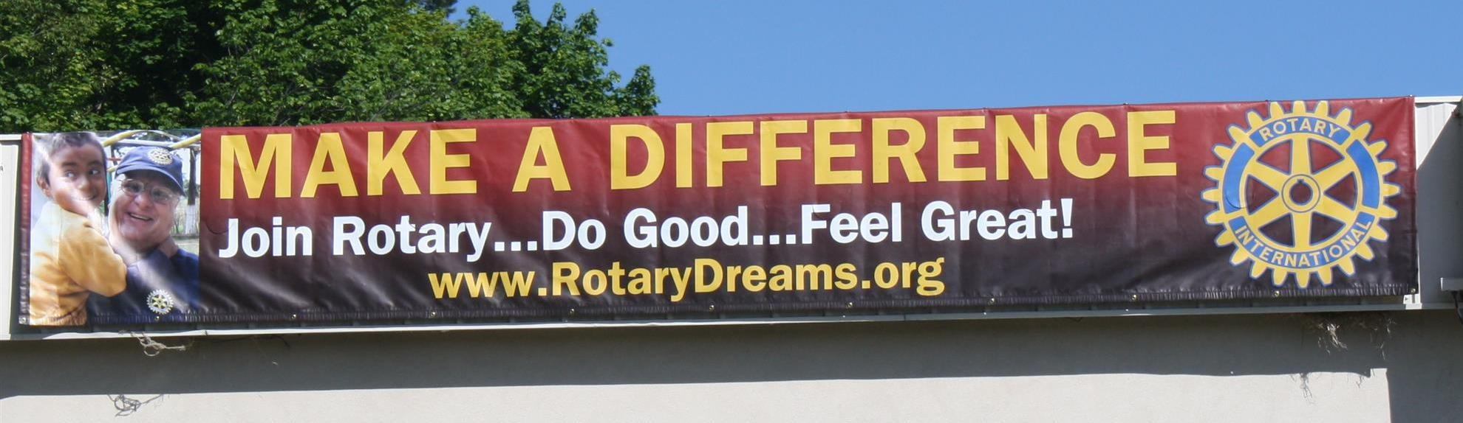

Our district banners are available for your use when you have an upcoming event or fundraiser.

If you want to reserve one of the banners, please contact PR Chair Laura Spear at laura@spear.net.

MAJOR DISTRICT & CLUB HAPPENINGS: WINTER 2017

Saturday, March 11: Uxbridge - 'Wine and Chocolate Tasting'

Click here, to visit and "like" our Facebook page

Click here to download event flyer

Wednesday, March 15: District 7910 - 'Deadline for Morley Scholarship Applications'

To learn more, click here

To download flyer in PDF format, click here

Friday, March 17: Auburn - '2017 St. Patrick's Day Music & Wine Event to Benefit Education'

To learn more, and to purchase tickets, click here

To download event flyer in PDF format, click here
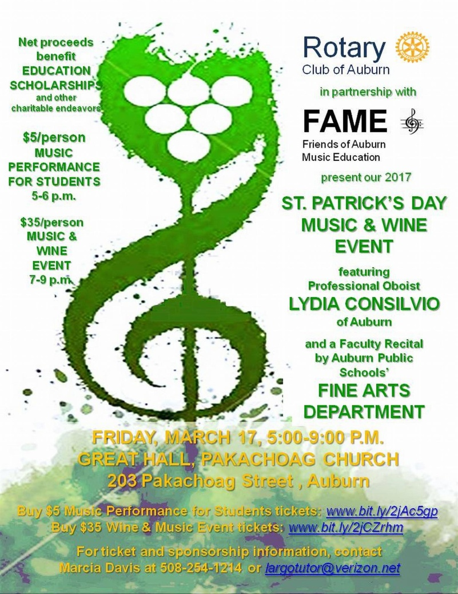

Friday, March 17: Billerica - 'Finnegan's Wake Hilarious'

To download flyer in PDF format, click here

Tuesday, March 21; Thursday, March 23; Tuesday, March 28; or Thursday, Match 30: - District 7910 - 'Membership Workshops'

To download flyer in PDF format, click here
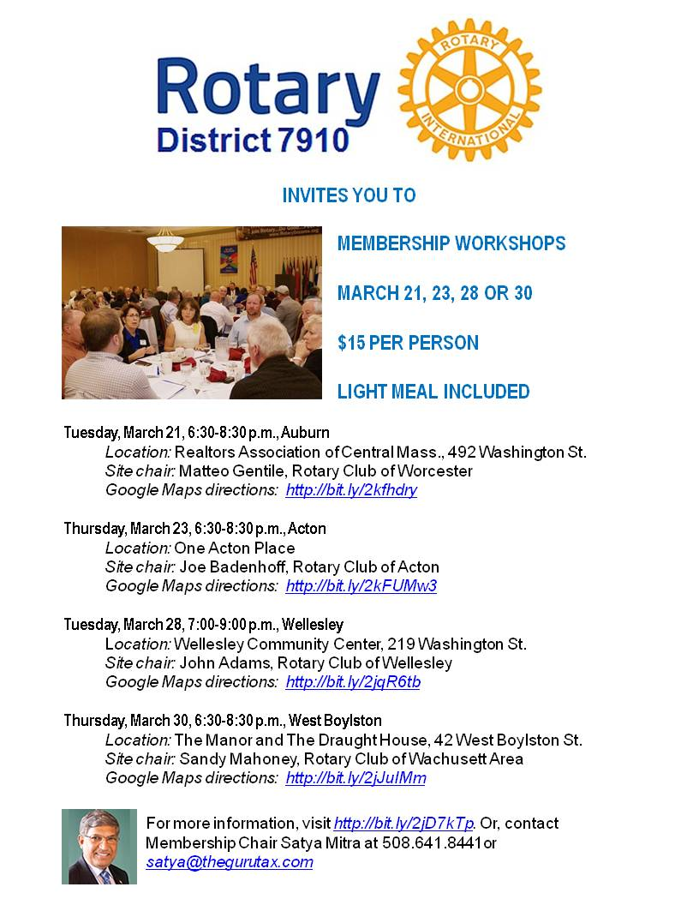

SUBMIT MAJOR CLUB HAPPENINGS

Send flyers of your club's major events and activities, in either JPEG or PDF format, to Immediate Past District
Governor/Newsletter Editor Jim Fusco at jim.fusco2@gmail.com.

