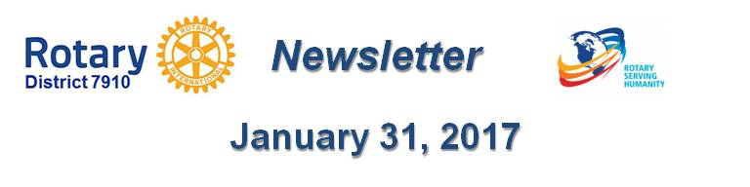

Get visual
By Laura Spear

Visual content engages the public and media outlets. According to a recent survey, 80 percent of North American journalists believe photos, infographics, and videos are key ingredients of effective content.

Submit photos to your local newspapers, post videos and pictures on Facebook. Also, share visual images from Rotary International, District 7910, and other Rotary clubs.

To learn more in Rotary Voice and Visual Identity Guidelines, click here.

To learn more about PR for your club, click on the Public Relations section of the navigation bar of the District 7910 website.

Laura Spear, chair of District 7910's Public Relations Committee, may be reached at laura@spear.net.

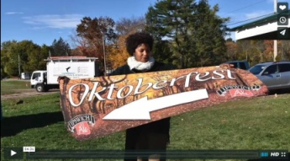Click here for an excellent example of a club-event promotional video by Concord President Steve Kirk.

Return to January 31 Newsletter

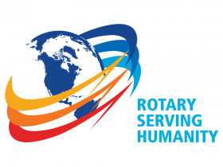Visit our website
'Like' our Facebook page
'Follow' us on Twitter
Watch our videos
View our photo albums

