

Register now for NEPETS, March 9-11, Framingham

RI President-Elect Ian Riseley to be Keynote Speaker
By Karin Gaffney
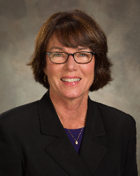
To register now for the Northeast Presidents-Elect Training Seminar on March 9 through 11 at the Sheraton Framingham Hotel and Conference Center in Framingham, click here. Explore the NEPETS website, where you will also find the agenda, the dress code, a bio of the speakers and a link to an innovative mobile app, Guidebook, that we’ve developed for your smartphone or tablet.

The program on Thursday, March 11 is not to be missed: the fantastic kick-off to your PETS experience, offering inspiration, tools and skills that you can use right away, both in Rotary and professionally. To watch a brief video featuring a sneak-peek of Thursday's programming, click here. You have the special opportunity that Thursday to meet Rotary International President-Elect Ian Riseley (shown, right) who will be our keynote speaker that evening. To learn more about him, click here.

I will provide a more detailed orientation regarding PETS at our upcoming Pre-PETS session. In the meantime, if you have a question, don’t hesitate to reach out to me by e-mail or phone, at karin.gaffney@rocklandtrust.com or 978-387-5369. I’ll check in with you in the coming weeks to make sure you have successfully registered.

For more information on the 2017 Rotary International Convention in Atlanta, click here.
District Governor-Elect Karin Gaffney may be reached at karin.gaffney@rocklandtrust.com.

Return to January 9 Newsletter


View past issues
Visit our website
'Like' our Facebook page
'Follow' our Twitter page

