Dear $NICK_NAME$,

It is our pleasure to share with you the January 9 issue of Rotary District 7910 Newsletter.

For the complete issue, click here.

To explore past issues, click here.

Highlights of the January 9 issue:

Governor’s Message: Snow, Resolutions, Nominations, RYLA and Club Planning - By Pat and Skip Doyle

District Governor-Elect Report: Register now for NEPETS, March 9-11, Framingham; RI President-Elect Ian Riseley to be Keynote Speaker - By Karin Gaffney

Nominations Call: Seeking qualified applicants - By Mike Ellis

Rotary Means Business: Next meeting on January 25 in Waltham - By Ron Bott

Membership Corner: The Rotary mid-year check - By Tom Sturiale

PR Tips: When a press release isn’t the answer - By Laura Spear

Polio Plus Update: History of wildpolio virus - By Carl Good III

ESSEX Essentials: Learn about academic-year and summer-cultural-exchange programs

District Scholarship Deadline, March 15: Applications Sought for David and Eleanor Morley Endowed Global Grant Scholarship

Rules for January’s District Interact Video Contest: Submission deadline is January 31

2017 Multi-District Conference: April 28-30 in Providence – Register Now!

Our next newsletter will come out on Monday, January 16. The submission deadline is Friday, January 13. Text content must be submitted in Word format. Image content must be submitted in either JPEG or PDF format. Send your content submissions to Immediate Past District Governor/Newsletter Editor Jim Fusco at jim.fusco2@gmail.com.

Governors Pat & Skip

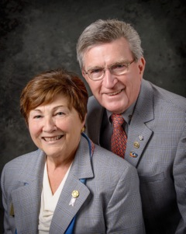Pat and Skip Doyle
2016-2017 Governors
Rotary District 7910
pwdoyle2@verizon.net
skipdoyle2@verizon.net

