On Snow, Newsletter, Resolutions, Nominations, RYLA and Planning
By Pat and Skip Doyle

We hope you are enjoying this winter wonderland we are living in. If you are one of our Rotary snowbirds, here is a picture so you can see just how much beauty you are missing. Know you are missed - see you in the spring!
Newsletter

After reviewing several different studies and following much discussion,we have decided to change the day and time for sending the Rotary District 7910 Newsletter to Tuesday at 10:00 a.m., beginning with next week's issue. We take this step because, as a March 2016 CoSchedule blog, What 10 Studies Say About The Best Time To Send E-mail, noted, Tuesday "is hands down the No. 1 best day to send e-mails according to the majority of the data from these studies." CoSchedule also found "the best time to send e-mails is at 10 a.m. ... "

District 7910's e-mail list is our most loyal audience, many of whom share our newsletter's content once they read it. By e-mailing the newsletter on Tuesday at 10:00 a.m., we expect to create the snowball effect of more web traffic - and, ultimately increased membership attraction and retention.

The weekly submission deadline will remain the same: Friday. As usual, text content must be submitted in Word format, and image content, in either JPEG or PDF format. Continue to submit your content to Immediate Past District Governor/Newsletter Editor Jim Fusco at jim.fusco2@gmail.com.

Resolutions
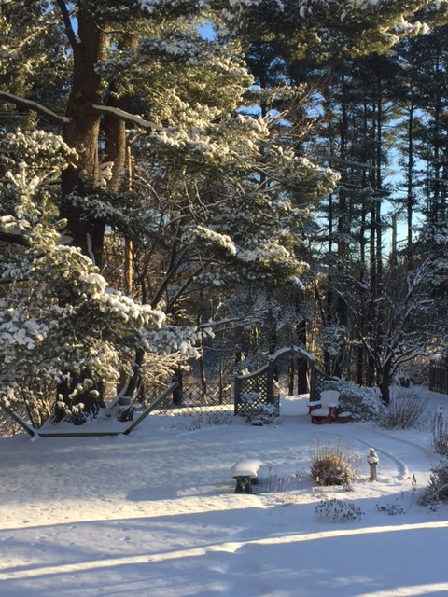
We are in the season of making resolutions - and our district is no exception. This Tuesday evening, the District Resolutions Committee will meet to discuss possible adjustments to the District Bylaws. The results of this meeting will be reported in upcoming newsletters.

Remember, all clubs can also submit resolutions to the committee. All resolutions will be voted on at the yearly District Business Meeting, to be held during the Multi-District Conference in Providence, on Saturday morning, April 29.

As your district governors, we have resolved to:
- Revisit as many clubs as possible in the next few months.
- Help our clubs achieve the goals they set in July
- Do all we can to build membership in the district
- Plan a grand event to celebrate our Million Dollar Foundation Journey
- "Move the ball forward," in harmony, with District Governor-Elect Karin Gaffney, District Governor-Nominee Steve Sager and District Governor-Nominee-Designate Pamela Anastasi
- Celebrate all of this at our Multi-District Conference this April in in Providence
Nominations, RYLA and Planning

Here are three important notes:

1. District Nominations: The District Nominating Committee is seeking qualified applicants to serve as District Trustee for 2017 to 2019 and District Charitable Fund Trustee for 2017 to 2020. Clubs and club leadership are asked and encouraged to actively recruit and promote service in Rotary through their members' service as district leaders. The deadline for submitting applications is this February 18. All completed applications should be either e-mailed to Nominating Committee Chair Michael Ellis (shown, right) at mellis0144@comcast.net, or mailed to him at: Michael Ellis, District 7910 Nominating Committee, 88 Coburn Ave., Gardner, MA 01440. Postmarked mail after February 18 will not be accepted. To download the Trustee Nomination Form, click here. To download the Nomination Form Supplement, click here.

2. Rotary Youth Leadership Awards: The RYLA Club Pack has been updated and posted on RYLA7910.org. When you download it, you will notice changes from last year. Please read the material carefully and direct your questions to Christine Pinney, chair of the RYLA Committee, who may be reached at christine@christinepinney.com. The RYLA season has begun and the RYLA Committee is working to make RYLA 2017 the "best RYLA ever."

3. Club Planning Worksheets: To download the Club Planning Worksheet, click here.This worksheet is made available to clubs so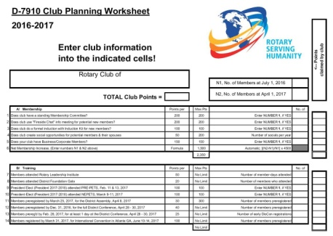 they can gauge their progress in achieving the goals they set last July. This month is a good time to review the worksheet and see how far you have come and how much farther you need to go as a club. You may surprise yourselves and realize that you are well on the way to earning district recognition. We recommend the club president appoint the president-elect to be the "champion" of the Worksheet, and to use it as a guide for the club, and to report monthly to the club's membership and board on the club's progress.
It is a wonderful time to look forward to the excitement, promise and adventures that lie ahead in the year to come. Your district governors wish you all the best in 2017!

Always remember, you can call us with questions at 508-393-9031.

District Governors Pat and Skip Doyle may be reached at pwdoyle2@verizon.net and skipdoyle2@verizon.net,
respectively.

Click here to submit content for the Tuesday, January 17 issue. The submission deadline for this issue is Friday, January 13.

Click here for past issues.

Return to January 9 Newsletter

Visit our website
'Like' our Facebook page
'Follow' us on Twit

