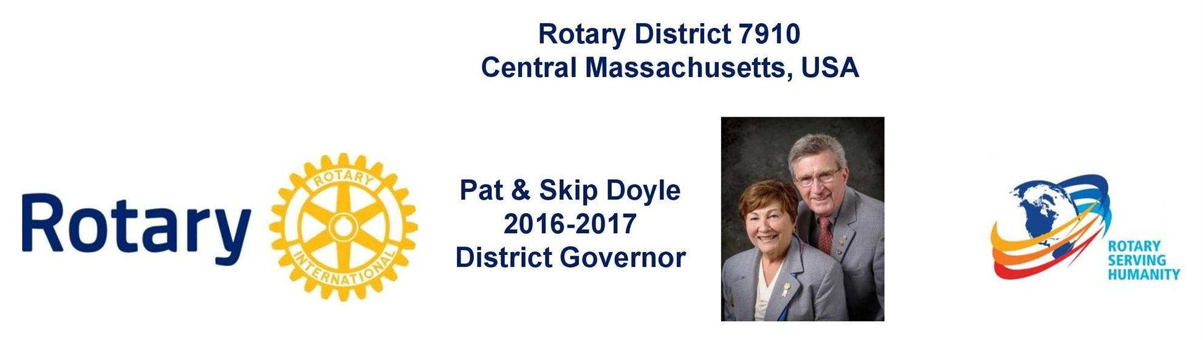

NOTICE
Due to a change in ownership of the Boxborough Holiday Inn, most of our district's schedule meetings have been relocated.

Please check the new meeting locations for all events and committee meetings.

Governors' Welcome
Welcome to Rotary District 7910, which serves Central Massachusetts. We are comprised of 51 clubs whose members represent a cross-section of society. Community members of all ages come together in Service Above Self by undertaking local and international projects that help improve the lives of people.

Our commitment to service is grounded in the fellowship of people who collaborate to make our communities and the world a better place. This year’s Rotary International theme—Rotary Serving Humanity—challenges us to come together for one, overriding goal: service.

District Governors Pat and Skip Doyle may be reached at pwdoyle2@verizon.net and
skipdoyle2@verizon.net, respectively.

District Governors' home club: Northborough

register now: 2017 Multi-District Conference, April 28-30, Providence. To Register, click here.
To download the Conference Highlights flyer (shown, below) in:
- PDF format, click here
- JPEG format, click here
To download the Conference Sponsorship Donation form in PDF format, click here

To download the Rotary Waterfire Fundraiser brochure in PDF format, click here

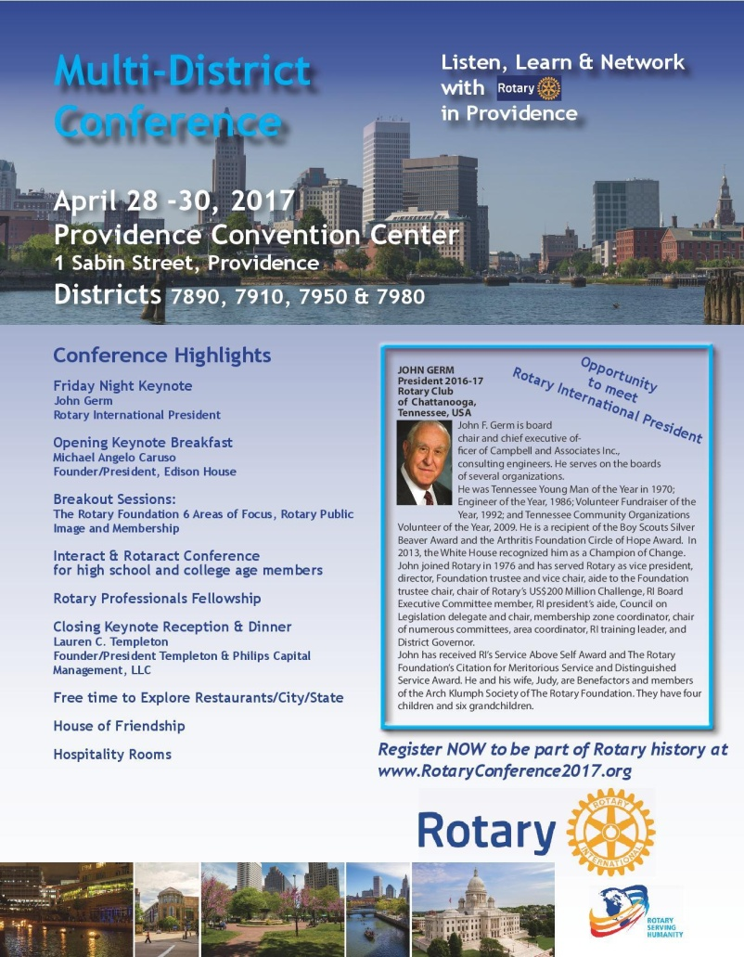

Hot Off the Press!
2016-2017 Rotary District 7910 Directory
Print copies of our 332-page, information-packed 2016-2017 Rotary District 7910 Directory will soon be delivered to your club.

The Directory includes:
- District 7910 and Rotary International general information
- District club information
- Yellow Pages of Rotarian-run businesses
- District Resolutions
- Complete membership directory

A digital version of the Directory is now available for automatic download, in PDF format. Please note: Member login is required.

Click here, to download

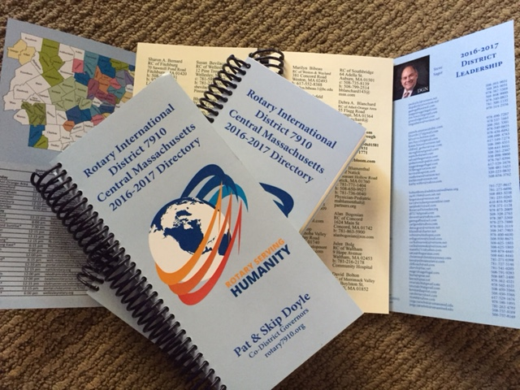

District at a glance

Click on each one

District SOCIAL MEDIA

Click on each one

View Live: Our Facebook Page!
Rotary District 7910

Click here for the complete issue

Or, click on each of these issue highlights:

Governor’s Message: On Snow, Newsletter, Resolutions, Nominations, RYLA and Planning - By Pat and Skip Doyle

District Governor-Elect Report: Register now for NEPETS, March 9-11, Framingham; RI President-Elect Ian Riseley to be Keynote Speaker - By Karin Gaffney

Nominations Call: Seeking qualified applicants - By Mike Ellis

Rotary Means Business: Next meeting on January 25 in Waltham - By Ron Bott

Membership Corner: The Rotary mid-year check - By Tom Sturiale

PR Tips: When a press release isn’t the answer - By Laura Spear

Polio Plus Update: History of wildpolio virus - By Carl Good III

ESSEX Essentials: Learn about academic-year and summer-cultural-exchange programs

District Scholarship Deadline, March 15: Applications Sought for David and Eleanor Morley Endowed Global Grant Scholarship

Rules for January’s District Interact Video Contest: Submission deadline is January 31

2017 Multi-District Conference: April 28-30 in Providence – Register Now!

Click here for our archive of past issues

