The Rotary mid-year check
By Tom Sturiale

We have reached the mid-point of the Rotary year. How are we doing? The new presidents have a better understanding of their objectives and their achievements. They are now beginning to think about the second half of their year and the process of turning the club over to a new administration. Now that the holiday season has ended, the Presidents-Elect Training Seminars will begin for the incoming presidents, district meetings will begin anew, Rotary Youth Leadership Awards preparations will start, and the Multi-District Conference will soon be here.

It may be helpful for the club presidents to reflect on their first six months to determine whether any mid-course corrections are needed. Here a few areas that you may review:
- Have you formed a steering committee of past, present and future presidents to help set the direction of the club?
- Have you nominated and elected incoming officers for 2017-2018?
- Have you assigned chairs for your key committees?
- How are you doing relative to the goals you set for the current year? Are you meeting with all the committees to help them achieve their objectives?
- Have you reached your club goal of Foundation giving? Have you invited speakers to explain the Foundation, the need for giving and the Paul Harris Awards?
- Have you effectively utilized the assembly meetings to review your club’s status on objectives and to determine member satisfaction?
- Are you holding monthly board meetings and issuing minutes to all members as now directed by Rotary International?
- Have you been successful in engaging all members by assignments to working committees, projects or other club activities?
- Have you tracked your club attendance and member participation?
- Are your members satisfied with your club agendas, meetings, meals, venues, speakers and club projects? How do you know? Have you conducted a survey?
- Have you determined your club priorities, signature projects and calendar for the next two to three years? What are your visioning plans?
- What are your membership goals? Are you on track to achieve them? If not, why not?
- Are your new members being properly welcomed, engaged and involved?
- Have you organized fellowship events during the year?
- What are your plans to help the new administration hit the ground running on July 1, 2017?
Every club has its own objectives, priorities and issues, and some of these questions will apply to a varying degree to each one. While there are many other questions that may be asked, the important point is that each club president should take the time for a mid-course assessment to reflect on goals and achievements. Do not dwell on past missed opportunities.

The year is brand new. Reassess, redirect and finish the year with a bang!

Tom Sturiale, chair of District 7910's Visioning Committee and vice chair of its Membership Committee, may be reached at tsturiale36@gmail.com.

December 2016 'Membership Corner' articles:
- December 5: Does your club’s strategy have an impact on membership?
- December 19 & 26: Improving effective membership efforts
- To read previous articles for Rotary 2016-2017, click here
Documents for October 2016 Membership Workshops, in PDF format:
- Participant Comments
- Introductory Notes for Moderators
- Sessions Discussion Points
- Rotary Membership-Development Ideas Sites
To learn about the October 2016 Membership Workshops, click here.

For more information on Rotary memberships:
- Rotary Individual Membership Application - Word Format
- Rotary Corporate Membership Application - Word Format
- Rotary Corporate Membership Opportunity - Word Format
- Rotary Corporate Membership Information - Word Format

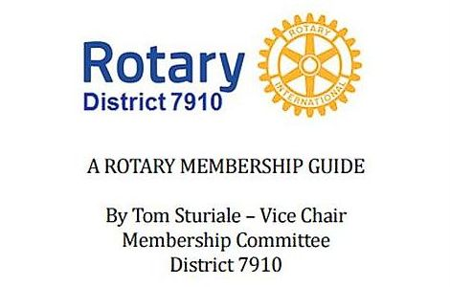"A Rotary Membership Guide" is a collection of "Membership Corner" articles written for this weekly newsletter during the 2015-2016 Rotary year, which began last July 1. It is intended to offer an idea or thought each week aimed at stimulating discussions, questions and actions to effectively increase membership at all our clubs. Click here, to download this 52-page "Guide," in Word format.

Return to January 9 Newsletter

Visit our website
'Like' our Facebook page
'Follow' us on Twitter

