GOVERNOR'S MESSAGE

On Snow, Resolutions, Newsletter, Nominations, RYLA and Planning

By Pat and Skip Doyle

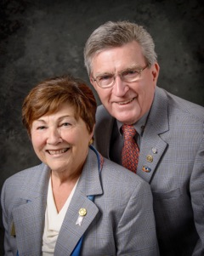
We hope you are enjoying this winter wonderland we are living in. If you are one of our Rotary snowbirds, here is a picture so you can see just how much beauty you are missing. Know you are missed - see you in the spring!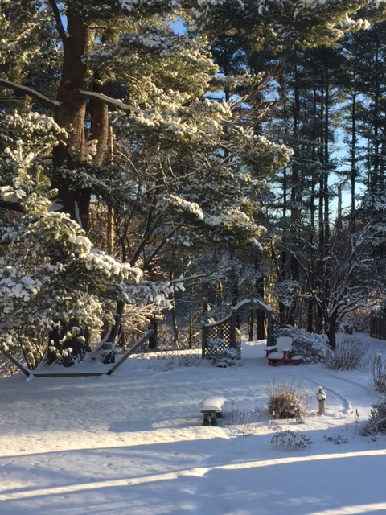

Newsletter

After reviewing several different studies and following much discussion,we have decided to change the day and time for sending the Rotary District 7910 Newsletter to Tuesday at 10:00 a.m., beginning withnext week's issue.
We take this step because, as a March 2016 CoSchedule blog, What 10 Studies Say About The Best Time To Send E-mail, noted, Tuesday "is hands down the No. 1 best day to send e-mails according to the majority of the data from these studies." CoSchedule also found "the best time to send e-mails is at 10 a.m. ... "

District 7910's e-mail list is our most loyal audience, many of whom share our newsletter's content once they read it. By e-mailing the newsletter on Tuesday at 10:00 a.m., we expect to create the snowball effect of more web traffic - and, ultimately increased membership attraction and retention.

The weekly submission deadline will remain the same: Friday. As usual, text content must be submitted in Word format, and imagecontent, in either JPEG or PDF format. Continue to submit your content to Immediate Past District Governor/Newsletter Editor Jim Fusco at jim.fusco2@gmail.com.

Resolutions

We are in the season of making resolutions - and our district is no exception. This Tuesday evening, the District Resolutions Committee will meet to discuss possible adjustments to the District Bylaws. The results of this meeting will be reported in upcoming newsletters.

Remember, all clubs can also submit resolutions to the committee. All resolutions will be voted on at the yearly District Business Meeting, to be held during the Multi-District Conference in Providence, on Saturday morning, April 29.

As your district governors, we have resolved to:
- Revisit as many clubs as possible in the next few months.
- Help our clubs achieve the goals they set in July
- Do all we can to build membership in the district
- Plan a grand event to celebrate our Million Dollar Foundation Journey
- "Move the ball forward," in harmony, with District Governor-ElectKarin Gaffney, District Governor-Nominee Steve Sager and District Governor-Nominee-Designate Pamela Anastasi
- Celebrate all of this at our Multi-District Conference this April in in Providence
Nominations, RYLA and Planning

Here are three important notes:

1. District Nominations: The District Nominating Committee is seeking qualified applicants to serve as District Trustee for 2017 to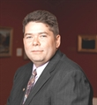2019 and District Charitable Fund Trusteefor 2017 to 2020. Clubs and club leadership are asked and encouraged to actively recruit and promote service in Rotary through their members' service as district leaders. Thedeadline for submitting applications is thisFebruary 18. All completed applications should be either e-mailed to Nominating Committee Chair Michael Ellis (shown, right) at mellis0144@comcast.net, or mailed to him at: Michael Ellis, District 7910 Nominating Committee, 88 Coburn Ave., Gardner, MA 01440. Postmarked mail after February 18 will not be accepted. To download the Trustee Nomination Form, click here. To download the Nomination Form Supplement, click here.
Rotary Youth Leadership Awards: The RYLA Club Pack has been updated and posted on RYLA7910.org. When you download it, you will notice changes from last year. Please read the material carefully and direct your questions to Christine Pinney, chair of the RYLA Committee,who may be reached at christine@christinepinney.com. The RYLA season has begun and the RYLA Committee is working to make RYLA 2017 the "best RYLA ever."

Club Planning Worksheet: To download the Club Planning Worksheet, click here.This worksheet is made available to clubs so 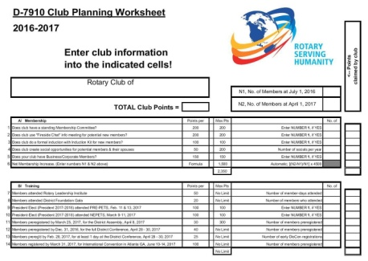they can gauge their progress in achieving the goals they set last July. This month is a good time to review the worksheet and see how far you have come and how much farther you need to go as a club. You may surprise yourselves and realize that you are well on the way to earning district recognition. We recommend the club president appoint the president-elect to be the "champion" of the Worksheet, and to use it as a guide for the club, and to report monthly to the club's membership and board on the club's progress.

It is a wonderful time to look forward to the excitement, promise and adventures that lie ahead in the year to come. Your district governors wish you all the best in 2017!

District Governors Pat and Skip Doyle may be reached at pwdoyle2@verizon.net and skipdoyle2@verizon.net, respectively.

Click here to submit content for the Tuesday, January 17 issue. The submission deadline for this issue is Friday, January 13.

Click here for past issues.

WELCOME, NEW ROTARIANS
Alphabetical order, by last name

- Neil Bock, Westborough
- Charlie Breitrose, Watertown
- Mike Driscoll, Watertown
- Stephen Janes, Groton-Pepperell
- Thomas Popson, Acton-Boxborough
- Mark Sideris, Watertown
- Charles Summers, Acton-Boxborough
Remember to ask ... ask ... ask!

DISTRICT SCHOLARSHIP DEADLINE, MARCH 15
Applications Sought for David and Eleanor Morley Endowed Global Grant Scholarship

To learn more about the Morley Scholarship, click here.
To download the Morley Scholarship flyer in PDF format, click here.

CLUB MEMBERSHIP GROWTH, ’16-‘17
We share with you the results of club-membership growth in our district during Rotary year 2016-2017, which began July 1.

This is a unique opportunity for Rotarians and friends to discuss partnering on humanitarian projects affecting our local communities.

READ MORE

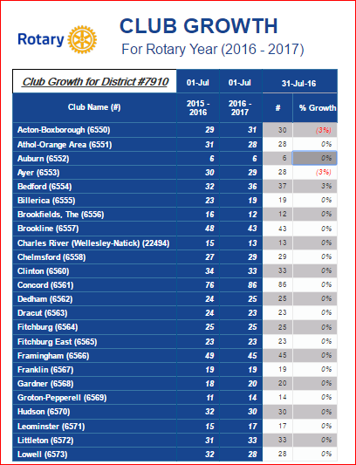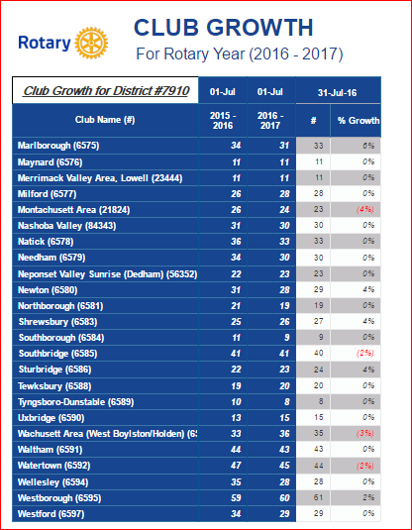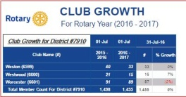

DISTRICT & CLUB ROUNDS
Southborough Looks for Talent

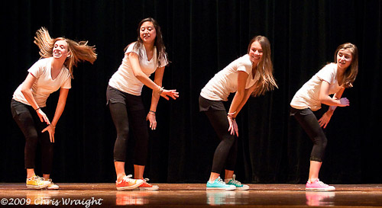

The Rotary Club of Southborough is looking for talented performers from fifth grade to adults to participate in the 17th Annual Talent Show, to be held Friday, March 10. Auditions will take place Monday,January 23 starting at 6:30 p.m. in the auditorium of the Trottier Middle School, located 49 Parkerville Rd. in Southborugh.

For more information or to schedule an audition, contact eitherRachel Bartolomei at rbartolomei@nsboro.k12.ma.us or Jessica Dimitrov jdimitrov@nsboro.k12.ma.us.

To learn more about Southborough Rotary, click here.

Uxbridge Present Student Scholarships

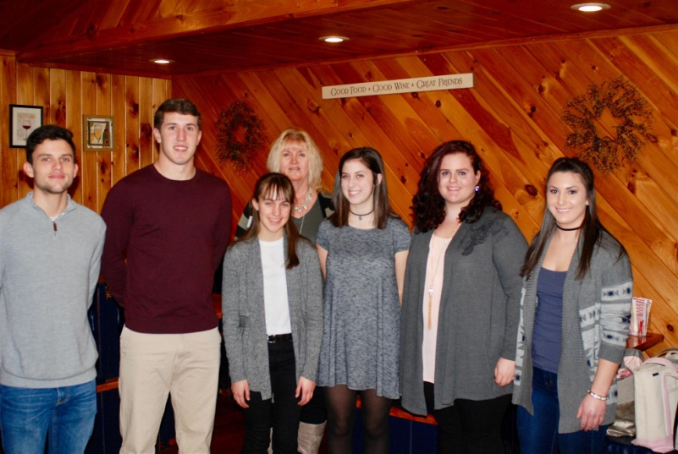

At the weekly meeting of the Rotary Club of Uxbridge on January 3, members, parents and students gathered as scholarships were presented to seven high school students.

Left to right: Zachary Ells and Michael Tourony, of Douglas High School; Angela Eppelet, of Whitinsville Christian School; Uxbridge Rotary President Linn Doll Butler; Keryn Moriarty, of Uxbridge High School; and Samantha Tackett-Marvill and Jillian Shenian, of Northbridge High School. Not shown: Taylor Walsh, of Blackstone Valley Regional Vocational Technical School.

To learn more about Uxbridge Rotary, click here.

Westborough Inducts Jason Burack as Newest Member

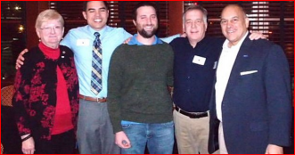

Left to right: Membership Chairs Sue Albladian and Bo Daley, Jason Burack, President Gerry Gross, and District Governor-Nominee Steve Sager

To learn more about Westborough Rotary, click here.

Rotarians Ring Bell For Salvation Army

Each holiday season, most of our district's Rotary clubs volunteer to Ring the Bell for the Salvation Army. The 2016 season was no different as Rotarians and friends braved the cold and snow to Ring the Bell - although some clubs got to ring in the warmth of indoor malls. Many clubs also have Rotarians who are also members of the Salvation Army. Here are two photos we want to share with you. If your club Rang the Bell, please send your photos to Newsletter Editor Jim Fusco at jim.fusco2@gmail.com, and we will include them in future issues. Thank you for your efforts!

Rotary Club of Fitchburg

Left to right: Fitchburg President Dan Cunningham; Fitchburg MayorStephen DiNatale; and Fitchburg Rotarian and Salvation Army member Lynnette Valentine

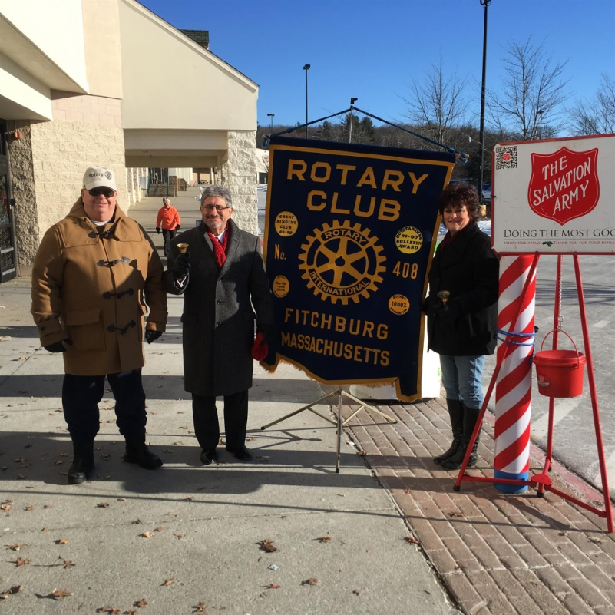

Rotary Club of Montachusett Area

Left to right: Salvation Army member and Rotary friend Keith LaFerriere; Past President Leslie Storrs; and Fitchburg Rotarian and Salvation Army member Lynnette Valentine

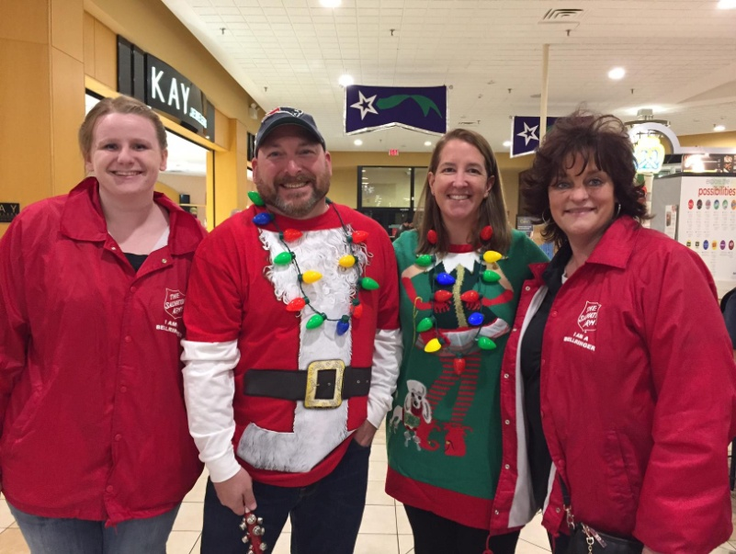

District Interact Committee Picks December Video Contest Winner, Presents Check to November Winner

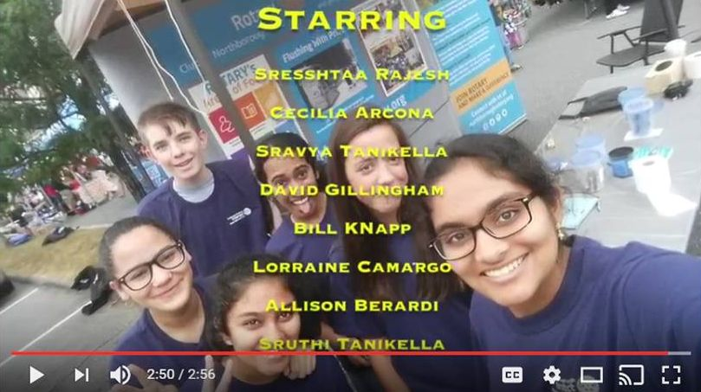

The newly formed Interact Club of Northborough-Southboroughhas won the District Interact Video Contest for December.The three-minute video focuses on the history behind the formation of the club. The selection, which includes a $250 prize, was made by the District Interact Committee.

WATCH NORTHBOROUGH-SOUTHBOROUGH'S AWARD-WINNING VIDEO FOR DECEMBER

Northborough-Southborough Interact is sponsored by the Rotary Club of Northborough. To learn more about Northborough Rotary,click here. To learn more about Interact, click here.

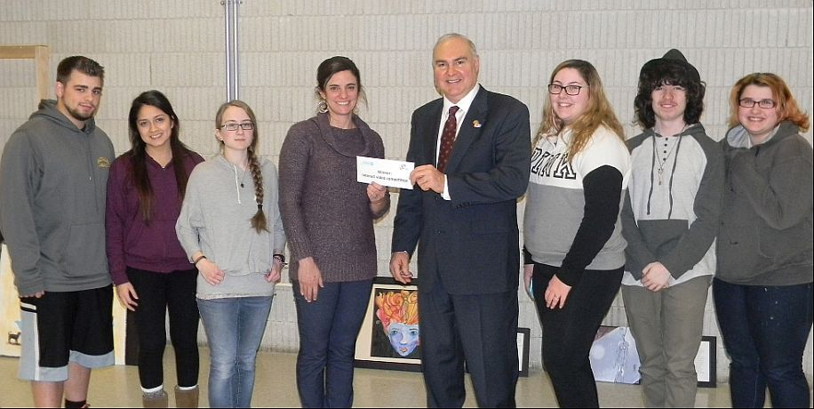

Bob Anthony (fourth from right), chair of the District Interact Committee, has presented a $250 check to the Interact Club of Bay Path Regional Vocational Technical High School, which won the district’s first Interact Video Contest, for November. The award ceremony took place on December 19 at Bay Path in Charlton. The winning video was inspired by Bay Path High’s participation in the sixth annual Worcester County Coat Drive, conducted by the Worcester County Sheriff's Office. Bay Path Interact is splitting the $250 award, 50-50, with the school’s Video Club, which shot and edited the winning entry.

Left to right: Interactor Matt Pecore; Interact President Veronica Martinez; Interactor Kayleigh Blanchard; Bay Path Teacher Jennifer Reil, Auburn Rotary’s advisor to the Interact Club; Bob Anthony; Interactor Taryn Stevens; Interactor Jamie Butkiewicz, who stars in the video; and Interactor Maura Griffis.

WATCH BAY PATH HIGH'S AWARD-WINNING VIDEO FOR NOVEMBER

Bay Path Interact is sponsored by the Rotary Clubs of Auburn and Southbridge. To learn more about Auburn Rotary, click here. Tolearn more about Southbridge Rotary, click here. To learn more about Interact, click here.

RULES FOR DISTRICT INTERACT VIDEO CONTEST; JANUARY 2017

Nashoba Valley To Host Third Annual 'Power of Change' Event on January 23

READ MORE, AND REGISTER NOW

To learn more about Nashoba Valley Rotary, click here.

Nashoba Valley Tools Up for Bolton Repair Cafe on January 21

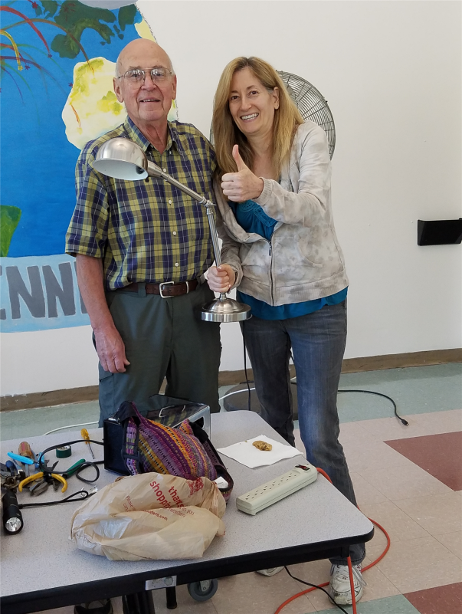
Left to right: Volunteer Rene Goutte of the Bolton Lions Club and guest Sue Brent.

READ MORE

To learn more about Nashoba Valley Rotary, click here.

Westborough Uses PayPal to Raise Nearly $2,000 for Polio Plus

READ MORE

To research charities that have a registered 501(c)3 account with PayPal, click here.

To learn more about Westborough Rotary, click here.

District Highlights Fundraising Goals in Video

We are all well aware that The Rotary Foundationis celebrating its 100th anniversary in 2017.Steve Kirk, president of the Rotary Club of Concord, has produced a five-minute video that outlines our own district’s fundraising goals for the current Rotary year, which ends next June 30.

WATCH VIDEO

To learn more about The Rotary Foundation, click here.

Tewksbury Rotary, Lions Teaming Up for Sock Hop on January 20

READ MORE

To learn more about Tewksbury Rotary, click here.

Video of Governor Baker's Address to District Rotarians Now Available

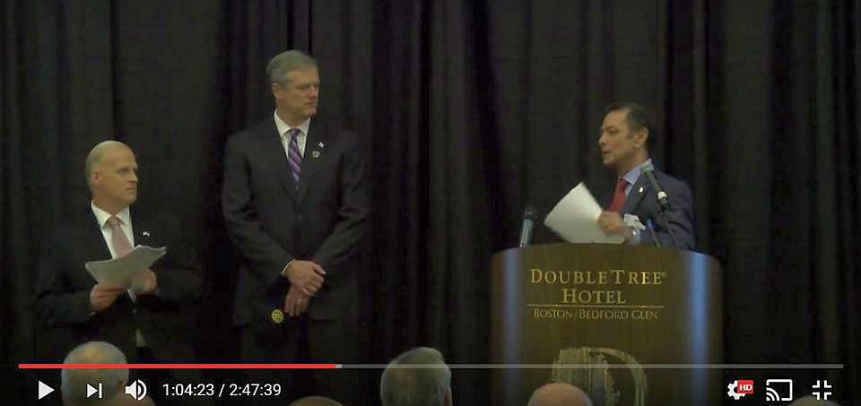

The Rotary Club of Billerica has provided a video of Governor Charlie Baker's address to District 7910 Rotarians on September 27 at the DoubleTree Hotel in Bedford. To watch the two-hour-47-minute video, click here.

The Rotary Clubs of Bedford, Billerica, Lowell, Newton and Shrewsbury sponsored the event, which was a unique opportunity for Rotarians and friends to discuss partnering on humanitarian projects affecting our local communities. To view event photos, click here.

Meet Tatsuya Hayase, Our Rotary Scholar

To Have Tatsuya Speak to Your Club, Contact Indira Desai

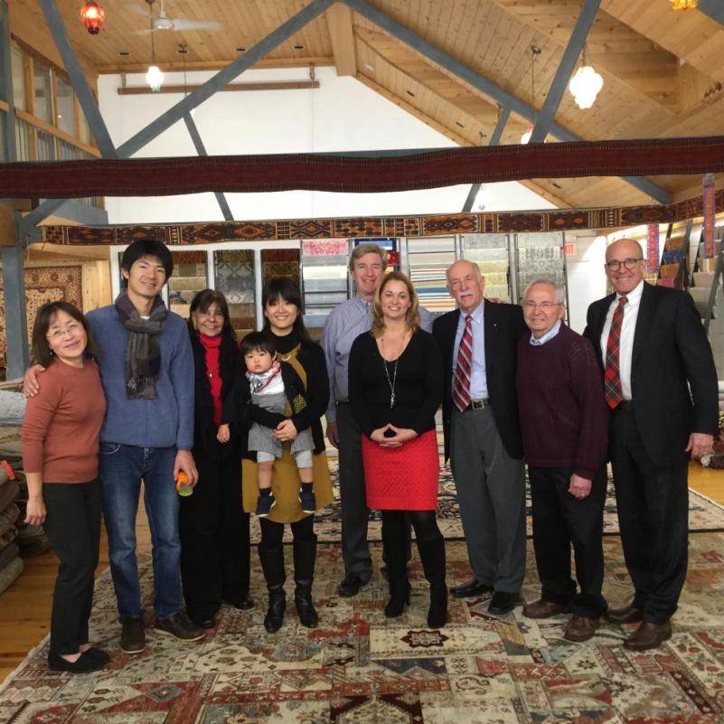

READ MORE
Left to right: Newton Rotarian Chris Chu; Rotary Scholar Tatsuya Hayase, his wife, Marie Hayase, and their son, Yuto Hayase; Host Counselor Indira Desai, immediate past president of Newton Rotary; Newton Rotary President Paul Sullivan and his wife, Monica Sullivan; District Scholarship Chair Tory DeFazio, a Wellesley Rotarian; and Newton Rotarians Tony Bibbo and Tom Keery.

Wachusett Area Rotary, Chamber Hear State Secretary Jay Ash Offer Local Economic Outlook

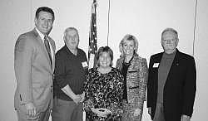

Left to right: Secretary Jay Ash, Chamber President Iain McKinlay, State Senator Anne Gobi, State Representative Kim Ferguson, and Rotary President Gary Hough.

READ MORE

To learn more about Wachusett Area Rotary, click here.

A Great Fundraising Idea for All Clubs

Milford Distributes '16 Tab to 13,000 Homes - Record sales, 94 photos, 334 smiling faces

To read the Milford RotaryTab, click here.

To learn more about Milford Rotary, click here.

On to Atlanta in 2017: Register now!

Planning to attend? Contact District Chair Steve Glines.

To learn more, click here.

To register for the 2017 RI Convention in Atlanta, click here.

Pat and Skip Doyle Installed as '16-'17 DGs

To watch a video of the installation, click here.

District Banners Available

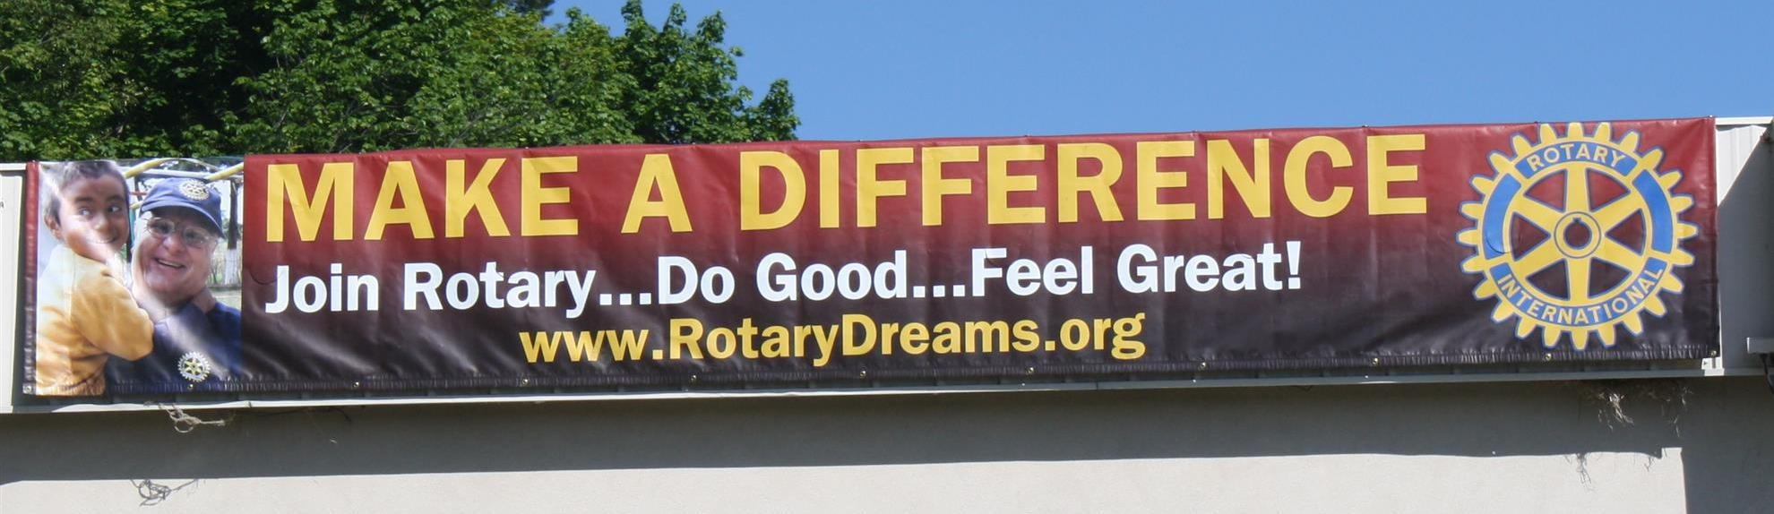

Our district banners are available for your use when you have an upcoming event or fundraiser.

If you want to reserve one of the banners, please contact PR Chair Laura Spear at laura@spear.net.

MAJOR DISTRICT & CLUB HAPPENINGS: WINTER 2017

Friday, January 20: - Tewksbury - 'Sock Hop'

To learn more, click here

Monday, January 23: Nashoba Valley - 'Third Annual Power of Change Event'

To learn more, and to register for this free event, click here

To download flyer in PDF format, click here

Saturday, January 28: Brookfields - 'Murder Mystery Dinner'

For more information, contact Lynn Duffey-O'Shea at 413-262-8783 or President Chet Lubelczyk at 508-867-3203.

Click here to download event flyer

Saturday, March 11: Uxbridge - 'Wine and Chocolate Tasting'

See our Facebook Page <click here>

Click here to download event flyer

Wednesday, March 15: District 7910 'Deadline for Morley Scholarship Applications'

To learn more, click here

To download flyer in PDF format, click here

SUBMIT MAJOR CLUB HAPPENINGS

Send flyers of your club's major events and activities, in eitherJPEG or PDF format, to Immediate Past District
Governor/Newsletter Editor Jim Fusco at jim.fusco2@gmail.com.

