When a press release isn’t the answer
By Laura Spear
Sometimes, the traditional press release isn’t always the answer - and not always appropriate. There are better ways for the public to read your news.

Alternatives include community-calendar listings and social-networking sites such as Facebook and Twitter. Think about what your local newspaper wants to communicate to its subscribers, and how important your information may be. (from nonprofitpr.org.)

To learn more about PR for your club, click on the "Public Relations" section of the navigation bar of the District 7910 website.

Laura Spear, chair of District 7910's Public Relations Committee, may be reached at laura@spear.net.

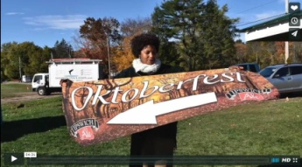Click here for an excellent example of a club-event promotional video by Concord President Steve Kirk.

Return to January 9 Newsletter

Visit our website
'Like' our Facebook page
'Follow' us on Twitter

