COMMITTEE REPORTS

Governor-Elect Report: Register now for NEPETS, March 9-11, Framingham

RI President-Elect Ian Riseley to be Keynote Speaker

By Karin Gaffney

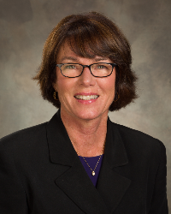

READ MORE

Nominations Call: Seeking qualified applicants

By Mike Ellis

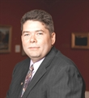

READ MORE

ESSEX: Learn about a great youth program

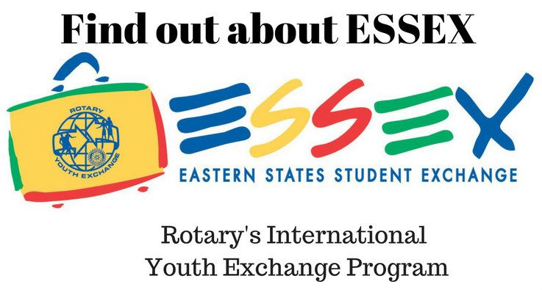
READ MORE

Treasurer's Report: Always keep your membership numbers updated - District and RI dues are billed semi-annually

By Jack Hoell
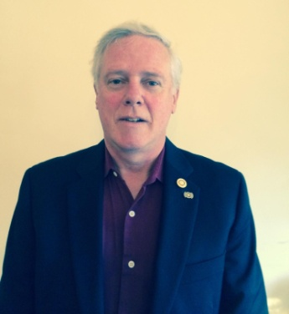

READ MORE

Rotary Means Business: Next meeting on January 25 in Waltham
By Ron Bott

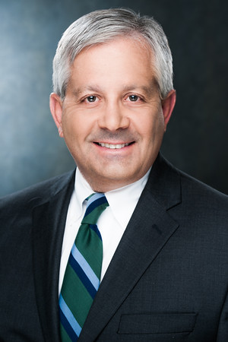

READ MORE

Membership Corner: The Rotary mid-year check

By Tom Sturiale
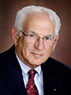

READ MORE

To learn how the Rotary Club of Melbourne in Victoria, Australia does corporate membership, click here

To learn about District 7910 Membership Workshops in October, click here.

Membership Materials On Sale: Order now!
To order, click here

PR Tips: When a press release isn’t the answer

By Laura Spear
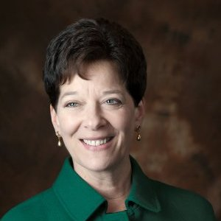

READ MORE

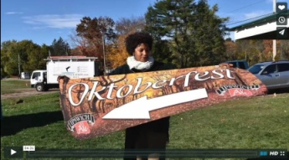

Click here for an excellent example of a club-event promotional video by Concord President Steve Kirk.

Polio Plus Update: History of wildpolio virus

By Carl Good III

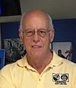

READ MORE

What Is The Mission of Rotary Leadership Institute?

By Doug Detweiler

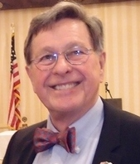

READ MORE

What are the courses? Click here
To download the brochure with all of the RLI Northeast America classes for 2016-2017, click here.

For the complete RLI Northeast America schedule, click here.

'17 RI Convention in Atlanta: Register now!

Beyond Borders Dinner on June 11: To register now, click here.

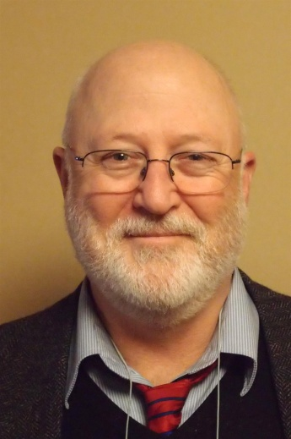

More Than 100 Breakout Sessions

There will be more than 100 breakout sessions at the RI Convention in Atlanta. Help us plan the sessions by taking a survey: TAKE SURVEY
Here's a letter from Steve Glines, chair of the District International Convention Promotion Committee: READ LETTER

To register and find hotel options, click here

For more information on the 2017 RI Convention in Atlanta, click here

Interact Actions: Interact teens invited to help in Providence and Atlanta
By Bob Anthony
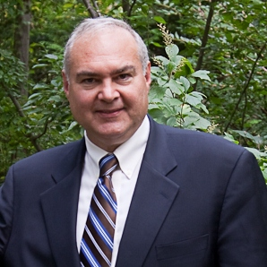

READ MORE

How to launch an Interact club

WATCH VIDEO

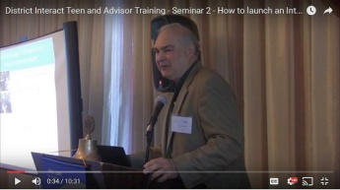

Foundation Note: Foundation-Giving Scorecard for ‘16-‘17
By Sanjay Deshpande

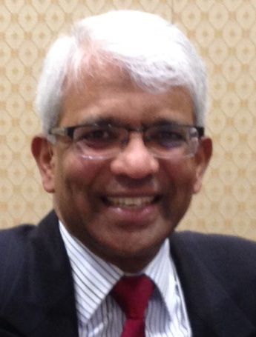

READ MORE

Million Dollar Dinner on May 27: RI Past President Kalyan Banerjee to be keynote speaker

By Satya Mitra

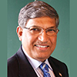

READ MORE

A Healthy Rotarian Is A More Effective Rotarian - Make a great New Year's resolution

By Ron Goodenow

READ MORE

Club Central: Short video on how to post your club goals

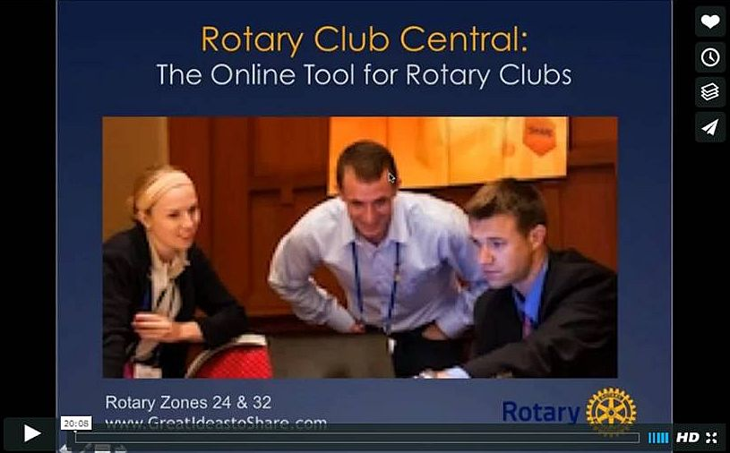
This 20-minute webinar recording is designed for club leaders to assist in posting goals on Rotary Club Central. Bob Wallace andIan Lancaster, facilitators from Rotary Zone 24 East, provide practical start-up information.

CLICK HERE

Did You Know?: District 7640 has more Interactors than Rotarians

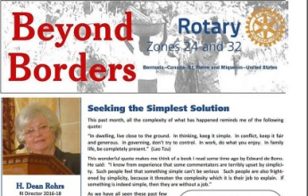

READ MORE

RAAGNE Newsletter: Update on visioning process

By Klaus Hachfeld

READ MORE

Speaker's Bureau: Looking for good speaker for your club?

By Steve Levitsky

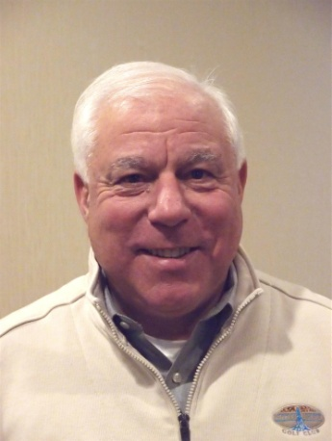

It's not always easy to come up with ideas week after week. We have many suggestions for you. Here are just a few:
- Rwandan genocide: Carine Boggis
- Elevator-pitch tips: Andy Winig
- Positive-results hypnosis: Bob Martel
- Differentiation and game-changing simplicity: Stephen Melanson
VIEW MORE

District Charity Fund: How does DCF operate?

By Karin Gaffney

READ MORE

Communications Link: Seeking club photo, video albums
By Steve Jones-D'Agostino
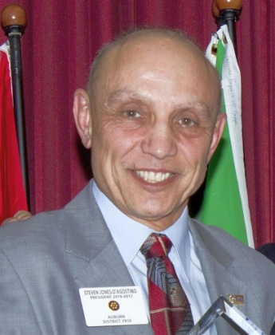

READ MORE

SUBMIT CONTENT
After reviewing several different studies and following much discussion, we have decided to change the day and time for sending the Rotary District 7910 Newsletter to Tuesday at 10:00 a.m., beginning with next week's issue. (See this week's Governor's Message for more information).
To submit content for consideration for theTuesday, January 17 issue of Rotary District 7910 Newsletter, please e-mail it to Immediate Past District Governor and Newsletter Editor Jim Fusco at jim.fusco2@gmail.com.
The weekly submission deadline remains the same:Friday. All text must be in Word format. All images must be in either JPEG or PDF format. Please identify the people, left to right, who are shown in your photos, including their first and last name as well as their club or other title.

PAST ISSUES
To view past issues of the weekly Rotary District 7910 Newsletter, click here

D7910 ONLINE
Visit Our Website
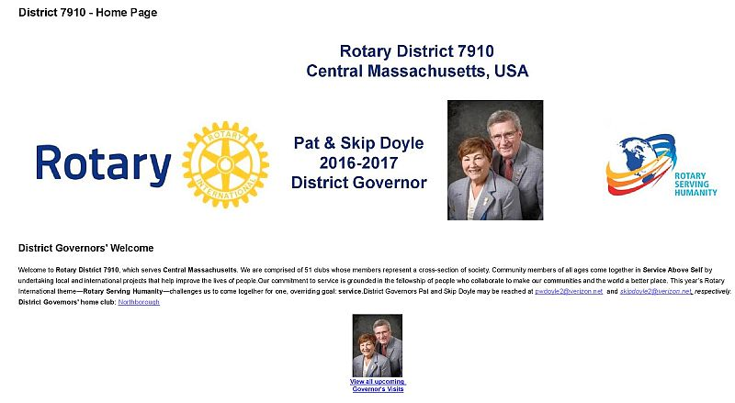
Click on each one

'Like' And Share Us On Facebook

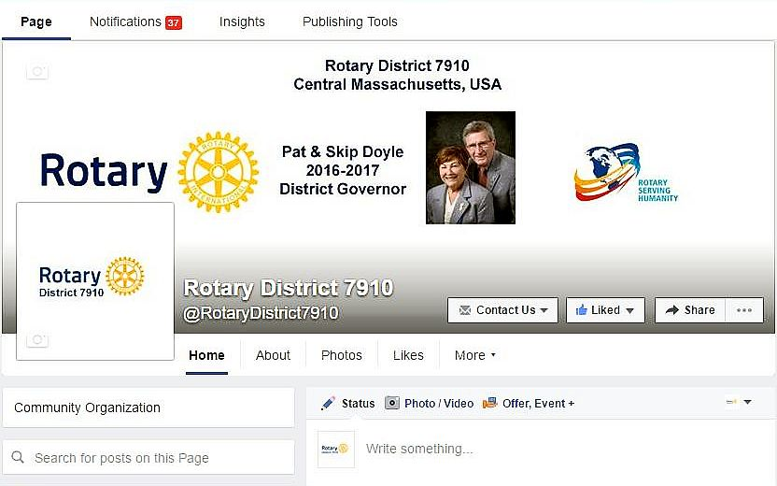

'Follow' Us On Twitter

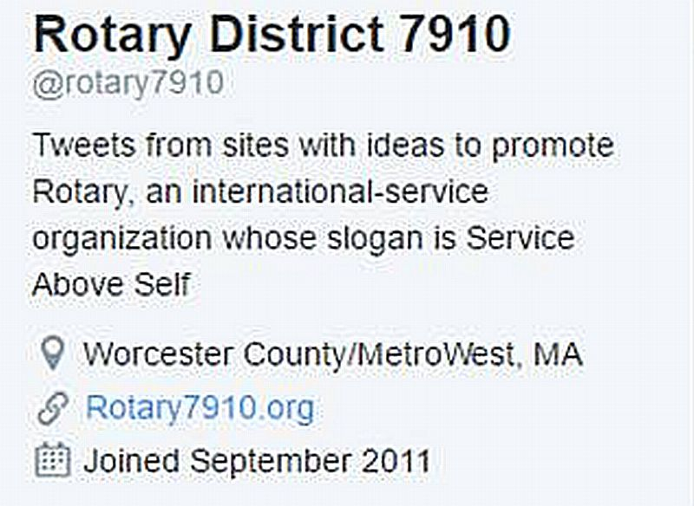

Watch Our Videos
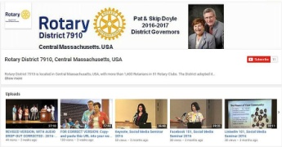

View Our Photos
Archived on Google Photos, since May 2015; and on ClubRunner, before May 2015
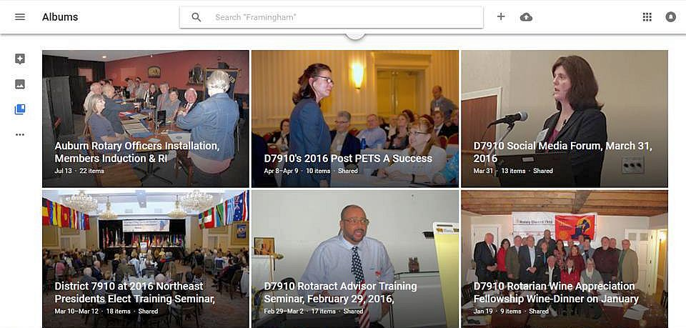

CONTACT US
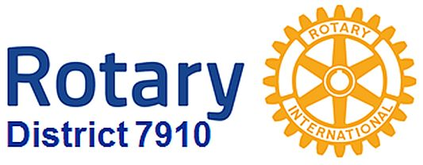

Jim Fusco, Immediate Past District Governor and Newsletter Editor
​jim.fusco2@gmail.com
Steve Jones-D'Agostino, District Webmaster and Newsletter Copyeditor
​srdagostino@icloud.com
© Copyright 2016-2017 - Rotary District 7910, Central Massachusetts, USA

