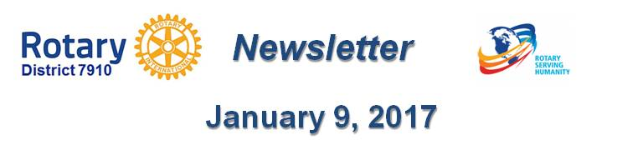

Rotary Means Business: Next meeting on January 25 In Waltham
By Ron Bott

The next Rotary Means Business event in District 7910 will be held on Wednesday, January 25 from 5:30 to 7:30 p.m. at the Hilton Garden Inn in Waltham. The cost is $15 for Rotarians and $20 for non-Rotarians. Light appetizers will be served and a cash bar will be available.

To save $5 on the registration fee, interested Rotarians are encouraged to pre-register by January 20 at http://bit.ly/2iMEMqW.

Non-Rotarians are encouraged to register at http://bit.ly/2iUBDCw
Founded in 2013 as an official Rotary International Fellowship, Rotary Means Business provides Rotarians with business-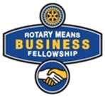networking events to meet and socialize with other Rotarians in business. RMB encourages Rotarians to support the success of their fellow Rotarians by doing business with them, and by referring others to them.

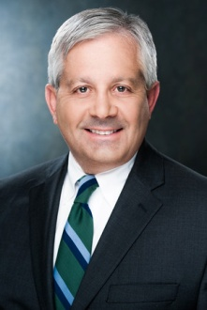Rotary was originally established in 1905 as a business-networking organization and evolved into the international service organization that we know today. With Rotary Means Business, Rotarians are embracing the original foundations on which the Rotary was based. An active RMB chapter serves as another value-added benefit to Rotary membership.

For more information, contact Ron Bott, chair of the District 7910 Rotary Means Business Committee, at 978-423-0564 or ron@bottgroup.com.

Return to January 9 Newsletter

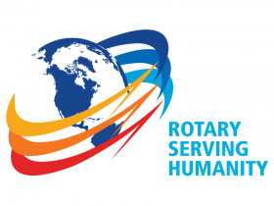Visit our website
'Like' our Facebook page
'Follow' us on Twitter

