Important District Meetings To Bring To Your Attention
By Pat and Skip Doyle

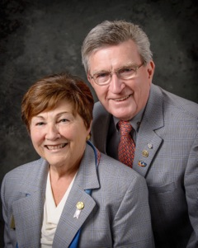
This past week's meetings reminded us of two things. One, we only have four months left as your district governors. And two, those four months are packed with district events and the meetings needed to plan them.

The meeting we would like to bring to your attention today is the Council Meeting with our past district governors, held last Thursday. Nine PDGs met with us, District Governor-Nominee Steve Sager and District Governor-Nominee-Designate Pam Anastasi. Our past district governors don't get a lot of mention and some might say they don't get a lot of attention, either. Finding an appropriate role in the years following a term as governor can be a challenge.

PDGs have knowledge, connections, training, experience - and lots of good ideas. The challenge is translating that passion into action. Or, to quote a Rotary Zone 24/32 publication, having a PDG means having a "proactive, dynamic guide rather than past district governor."

Rotary International spends a great deal of time and money training those of us in the district-governor track. The training we were exposed to at Zone Institutes and the International Assembly was of the highest caliber and we are sure RI expects us to continue to put this training to use for the good of our district, our zone and RI.

The PDGs we met with last Thursday evening represented 27 years of training and action. We thank them for sharing their guidance and wisdom. Many of the readers of this Governor's Message are newer members who have not had the privilege of meeting many of our PDGs. For this reason, we will be adding a column similar to <eet the Presidents, called meet the Past District Governors. PDG Carol Toomey's interview is below.

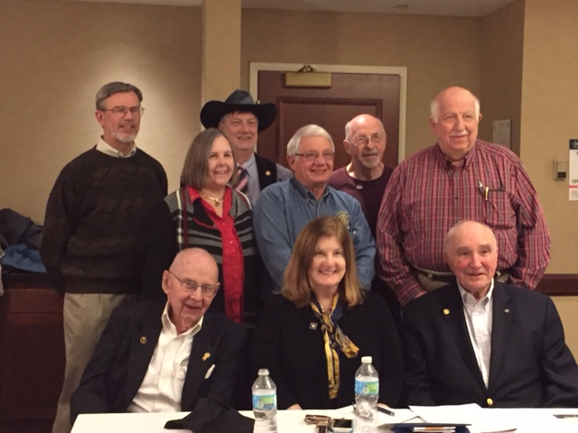Shown, front, left to right, are PDGs Ed Hall, Val Callahan, and Roger Frost

Shown back, left to right, are PDGs Klaus Hachfeld, Carol Toomey, Carl Kalisczski, Jim Fusco, Ed King and Bob Cassidy

QuadCon Call

Int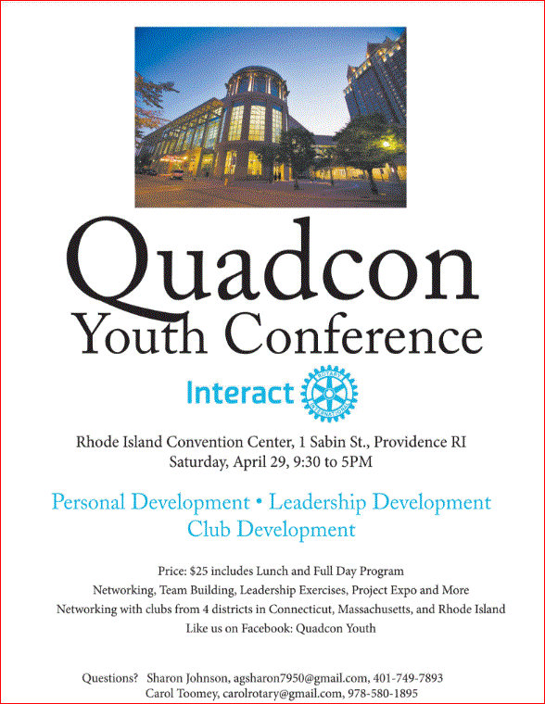eractors from all over the District 7910 are getting excited about theYouth Conference to be held as part of the Multi District Conference - QuadCon, for short - this April in Providence. Check Quadcon web page for updates.

Four important things to know:

1. The weekly submission deadline for the Newsletter is Friday. As usual, text content must be submitted in Word format, and image content, in either JPEG or PDF format. Continue to submit your content to Immediate Past District Governor/Newsletter Editor Jim Fusco at jim.fusco2@gmail.com.

2. Rotary Youth Leadership Awards: The RYLA Club Pack has been updated and posted on RYLA7910.org. When you download it, you will notice changes from last year. Please read the material carefully and direct your questions to Christine Pinney, chair of the RYLA Committee,who may be reached at christine@christinepinney.com. The RYLA season has begun and the RYLA Committee is working to make RYLA 2017 the "best RYLA ever." (See RYLA article, right-hand column.)

3. Club Planning Worksheet: To download the Club Planning Worksheet, click here.This worksheet is made available to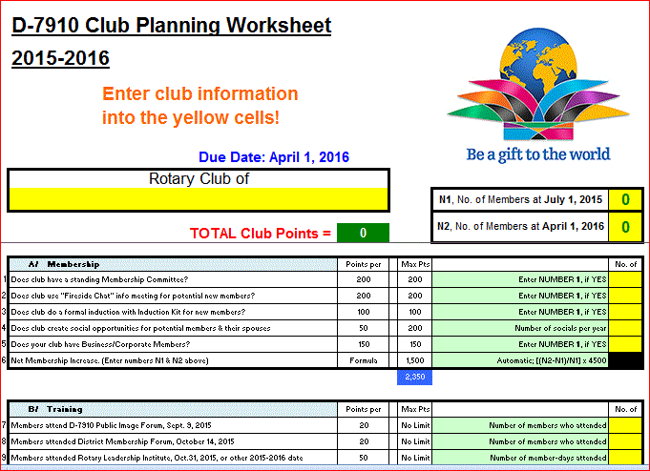 clubs so they can gauge their progress in achieving the goals they set last July. This month is a good time to review the worksheet and see how far you have come and how much farther you need to go as a club. You may surprise yourselves and realize that you are well on the way to earning district recognition. We recommend the club president appoint the president-elect to be the "champion" of the Worksheet, and to use it as a guide for the club, and to report monthly to the club's membership and board on the club's progress.

4. As your district governors, we have resolved to: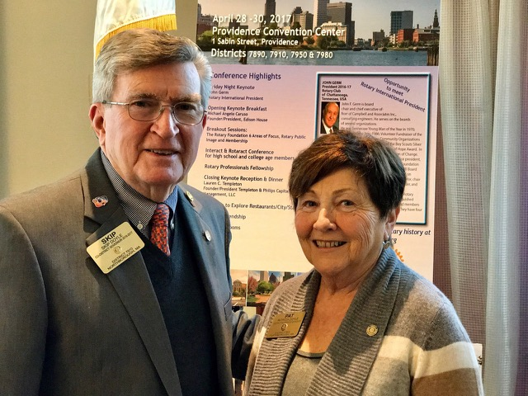
- Revisit as many clubs as possible in the next few months.
- Help our clubs achieve the goals they set in July
- Do all we can to build membership in the district
- Plan a grand event to celebrate our Million Dollar Foundation Journey
- "Move the ball forward," in harmony, with District Governor-ElectKarin Gaffney, District Governor-Nominee Steve Sager and District Governor-Nominee-Designate Pamela Anastasi
- Celebrate all of this at our Multi-District Conference this April in in Providence
District Governors Pat and Skip Doyle (shown, right) may be reached at pwdoyle2@verizon.net and skipdoyle2@verizon.net, respectively.

Click here to submit content for the Tuesday, March 14 issue.
The submission deadline for this issue is Friday, March 10.

Click here for past issues.

Return to March 7 Newsletter

Visit our website
'Like' our Facebook page
'Follow' us on Twitter
Watch our videos
View our photo albums

