Carol Toomey, Nashoba Valley

Past District Governor, 2009-2010

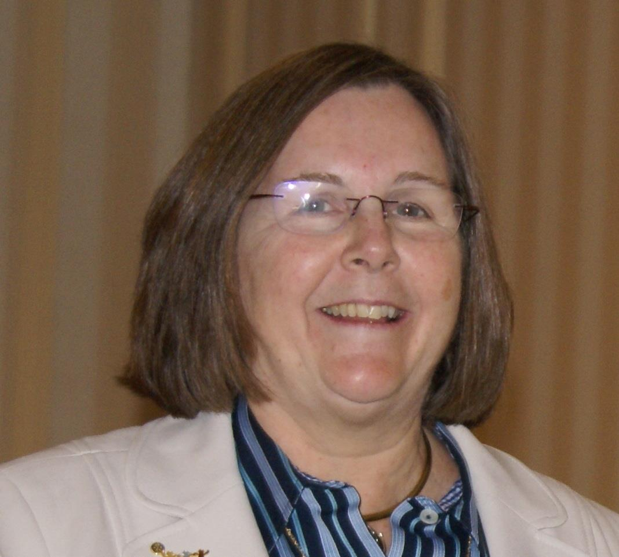
Please tell us what factors helped you decide to join Rotary.

I met PDG Bob Erickson when I moved my Action Unlimited office from Marlboro to Maynard in 1970. My office was next door to his and I used to tease him about how much nicer his office was than mine. I started running ads in my paper for the pancake breakfast that the Acton Rotary had. In the ad, it said all the good things they did with the money. I went to them and asked if I could join. Little did I know that women weren’t allowed.

Fast forward to 1988 and he asked me to join but I felt that they didn’t want me then. . .so no.
In 2000, Marvin Gould asked me to speak at the Acton Club. I finally agreed to join when I heard about the fight to end polio. My father had polio and it is a nasty disease.

Of the activities during your year as DG what do you consider the one thing that best identifies your year?

I think public image and the idea of telling your story was new to many. One of the fun things we did was to decorate a white frog with the most significant project your club does each year. FROG stood for Featuring Rotarians Outstanding Generosity. Westford did a great job of decorating a frog for their Blues and Brews. Marlboro did their turkey shoot. There were so many neat ones. It was a fun display at the PR dinner and the district conference.

What advice do you have to offer others in our district about how best to be involved in Rotary activities?

Do what hits your heart. And, help your fellow Rotarians with their projects. But don’t feel guilty if you don’t help with every project. Whatever you do is appreciated. At Nashoba Valley, we often hear of great projects from our speakers. We like to offer to help them with their project. After helping, some people join our club but we don’t offer to help with that in mind.

What thoughts do you have related to publicity efforts in our district?

Rotarians don’t seem to realize that many people want to help make the world a better place but don’t know how or think “I am only one person”. When you take the time to send articles out to local media, you are giving other people a chance to find out how they can help. Sometimes the help is just coming to the event held by your club. Sometimes it is much more. Without publicity, you are keeping everyone in the dark.

What thoughts do you have related to membership efforts in our district?

My biggest pet peeve is that club members don’t know what to do when a new person visits a club. In some clubs so many people descend on him/her that it is intimidating and we lose that person. In other clubs, there is no follow up. New people need to be made welcome but not overwhelmed. A phone call when someone has missed a couple of meetings should happen as well. That’s what friends do.

As a past district governor, what’s your biggest concern for the coming year?

Mentoring is so important. Experienced Rotarians need to look around and get new people involved and then help them succeed. It works for one’s employment as well as for Rotary positions. That’s one of the great things about Rotary that many people don’t think of. I was visiting a club and one of the members said to the entire club that she was giving her notice to go to a new position right after the meeting. “I would never have had the confidence to do this if it wasn’t for you, my fellow Rotarians. I have learned a lot.” Rotary grows leaders. We need to grow District leadership.

What’s the best book you’ve read in the past three years?

I read mostly business books. My favorite books are by Malcolm Gladwell. I love the way he thinks. The Tipping Point, Blink, and the Outliers are very much worth reading.

What’s your favorite quotation?

"Every course can’t be flambee."

Carol Toomey may be reached at carolaction@aol.com.

Return to March 7 Newsletter

Visit our website
'Like' our Facebook page
'Follow' us on Twitter
Watch our videos
View our photo albums

