SUBMIT EVENTS
You may submit event information per the District 7910 Promotional Guidelines. If your club does not use ClubRunner, please send your event information to Immediate Past Governor/Newsletter Editor Jim Fusco, jim.fusco2@gmail.com. And, please make sure to add Jim to your club's distribution list.

DISTRICT SOCIAL MEDIA
'Like' and share us on Facebook

'Follow' us on Twitter

DISTRICT & CLUB EVENTS

UPCOMING DISTRICT EVENTS

FOR: MARCH 7-APRIL 7

Tonight: Rotary Youth Leadership Awards Committee Meeting

Tuesday, March 7
6:30-9:00 p.m.

DoubleTree Hotel, Leominster

Northeast Presidents-Elect Training Seminar

Thursday, March 9-Saturday, March 11

Sheraton Framingham Hotel & Conference Center, Framingham

Rotary Youth Leadership Awards - Group Facilitator Training Session #1

Sunday, March 12
1:00-5:00 p.m.

DoubleTree Hotel, Leominster

District Governor-Elect Karin Gaffney's Cabinet Meeting

Thursday, March 16

6:00– 7:30 p.m.

Courtyard Hotel, Littleton

Membership Workshop in Auburn

Tuesday, March 21
6:30 PM – 8:30 PM

Realtors Association of Central Mass.

Assistant Governors Meeting - Live

Wednesday, March 22
6:30– 8:30 p.m.

DoubleTree Hotel, Leominster

Membership Workshop in Acton

Thursday, March 23
6:30–8:30 p.m.

One Acton Place

Membership Workshop in Wellesley

Tuesday, March 28

Wellesley Community Center

Membership Workshop in West Boylston

Thursday, March 30

The Manor/Draught House Bar & Grill

District Training Assembly

Monday, April 3
5:45- 8:00 p.m.

Location to be announced

VIEW THESE PLUS MORE UPCOMING DISTRICT EVENTS - INCLUDING ALL GOVERNOR'S VISITS

RI SPOTLIGHT

'17-'19 UNESCO-IHE Scholarship Applications Available

By Abby McNear

READ MORE

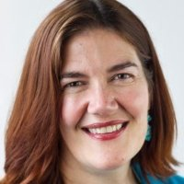

Rotary Peace Centers: 2019 Rotary Peace Fellowship applications now available

READ MORE

Rotary Releases $35 Million to Combat Polio

READ MORE

To read the February 2017 issue of End Polio Now Newsletter, click here.

RI Website Has Been Updated

For a sneak peak at the new Rotary International website, click here.
Read more about the web-refresh project
Learn more about the online tools available to you and your club

Club & District Report from RI

By Katlin Bautz

READ REPORT

In the New Year: Spend Less. Give More.

To learn 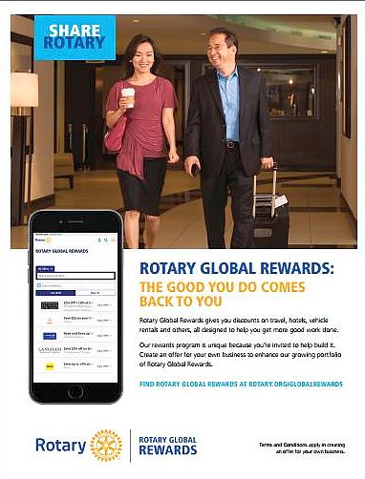more about Rotary Global Reward, click here

To download the Rotary Global Reward flyer,click here

Contact Judy Merriman, chair of the District Rotary Global Rewards Committeeat judymerriman@townisp.com.

The Rotary Foundation Named 'World’s Outstanding Foundation'

READ MORE

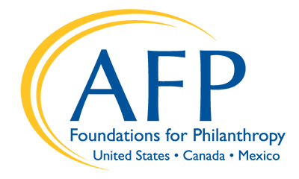

'Rotary Leader' Newsletter: January 2017

READ NEWSLETTER

Meet Ian Riseley: '17-'18 RI President

READ MORE
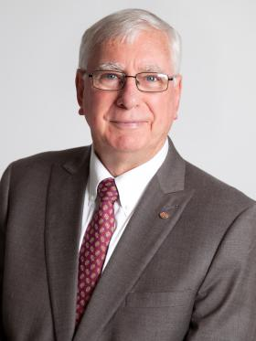

'Beyond Borders:' 2017
By Dean Rohrs, RI Vice President and RI Director for Zones 24 & 32
To read the March 2017 issue of Beyond Borders, click here.
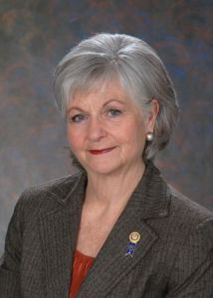
In the March issue:
- Director-Nominee Jeff Cadorette (see below) discusses his "journey" toward directorship - and promises to take us along with him on a great ride.
- Rezoning the Rotary Globe by Mike McGovern
- Zone Coordinator Training in Evanston
- Membership Matters by Quentin Wodon
- How Dies a Club Attract New Members?
- Million Dollar Dinner Reaps Big Rewards
- Polar Plunge in District 7930 Raises over $250,000

To read Dean's highlights of the January RI Board of Directors meeting, click here.

Meet Jeff Cadorette: Our New RI Director

READ MORE
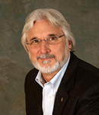

Meet Sam Owori: Our '18-'19 RI President

Sam Owon is a Ugandan businessman and a member of the Rotary Club of Kampala.

READ MORE

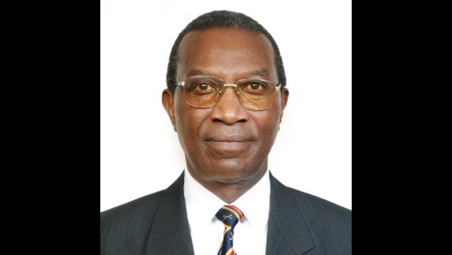

A Letter from '16-'17 RI President John Germ
READ MORE
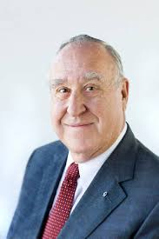

To download the World Polio Day toolkit, click here

For information on the April 2017 Rotary International Convention, click here.

To read a profile of John Germ, click here

To visit the President’s page, click here

To watch the Meet Your President video, click here

2017 Rotary Zone 24 & 32 Institute

READ MORE & REGISTER NOW

Campaign to End Polio: What you don't know

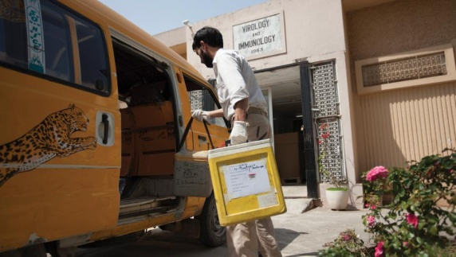
When was the last time there was polio in Europe?

READ MORE

What Millennials Love about Rotary

Millennials, an ethnically diverse, fiercely independent generation of digital natives, are doing more than just snapping selfies—they’re looking for a way to make a difference in their communities.

READ MORE

Get Ready for Your District Rotary Foundation Seminar
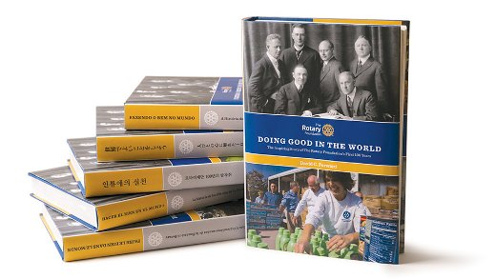
The Rotary Foundation is celebrating its 100th year of Doing Good in the World. Take the opportunity to strengthen your district and clubs during your district's Rotary Foundation Seminar by using resources from centennial.rotary.org.
Go to the Promotional resources tab to download the following Centennial Promotional Kit materials:
- Ideas and activities for clubs
- Doing Good in the World promotional flier
- Doing Good in the World bookmark
- Sample press release
- Centennial letterhead
- Centennial PowerPoint template
- History of the Rotary Foundation PowerPoint
- Centennial postcard
Let others know about these materials they can use to promote the Foundation in their clubs and communities.

Membership Minute: Impact Begins with You

A positive member experience begins long before someone joins a Rotary club. Start by introducing prospective members to Rotary with the Impact Begins With You brochure.

READ MORE

New Tools for Membership Tool Belt

Looking to enhance your club-membership experience?

READ MORE

A How-To Membership-Leads Video
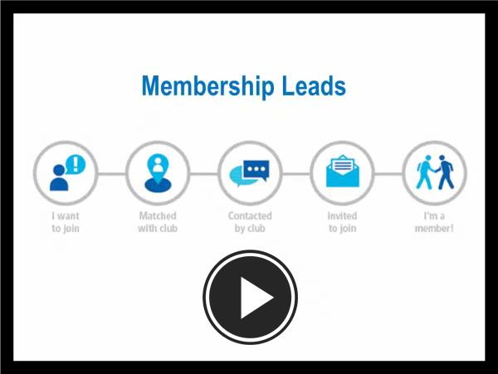
WATCH VIDEO

RI Membership Resource Guide
To download the Guide in PDF format, click here
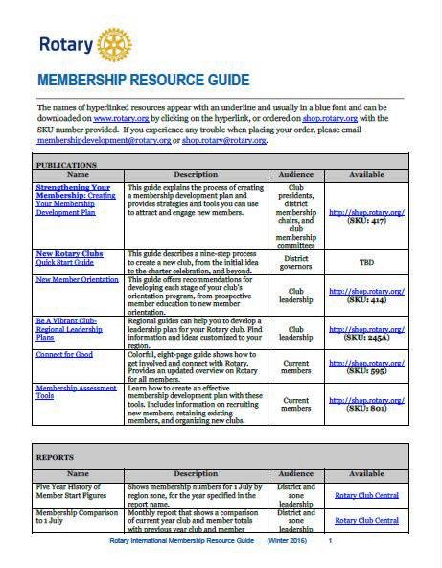

RI Makes Changes in 'Brand Center' Online Tool

W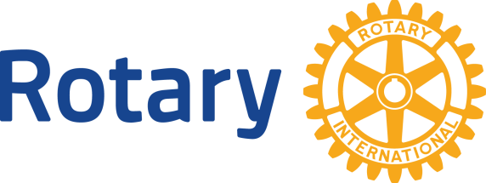e hope that you've found Rotary International’s Brand Center a useful tool to create customized logos and brochures - and to tell Rotary's story in a consistent and engaging way. To gain access, you will need to login with your Rotary Membership ID.

'16-'17 Rotary Theme: 'Rotary Serving Humanity'
To download the image in JPEG format, click here.

Check Out 'Rotary Voices' Blog

Check out Rotary Voices, the official blog of Rotary International. This blog features stories by and about Rotary members, Rotary program alumni, and the people we partner and work with.

